Visualization Analysis Report
R Programming Practical Assessment

Q1. Comparing Distributions — Histogram, Density and ECDF
Processing times (in minutes) were recorded for 20 randomly selected tasks: 18, 21, 22, 24, 25, 25, 27, 28, 29, 30, 31, 32, 33, 35, 36, 38, 41, 43, 46, 50. A histogram, a density plot, and an empirical cumulative distribution function (ECDF) are constructed to compare what each reveals about the distribution.
R Code
# Q1: Histogram, density, and ECDF
library(ggplot2)

Time <- c(18, 21, 22, 24, 25, 25, 27, 28, 29, 30, 31, 32, 33, 35, 36, 38, 41, 43, 46, 50)
df <- data.frame(Time)

mean_t <- mean(Time); median_t <- median(Time)
cat('Mean:', mean_t, ' Median:', median_t, ' SD:', sd(Time), '\n')

# Histogram
ggplot(df, aes(x = Time)) +
geom_histogram(bins = 8, fill = '#4C72B0', color = 'white', alpha = 0.9) +
geom_vline(xintercept = mean_t, color = '#C44E52', linetype = 'dashed') +
geom_vline(xintercept = median_t, color = '#55A868', linetype = 'dotted') +
labs(title = 'Histogram of Processing Time', x = 'Processing Time (min)', y = 'Frequency') +
theme_minimal()

# Density plot
ggplot(df, aes(x = Time)) +
geom_density(fill = '#4C72B0', alpha = 0.3, color = '#4C72B0', size = 1) +
geom_vline(xintercept = mean_t, color = '#C44E52', linetype = 'dashed') +
geom_vline(xintercept = median_t, color = '#55A868', linetype = 'dotted') +
labs(title = 'Density Plot of Processing Time', x = 'Processing Time (min)', y = 'Density') +
theme_minimal()

# ECDF
ggplot(df, aes(x = Time)) +
stat_ecdf(geom = 'step', color = '#4C72B0', size = 1) +
labs(title = 'Empirical CDF of Processing Time', x = 'Processing Time (min)', y = 'F(x)') +
theme_minimal()
Output
Mean : 31.70 minutes
Median : 30.50 minutes
Standard deviation : 8.63 minutes
Skewness : 0.48 (mild right skew)
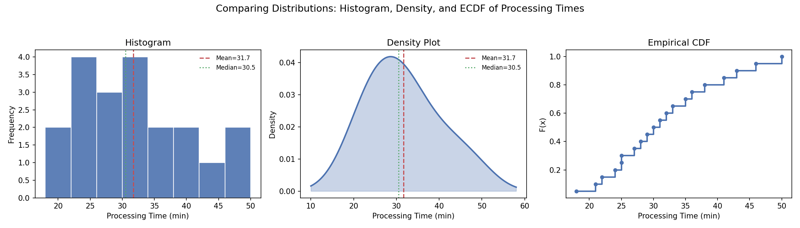
Figure 1. Histogram (left), density plot (middle), and ECDF (right) of processing times, with mean (red dashed) and median (green dotted) marked on the first two panels.
Interpretation
The histogram most clearly communicates the center and rough shape of the distribution: most tasks take between 24 and 33 minutes, with a visible tail of a few longer tasks (41-50 minutes) pulling the mean (31.70) slightly above the median (30.50), consistent with the mild positive skewness (0.48). However, its shape is sensitive to bin width and can look choppy with only 20 observations. The density plot smooths over this binning noise and gives a cleaner visual read on spread and skewness — the longer right tail is visible as a gentle stretch of the curve past 40 minutes rather than a jagged individual bar, making it the best tool for judging skewness and overall smoothness of the underlying distribution. The ECDF communicates cumulative behavior most directly: it shows, for any processing time x, what proportion of tasks were completed in x minutes or less (for example, roughly 75% of tasks finished within 35 minutes). While the ECDF does not visually emphasize a single 'center' or 'peak' the way a histogram does, it is the only one of the three that lets a viewer read off exact percentiles and compare cumulative proportions precisely, and it never requires a bin-width or bandwidth choice, making it the most objective of the three views.

Q2. Q-Q Plot and Normality Analysis
Response times (in seconds) were measured: 42, 45, 47, 49, 50, 51, 52, 53, 54, 55, 56, 57, 58, 60, 61, 63, 66, 70, 76, 85. A normal Q-Q plot and a histogram/density visualization assess whether the data are reasonably consistent with a normal distribution.
R Code
# Q2: Q-Q plot and normality check
library(ggplot2)

Response <- c(42, 45, 47, 49, 50, 51, 52, 53, 54, 55, 56, 57, 58, 60, 61, 63, 66, 70, 76, 85)
df <- data.frame(Response)

shapiro.test(Response)

# Base R Q-Q plot
qqnorm(Response, main = 'Normal Q-Q Plot of Response Times')
qqline(Response, col = '#C44E52', lwd = 2)

# ggplot2 Q-Q plot
ggplot(df, aes(sample = Response)) +
stat_qq(color = '#4C72B0', size = 2) +
stat_qq_line(color = '#C44E52', size = 1) +
labs(title = 'Normal Q-Q Plot', x = 'Theoretical Quantiles', y = 'Sample Quantiles') +
theme_minimal()

# Histogram + density
ggplot(df, aes(x = Response)) +
geom_histogram(aes(y = after_stat(density)), bins = 8, fill = '#4C72B0', alpha = 0.75, color = 'white') +
geom_density(color = '#C44E52', size = 1) +
labs(title = 'Histogram and Density of Response Times', x = 'Response Time (s)', y = 'Density') +
theme_minimal()
Output
Mean : 57.50 s
Median : 55.50 s
Standard deviation : 10.58 s
Skewness : 0.98 (moderate right skew)
Shapiro-Wilk test : W = 0.936, p = 0.197 (fails to reject normality at alpha=0.05)
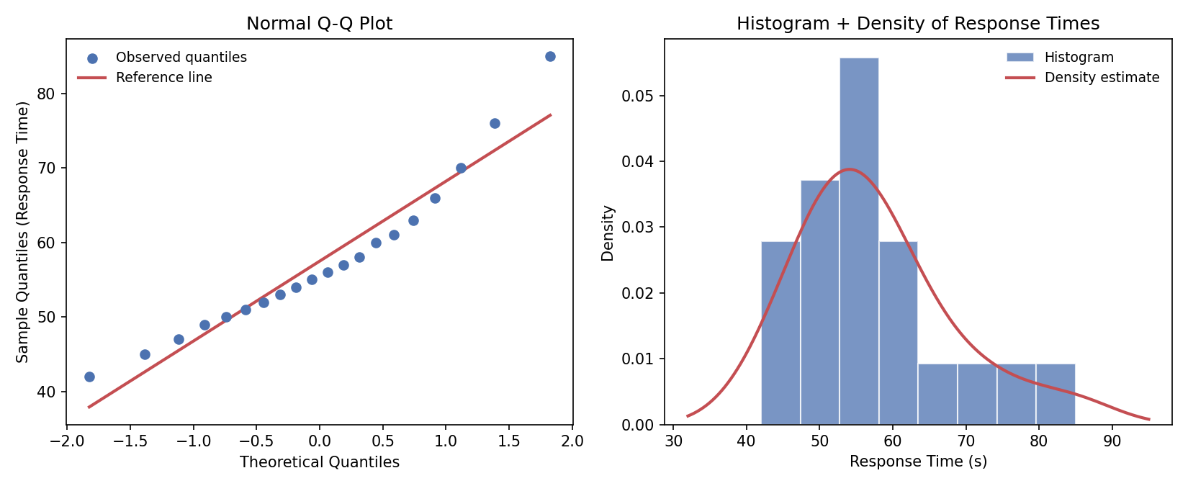
Figure 2. Normal Q-Q plot (left) with reference line, and histogram with overlaid density curve (right) for response times.
Interpretation
In the Q-Q plot, the bulk of the points (roughly the lower and middle 80% of the data) lie close to the reference line, suggesting the central portion of the distribution is broadly consistent with normality. However, the upper tail departs noticeably above the line: the two largest values (76 and 85 seconds) sit well above where a normal distribution would place them, indicating a heavier-than-normal right tail. This pattern - points on the line in the middle, curving away and above the line at the upper end - is the classic signature of positive (right) skewness and possible high-end outliers, which is corroborated by the histogram/density plot showing a longer tail stretching toward 80-85 seconds and a skewness coefficient of 0.98. Despite this, the Shapiro-Wilk test does not reject normality (p = 0.197) at the 5% level, largely because the sample is small (n = 20) and the departure, while visible, is not extreme enough to be statistically significant. In practice, this means the response-time data is approximately, but not perfectly, normal: a few unusually slow responses stretch the right tail, and analyses sensitive to that tail (e.g., strict parametric confidence intervals) should be interpreted with some caution, or a robust/nonparametric approach considered.

Q3. Visualizing Many Distributions at Once
Examination scores were recorded for three groups of 15 students each. A combined violin + boxplot with jittered individual observations compares the distributions of all three groups simultaneously.
R Code
# Q3: Grouped violin + boxplot with jittered points
library(ggplot2)
library(dplyr)
library(tidyr)

GroupA <- c(52,55,57,58,60,61,62,64,65,66,68,70,72,74,78)
GroupB <- c(45,49,51,53,55,56,58,59,60,62,63,65,67,69,71)
GroupC <- c(58,60,61,63,64,65,67,68,70,71,72,74,76,80,84)

df <- data.frame(Score = c(GroupA, GroupB, GroupC),
Group = rep(c('Group A','Group B','Group C'), each = 15))

df %>% group_by(Group) %>%
summarise(mean = mean(Score), median = median(Score), sd = sd(Score))

ggplot(df, aes(x = Group, y = Score, fill = Group)) +
geom_violin(alpha = 0.35, trim = FALSE, color = NA) +
geom_boxplot(width = 0.15, fill = 'white', outlier.shape = NA) +
geom_jitter(width = 0.05, size = 2, alpha = 0.8, aes(color = Group)) +
labs(title = 'Distribution Comparison Across Three Groups',
y = 'Examination Score') +
theme_minimal() + theme(legend.position = 'none')
Output
Group A: mean=64.13 median=64.00 sd=7.35 range=[52, 78]
Group B: mean=58.87 median=59.00 sd=7.52 range=[45, 71]
Group C: mean=68.87 median=68.00 sd=7.47 range=[58, 84]
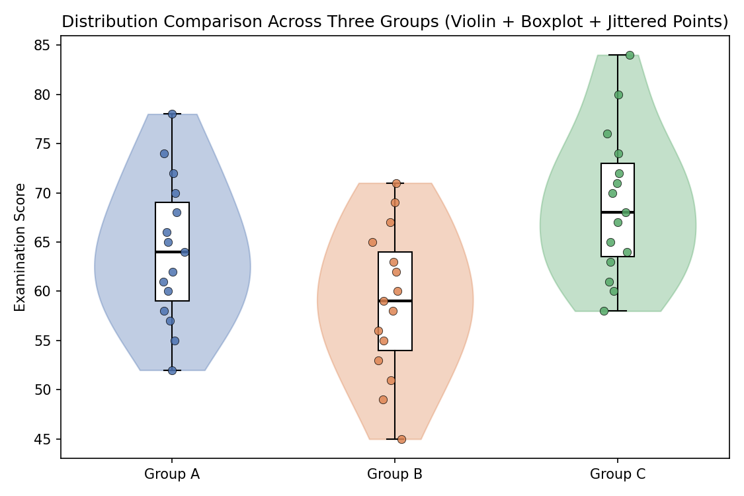
Figure 3. Violin plots (distribution shape) overlaid with boxplots (quartiles/median) and jittered individual scores for Groups A, B, and C.
Interpretation
The three groups show clearly different centers: Group C has the highest average score (68.87), followed by Group A (64.13), with Group B lowest (58.87); a roughly 10-point gap separates Group B from Group C. Spread, measured by standard deviation, is similar across all three groups (approximately 7.3-7.5 points), so differences between groups are driven mainly by shifts in location rather than differences in variability. The violin shapes show that Group C's distribution is fairly symmetric with a slightly wider bulge in the upper-middle scores, Group A is close to symmetric with mild spread toward the top score (78), and Group B is the most tightly packed around its median with no extreme values. Individual jittered points confirm there are no dramatic outliers in any group; the maximum values (78, 71, 84) and minimum values (52, 45, 58) fall at the natural edges of each violin without isolated extreme points.
This combined visualization is more informative than three separate plots because it places all three distributions on a single shared score axis, allowing direct visual comparison of medians, spreads, and shapes at a glance rather than requiring the viewer to mentally align three different figures (each potentially drawn with different axis scales). The violin component reveals the full shape and any multimodality that a boxplot alone would hide, the boxplot overlay preserves precise quartile and median markers, and the jittered points show the actual sample size and individual data density, together giving a much richer picture in the space of a single, directly comparable figure.

Q4. Relationships and Multivariate Visualization
Advertising expenditure, website visits, and sales were recorded for 15 observations. A scatterplot of Advertising vs Sales incorporates Website Visits via point color and size, with a fitted trend line added.
R Code
# Q4: Multivariate scatterplot with third-variable encoding
library(ggplot2)

Advertising <- c(10,12,14,16,18,20,22,24,26,28,30,32,34,36,38)
Visits <- c(120,135,150,165,180,195,210,225,245,260,275,290,305,320,340)
Sales <- c(48,50,53,55,58,61,63,66,69,71,74,77,80,83,86)
df <- data.frame(Advertising, Visits, Sales)

cor(df)
model <- lm(Sales ~ Advertising, data = df)
summary(model)

ggplot(df, aes(x = Advertising, y = Sales)) +
geom_point(aes(size = Visits, color = Visits), alpha = 0.9) +
geom_smooth(method = 'lm', se = FALSE, color = '#C44E52',
linetype = 'dashed', size = 1) +
scale_color_viridis_c(name = 'Website\nVisits') +
scale_size_continuous(name = 'Website\nVisits', range = c(3, 10)) +
labs(title = 'Sales vs Advertising Expenditure, Encoded by Website Visits',
x = 'Advertising Expenditure', y = 'Sales') +
theme_minimal()
Output
Correlation (Advertising, Sales) : 0.999
Correlation (Advertising, Visits) : 1.000
Correlation (Visits, Sales) : 0.999
Regression: Sales = 33.65 + 1.36 x Advertising
R-squared = 0.999, p < 0.001
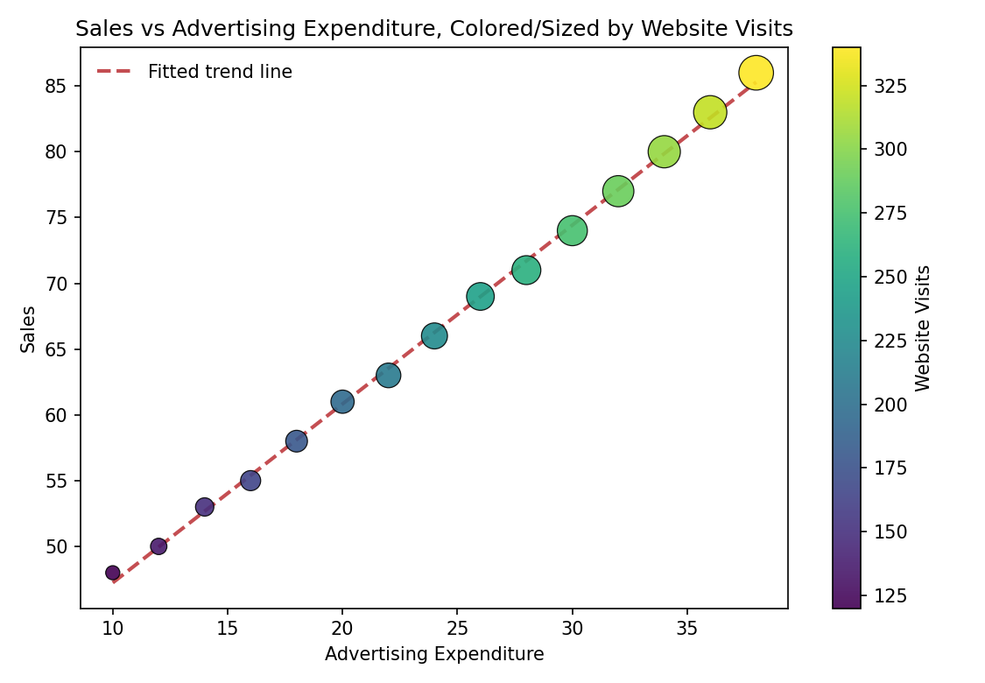
Figure 4. Scatterplot of Sales vs Advertising Expenditure, with point size and color encoding Website Visits, and a dashed linear trend line.
Interpretation
The relationship between advertising expenditure and sales is very strong, positive, and essentially linear: the correlation is 0.999 and the fitted model (Sales = 33.65 + 1.36 x Advertising) explains 99.9% of the variance in sales. Each additional unit of advertising is associated with about 1.36 additional units of sales across the observed range. Website visits are added as a third variable via point size and color; visually, the points grow larger and shift toward yellow (higher visits) as Advertising and Sales both increase, reinforcing the overall upward trend.
However, because Advertising, Visits, and Sales are almost perfectly collinear here (all pairwise correlations are 0.999-1.000), the extra encoding does not reveal new structure or a different pattern - it simply re-displays the same near-perfect trend a second time through size and color. In this specific data set, therefore, the additional variable adds visual complexity without adding new interpretive value, and arguably risks mild clutter: a viewer must now also process a color legend and a size legend for information that closely tracks the x and y axes already shown. Encoding a third variable is most valuable when it varies somewhat independently of the two plotted axes (e.g., revealing that some high-advertising periods had unexpectedly low visits); when all three variables move together as strongly as they do here, a simpler two-variable scatterplot with a trend line would communicate the relationship just as effectively, and the third-variable encoding is better reserved for annotation or supplementary analysis rather than the primary chart.

Q5. Misleading Visualization and Redesign
A college reports pass percentages for seven departments: CSE 91, ECE 93, EEE 92, MECH 89, CIVIL 90, AIDS 95, IT 94. Two bar charts are constructed: a misleading version with a truncated y-axis, and a redesigned, honest version with a full baseline and ordered categories.
R Code
# Q5: Misleading truncated-axis chart vs honest redesign
library(ggplot2)
library(dplyr)

Department <- c('CSE','ECE','EEE','MECH','CIVIL','AIDS','IT')
Pass_Percentage <- c(91,93,92,89,90,95,94)
df <- data.frame(Department, Pass_Percentage)

# Plot 1: misleading version (truncated y-axis, unordered categories)
ggplot(df, aes(x = Department, y = Pass_Percentage)) +
geom_col(fill = '#4C72B0', width = 0.6) +
coord_cartesian(ylim = c(88, 96)) + # truncated baseline exaggerates differences
labs(title = 'Department Pass Percentage (Truncated Y-Axis)',
y = 'Pass Percentage (%)') +
theme_minimal()

# Plot 2: honest redesign (full 0-100 baseline, ordered, labeled)
df_ord <- df %>% arrange(Pass_Percentage) %>%
mutate(Department = factor(Department, levels = Department))

ggplot(df_ord, aes(x = Department, y = Pass_Percentage)) +
geom_col(fill = '#4C72B0', width = 0.6) +
geom_text(aes(label = Pass_Percentage), vjust = -0.5, size = 3.5) +
ylim(0, 100) +
labs(title = 'Department Pass Percentage (Full Axis, Ordered)',
x = 'Department (ordered by pass percentage)', y = 'Pass Percentage (%)') +
theme_minimal()
Output
Misleading (Truncated Axis) | Honest Redesign (Full Axis)
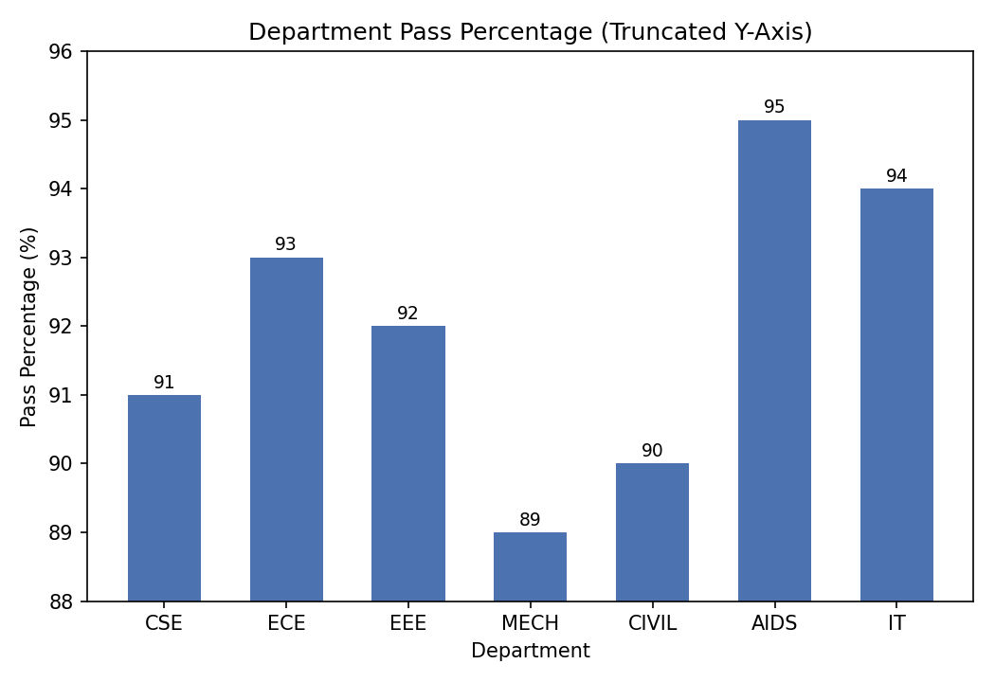 | 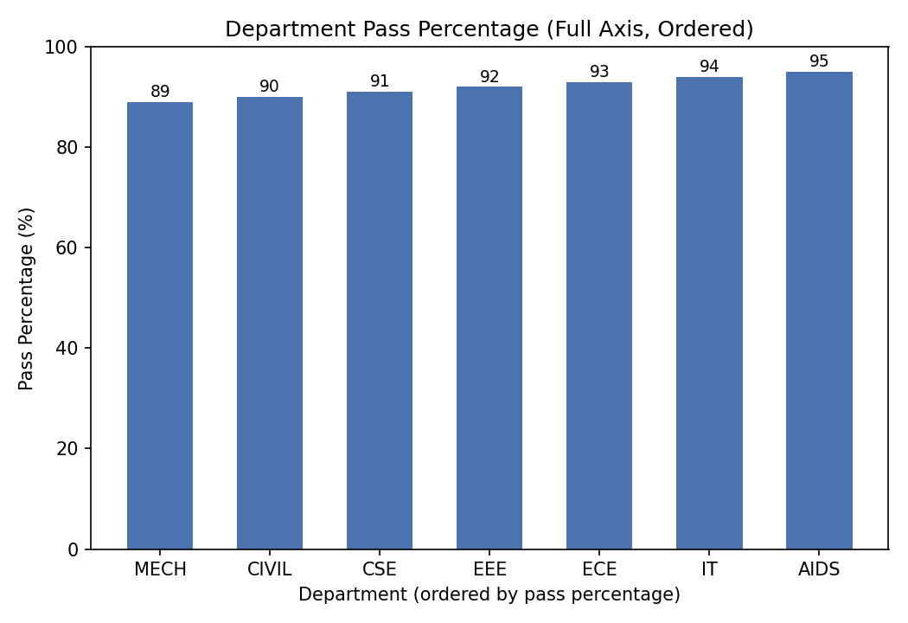
Figure 5. Left: truncated y-axis (88-96%) makes small real differences look dramatic. Right: full 0-100% baseline with departments ordered by pass percentage and value labels.
Interpretation
All seven departments have pass percentages within a narrow six-point band (89% to 95%) - a genuinely small, realistic spread for exam pass rates. In the first chart, the y-axis is truncated to run from 88% to 96%, which stretches this six-point range across the entire height of the plot. As a result, MECH's bar (89%) looks barely a quarter the height of AIDS's bar (95%), visually suggesting AIDS performs roughly four times better than MECH, when in reality the difference is under seven percentage points out of a maximum possible 100. The unordered department listing and lack of value labels compound the problem, forcing the viewer to rely entirely on the exaggerated bar heights to judge differences.
The redesigned chart starts the y-axis at zero, which is the appropriate baseline for a bar chart because bar length is perceived proportionally to value - truncating the baseline breaks that proportional relationship and creates a false visual impression of magnitude. With the full 0-100% scale, all seven bars appear close in height, correctly conveying that every department has a similarly high pass rate. Ordering departments from lowest to highest pass percentage makes the ranking immediately readable left-to-right, and printed value labels let the viewer see the exact, modest differences (89% to 95%) without needing to rely on visual bar-height comparison at all. Together, these choices - zero baseline, ordered categories, and explicit labels - communicate the same underlying data far more honestly, preventing a six-percentage-point difference from being visually misrepresented as a dramatic performance gap between departments.

Summary
This assessment illustrated five complementary aspects of statistical visualization in R. Q1 compared histograms, density plots, and ECDFs, showing each is best suited to a different descriptive task (shape/center, smooth skewness assessment, and precise cumulative/percentile reading, respectively). Q2 used a Q-Q plot alongside a histogram/density view to detect a right-tail departure from normality that a formal test alone (Shapiro-Wilk) did not flag as significant at this sample size, underscoring the value of visual diagnostics alongside hypothesis tests. Q3 demonstrated that combining violin plots, boxplots, and jittered points into one grouped figure communicates center, spread, shape, and individual observations across multiple groups far more efficiently than separate plots. Q4 showed that adding a third variable via color/size encoding is only informative when that variable is not already redundant with the two plotted axes - here, near-perfect collinearity meant the extra encoding added visual load without new insight. Q5 provided a direct case study in how a truncated y-axis can visually exaggerate small, unremarkable differences, and how a zero-baseline, ordered, clearly labeled redesign restores an honest, proportionate impression of the same data.

