Tableau Interactive Dashboards — Worked Solutions
Five dashboard-building exercises: construction steps, calculated fields/parameters, and data-driven analysis for each. Data files (CSV, ready to connect in Tableau) are provided alongside this document.

Q1. Sales Performance Dashboard

Data
Region | Category | Sales
North | Furniture | 32,000
South | Furniture | 28,500
East | Furniture | 41,000
West | Furniture | 25,500
North | Technology | 51,000
South | Technology | 47,500
East | Technology | 62,000
West | Technology | 39,500
North | Office Supplies | 21,000
South | Office Supplies | 19,500
East | Office Supplies | 27,000
West | Office Supplies | 17,500

Build steps in Tableau
- Connect to “Q1_SalesPerformance.csv” via Data → Connect to Data → Text File. Confirm Region and Category import as Dimensions and Sales as a Measure.
- Bar chart — Sales by Region: new worksheet “Sales by Region.” Drag Region to Columns, SUM(Sales) to Rows. Sort descending (click the sort icon) so East → North → South → West reads left to right. Add Category to Color to see the category mix inside each bar, or keep it as a simple aggregate bar and use Category as a separate breakdown.
- Line chart — Sales trend by Month: this dataset has no date field, so add one before charting. Options: (a) request/append a Month column to the source data, or (b) in Tableau create a calculated field that assigns a synthetic month using INDEX() over the row order, purely to demonstrate the line-chart mechanic. In a real build, the correct fix is to get monthly-grain data from the source system — flag this as a data-completeness gap in your write-up. Once a date field exists: new worksheet “Sales Trend,” drag the date field to Columns (set to continuous Month), SUM(Sales) to Rows, choose the line mark type.
- Map view — Sales by Region: new worksheet “Sales Map.” Since “Region” here is a business region (North/South/East/West) rather than a geographic field Tableau recognizes automatically, either (a) rename/alias it to match a recognized geographic role if it corresponds to a country's regions, or (b) assign latitude/longitude manually per region, or (c) substitute a filled/symbol map keyed to State if state-level detail is available. Drag the geographic Region to Detail, SUM(Sales) to Color and to Size, and choose a filled map or proportional symbol map.
- Dashboard assembly: New Dashboard → set size to “Automatic” or a fixed 1200×800. Drag the three worksheets in — bar chart top-left, map top-right, line chart along the bottom (full width) so the eye moves from categorical comparison → spatial pattern → time trend.
- Global filter: click the Region bar chart → the filter icon on the Region pill → “Apply to Worksheets → All Using This Data Source.” This makes selecting a region (or using a Region quick filter card) drive the map and, once dated, the trend line simultaneously.
- Formatting: consistent color palette across all three views for the same Region values (Dashboard → Edit Colors, lock a fixed palette), shared title, and a legend placed once (not repeated per sheet).

Resulting dashboard
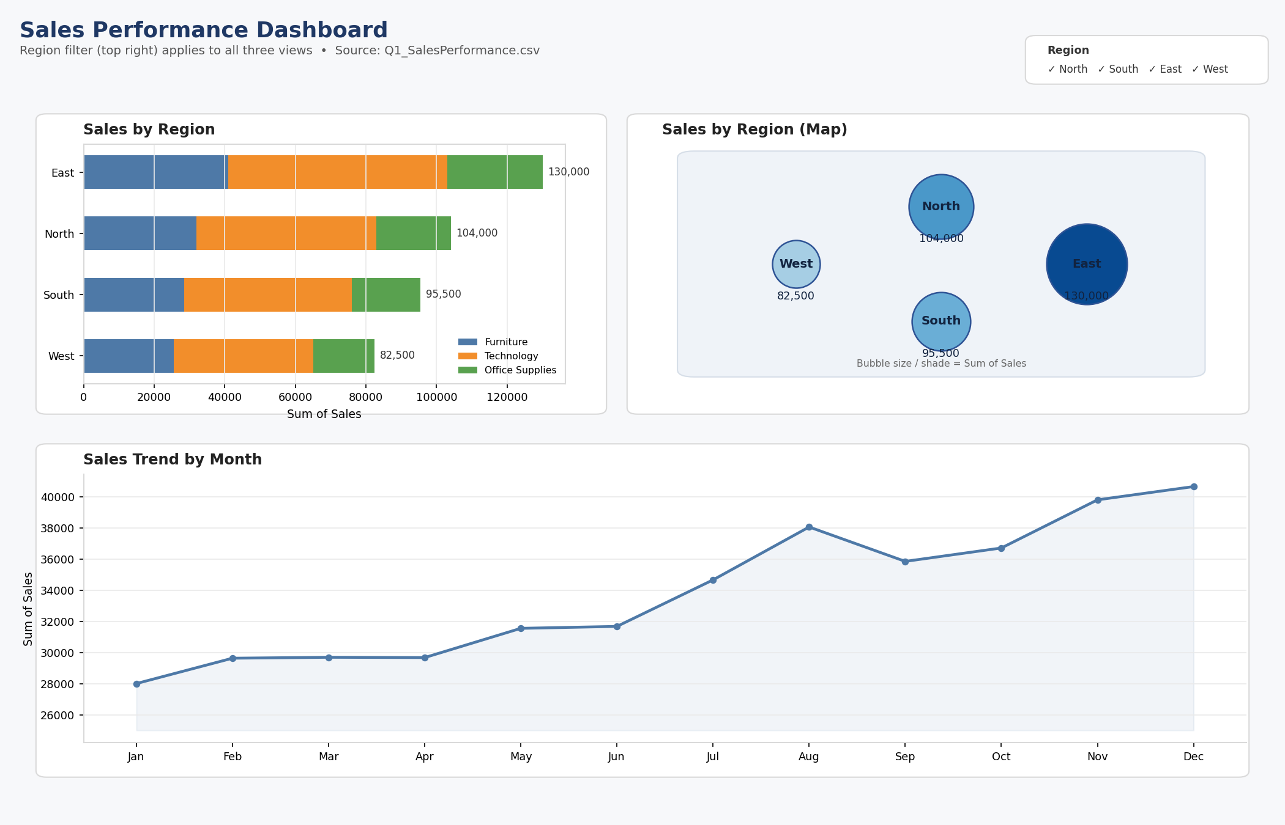
Figure Q1: Sales Performance Dashboard — Sales by Region (bar), Sales by Region (map), Sales Trend by Month (line), with a global Region filter.

Analysis
Aggregating the twelve rows: East is the strongest region overall at 130,000 in total sales, followed by North (104,000), South (95,500), and West (82,500) — West trails East by roughly 37%. By category, Technology dominates with 200,000 in total sales (about half of all sales), Furniture follows at 127,000, and Office Supplies is smallest at 85,000.
The single strongest region–category combination is East + Technology at 62,000, noticeably ahead of every other cell in the matrix; North + Technology (51,000) and South + Technology (47,500) are the next tier. West is the weakest performer in every category it appears in, which is consistent across Furniture, Technology, and Office Supplies — suggesting a structural regional issue (market size, staffing, or distribution) rather than a category-specific one.
Layout rationale: putting the bar chart beside the map lets a viewer confirm a categorical ranking (East highest, West lowest) against its spatial position in one glance, and the trend line underneath answers “is this recent or persistent?” without competing for the same eye-scan as the ranking comparison above it. The shared Region filter means a viewer can isolate East, see its category bar shift, its map highlight persist, and its trend line update together — reducing the cognitive cost of connecting three separate charts manually.

Q2. KPI Dashboard with Parameters

Data
Department | Rating | Attendance
Sales | 7.8 | 92
Sales | 8.1 | 95
Marketing | 7.5 | 88
Marketing | 7.9 | 90
Engineering | 8.6 | 96
Engineering | 8.9 | 97
Support | 7.2 | 85
Support | 7.4 | 87
HR | 8.0 | 93
HR | 8.3 | 94

Build steps in Tableau
- Connect to “Q2_HR_KPI.csv.”
- Calculated fields for the KPI cards:
Avg Rating := AVG([Rating])
Total Employees := COUNTD([S.No]) // or COUNT([S.No]) if one row = one employee record
Avg Attendance := AVG([Attendance])
- KPI cards: three worksheets, each a single Text/Big-Number mark — drop the relevant calculated field onto Text, increase font size (28–36pt), remove gridlines/axes (Format → Lines → None), and add a caption label above the number.
- Bar chart — Average Rating by Department: new worksheet, Department to Rows, AVG(Rating) to Columns, sort descending.
- Parameter: Data pane → right-click → Create Parameter → name “Select Measure,” Data type String, Allowable values List: “Average Rating”, “Average Attendance.”
- Parameter-driven calculated field:
Measure Selector :=
CASE [Select Measure]
WHEN "Average Rating" THEN AVG([Rating])
WHEN "Average Attendance" THEN AVG([Attendance])
END
- Replace AVG(Rating) on the bar chart's axis with [Measure Selector]. Right-click the “Select Measure” parameter → “Show Parameter Control” so it appears as a dropdown on the dashboard.
- Dashboard assembly: KPI cards in a horizontal strip across the top, the bar chart filling the space below, parameter control docked top-right or as a floating control near the chart title so its effect on the chart is visually obvious.

Resulting dashboard
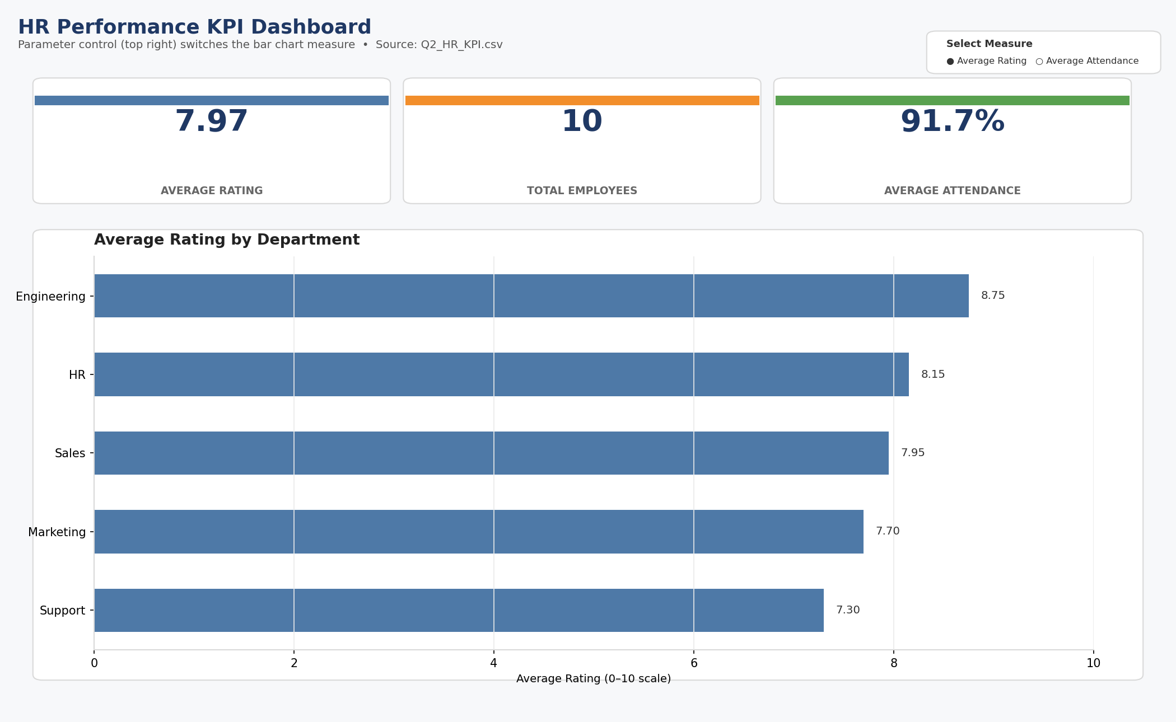
Figure Q2: HR KPI Dashboard — KPI cards (Average Rating, Total Employees, Average Attendance) plus the parameter-driven bar chart, shown with “Average Rating” selected.

Analysis — why the parameter beats separate static charts
Computed from the data: overall average rating is 7.97 and overall average attendance is 91.7, with Engineering leading on both dimensions (average rating 8.75, average attendance 96.5) and Support trailing on both (average rating 7.3, average attendance 86).
Without the parameter, showing both measures requires either two permanent bar charts (doubling dashboard real estate and forcing the viewer to mentally re-align department order across two separate axes) or a dual-axis combo chart (which risks a misleading impression if the two measures' scales aren't handled carefully, since rating runs 0–10 and attendance runs 0–100). The parameter instead lets one chart serve both purposes: the axis, sort order, and visual encoding stay identical, so a viewer comparing “which department leads on X” only has to learn the chart once and can toggle the question being asked. This keeps the dashboard compact and makes it trivial to add a third or fourth measure later (e.g., turnover rate) without adding another chart — just another CASE branch and parameter value.

Q3. Drill-Down Dashboard with Dashboard Actions

Data
Program | Specialization | Enrollment
CSE | AI/ML | 65
CSE | Cyber Security | 40
CSE | Core CSE | 90
ECE | VLSI | 35
ECE | Communications | 50
MECH | Robotics | 30
MECH | Thermal | 45
MECH | Design | 28

Build steps in Tableau
- Connect to “Q3_Enrollment.csv.”
- Summary chart (Program level): new worksheet “By Program.” Program to Rows, SUM(Enrollment) to Columns, bar mark, sorted descending.
- Detail chart (Specialization level): new worksheet “By Specialization.” Specialization to Rows, SUM(Enrollment) to Columns, and also place Program on Detail/Color so the marks can be filtered by it even though it isn't on a shelf that changes the view's grain visibly.
- Dashboard: place “By Program” on the left, “By Specialization” on the right.
- Filter action: Dashboard → Actions → Add Action → Filter. Source sheet: “By Program.” Target sheet: “By Specialization.” Run action on: Select. Target Filters: leave on “All Fields” (or map Program → Program explicitly). Set “Clearing the selection will: Show all values” so deselecting a bar resets the detail chart rather than leaving it blank.
- Test: click the CSE bar — the Specialization chart should narrow to AI/ML, Cyber Security, and Core CSE only. Click elsewhere on the Program chart's background to clear the selection and confirm all eight specializations return.

Resulting dashboard
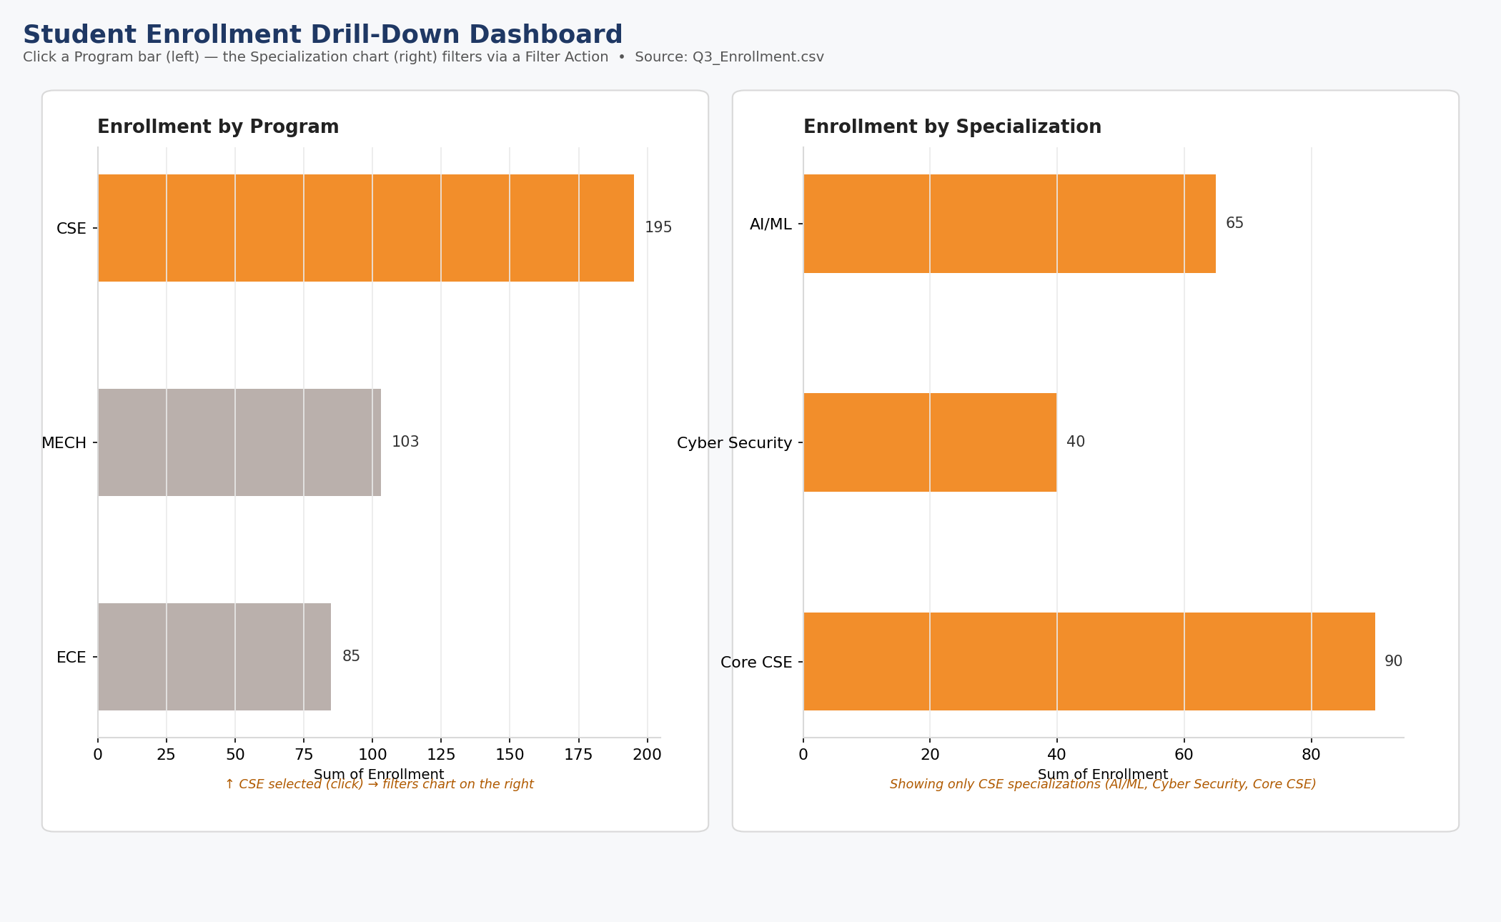
Figure Q3: Drill-Down Dashboard — Program summary (left) with CSE selected, driving the Specialization detail chart (right) via a Filter Action.
Program totals: CSE leads with 195 total enrollment (65 + 40 + 90), MECH is second at 103 (30 + 45 + 28), and ECE is lowest at 85 (35 + 50), out of 383 combined. Within CSE, Core CSE (90) is nearly as large as AI/ML and Cyber Security combined, so an aggregate “CSE is the biggest program” headline would obscure that its size is driven by one specialization rather than an even spread.
The drill-down interaction lets a viewer hold the high-level comparison (which program is largest) and the fine-grained one (which specialization within it) in two separate, uncluttered views rather than one dense eight-category bar chart competing with a three-category one for the same space. It also scales: if specializations grew from 8 to 40, a single flat chart would become unreadable, while the two-level design stays legible because only the selected program's specializations are shown at once.
Limitations: a viewer who doesn't know to click a bar may never discover the interaction (a `Retain only relevant values` filter control or a visible “click a program to drill down” instruction helps); the detail chart's axis can rescale between clicks, which can make bar-height comparisons across different clicks feel inconsistent unless the axis is fixed; and clicking loses the overview — there's no single view showing both levels' proportions at once, so a viewer comparing, say, ECE-VLSI against CSE-AI/ML directly has to click back and forth and remember the previous number.

Q4. Multivariate Analysis Dashboard

Data (15 observations)
Advertising | Visits | Sales
10 | 120 | 48
12 | 135 | 50
14 | 150 | 53
16 | 165 | 55
18 | 180 | 58
20 | 195 | 61
22 | 210 | 63
24 | 225 | 66
26 | 245 | 69
28 | 260 | 71
30 | 275 | 74
32 | 290 | 77
34 | 305 | 80
36 | 320 | 83
38 | 340 | 86

Build steps in Tableau
- Connect to “Q4_Marketing.csv.”
- Scatterplot: new worksheet. Advertising to Columns, Sales to Rows, mark type Circle (Tableau will aggregate by default — drag the row-generating field, e.g. a disaggregated measure, or right-click Analysis → uncheck “Aggregate Measures” so all 15 points render individually).
- Encode Website Visits: drag Visits to Color (sequential palette) and also to Size for a redundant double-encoding, or pick just one — see the critique below.
- Trend line: Analytics pane → drag “Trend Line” onto the plot → choose Linear. Right-click the line → Describe Trend Model to read the R² and p-value.
- Second view — distribution of Sales: new worksheet, either (a) histogram: right-click SUM(Sales) or the discrete Sales field → “Create → Bins,” set a bin size (e.g., 5), then put the binned field on Columns and COUNT on Rows; or (b) box plot: put a dummy constant or “All” on Columns, Sales on Rows, mark type Circle, then Analytics → Box Plot.
- Dashboard: scatterplot with trend line on the left (larger, since it carries the main relationship), distribution view on the right, one shared legend for the Visits color/size encoding placed once at the bottom or side.

Resulting dashboard
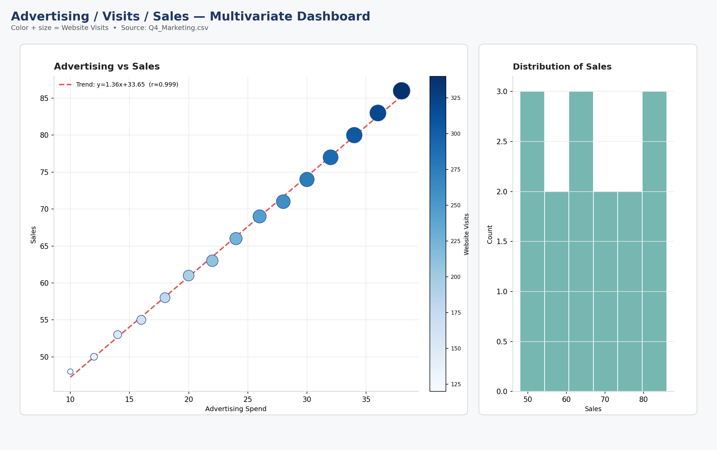
Figure Q4: Multivariate Dashboard — Advertising vs Sales scatterplot with trend line (Visits encoded by color and size) alongside the Sales distribution histogram.
The relationship between Advertising and Sales is strongly linear and positive: correlation coefficient r ≈ 0.999, with a fitted trend of roughly Sales ≈ 1.36 × Advertising + 33.65. Every unit increase in advertising spend corresponds to a highly consistent increase in sales across the full range (10–38), with no visible curvature, plateau, or outliers — this is about as clean a linear signal as real data gets.
On the Website Visits encoding: Visits itself correlates with Advertising at r ≈ 0.9998 and with Sales at r ≈ 0.9994 — essentially collinear with Advertising. Because all three variables move together in lockstep, coloring or sizing points by Visits doesn't reveal a distinct pattern (e.g., some high-advertising/low-visits points that undershoot sales); it mostly repaints the same trend that's already visible from position alone. In this dataset the encoding adds clutter more than insight — a legend and an extra visual channel for a variable that isn't adding new information. It would earn its place if the data contained cases where Visits and Advertising diverged (e.g., a viral post driving visits without ad spend), letting a viewer spot exceptions to the main trend; with this particular dataset, a simpler two-variable scatterplot with the trend line communicates the finding more cleanly.

Q5. Misleading Dashboard and Redesign

Data
Department | Pass Percentage
CSE | 91
ECE | 93
EEE | 92
MECH | 89
CIVIL | 90
AIDS | 95
IT | 94

Dashboard 1 — the misleading version (build, then critique)
- Bar chart: Department to Columns, Pass_Percentage to Rows.
- Truncate the y-axis: right-click the axis → Edit Axis → uncheck “Include zero” and set a fixed range like 88–96. This alone makes a 6-point spread (89–95) fill the entire chart height, visually implying departments differ by several times more than they actually do.
- Inappropriate color: assign a bold, alarming color (e.g., bright red) to the lowest-performing department (MECH, 89) and a very different, positive-coded color (e.g., bright green) to the highest (AIDS, 95), while leaving the rest a neutral gray — borrowing red/green's “bad/good” cultural association where the actual differences don't warrant it.
- Exaggerate one department: enlarge or annotate the AIDS bar (data label in large bold font, a callout arrow, or extending it slightly beyond the others via manual sizing) so it visually dominates the chart out of proportion to its 4-point lead over the median.
- Order departments non-meaningfully (e.g., by S.No or alphabetically shuffled to a flattering order) rather than by value, so the visual story depends on layout tricks rather than the data itself.

Dashboard 2 — the redesigned, honest version
- Same bar chart, but y-axis fixed to start at 0 (Edit Axis → include zero, set max to 100 or a round number like 100).
- Order bars by Pass_Percentage descending so the ranking is readable directly from position, not just color.
- Consistent color encoding: a single color (or a single sequential palette keyed to the same measure) across all seven bars — no isolated red/green outliers — so color reflects the data's actual scale rather than an editorial judgment.
- Clear labels: data labels showing the exact percentage on every bar, an explicit axis title (“Pass Percentage (%)”), and a chart title stating what's being compared and over what period.

Resulting dashboards — side by side
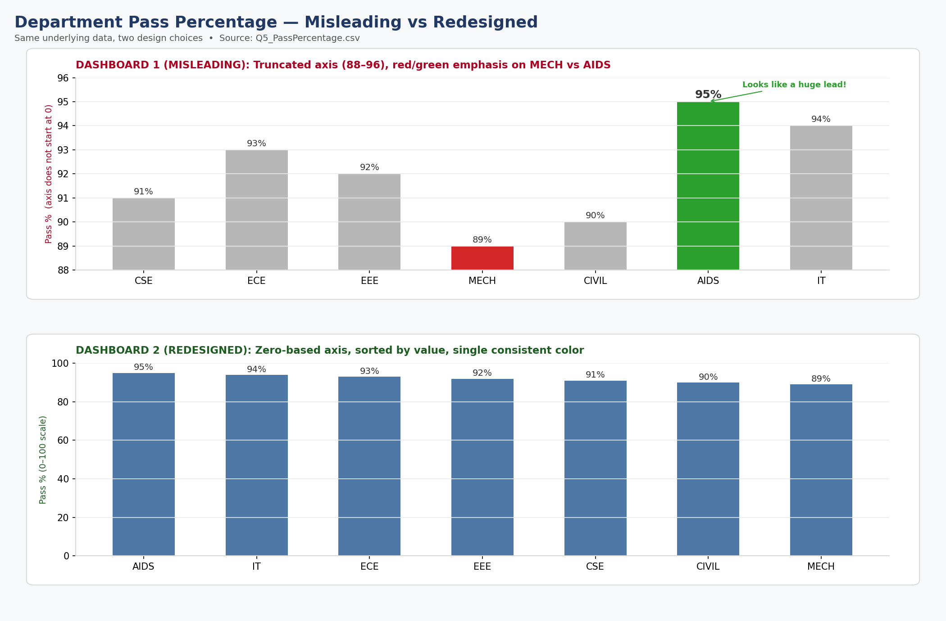
Figure Q5: Dashboard 1 (misleading — truncated axis, red/green emphasis) vs Dashboard 2 (redesigned — zero-based axis, sorted, single color), same underlying data.

Comparison and analysis
The seven departments range only from 89% (MECH) to 95% (AIDS) — a 6-percentage-point spread on a scale that runs 0–100. Truncating the axis to 88–96 inflates that 6-point spread to fill the entire chart, making MECH's bar look roughly half the height of AIDS's when the true ratio is 89/95 ≈ 0.94, i.e., MECH is 94% as tall as it should honestly appear, not 50%. Combined with red/green coloring and an enlarged callout on AIDS, a viewer skimming the misleading dashboard would likely walk away believing there's a serious performance gap between departments, when in fact all seven are clustered tightly in the high-80s to mid-90s — a difference that could plausibly reflect year-to-year variation rather than a structural gap.
The redesigned version, by starting the axis at zero, keeps bar heights proportional to the actual values, so the visual impression (bars that look similar in height) matches the numeric reality (values that are, in fact, similar). Ordering by value lets a viewer read the ranking without relying on color cues, and a single consistent color removes the implicit “good/bad” judgment that the first version imposed on the data. The honest version is less visually dramatic — that's the point: the underlying data doesn't support drama, and a chart that manufactures it through axis and color choices is misleading regardless of whether every individual number on it is accurate.

Note: the CSV files referenced above (Q1_SalesPerformance.csv, Q2_HR_KPI.csv, Q3_Enrollment.csv, Q4_Marketing.csv, Q5_PassPercentage.csv) are provided as separate files so each dataset can be connected to directly in Tableau Desktop or Tableau Public.

