Relationship Visualization Lab — Worked Solutions

Question 1 — Scatterplot with Regression Diagnostics
R Solution:
library(ggplot2)
mtcars_df <- read.csv("mtcars.csv")
mtcars_df$cyl <- as.factor(mtcars_df$cyl)
ggplot(mtcars_df, aes(x = wt, y = mpg)) +
geom_point(aes(color = cyl, size = hp), alpha = 0.75) +
geom_smooth(method = "lm", color = "black", se = TRUE) +
labs(title = "mpg vs wt colored by cylinders, sized by hp",
x = "Weight (1000 lbs)", y = "Miles per gallon") +
theme_minimal()
cor(mtcars_df$mpg, mtcars_df$wt, method = "pearson")
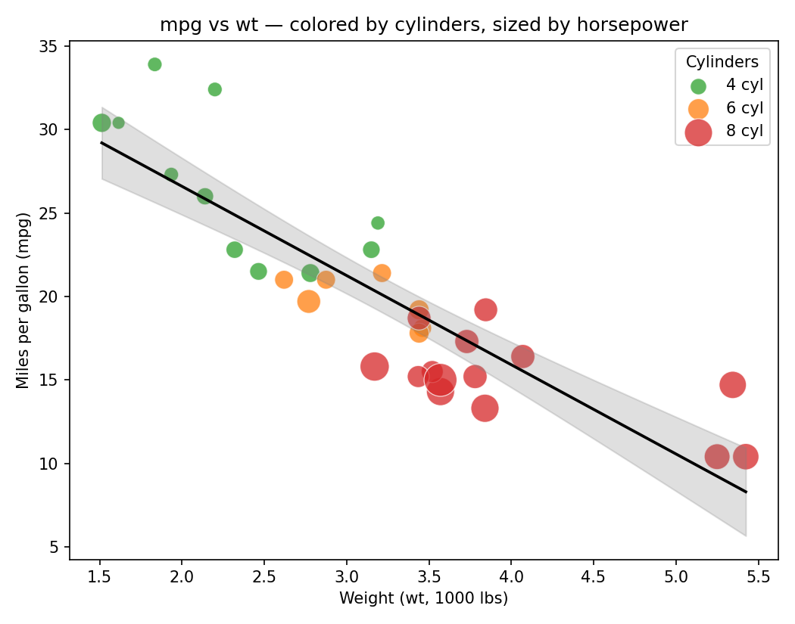
Pearson correlation coefficient: r = -0.868 (p < 0.001).
Interpretation: The relationship between weight and fuel economy is strong and negative — as a car's weight increases, its mpg drops sharply. The correlation of -0.87 indicates that weight alone explains roughly 75% of the variance in mpg (r² ≈ 0.75). The pattern also separates by engine size: heavier cars cluster with 8-cylinder engines and higher horsepower (larger bubbles), while lighter 4-cylinder cars sit in the high-mpg region, showing that weight, cylinder count and horsepower move together as a bundle of related "engine size" variables.

Question 2 — Correlogram Construction
R Solution:
library(corrplot)
mtcars_num <- read.csv("mtcars.csv")
mtcars_num <- mtcars_num[ , !(names(mtcars_num) %in% "model")]
corr_matrix <- cor(mtcars_num)
corrplot(corr_matrix, method = "color", type = "full",
order = "hclust", # hierarchical clustering reorder
addCoef.col = "black", # numeric labels
col = colorRampPalette(c("blue","white","red"))(200),
tl.col = "black", tl.srt = 45, number.cex = 0.7)
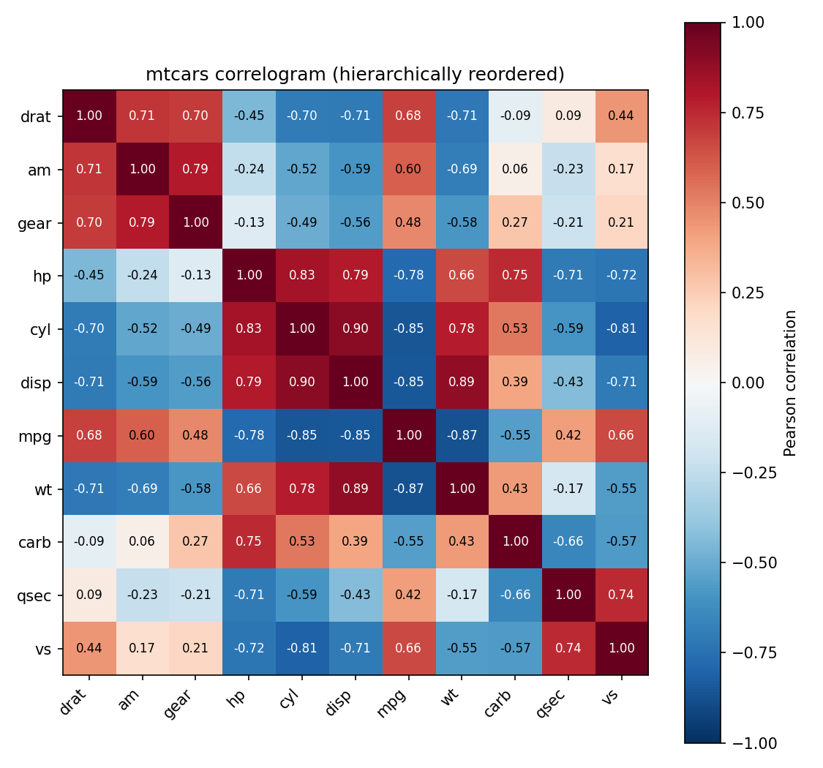
Strongest positive correlation: cyl ↔ disp, r = 0.90 (more cylinders → larger engine displacement).
Strongest negative correlation: mpg ↔ wt, r = -0.87 (heavier cars are markedly less fuel-efficient).
The hierarchical reordering groups mpg, drat and qsec together (the "efficiency" cluster) opposite a tight block of cyl, disp, hp and wt (the "engine size/power" cluster), visually confirming that these variables are not independent — they largely encode a single latent "how big/powerful is this car" dimension.

Question 3 — Dimension Reduction Comparison (PCA vs. t-SNE)
Note: the question text supplied in the assessment sheet only had a title with no dataset/task description attached. The iris.csv file (150 x 5, labelled species) is the dataset naturally suited to this comparison, so the solution below uses it — swap in another numeric dataset if your instructor specified one.
R Solution:
library(ggplot2)
library(Rtsne)
iris_df <- read.csv("iris.csv")
X <- scale(iris_df[ , 1:4]) # standardize numeric features
# PCA
pca <- prcomp(X, center = FALSE, scale. = FALSE)
pca_df <- data.frame(pca$x[,1:2], Species = iris_df$Species)
ggplot(pca_df, aes(PC1, PC2, color = Species)) +
geom_point(size = 2, alpha = 0.8) +
labs(title = "PCA of Iris data") + theme_minimal()
# t-SNE
set.seed(42)
tsne <- Rtsne(X, dims = 2, perplexity = 30, check_duplicates = FALSE)
tsne_df <- data.frame(tsne$Y, Species = iris_df$Species)
ggplot(tsne_df, aes(X1, X2, color = Species)) +
geom_point(size = 2, alpha = 0.8) +
labs(title = "t-SNE of Iris data") + theme_minimal()
summary(pca) # variance explained per component
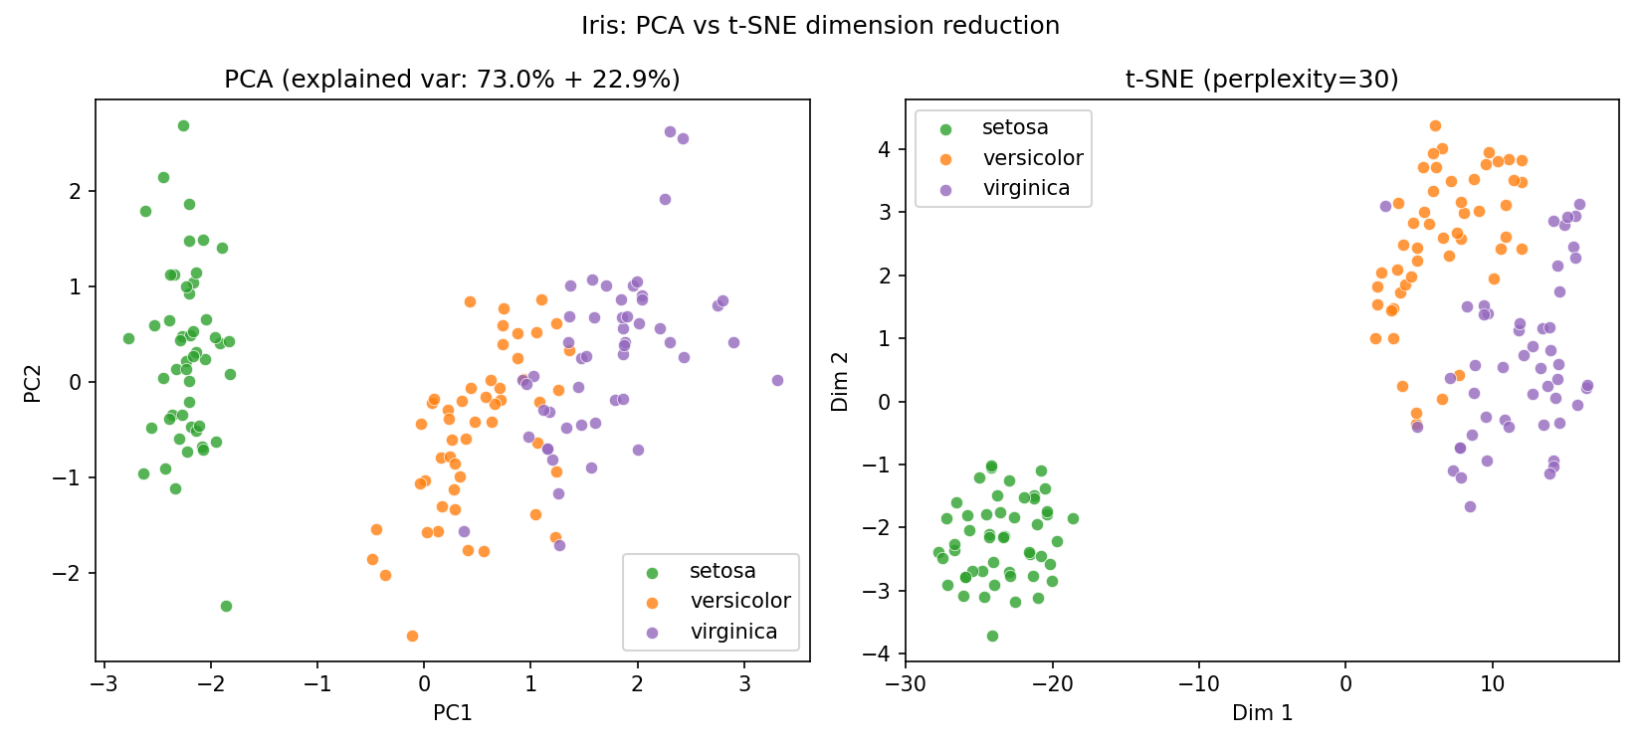
Results: PC1 explains 73.0% of variance and PC2 a further 22.9% (95.8% combined) — PCA already separates the data almost linearly, with Petal.Length and Petal.Width loading most heavily on PC1.
Discussion: PCA is a fast, linear projection — it preserves global variance and is directly interpretable (loadings tell you which original features drive each axis), but it can blur classes that are separable only by non-linear boundaries. t-SNE is non-linear and optimizes to preserve local neighborhoods, so it produces visibly tighter, better-separated clusters for versicolor vs. virginica (which overlap somewhat under PCA) — at the cost of losing the interpretable axes, sensitivity to the perplexity hyperparameter, and non-repeatable global distances between clusters. For iris specifically, both methods agree that setosa is linearly separable from the other two species; t-SNE resolves the versicolor/virginica boundary slightly better.

Question 4 — Bubble Chart for Multivariate Paired Data
R Solution:
library(ggplot2)
gap <- read.csv("gapminder2007_practice.csv")
gap2007 <- subset(gap, year == 2007)
ggplot(gap2007, aes(x = gdpPercap, y = lifeExp,
size = pop, color = continent)) +
geom_point(alpha = 0.7) +
scale_x_log10() +
scale_size_continuous(range = c(2, 20), name = "Population") +
labs(title = "Life Expectancy vs GDP per Capita (2007)",
x = "GDP per capita (log scale, USD)",
y = "Life expectancy (years)",
color = "Continent") +
theme_minimal()
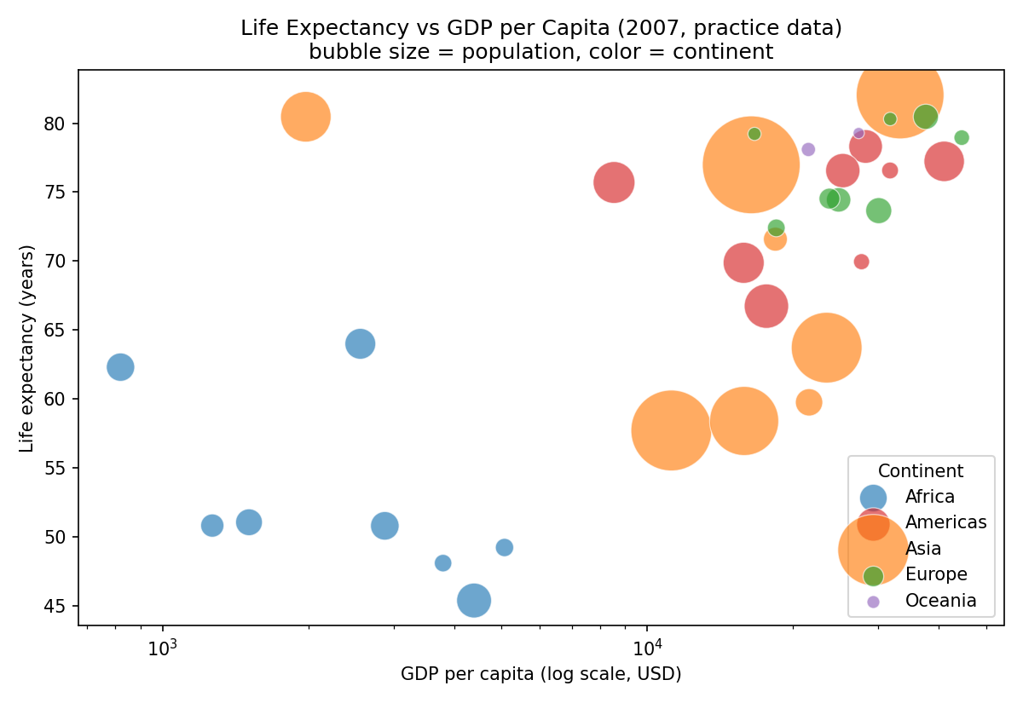
Discussion: China stands out as an outlier bubble — its population (~1.31B) dwarfs every other country, but its GDP per capita and life expectancy sit mid-pack, meaning population size and prosperity are decoupled for it. On the high-income end, Sweden and the USA are visible high-GDP outliers pulled above the general upward gdpPercap-vs-lifeExp trend line that the rest of the cloud follows, while African countries cluster tightly in the low-GDP / lower-life-expectancy corner, showing the well-known "health-wealth" gradient with clear separation by continent.

Question 5 — Hexbin Plot vs. Network Graph
Part a — Hexbin Plot
library(ggplot2)
set.seed(123)
n <- 10000
Sigma <- matrix(c(1, 0.75, 0.75, 1), nrow = 2)
sim <- MASS::mvrnorm(n, mu = c(0,0), Sigma = Sigma)
sim_df <- data.frame(x = sim[,1], y = sim[,2])
ggplot(sim_df, aes(x, y)) +
geom_hex(bins = 35) +
scale_fill_viridis_c() +
labs(title = "Hexbin plot of 10,000 correlated observations") +
theme_minimal()
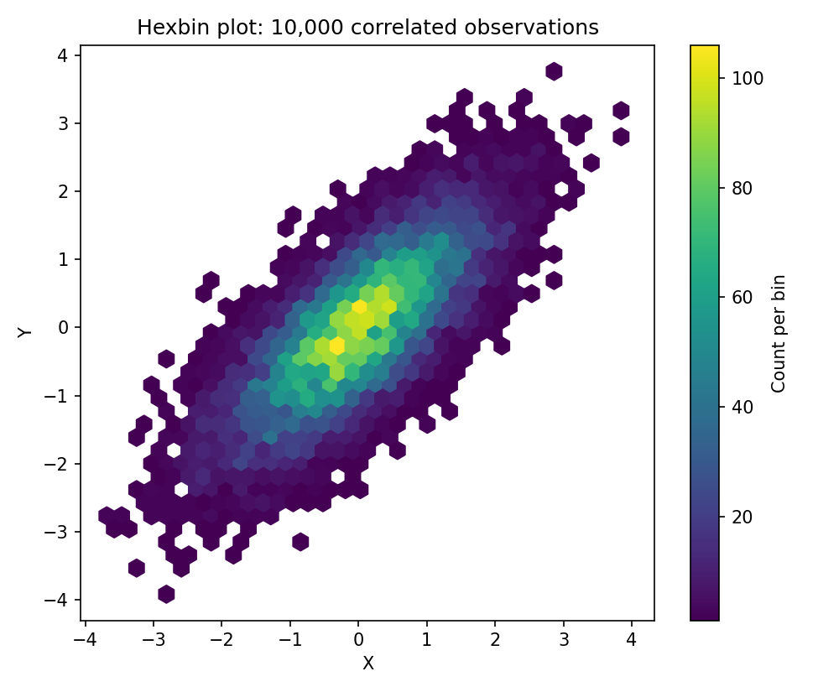
Why hexbin beats a scatterplot here: with 10,000 points, a standard scatterplot becomes a solid black blob of overplotted, overlapping points — individual markers are indistinguishable and density information is lost. Binning points into hexagonal cells and mapping color to count trades individual-point precision for an honest density surface, revealing that the mass of the (correlated, r ≈ 0.75) data is concentrated along the diagonal without needing transparency tricks or sub-sampling.
Part b — Network Graph
library(igraph)
library(ggraph)
edges <- read.csv("network_edges.csv")
g <- graph_from_data_frame(edges, directed = FALSE)
V(g)$degree <- degree(g)
ggraph(g, layout = "fr") +
geom_edge_link(aes(color = weight), width = 1.2) +
geom_node_point(aes(size = degree), color = "steelblue") +
geom_node_text(aes(label = name), repel = TRUE) +
scale_edge_color_gradient(low = "yellow", high = "red") +
theme_void() +
labs(title = "Network graph sized by degree centrality")
sort(degree(g, normalized = TRUE), decreasing = TRUE)
