CO3_AT2_Dat Analysis Project
Question 1 – Employee Salary Distribution
CODE:
# Data
data <- data.frame(
Employee_ID = c("E001","E002","E003","E004","E005",
"E006","E007","E008","E009","E010",
"E011","E012","E013","E014","E015",
"E016","E017","E018","E019","E020"),
Department = c(rep("IT",5),rep("HR",5),rep("Finance",5),rep("Marketing",5)),
Salary = c(42000,45000,48000,51000,55000,
38000,40000,42000,46000,50000,
47000,49000,52000,58000,65000,
36000,39000,43000,47000,72000)
)

# 1. ECDF
plot(ecdf(data$Salary),
main="ECDF of Employee Salaries",
xlab="Salary",
ylab="Cumulative Probability",
verticals=TRUE,
do.points=TRUE)

# 2. Q-Q Plot
qqnorm(data$Salary,
main="Normal Q-Q Plot of Salaries",
xlab="Theoretical Quantiles",
ylab="Sample Quantiles")
qqline(data$Salary, col="red", lwd=2)

# 3. Compare departments
boxplot(Salary ~ Department,
data=data,
main="Salary Distribution by Department",
xlab="Department",
ylab="Salary",
col="lightblue")

# 4. Distribution plot
stripchart(Salary ~ Department,
data=data,
vertical=TRUE,
method="jitter",
pch=19,
col="blue",
main="Employee Salary Distribution",
xlab="Department",
ylab="Salary")

# 5. Summary
print(summary(data$Salary))
Interpretation
- The ECDF shows the cumulative distribution of salaries.
- The Q-Q plot can be used to check normality. Deviations from the straight line indicate that salaries are not perfectly normal.
- The boxplot allows comparison of salary distributions across the four departments.
- Marketing has a possible high-value unusual observation (₹72,000), while Finance also has relatively high salaries.
- The salary distribution shows some right skewness, mainly due to the higher salaries such as ₹65,000 and ₹72,000.
Output:
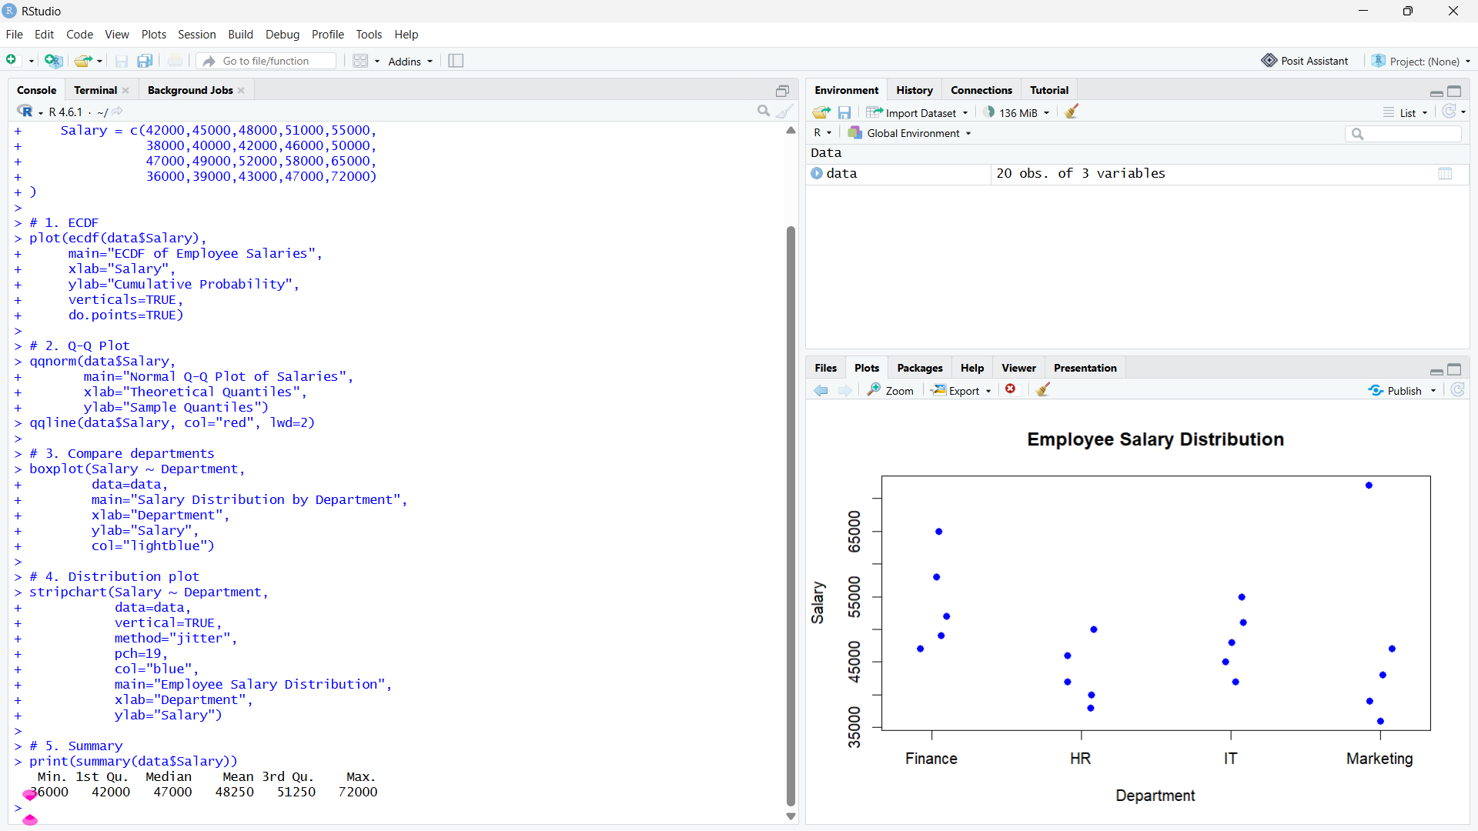
Conclusion:
The salary data was successfully analyzed using ECDF, Q-Q plot, boxplot, and distribution plot. The results show that salaries differ across departments, with Finance and Marketing having some higher salaries. Marketing has a possible unusual salary of ₹72,000. The salary distribution is slightly right-skewed because of the higher salary values.

Question 2 – Student Score Distribution
Code:
# Data
data <- data.frame(
Student_ID = paste0("S", sprintf("%03d", 1:20)),
Course = rep(c("Python","Statistics","DataViz","MachineLearning"), each=5),
Study_Hours = c(5,7,9,11,14, 4,6,8,10,13, 3,5,7,9,12, 6,8,10,13,16),
Score = c(62,68,74,81,88, 58,64,71,79,86, 55,61,69,77,84, 65,72,78,87,93)
)

# 1. Compare all distributions
boxplot(Score ~ Course,
data=data,
main="Score Distribution by Course",
xlab="Course",
ylab="Score",
col="lightblue")

# 2. Bean plot equivalent - Violin plot
install.packages("ggplot2")
library(ggplot2)

ggplot(data, aes(x=Course, y=Score, fill=Course)) +
geom_violin() +
geom_jitter(width=0.1, size=2) +
labs(title="Bean/Violin Plot of Student Scores",
x="Course",
y="Score")

# 3. Distributions along vertical axis
ggplot(data, aes(x=Score, y=Course, fill=Course)) +
geom_violin() +
geom_jitter(height=0.1, size=2) +
labs(title="Score Distributions Along Vertical Axis",
x="Score",
y="Course")

# 4. Mean and standard deviation
aggregate(Score ~ Course, data=data,
FUN=function(x) c(Mean=mean(x), SD=sd(x)))
Interpretation
- MachineLearning has the highest performance, with scores ranging from 65–93.
- Python has the next highest scores.
- DataViz has the lowest overall scores.
- MachineLearning has the highest mean score (79) and a relatively consistent distribution.
- Python has the smallest spread (62–88), making it the most consistent based on range.
- Violin/bean plots show the shape and density of each course's score distribution better than a simple bar chart.

Output:
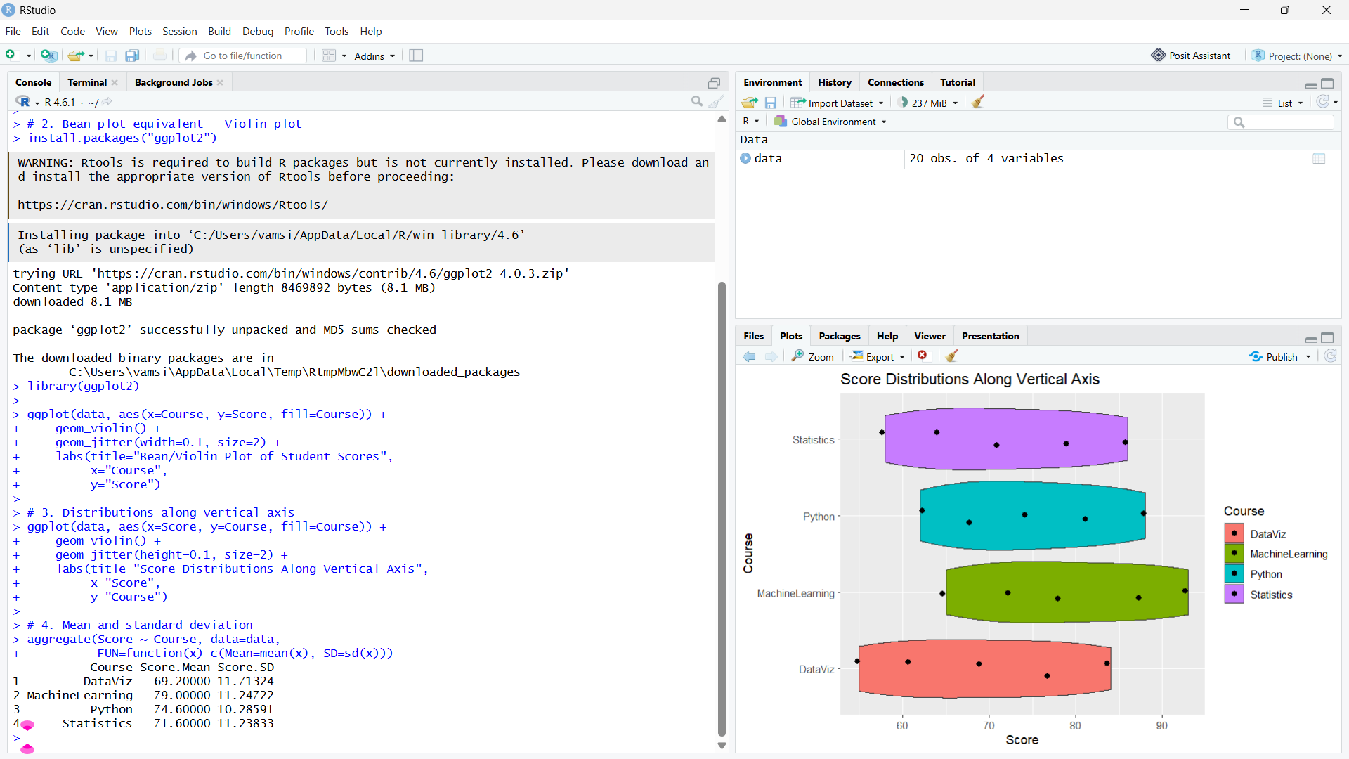

Conclusion:
The student scores were compared across different courses using boxplots and violin plots. Machine Learning students achieved the highest overall performance, while Data Visualization had the lowest scores. Machine Learning also had the highest mean score of 79. The violin plots provided a better understanding of the distribution and spread of student scores.

Question 3 – Product Purchase Distribution
Code:
# Data
data <- data.frame(
Customer_ID = paste0("C", sprintf("%03d", 1:12)),
Region = rep(c("North","South","East","West"), each=3),
Product = rep(c("Laptop","Phone","Tablet"), 4),
Purchase_Type = c("Online","Online","Store",
"Store","Online","Store",
"Online","Store","Online",
"Store","Online","Store"),
Count = c(25,35,20,30,40,25,28,32,18,22,38,27)
)

# 1. Pie Chart - Overall Product Proportion
product_total <- aggregate(Count ~ Product, data, sum)

pie(product_total$Count,
labels=paste(product_total$Product,
round(product_total$Count/sum(product_total$Count)*100,1), "%"),
main="Overall Purchase Proportion by Product")

# 2. Side-by-side Bar Chart
bar_data <- xtabs(Count ~ Region + Product, data)

barplot(t(bar_data),
beside=TRUE,
col=c("skyblue","orange","lightgreen"),
main="Product Counts Across Regions",
xlab="Region",
ylab="Purchase Count",
legend.text=TRUE)

# 3. Stacked Bar Chart
barplot(t(bar_data),
beside=FALSE,
col=c("skyblue","orange","lightgreen"),
main="Product Composition by Region",
xlab="Region",
ylab="Purchase Count",
legend.text=TRUE)

# 4. 100% Stacked Bar Chart
prop_data <- prop.table(bar_data, margin=1)

barplot(t(prop_data),
beside=FALSE,
col=c("skyblue","orange","lightgreen"),
main="100% Stacked Bar Chart",
xlab="Region",
ylab="Proportion",
legend.text=TRUE,
ylim=c(0,1))

# 5. Display proportions
print(round(prop_data * 100, 2))

Interpretation
- The pie chart shows the overall proportion of Laptop, Phone and Tablet purchases.
- The side-by-side bar chart makes it easy to compare actual product counts between regions.
- The stacked bar chart shows both total purchases and product composition.
- The 100% stacked bar chart is best for comparing regional proportions, because every region has the same total height and differences in composition are easier to see.
- Pie charts are less suitable for regional comparison because comparing slice angles across multiple regions is harder than comparing aligned bars.
Output:
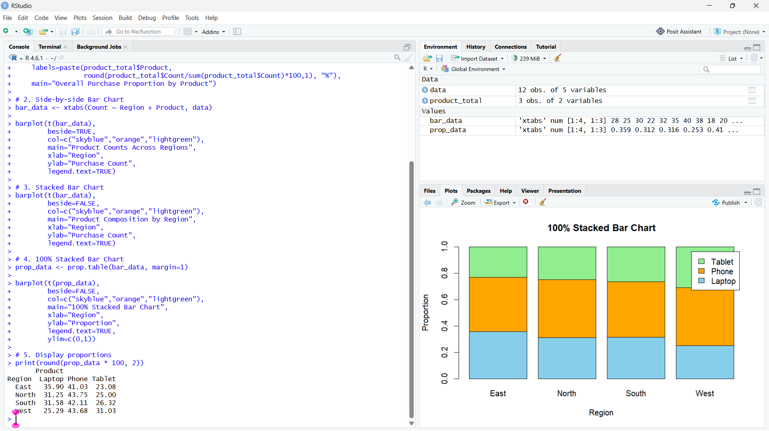

Conclusion:
The product purchases were analyzed using pie charts, bar charts, stacked bar charts, and 100% stacked bar charts. These visualizations helped compare product purchases across different regions. The 100% stacked bar chart was most useful for comparing the proportion of products between regions, while the side-by-side bar chart was useful for comparing actual purchase counts.

Question 4 – Sales Hierarchy Analysis
Code:
# Install packages if needed
install.packages("treemap")
install.packages("sunburstR")

library(treemap)
library(sunburstR)

# Data
data <- data.frame(
Region = rep(c("North","South","East","West"), each=4),
Category = rep(c("Electronics","Electronics","Furniture","Furniture"), 4),
Subcategory = rep(c("Laptop","Phone","Chair","Desk"), 4),
Sales = c(52000,38000,22000,18000,
46000,42000,25000,21000,
58000,35000,19000,23000,
49000,44000,27000,20000)
)

# 1. Treemap
treemap(data,
index=c("Region","Category","Subcategory"),
vSize="Sales",
type="index",
title="Company Sales Treemap")

# 2. Sunburst
sun_data <- data.frame(
pathString=c(
"North","North/Electronics","North/Electronics/Laptop",
"North/Electronics/Phone","North/Furniture","North/Furniture/Chair",
"North/Furniture/Desk",

"South","South/Electronics","South/Electronics/Laptop",
"South/Electronics/Phone","South/Furniture","South/Furniture/Chair",
"South/Furniture/Desk",

"East","East/Electronics","East/Electronics/Laptop",
"East/Electronics/Phone","East/Furniture","East/Furniture/Chair",
"East/Furniture/Desk",

"West","West/Electronics","West/Electronics/Laptop",
"West/Electronics/Phone","West/Furniture","West/Furniture/Chair",
"West/Furniture/Desk"
)
)

sunburst(sun_data)

# 3. Largest Region
region_total <- aggregate(Sales ~ Region, data, sum)
category_total <- aggregate(Sales ~ Category, data, sum)
subcategory_total <- aggregate(Sales ~ Subcategory, data, sum)

cat("Largest Region:\n")
print(region_total[which.max(region_total$Sales),])

cat("Largest Category:\n")
print(category_total[which.max(category_total$Sales),])
cat("Largest Subcategory:\n")
print(subcategory_total[which.max(subcategory_total$Sales),])

Interpretation
- Largest Region: East = ₹1,35,000
- Largest Category: Electronics = ₹3,64,000
- Largest Subcategory: Laptop = ₹2,05,000
Treemap: Better for quickly comparing sales using rectangle areas and seeing the overall hierarchy.
Sunburst: Better for understanding the Region → Category → Subcategory hierarchy and relationships.
Limitations:
- Treemap: Small rectangles can become difficult to compare and label.
- Sunburst: Comparing similar-sized segments across different rings can be difficult.
Output:
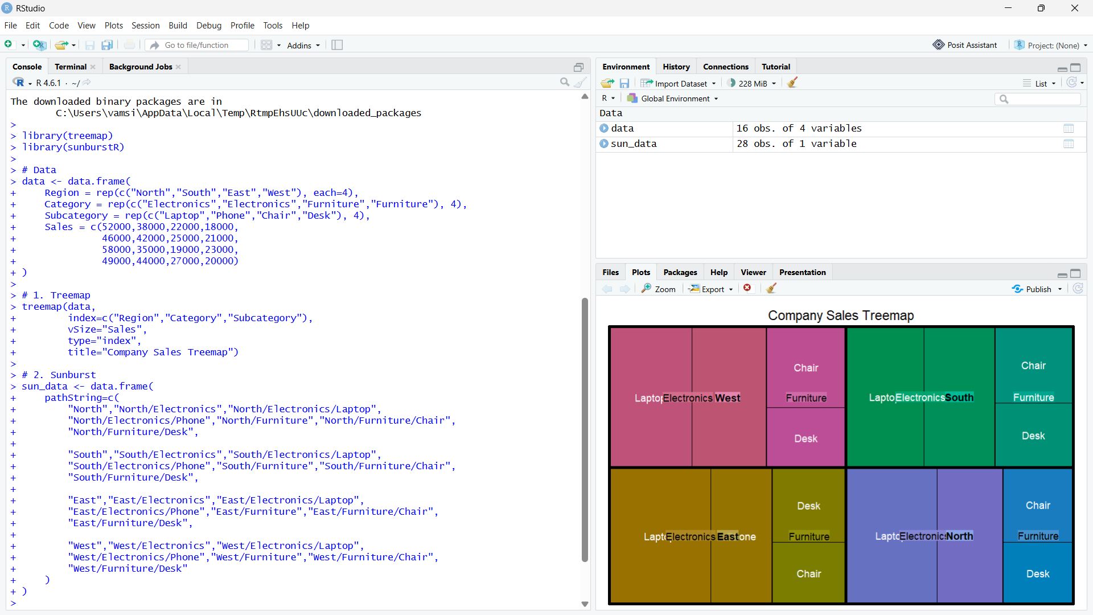
Conclusion:
The sales data was successfully visualized using treemap and sunburst charts. East was the highest-performing region with ₹1,35,000 in sales, Electronics was the largest category with ₹3,64,000, and Laptop was the highest-selling subcategory with ₹2,05,000. The treemap is useful for quickly comparing sales, while the sunburst clearly represents the Region → Category → Subcategory hierarchy.

Question 5 – Student Career Flow Analysis
Code:
# Install packages if needed
install.packages("networkD3")
install.packages("ggplot2")
install.packages("ggalluvial")

library(networkD3)
library(ggplot2)
library(ggalluvial)

# Data
data <- data.frame(
Student_Group = paste0("G",1:12),
Specialization = c("Data Analytics","Data Analytics","Data Analytics",
"AI","AI","AI",
"Cyber Security","Cyber Security","Cyber Security",
"Cloud Computing","Cloud Computing","Cloud Computing"),
Internship = c("Yes","Yes","No","Yes","Yes","No",
"Yes","Yes","No","Yes","Yes","No"),
Placement_Sector = c("IT","Finance","IT",
"IT","Healthcare","IT",
"IT","Finance","Government",
"IT","Finance","Government"),
Students = c(18,12,8,20,10,6,16,9,7,15,8,5)
)

# 1. Sankey Diagram

nodes <- data.frame(
name = unique(c(data$Specialization,
data$Internship,
data$Placement_Sector))
)

data$SpecID <- match(data$Specialization,nodes$name)-1
data$InternID <- match(data$Internship,nodes$name)-1
data$SectorID <- match(data$Placement_Sector,nodes$name)-1

links1 <- data.frame(
source=data$SpecID,
target=data$InternID,
value=data$Students
)

links2 <- data.frame(
source=data$InternID,
target=data$SectorID,
value=data$Students
)

links <- rbind(links1,links2)

sankeyNetwork(
Links=links,
Nodes=nodes,
Source="source",
Target="target",
Value="value",
NodeID="name",
fontSize=12,
nodeWidth=30
)

# 2. Parallel Sets

ggplot(data,
aes(axis1=Specialization,
axis2=Internship,
axis3=Placement_Sector,
y=Students)) +
geom_alluvium(aes(fill=Internship), width=1/12) +
geom_stratum(width=1/8, fill="lightgray") +
geom_text(stat="stratum",
aes(label=after_stat(stratum))) +
scale_x_discrete(
limits=c("Specialization","Internship","Placement Sector"),
expand=c(.05,.05)
) +
labs(
title="Parallel Sets: Student Career Path",
x="Category",
y="Number of Students"
)

# 3. Major Flows
data$Percentage <- data$Students/sum(data$Students)*100

top_flows <- data[order(-data$Students),][1:5,]

print(top_flows[,c("Specialization",
"Internship",
"Placement_Sector",
"Students",
"Percentage")])

# 4. Placement patterns with and without internships
placement <- aggregate(
Students ~ Internship + Placement_Sector,
data=data,
sum
)
print(placement)
# 5. Total students
cat("Total Students =",sum(data$Students),"\n")

Interpretation
Major flows:
- AI → Yes → IT: 20 students (14.93%)
- Data Analytics → Yes → IT: 18 students (13.43%)
- Cyber Security → Yes → IT: 16 students (11.94%)
- Cloud Computing → Yes → IT: 15 students (11.19%)
- Data Analytics → Yes → Finance: 12 students (8.96%)
Internship pattern:
- Students with internships are mainly placed in IT, followed by Finance and Healthcare.
- Students without internships mainly appear in IT and Government placements.
Sankey vs Parallel Sets:
- Sankey communicates flow magnitude more clearly because wider links directly represent more students.
- Parallel sets are useful for comparing relationships between the three categorical variables.
Possible misleading design: Using inconsistent link widths or inappropriate colors can make a smaller flow appear more important than a larger one. Truncated or unclear labels can also cause incorrect interpretation.
Output:
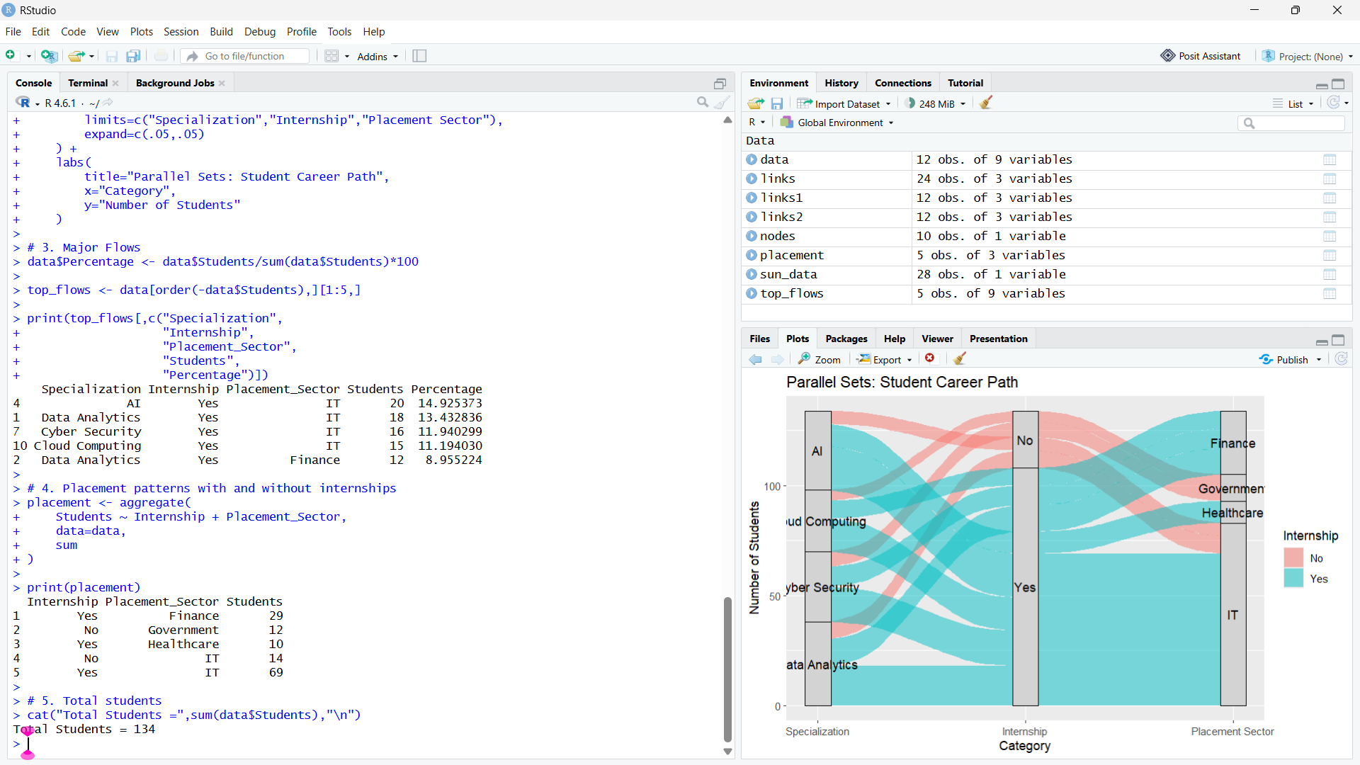

Conclusion:
The student career paths were analyzed using Sankey and Parallel Sets diagrams. Students with internships showed a strong tendency toward IT placements, with AI → Internship → IT being the largest individual flow. The Sankey diagram was more effective for showing the magnitude and direction of student flows, while Parallel Sets helped compare relationships between categories.

