Question 1: Mapping Data onto Aesthetics
Code:
%%R

library(ggplot2)
sales <- data.frame(
Product = c("P1","P2","P3","P4","P5","P6"),
Sales = c(120,90,150,80,135,100),
Profit = c(18,12,25,8,22,16),
Category = c("Electronics","Clothing","Electronics","Furniture","Furniture","Clothing")
)
ggplot(
sales,
aes(
x = Sales,
y = Profit,
color = Category,
size = Sales
)
) +
geom_point(alpha = 0.8) +
labs(
title = "Sales vs Profit",
x = "Sales (Lakhs)",
y = "Profit (%)"
) +
theme_minimal()
output:
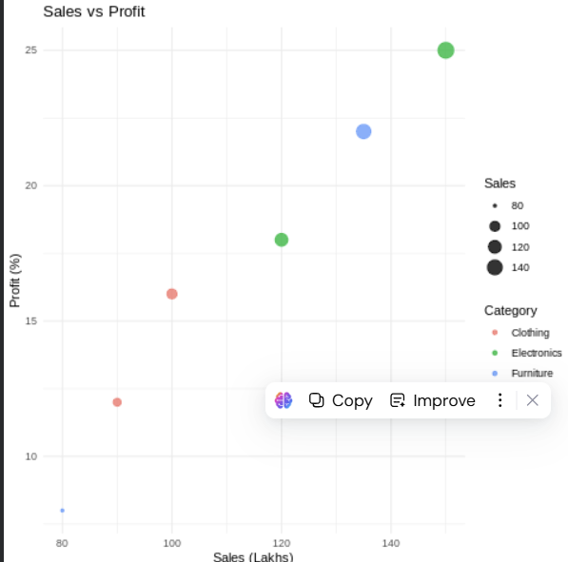
3. Interpret the relationship between Sales and Profit.
From the given data, Sales and Profit show a positive relationship. Products with higher sales generally have higher profit percentages. For example, Product P3 has the highest sales (₹150 Lakhs) and the highest profit (25%), while Product P4 has the lowest sales (₹80 Lakhs) and the lowest profit (8%).
4. Identify the type of scale used for each variable.
- Product → Categorical (Nominal)
- Sales → Continuous
- Profit → Continuous
- Category → Categorical (Nominal)
5. Suggest one alternative visualization that better represents the same data.
A Bubble Chart is a suitable alternative because it can simultaneously represent:
- Sales on the X-axis,
- Profit on the Y-axis,
- Category using color,
- Sales or Profit using bubble size

Question 2: Coordinate Systems
Code:
library(ggplot2)
library(patchwork)

direction <- data.frame(
Direction = c("N", "NE", "E", "SE", "S", "SW", "W", "NW"),
Frequency = c(18, 12, 20, 15, 22, 11, 16, 14)
)

cartesian <- ggplot(direction, aes(x = Direction, y = Frequency)) +
geom_bar(stat = "identity", fill = "steelblue") +
labs(
title = "Cartesian Coordinate System",
x = "Direction",
y = "Frequency"
) +
theme_minimal()

polar <- ggplot(direction, aes(x = Direction, y = Frequency, fill = Direction)) +
geom_bar(stat = "identity") +
coord_polar() +
labs(title = "Polar Coordinate System") +
theme_minimal()

cartesian + polar
output:
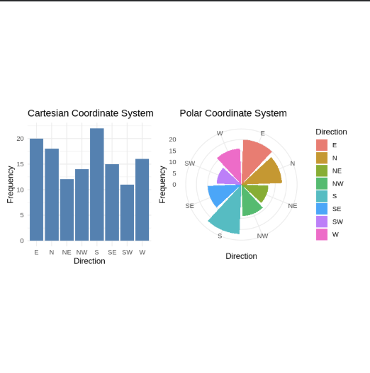
3. Compare the effectiveness of both visualizations.
- Cartesian Coordinate System: Better for comparing exact frequencies because the bar heights are easy to compare.
- Polar Coordinate System: Better for displaying directional data since it naturally represents compass directions in a circular format.
4. Explain which coordinate system is more appropriate for directional data.
- The Polar Coordinate System is more appropriate because compass directions (N, NE, E, etc.) are circular in nature, making the visualization more intuitive.
5. Justify your answer based on data interpretation.
- Polar coordinates improve interpretation by arranging the directions around a circle, making it easier to identify the direction with the highest or lowest frequency. In this dataset, South has the highest frequency (22), while South-West has the lowest frequency (11).

Question 3: Color Scales for Data Representation

Code:

# Load packages
library(ggplot2)
library(viridis)

# Dataset
marks <- data.frame(
Student = c("A", "B", "C", "D", "E", "F"),
Marks = c(45, 58, 72, 81, 67, 90)
)

# Bar Chart with Sequential Color Scale
ggplot(marks, aes(x = Student, y = Marks, fill = Marks)) +
geom_bar(stat = "identity") +
scale_fill_viridis_c(option = "C") +
labs(
title = "Student Marks",
x = "Student",
y = "Marks"
) +
theme_minimal()

output:
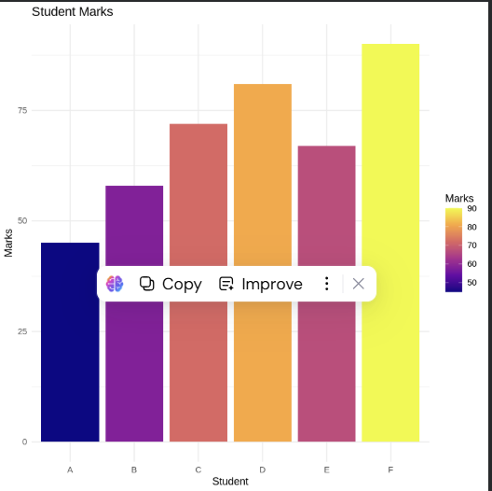

2. Identify the students with the highest and lowest marks.
- Highest Marks: Student F – 90
- Lowest Marks: Student A – 45

3. Explain why a sequential color scale is appropriate.
- A sequential color scale is appropriate because Marks are continuous numerical values. It uses lighter shades for lower marks and darker shades for higher marks, making differences easy to interpret.

4. Suggest a color palette suitable for color-blind users.
- A Viridis color palette is recommended because it is color-blind friendly, provides good contrast, and is easy to interpret.

5. Explain the difference between sequential and categorical color scales.
- Sequential Color Scale: Used for continuous numerical data. Colors gradually change from light to dark to represent increasing or decreasing values.
- Categorical Color Scale: Used for categorical data. Different colors represent different groups without implying any order.

Question 4: Highlighting with Color

Code:
# Load package
library(ggplot2)

# Dataset
revenue <- data.frame(
Region = c("North", "South", "East", "West", "Central"),
Revenue = c(820, 760, 790, 1010, 770)
)

# Highlight Highest Revenue
revenue$Highlight <- ifelse(
revenue$Revenue == max(revenue$Revenue),
"Highest",
"Others"
)

# Bar Chart
ggplot(revenue, aes(x = Region, y = Revenue, fill = Highlight)) +
geom_bar(stat = "identity") +
scale_fill_manual(values = c("Highest" = "red", "Others" = "skyblue")) +
labs(
title = "Revenue by Region",
x = "Region",
y = "Revenue (₹ Crores)"
) +
theme_minimal()

output:
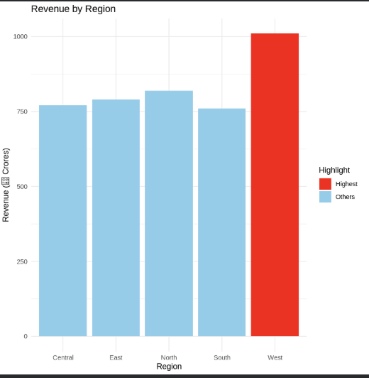

2. Explain how highlighting improves data interpretation.
- Highlighting draws attention to the most important data point, making it easier to identify key information quickly. In this case, it clearly emphasizes the region with the highest revenue.
3. Identify the highest-performing region.
- The West region is the highest-performing region with a revenue of ₹1010 Crores.
4. Discuss how excessive use of colors can affect interpretation.
- Using too many colors can make the chart cluttered, distract viewers, and reduce the effectiveness of highlighting important information.
5. Suggest one alternative highlighting technique other than color.
An alternative technique is to:
- Add data labels,
- Use bold outlines,
- Increase the size of the important bar,
- Add an annotation or arrow pointing to the highest value.

Question 5: Integrated Visualization
Code:
# Load package
library(ggplot2)

# Dataset
city <- data.frame(
City = c("A", "B", "C", "D", "E"),
Population = c(8.2, 5.6, 9.4, 6.8, 4.9),
AQI = c(110, 180, 90, 240, 150),
Rainfall = c(850, 430, 1200, 520, 680),
Region = c("North", "South", "North", "East", "West")
)

# Bubble Chart
ggplot(city,
aes(
x = Population,
y = AQI,
size = Rainfall,
color = Region
)) +
geom_point(alpha = 0.8) +
labs(
title = "Population vs AQI",
x = "Population (Million)",
y = "AQI"
) +
theme_minimal()

Output:
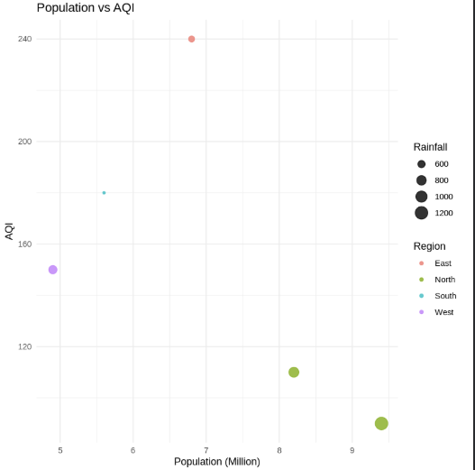
2. Select suitable aesthetics for Population, AQI, Rainfall, and Region.
- Population → X-axis
- AQI → Y-axis
- Rainfall → Bubble Size
- Region → Color
3. Interpret the relationship between Population and AQI.
The dataset does not show a strong linear relationship between Population and AQI. Some cities with higher populations have lower AQI values, while others with moderate populations have higher AQI values.
4. Identify the continuous and categorical variables.
Continuous Variables:
- Population
- AQI
- Rainfall
Categorical Variables:
- City
- Region
5. Recommend one improvement to enhance the visualization's readability.
One effective improvement is to add labels for each city so viewers can easily identify each data point. Other improvements include adding a clear title, descriptive axis labels, and an appropriate legend.

