# Crime Track Online Crime Reporting System

Crime Track is an innovative online platform designed to facilitate the reporting of criminal activities and provide users with essential information about various crimes. The platform aims to enhance public safety by offering a streamlined and secure process for reporting incidents, alongside educational resources to empower users with knowledge about crime prevention and legal actions.

## Key Features

1. User-Friendly Interface: Allows users to quickly and securely report incidents, including details such as crime type, location, time, and evidence.
2. Real-Time Updates: Provides real-time updates on crime trends and statistics, helping users stay informed about safety concerns in their neighborhoods.
3. Educational Resources: Offers extensive information about common crimes, their impact on communities, and preventive measures.
4. Community Engagement: Enables users to share experiences, safety tips, and advice through discussion forums and subscribe to alerts for specific crime categories or local areas of interest.

## Scenario-Based Case Study

* Background: Priya, a tech student, was curious about the types of crimes and their prevention methods, as well as the legal actions associated with them.
* Problem: While returning from college, Priya noticed an unknown stranger following her, which made her feel unsafe.
* Solution: Priya visited the Crime Track platform, where she read about the crime and reported the incident. Her report was promptly addressed by the police, resolving her concern effectively.

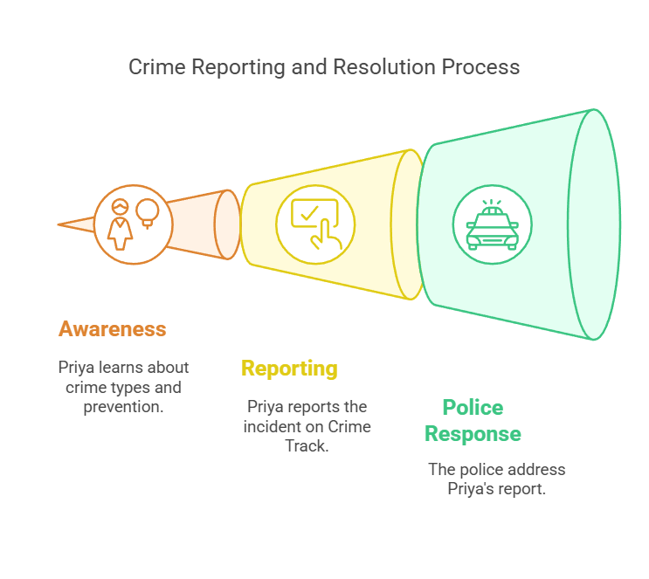

## Technical Architecture

1. **Authentication:** Manages user sign-up and stores user data securely.

2. **Database:** Utilizes separate collections for users and reports.

3. **User Component:** Includes sections for crime types and reporting forms.

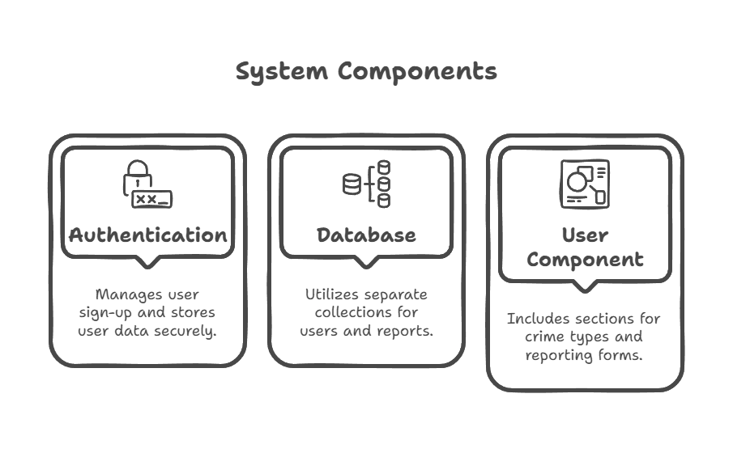

## ER Diagram

The Entity-Relationship (ER) diagram illustrates the structure of the database, including entities such as User, Report, and Admin, along with their relationships.

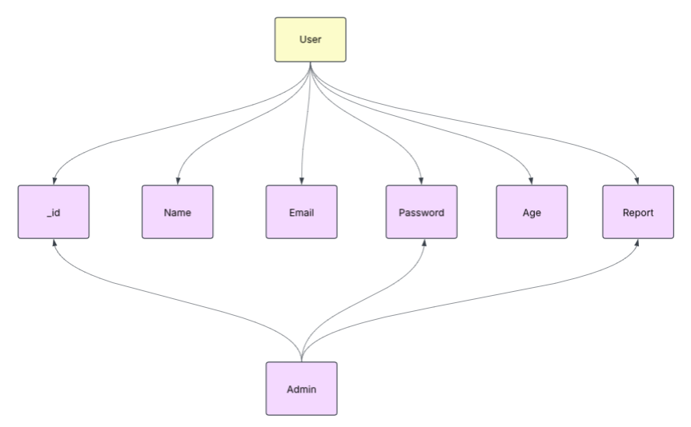

## Key Functionalities

1. User Dashboard: Displays types of crimes, prevention tips, and a reporting form.

2. Reporting Form: Allows users to report crimes and uneven activities securely.

## Prerequisites

1. Node.js and npm: Required for server-side JavaScript execution.
2. MongoDB: Used for database management.
3. Express.js: Framework for handling server-side routing and API development.
4. Visual Studio Code: IDE for development.
5. Postman or ThunderClient: Tools for API testing.

## Roles and Responsibilities

**User:**

* **Profile:** Users must sign up to access the platform.
* **Crime Info:** Provides information on various crimes and prevention tips.
* **Reporting Form:** Allows users to report crimes and uneven activities.

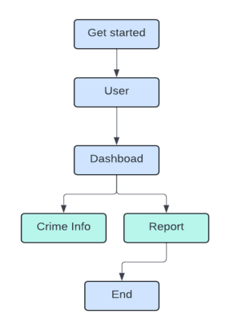

1.**Start:** This is the entry point of the user flow.

2. **User :** The user should signup/login.

3. **Dashboard:** The dashboard contains a Crime info section which lists the  various types of crimes and the prevention and legal actions. 4. Report: The form is to report the crime

## Project Setup and Configuration

Steps:

1. Install Required Tools: Node.js, MongoDB, and other necessary packages.

2. Create Project Folders and Files: Organize the project structure.

3. Install Packages: Express, dotenv, Nodemon, Mongoose, JWT, etc.

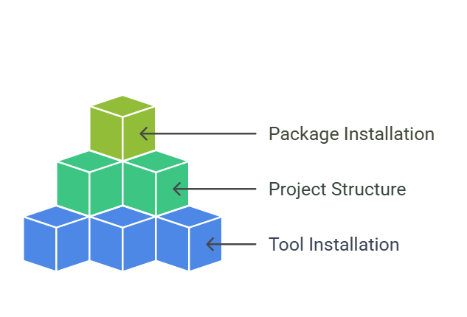

## Backend Development

**Setup Express Server:**

* Configure the server with cors, body-parser, and other middleware.
* Define API routes for user authentication, crime reporting, and data retrieval.

**User Authentication:**

* Implement routes and middleware for user registration, login, and logout.
* Set up authentication middleware to protect routes.

**Database Configuration:**

* Connect MongoDB to the backend and create schemas for user and report models.
* Ensure the database connection is established before performing any actions.

## 

## API Testing

* User Register: POST /api/users/register

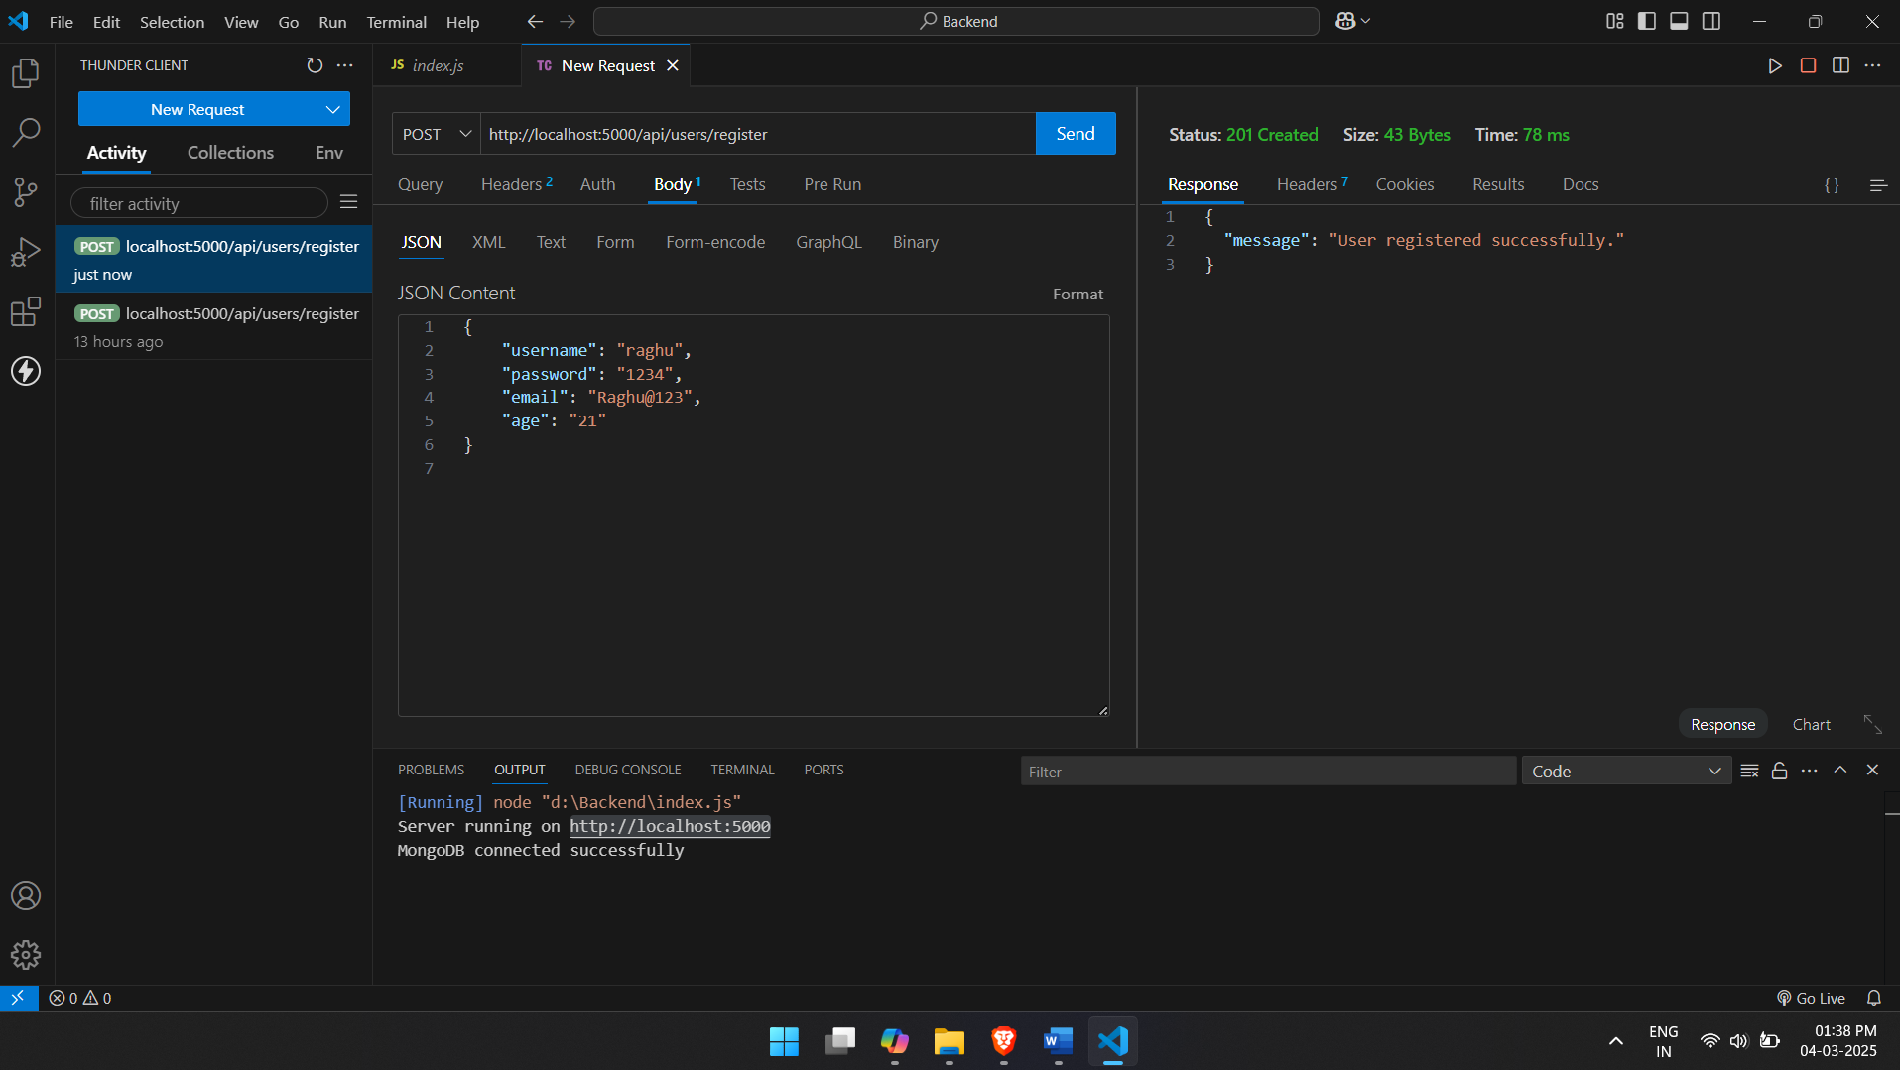

* User Login: POST /api/users/login

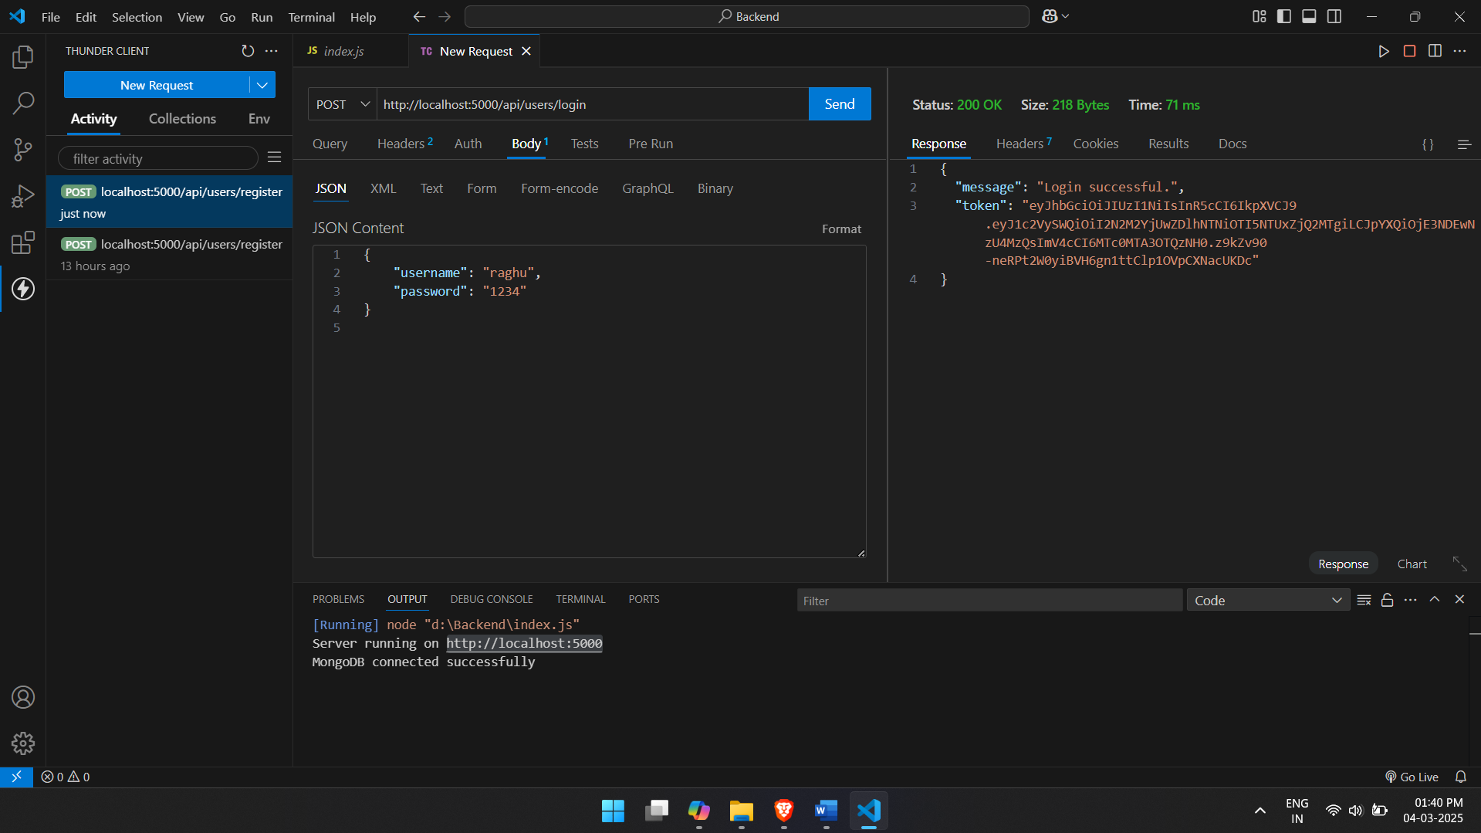

* Create Crime Report: POST /api/reports

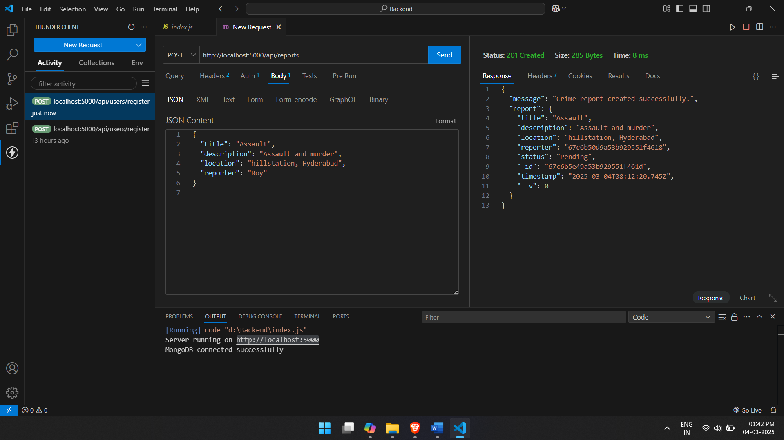

* Get All Crime Reports: GET /api/reports

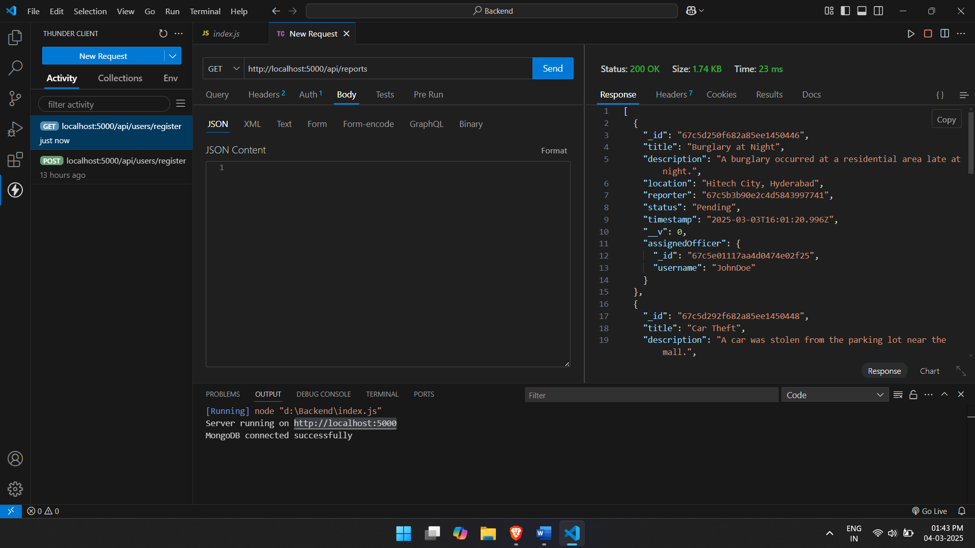

* Update Crime Report Status: PUT /api/reports/:id/status

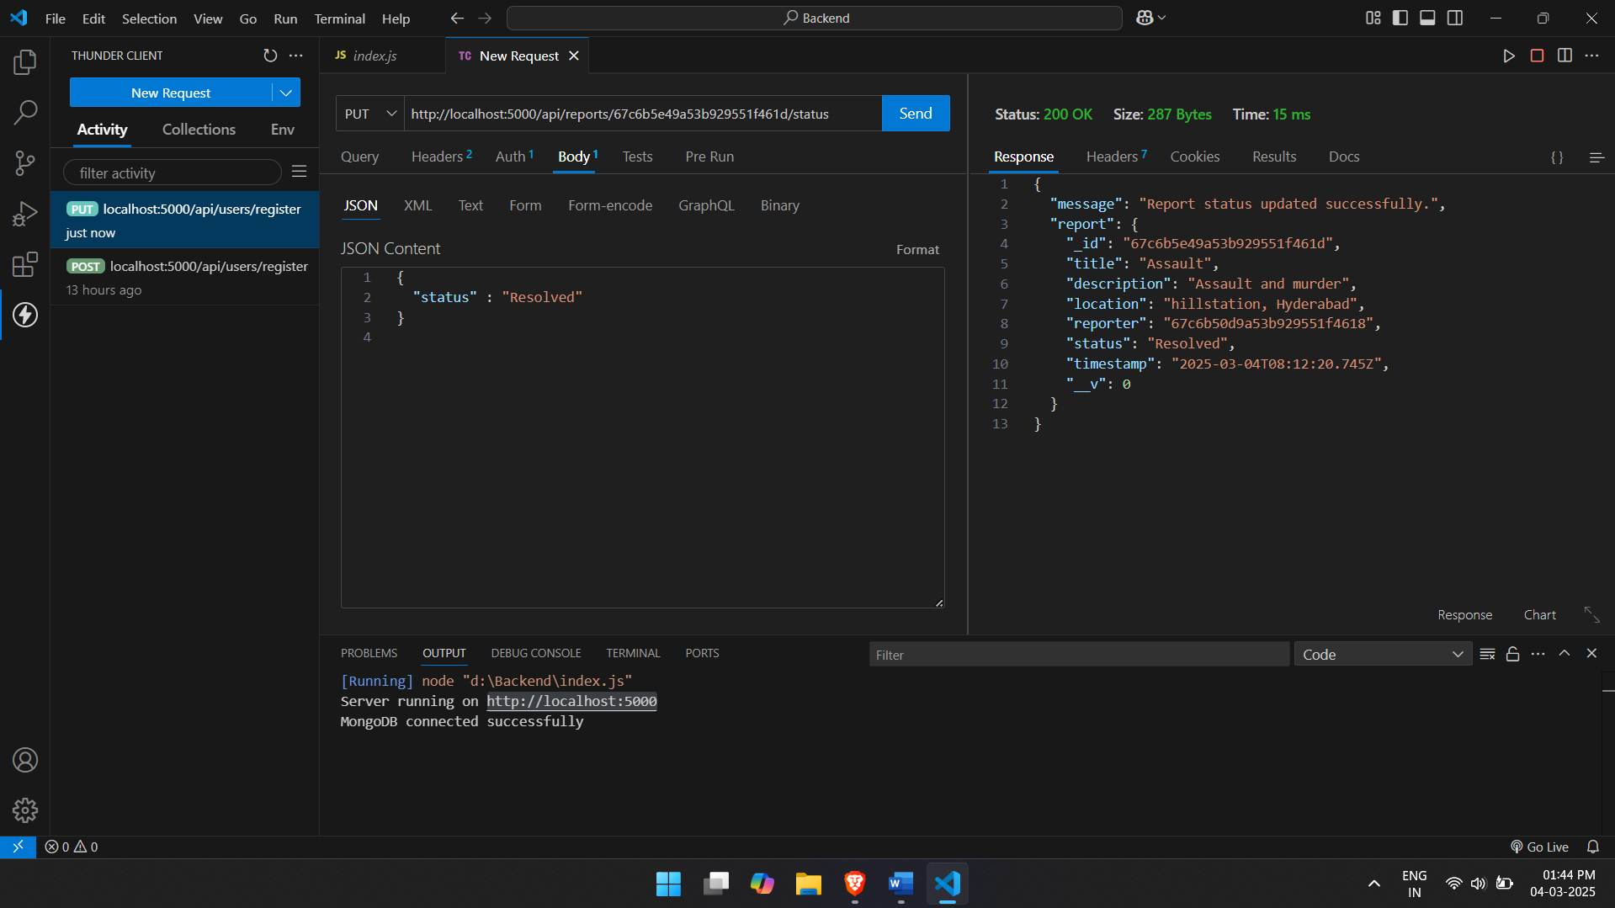

* Search Reports by Location: GET /api/reports/search?location=hill

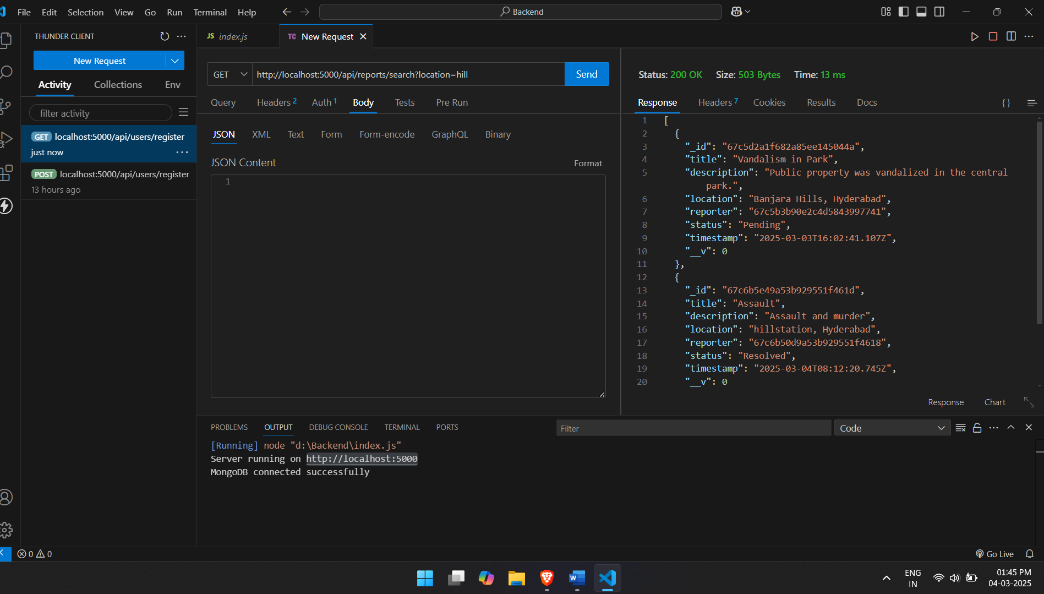

* Assign Crime Report to Officer: PUT /api/reports/:id/assign

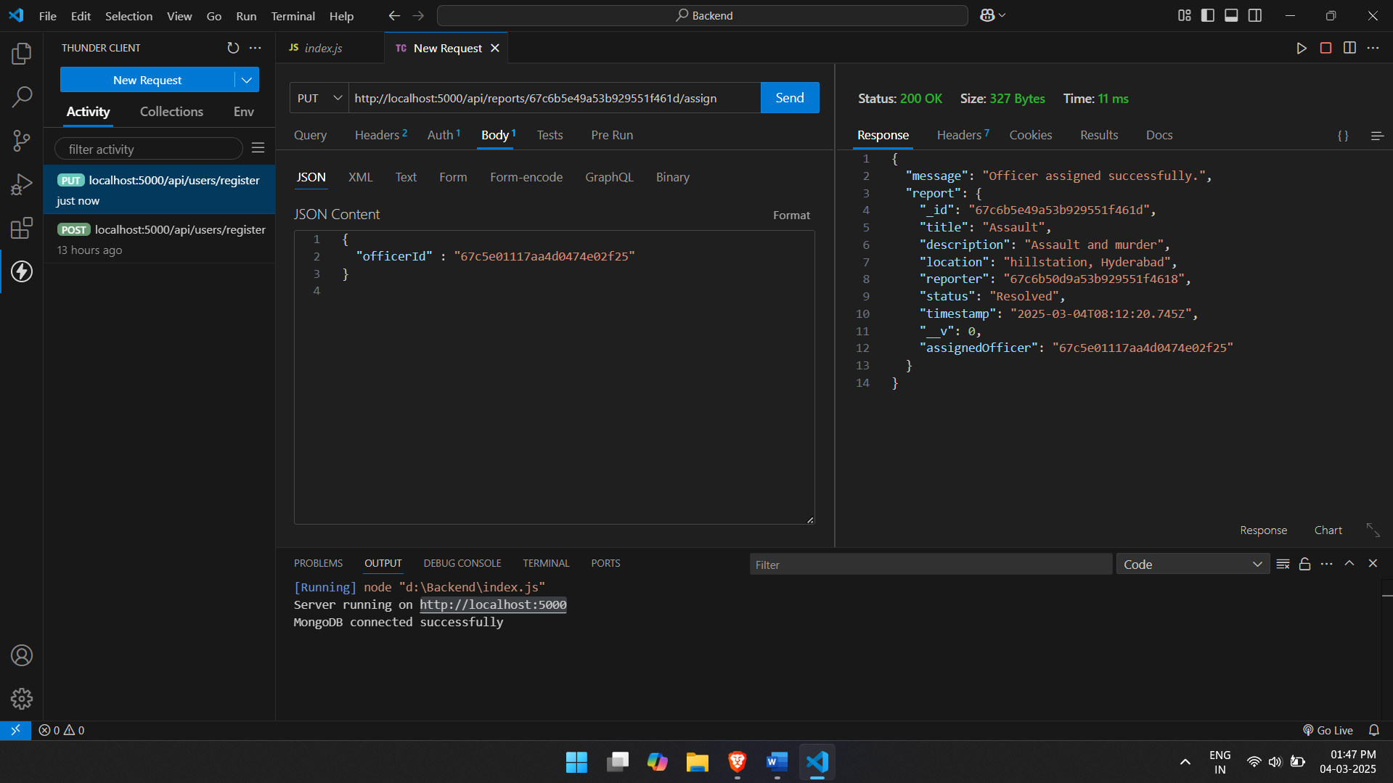

* Get Crime Report Statistics: GET /api/reports/stats

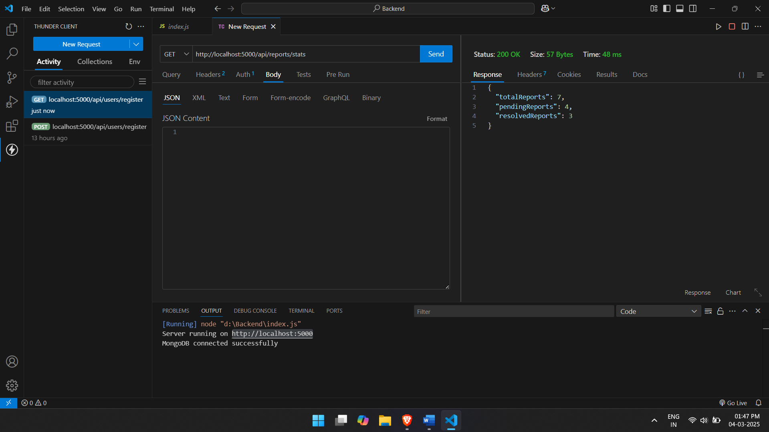

* Delete Report: DELETE /api/reports/:id

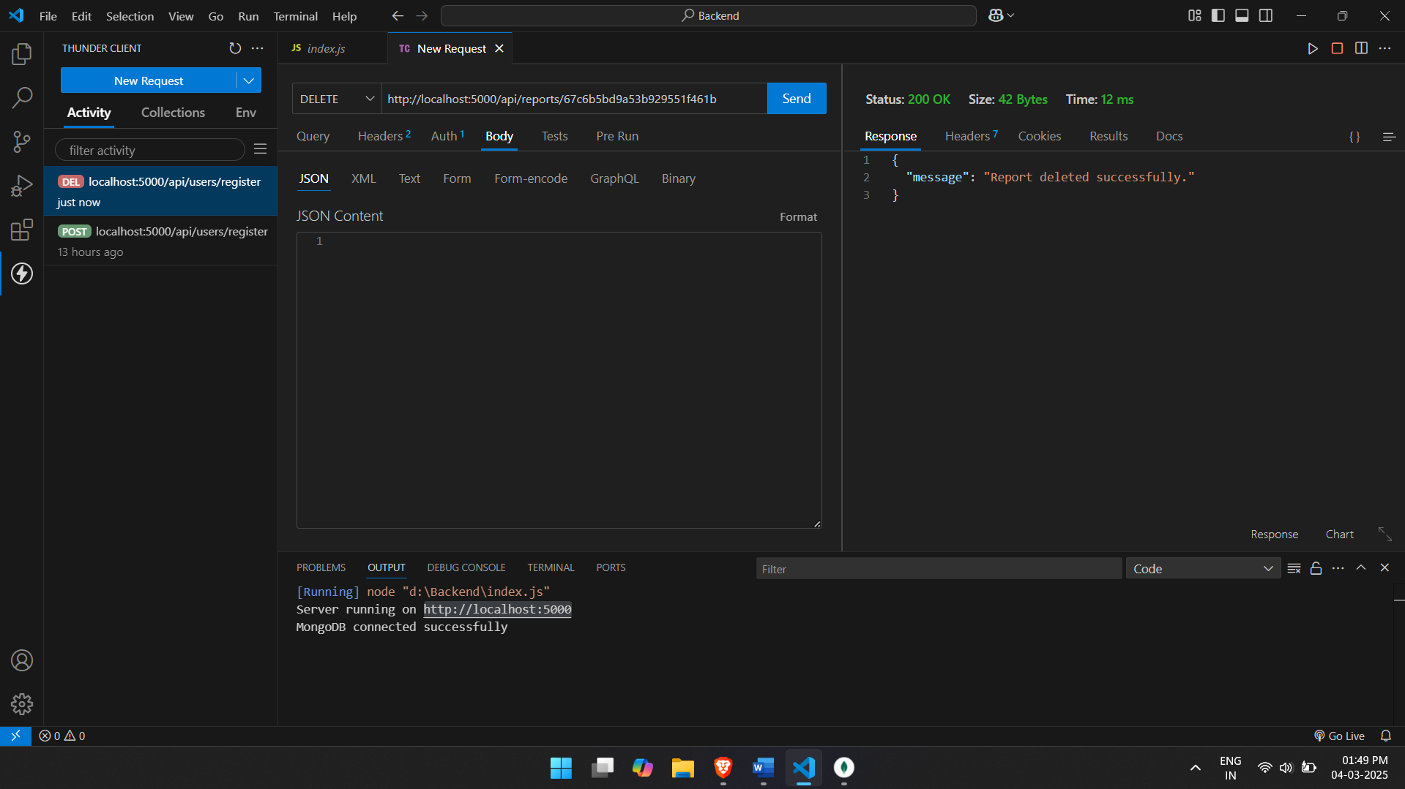

* User Profile: GET /api/users/profile

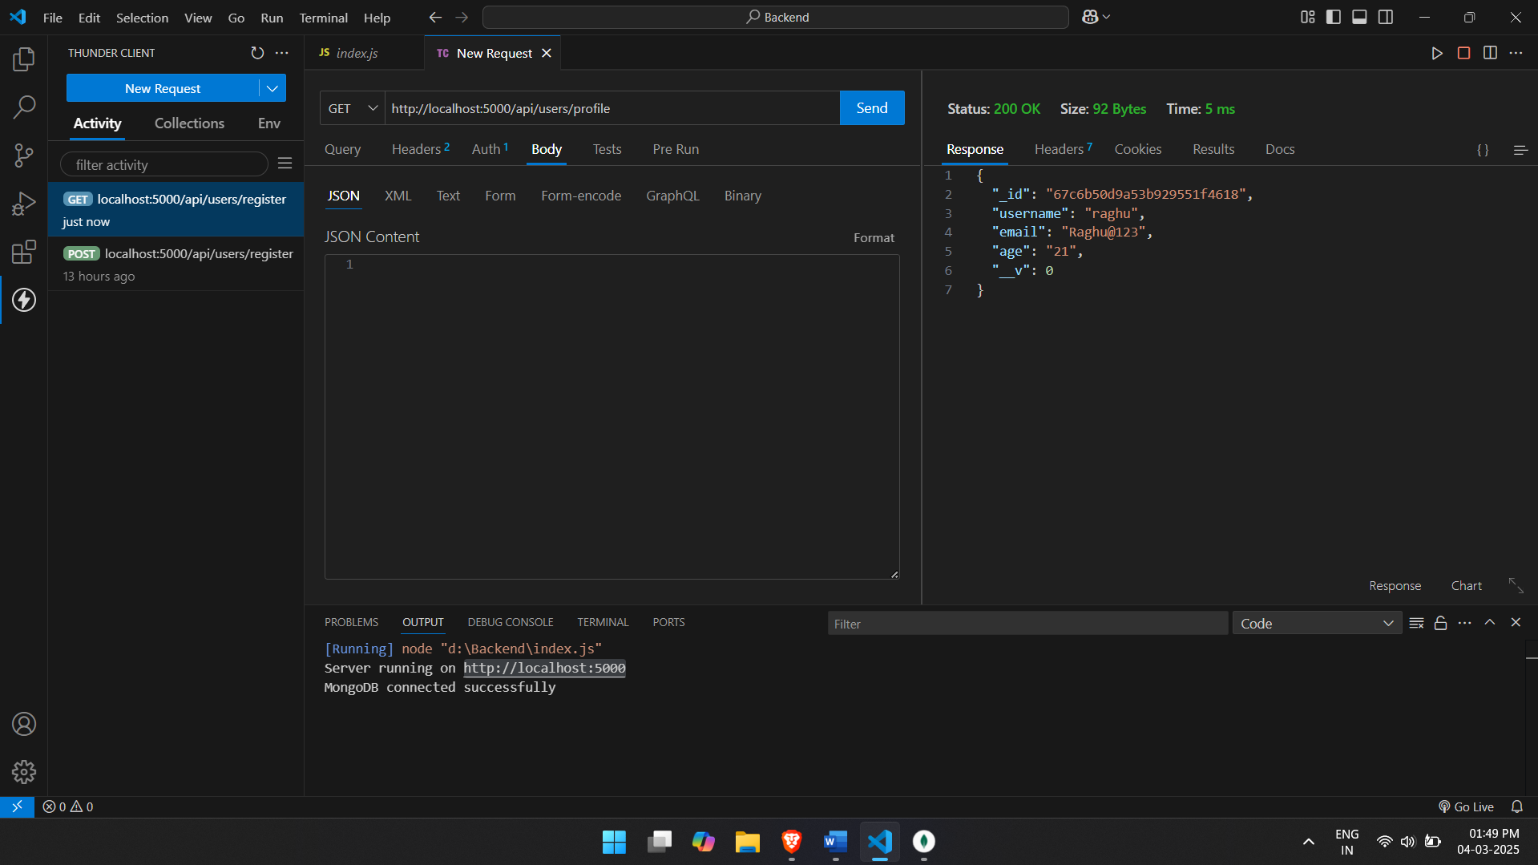

* Update Profile: PUT /api/users/profile

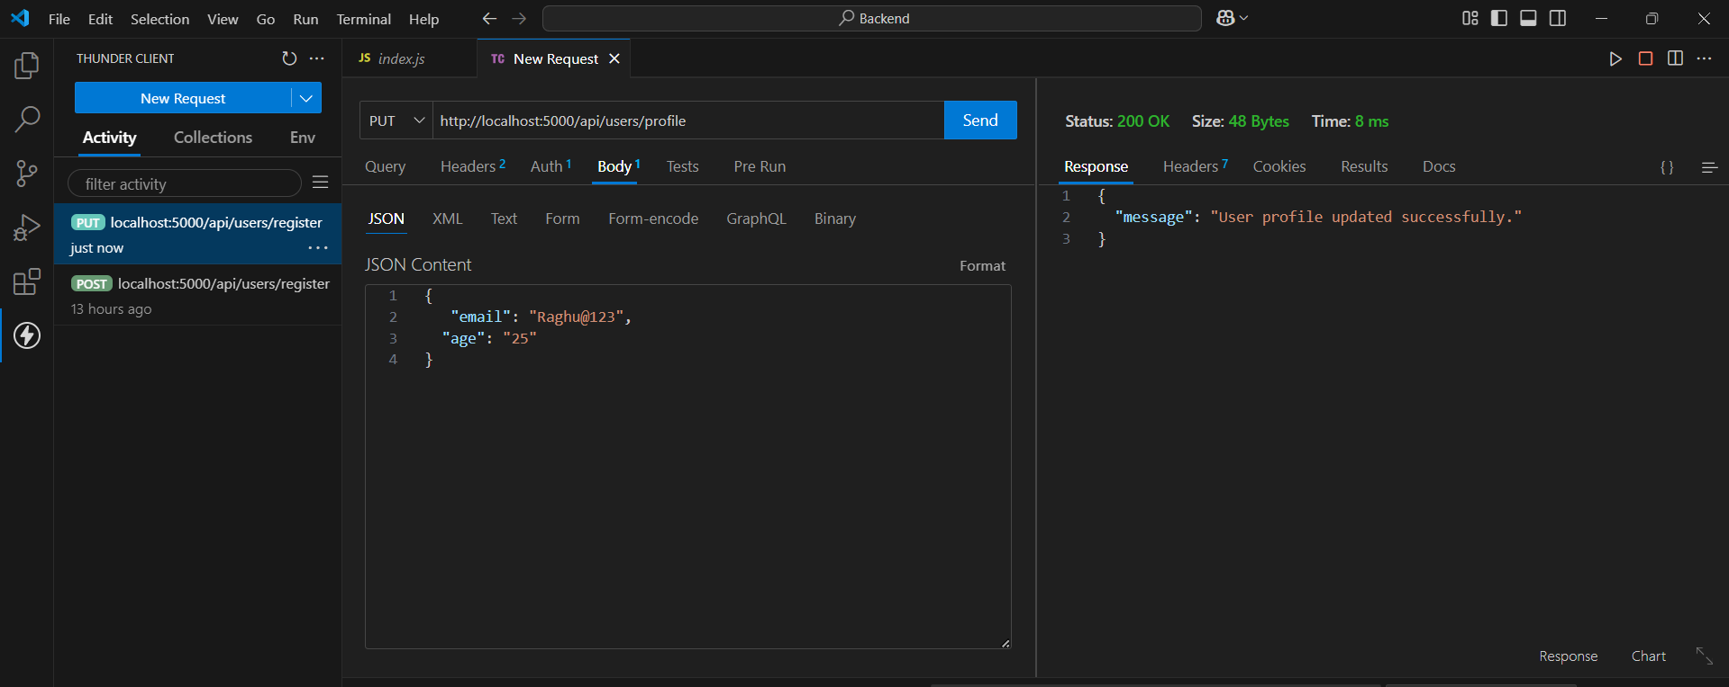

* User Logout: POST /api/users/logout

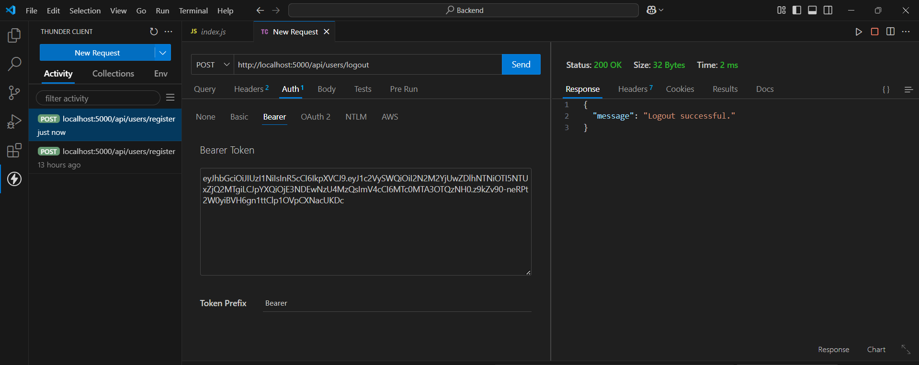

## Conclusion

Crime Track aims to create a safer environment by empowering individuals to report crimes and stay informed about safety concerns. Through its comprehensive features and user-friendly interface, the platform fosters community involvement and collaboration, contributing to enhanced public safety.

## Project Source Code (GitHub) Link: <https://github.com/somashekhar79938/Crime-Track---Online-Crime-Reporting-System>