Somasundaram M

Date: 18/11/2024

**DSA PRACTICE PROBLEMS_6**

1. **Bubble Sort**

Given an array, arr[]. Sort the array using bubble sort algorithm.

Examples :

Input: arr[] = [4, 1, 3, 9, 7]

Output: [1, 3, 4, 7, 9]

Input: arr[] = [10, 9, 8, 7, 6, 5, 4, 3, 2, 1]

Output: [1, 2, 3, 4, 5, 6, 7, 8, 9, 10]

**Code:**

import java.util.*;

public class BubbleSort{

public static void bubble(int arr[]) {

// code here

int n=arr.length;

for(int i=0;i<n-1;i++){

boolean swap=false;

for(int j=0;j<n-1-i;j++){

if(arr[j]>arr[j+1]){

arr[j]=arr[j]^arr[j+1];

arr[j+1]=arr[j]^arr[j+1];

arr[j]=arr[j]^arr[j+1];

swap=true;

}

}

if(swap==false) break;

}

for(int i=0;i<n;i++){

System.out.print(arr[i]+" ");

}

}

public static void main(String[] args){

int[] arr={10, 9, 8, 7, 6, 5, 4, 3, 2, 1};

bubble(arr);

}

}

**Output:**

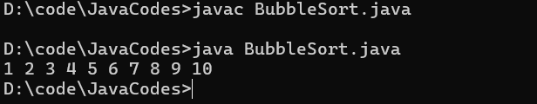

**Time Complexity: O(n^2)**

**Space Complexity: O(n)**

**2. Non Repeating Character**

Given a string s consisting of lowercase Latin Letters. Return the first non-repeating character in s. If there is no non-repeating character, return '$'.  
Note: When you return '$' driver code will output -1.

Examples:

Input: s = "geeksforgeeks"

Output: 'f'

Explanation: In the given string, 'f' is the first character in the string which does not repeat.

Input: s = "racecar"  
Output: 'e'  
Explanation: In the given string, 'e' is the only character in the string which does not repeat.

**Code:**

import java.util.*;

class NonRepeatingchars{

public static char Char(String s) {

// Your code here

int[] hash=new int[26];

char ans='$';

for(char i:s.toCharArray()){

hash[i-'a']++;

}

for(int i=0;i<s.length();i++){

if(hash[s.charAt(i)-'a']==1){

return s.charAt(i);

}

}

return ans;

}

public static void main(String[] ar){

String s="geeksforgeeks";

System.out.println(Char(s));

}

}

**Output:**

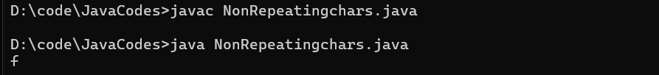

**Time Complexity:O(n)**

**Space Complexity: O(1)**

1. **K largest element**

Given an array **arr[]** of positive integers and an integer **k**, Your task is to return **k largest elements**in decreasing order.

**Examples**

**Input:** arr[] = [12, 5, 787, 1, 23], k = 2

**Output:** [787, 23]

**Explanation:** 1st largest element in the array is 787 and second largest is 23.

**Code:**

import java.util.*;

public class KLargest{

static List<Integer> largest(int arr[], int k) {

// write code here

List<Integer> ans=new ArrayList<>();

PriorityQueue<Integer> pq=new PriorityQueue<>(Comparator.reverseOrder());

for(int i:arr){

pq.add(i);

}

for(int i=0;i<k;i++){

ans.add(pq.poll());

}

return ans;

}

public static void main(String[] ar){

int[] arr={1, 23, 12, 9, 30, 2, 50};

int k=3;

System.out.println(largest(arr,k));

}

}

**Output:**

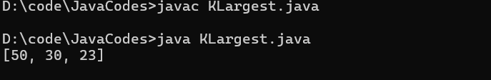

**Space complexity:O(n)**

**Time Complexity:** **O(n log n)**

1. **Form the Largest Number**

Given an array of strings arr[] representing non-negative integers, arrange them so that after concatenating them in order, it results in the largest possible number. Since the result may be very large, return it as a string.

Note: There are no leading zeros in each array element.

Examples:

Input: arr[] = ["3", "30", "34", "5", "9"]

Output: "9534330"

Explanation: Given numbers are {"3", "30", "34", "5", "9"}, the arrangement "9534330" gives the largest value.

Input: arr[] = ["54", "546", "548", "60"]

Output: "6054854654"

Explanation: Given numbers are {"54", "546", "548", "60"}, the arrangement "6054854654" gives the largest value.

**Code:**

import java.util.*;

class Largest{

public static String printLargest(String[] arr) {

// code here

String ans="";

Arrays.sort(arr,(a,b)->(b+a).compareTo(a+b));

if(arr[0].equals("0")) return "0";

for(int i=0;i<arr.length;i++){

ans+=arr[i];

}

return ans;

}

public static void main(String[] ar){

String[] arr={"3", "30", "34", "5", "9"};

System.out.println(printLargest(arr));

}

}

**Output:**

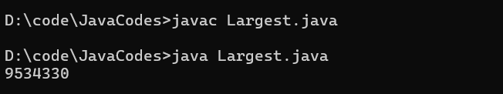

**Time Complexity:O(n logn)**

**Space Complexity: O(n)**

**5.Quick Sort**

Implement Quick Sort, a Divide and Conquer algorithm, to sort an array, **arr**[] in ascending order. Given an array, **arr**[], with starting index **low** and ending index **high**, complete the functions **partition()** and **quickSort()**. Use the last element as the pivot so that all elements less than or equal to the pivot come before it, and elements greater than the pivot follow it.

**Note**: The **low** and **high** are inclusive.

**Examples:**

**Input:** arr[] = [4, 1, 3, 9, 7]

**Output:** [1, 3, 4, 7, 9]  
**Explanation:** After sorting, all elements are arranged in ascending order.

**Code**:

import java.util.*;

public class QuickSort{

// Function to sort an array using quick sort algorithm.

public static int[] Sort(int arr[], int low, int high) {

// code here4

if(low<high){

int pi=partition(arr,low,high);

Sort(arr,low,pi-1);

Sort(arr,pi+1,high);

}

return arr;

}

public static int partition(int arr[], int low, int high) {

// your code here

int pivot=arr[high];

int i=low-1;

for(int j=low;j<high;j++){

if(arr[j]<pivot){

i++;

int temp=arr[i];

arr[i]=arr[j];

arr[j]=temp;

}

}

int temp=arr[i+1];

arr[i+1]=arr[high];

arr[high]=temp;

return i+1;

}

public static void main(String[] args){

int[] arr = {4, 1, 3, 9, 7};

int n=arr.length;

Sort(arr,0,n-1);

for(int i=0;i<n;i++){

System.out.print(arr[i]);

}

}

}

**Output**:

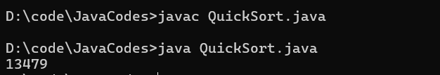

**Time Complexity: O(n logn)**

**Space Complexity: O(n)**

**6. Edit Distance**

Given two strings s1 and s2. Return the minimum number of operations required to convert s1 to s2.

The possible operations are permitted:

Insert a character at any position of the string.

Remove any character from the string.

Replace any character from the string with any other character.

Examples:

Input: s1 = "geek", s2 = "gesek"

Output: 1

Explanation: One operation is required, inserting 's' between two 'e'.

**Code:**

import java.util.*;

public class EditDistance{

public static int Distance(String s1, String s2) {

int n=s1.length();

int m=s2.length();

int[][] dp=new int[n+1][m+1];

for(int i=0;i<=n;i++){

for(int j=0;j<=m;j++){

dp[i][j]=-1;

}

}

return helper(s1,s2,n,m,dp);

}

public static int helper(String s1, String s2,int n, int m, int[][] dp){

if(m==0) return n;

if(n==0) return m;

if(dp[n][m]!=-1) return dp[n][m];

if(s1.charAt(n-1)==s2.charAt(m-1)){

dp[n][m]=helper(s1,s2,n-1,m-1,dp);

}

else{

int insert=helper(s1,s2,n,m-1,dp);

int delete=helper(s1,s2,n-1,m,dp);

int replace=helper(s1,s2,n-1,m-1,dp);

dp[n][m]=1+Math.min(insert,Math.min(delete,replace));

}

return dp[n][m];

}

public static void main(String[] ar){

String s1 = "GEEXSFRGEEKKS";

String s2 = "GEEKSFORGEEKS";

System.out.println(Distance(s1,s2));

}

**Output:**

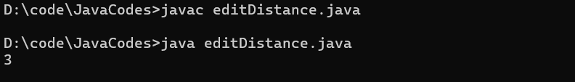

**Time Complexity: O(n*m)**

**Space Complexity: O(n*m)**