Round Robin vs. Shortest Remaining Time First (SRTF)

1. Introduction
This report documents the testing and evaluation of a Process Scheduler simulation tool that compares two CPU scheduling algorithms: Round Robin (RR) and Shortest Remaining Time First (SRTF). The application was built using Python with a Tkinter GUI and includes a Gantt chart visualizer, metrics table, and comparison analysis tab.
Three test scenarios were executed:
- Normal Case — a typical workload with varied burst times
- Behavior-Revealing Case — a workload designed to expose core behavioral differences between RR and SRTF
- Invalid Input Validation — tests to verify the system correctly rejects illegal inputs

2. Assumptions
- All burst times and arrival times are non-negative integers (burst > 0, arrival >= 0).
- Process IDs must be unique positive integers.
- Time quantum for Round Robin must be a positive integer (q > 0).
- At least two processes are required to run the simulation.
- SRTF is fully preemptive: a running process is preempted whenever a shorter job arrives.
- Round Robin uses a circular queue ordered by arrival time, then by process ID.
- All time values are discrete — floating-point inputs are rejected.

3. Test Scenarios

3.1 Normal Case
Purpose: Verify that both schedulers correctly handle a standard workload with 5 processes having varied burst and arrival times.

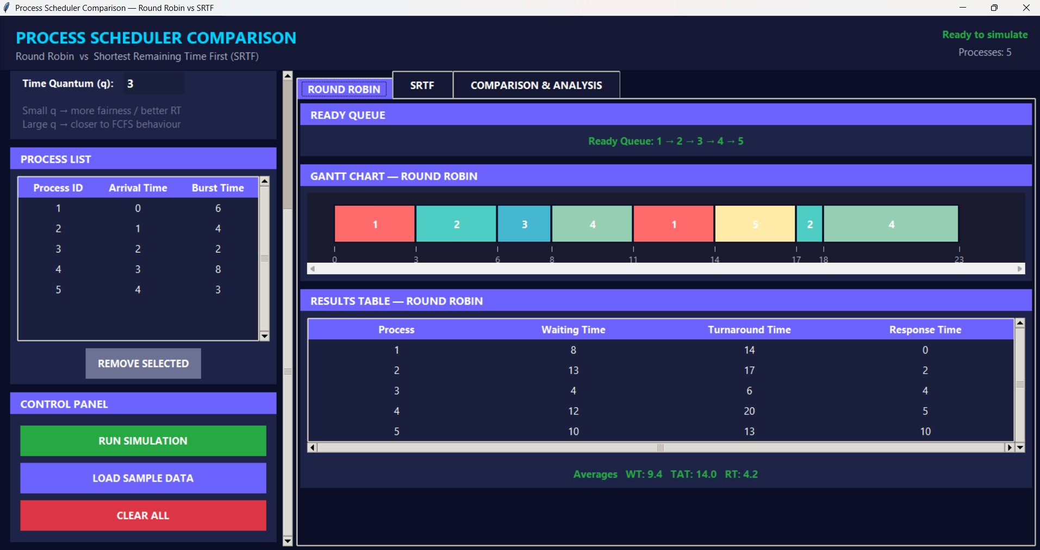
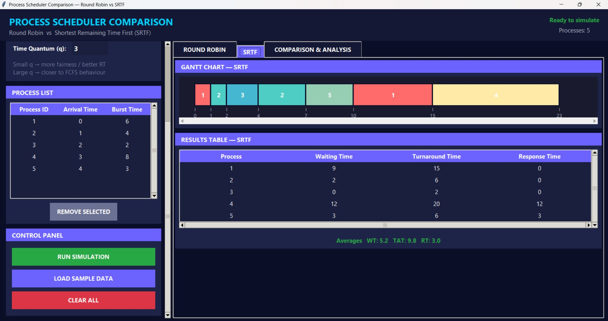
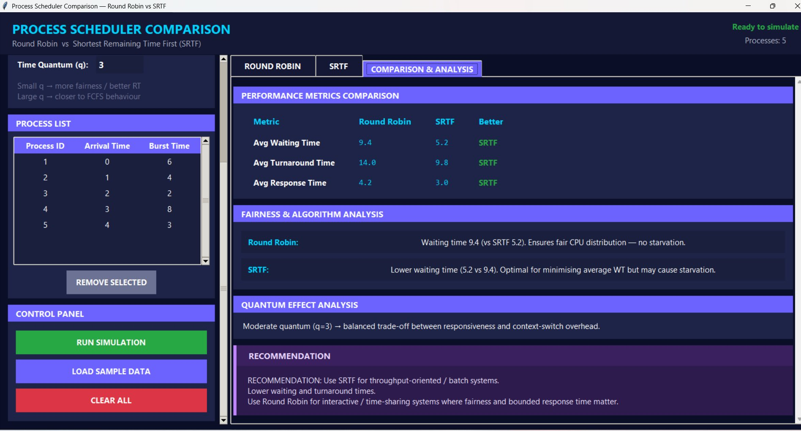

Results Summary:
Process | RR - WT | RR - TAT | RR - RT | SRTF - WT | SRTF - TAT | SRTF - RT
P1 | 8 | 14 | 0 | 9 | 15 | 0
P2 | 13 | 17 | 2 | 2 | 6 | 0
P3 | 4 | 6 | 4 | 0 | 2 | 0
P4 | 12 | 20 | 5 | 12 | 20 | 12
P5 | 10 | 13 | 10 | 3 | 6 | 3
Average | 9.4 | 14.0 | 4.2 | 5.2 | 9.8 | 3.0

Observations:
- Both schedulers completed all 5 processes correctly.
- SRTF achieved lower average WT (5.2 vs 9.4) and TAT (9.8 vs 14.0) by prioritizing shorter jobs.
- Round Robin ensured fair CPU distribution with no starvation.
- P3 (BT=2) finished with WT=0 under SRTF, as expected for the shortest job.

3.2 Behavior-Revealing Case
Purpose: Expose the core behavioral difference between RR and SRTF — specifically how SRTF preempts a long-running process to serve shorter jobs immediately, while RR enforces strict time-slice fairness.

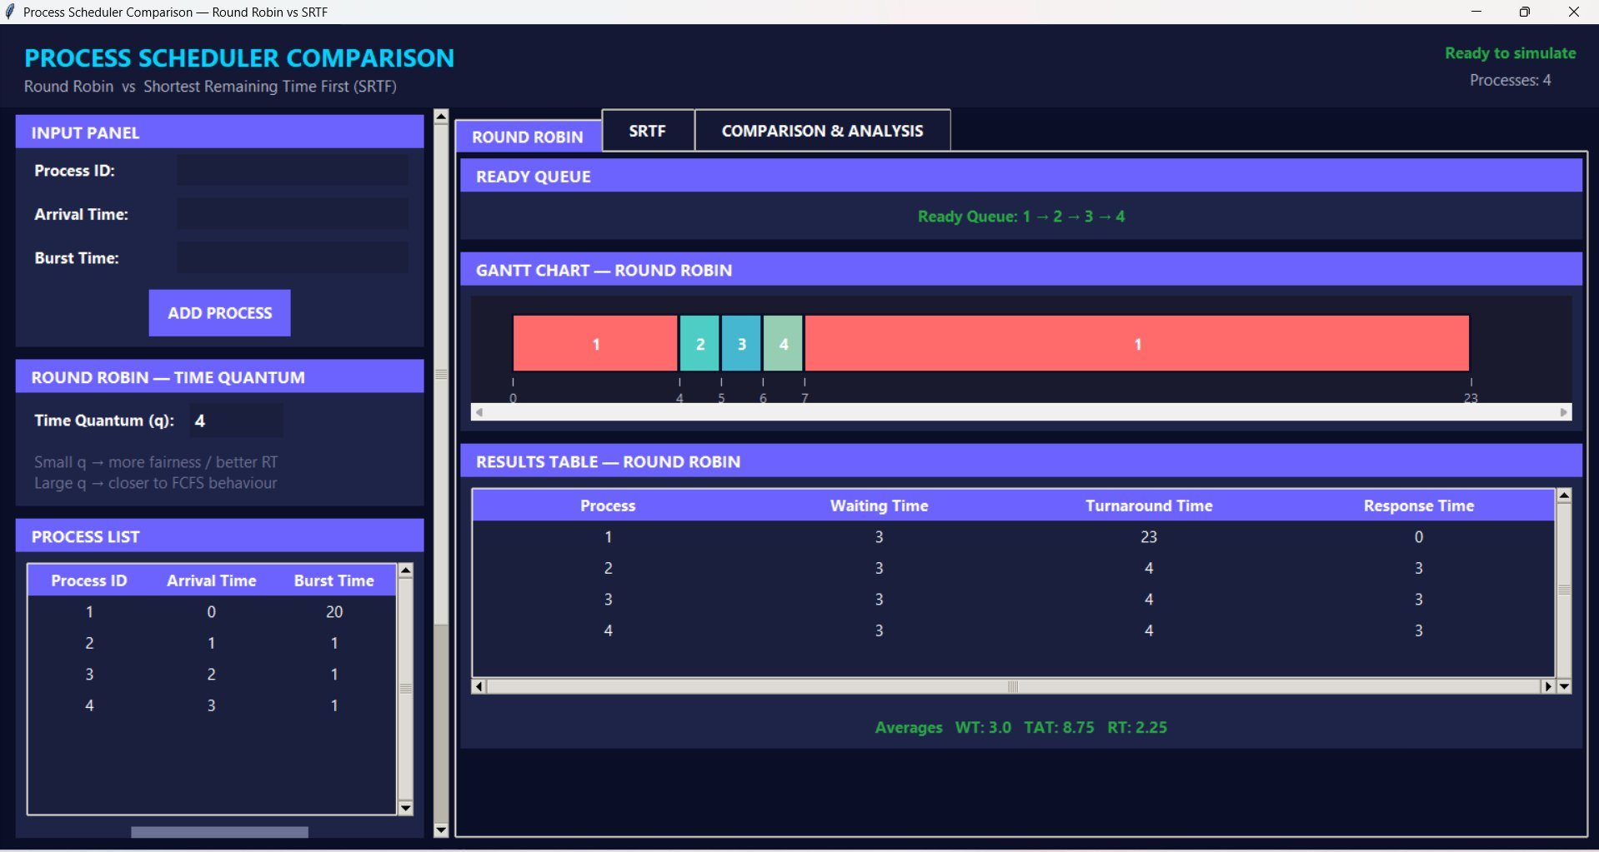
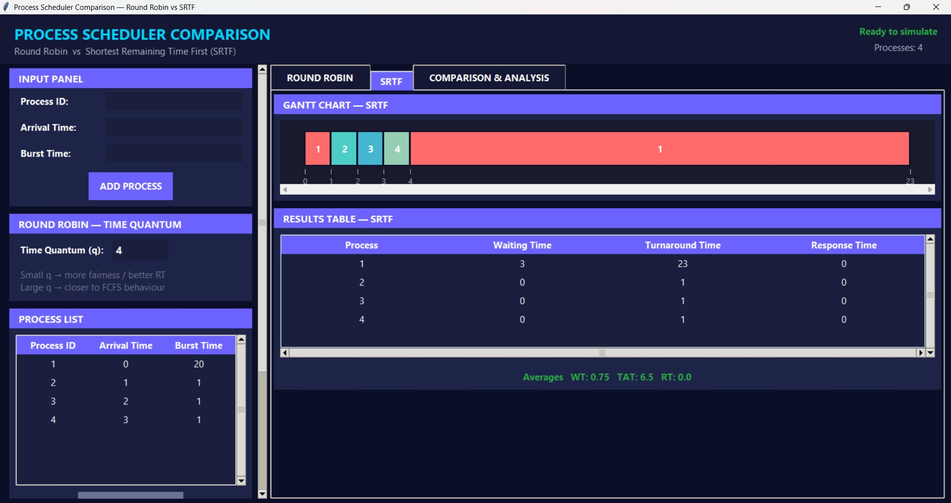
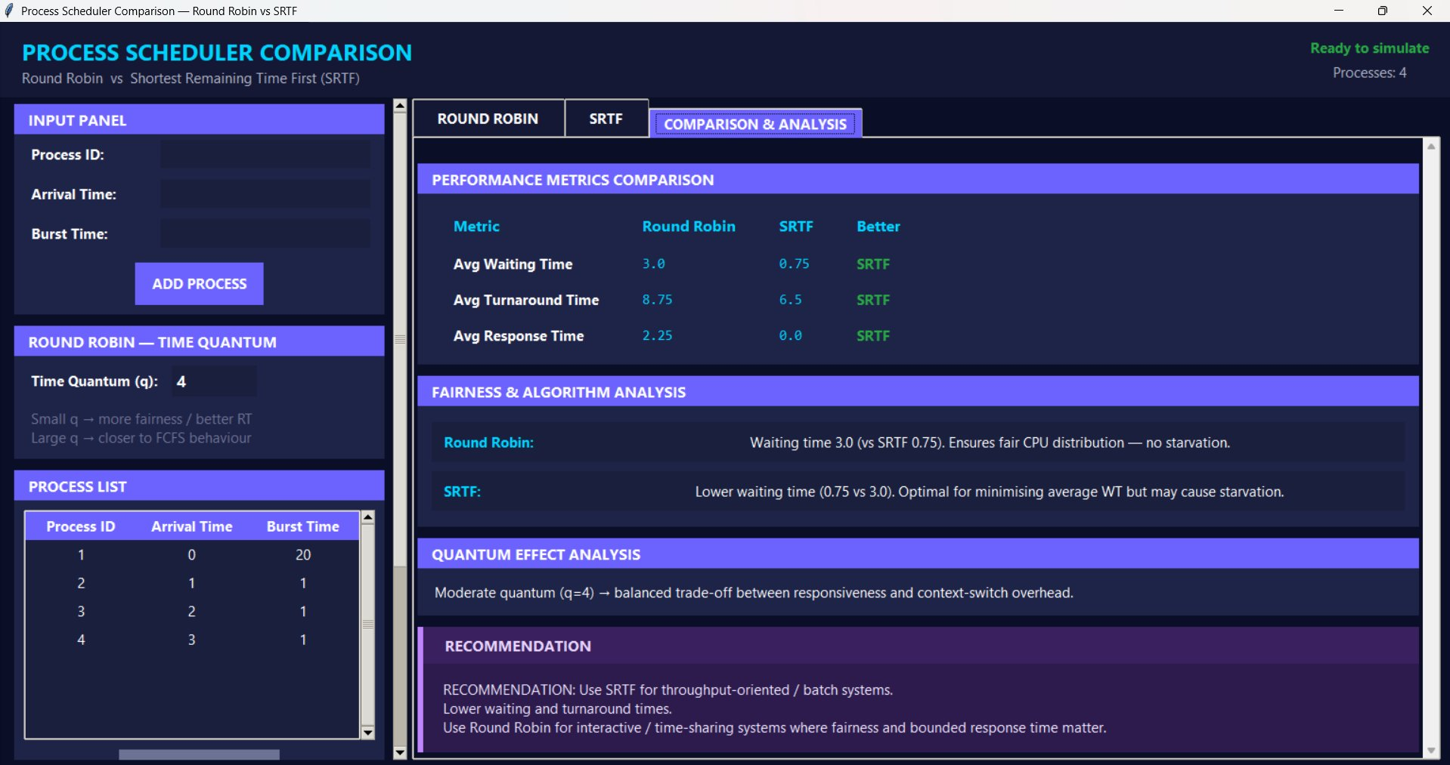

Results Summary:
Process | RR - WT | RR - TAT | RR - RT | SRTF - WT | SRTF - TAT | SRTF - RT
P1 | 3 | 23 | 0 | 3 | 23 | 0
P2 | 3 | 4 | 3 | 0 | 1 | 0
P3 | 3 | 4 | 3 | 0 | 1 | 0
P4 | 3 | 4 | 3 | 0 | 1 | 0
Average | 3.0 | 8.75 | 2.25 | 0.75 | 6.5 | 0.0

Key Behavioral Observations:
- SRTF immediately preempted P1 at t=1 when P2 arrived (remaining BT of P2=1 < P1=19). P2, P3, P4 all completed with WT=0 and RT=0.
- Round Robin gave P1 the full quantum (q=4) before switching. P2, P3, P4 each waited 3 units before their first CPU slot (RT=3).
- SRTF average response time = 0.0 vs RR = 2.25. This gap confirms SRTF is optimal for short-job-heavy workloads.
- Starvation risk: in SRTF, P1 (BT=20) could be indefinitely delayed if short jobs kept arriving — this is the known limitation of SRTF.

3.3 Invalid Input Validation
Purpose: Verify that the system correctly rejects all invalid inputs and displays appropriate error messages without crashing.

Test Cases & Error Messages:
Invalid Input | Field | Error Message
Burst Time = 0 | Burst Time | Burst time must be > 0.
Arrival Time = -1 | Arrival Time | Arrival time must be >= 0.
Process ID = "abv" | Process ID | Process ID must be a positive integer.
Duplicate PID | Process ID | Process '1' already exists. IDs must be unique.
Only 1 process + Run | Process count | Please add at least 2 processes.

Burst Time = 0
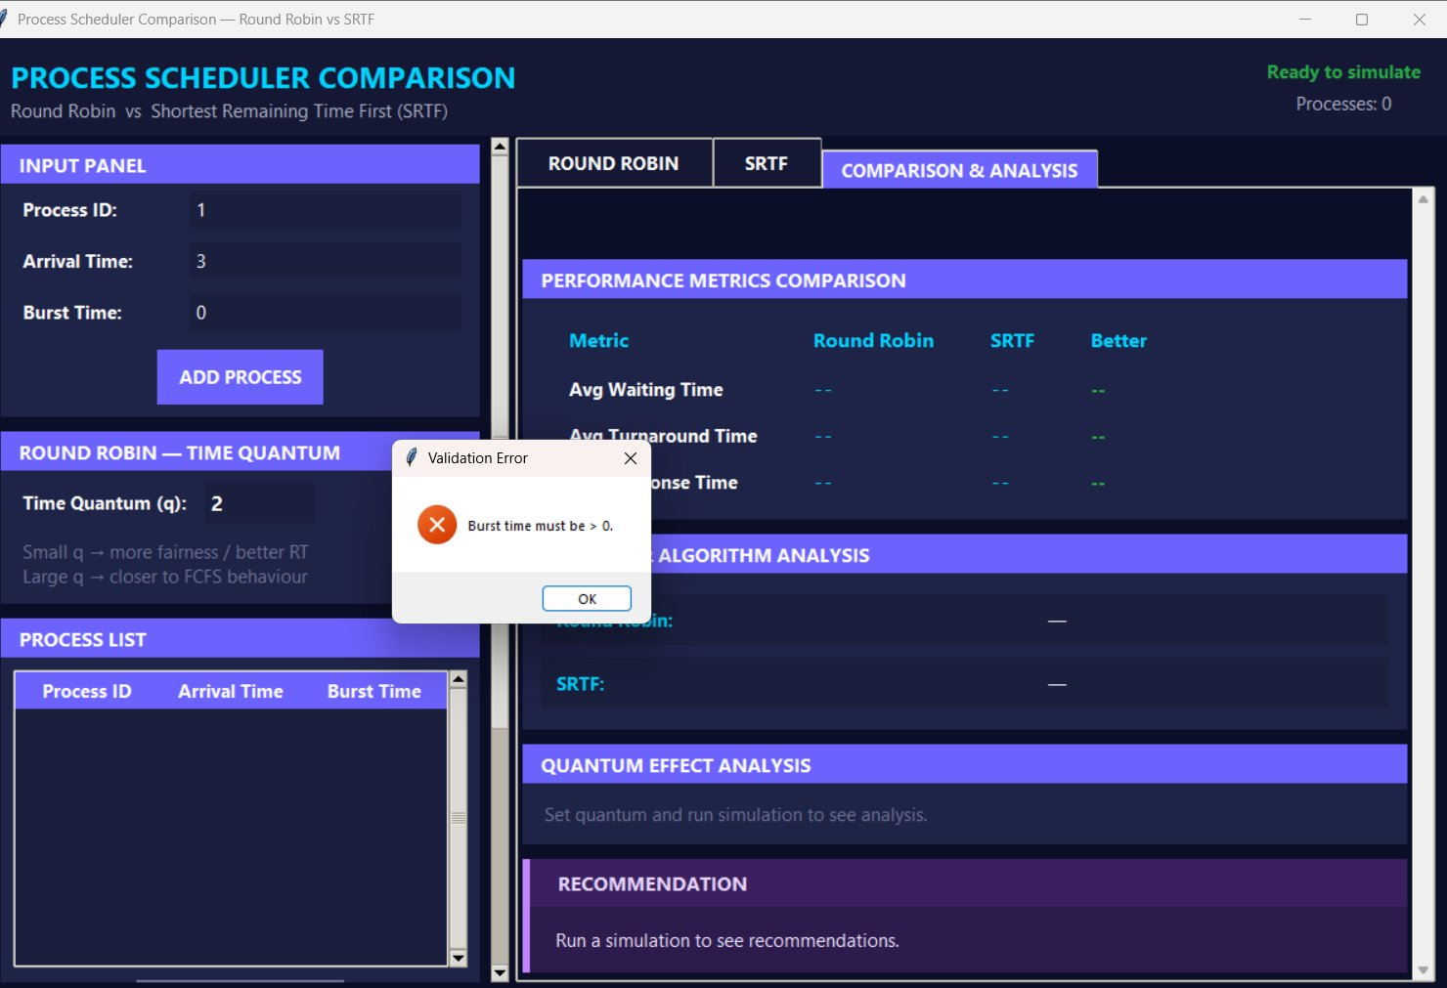

Arrival Time = -1
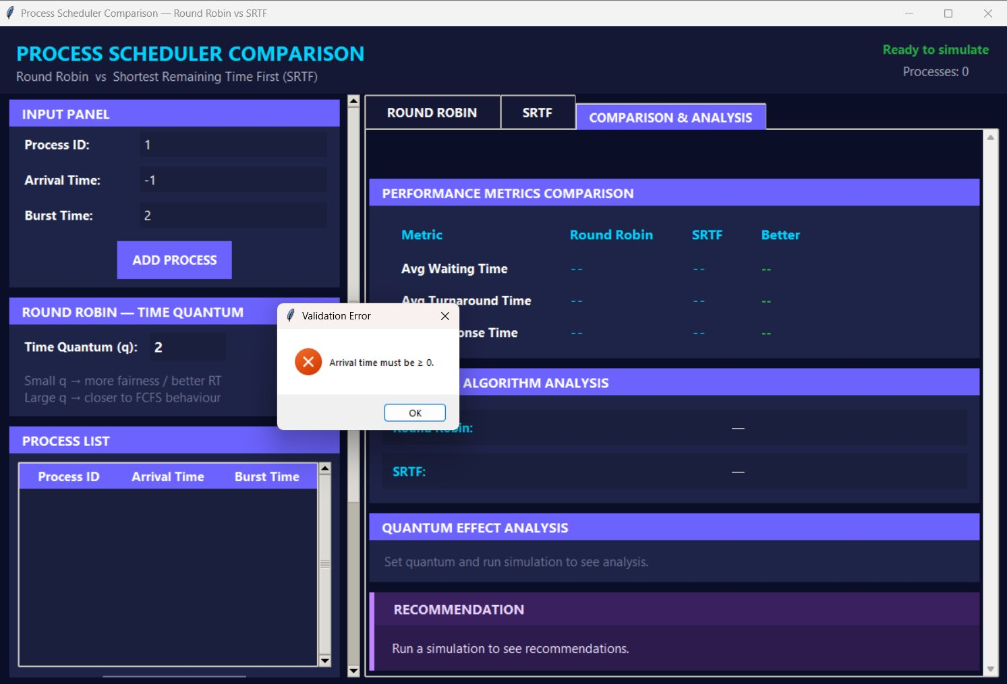

Non-integer Process ID ("abv")
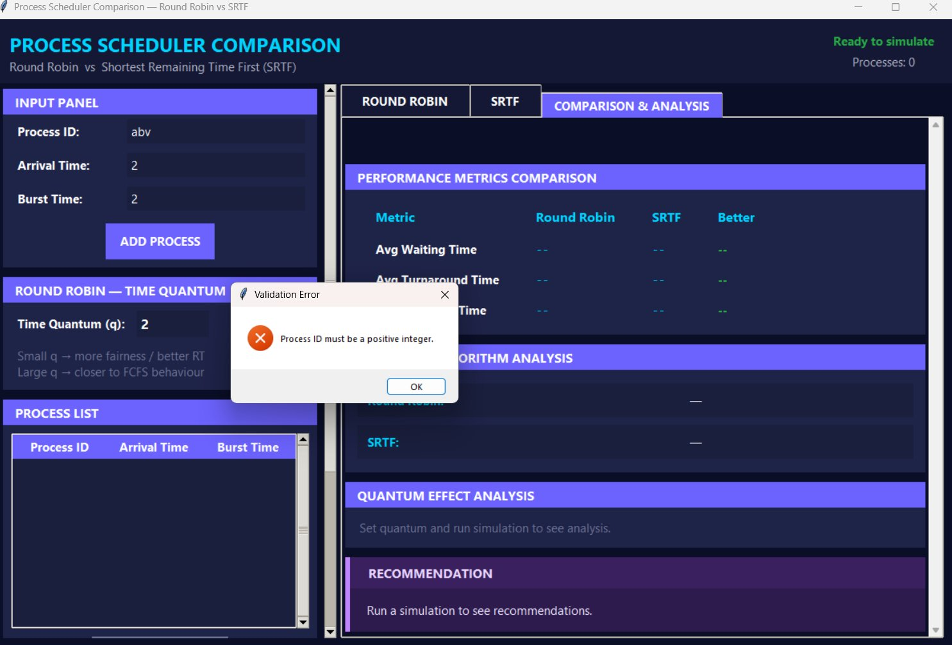

Only 1 Process (Run pressed)
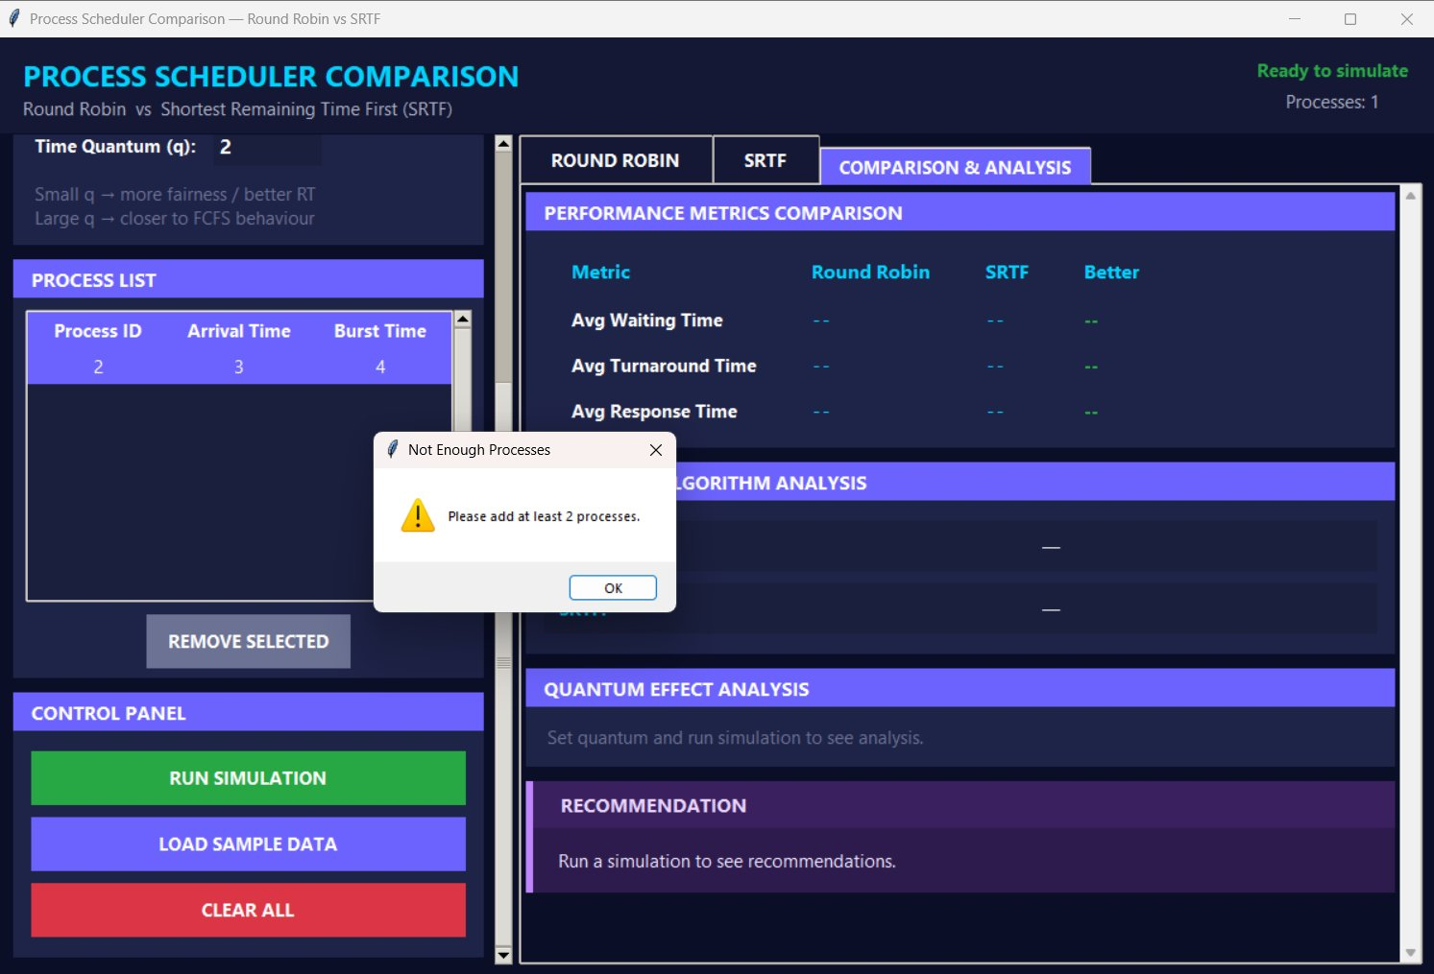

Duplicate Process ID
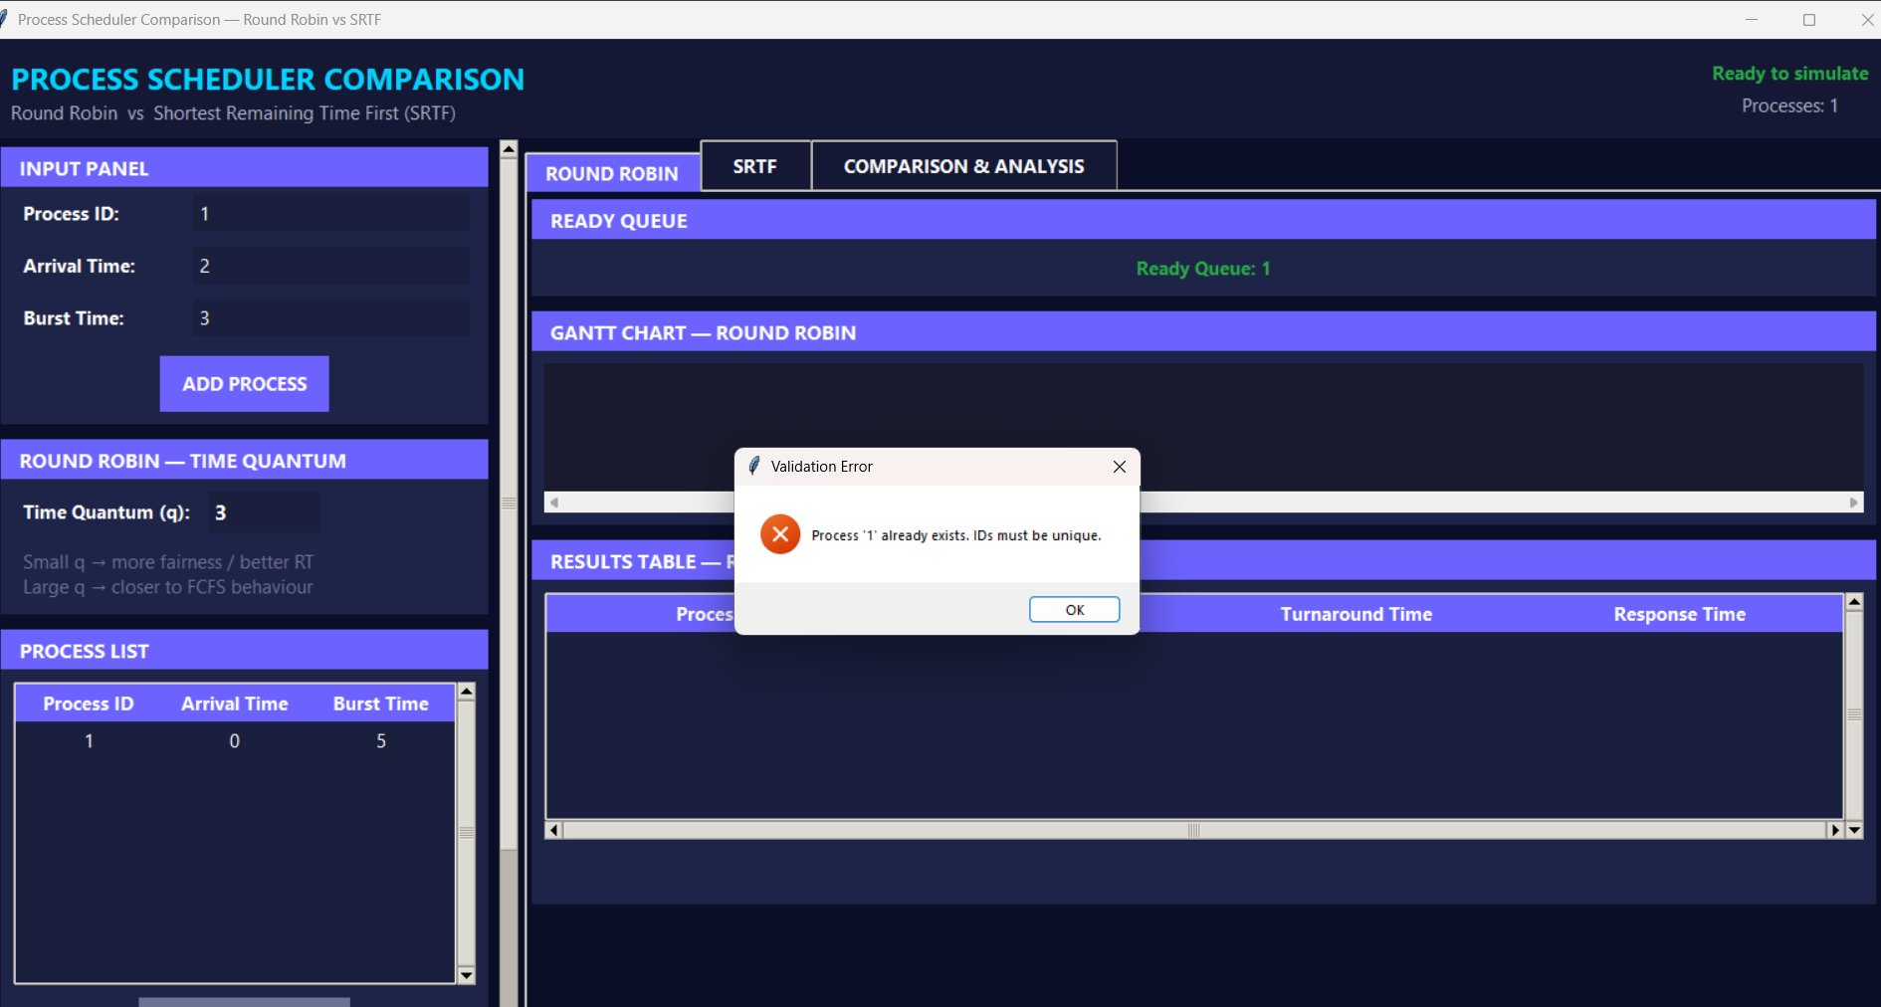

Observations:
- All 5 invalid input scenarios were correctly caught by the InputValidator module.
- Error dialogs appeared immediately with clear descriptive messages — no simulation was triggered.
- The application remained stable and responsive after each rejected input.
- Validation is enforced at the point of entry (Add Process / Run buttons) before any scheduler logic executes.

4. Limitations
- The scheduler does not support process priorities; all processes are treated equally within each algorithm.
- SRTF assumes burst times are known in advance, which is unrealistic in real operating systems.
- The simulation does not model I/O bursts or process blocking states.
- Context switch overhead is not accounted for in the time calculations.
- Very large quantum values (e.g., q=1000) are accepted without warning, causing RR to behave identically to FCFS.
- Floating-point burst/arrival times are rejected — only whole numbers are accepted.

5. Conclusions
The simulation correctly implements both Round Robin and SRTF scheduling algorithms. Testing confirmed the following technically correct conclusions:

5.1 Algorithm Performance
- SRTF consistently achieves lower average Waiting Time and Turnaround Time than Round Robin, as it is theoretically optimal for minimizing average waiting time among preemptive algorithms.
- Round Robin guarantees bounded response time for all processes, making it preferable for interactive and time-sharing systems.
- The quantum value q directly affects RR performance: small q improves responsiveness but increases context-switch frequency; large q approaches FCFS behavior.

5.2 Input Validation
- The application successfully enforces all input constraints, preventing invalid process configurations from causing incorrect results or runtime errors.
- Validation is applied at the boundary (GUI layer) before any scheduler logic executes.

5.3 Use Case Recommendation
- Use SRTF for batch/throughput-oriented systems where average waiting time is the primary concern and all burst times are known in advance.
- Use Round Robin for interactive/real-time systems where fairness, predictability, and starvation-free operation are required.

