COMP9415 Computer Graphics

Group Project
Member C: Lecun Xiao zID: z5661876

1. Game concept and gameplay
Voxel Arena is a 2.5D survival shooter. The player survives 180 seconds of active gameplay, defeats enemies and collects EXP to strengthen the arsenal. The core loop is move and aim, fire, collect drops, choose an upgrade or unlock, then survive increasingly mixed enemy waves.
Controls. Enter starts play; camera-relative WASD moves in eight directions with normalized diagonal speed. Mouse aiming projects onto the arena, and holding left mouse fires all owned weapons on independent cooldowns. Escape exits. Day/Night selection starts a fresh run; Restart and Play again keep the selected map. The local camera follows the player at fixed zoom.
Progression. EXP attracts within four blocks and collects within 0.65 blocks. The threshold is three times the current level. An English modal pauses simulation and the countdown, offering up to two random upgrades, evolutions or unlocks. A valid choice consumes EXP, increases level and heals to 5/5 HP. Unlocks add weapons; the team arsenal redesign is integrated and regression-tested.
Five HP, one-second contact-damage protection and a 180-second active countdown define survival. Zero HP triggers DEFEAT; surviving triggers VICTORY. Outcomes stop simulation and offer Play again. Restart clears progression, actors, drops, timers and effects and returns to the current map spawn.

Weapons and collision
The current base weapon values below describe the integrated team design. Bullet starts unlocked; Laser and Bomb can be offered on level-up. Swept projectile collision selects the nearest contact and prevents fast projectiles passing through thin cover; walls win equal-time ties.
Weapon | Base damage / interval / speed | Interaction
Bullet | 2 / 0.30 s / 5 blocks/s | Stops at the first enemy or wall; two base hits defeat a Zombie.
Laser | 1 / 0.48 s / 40 blocks/s | Base beam stops at the first enemy and reflects once. Evolution turns red and pierces until its first bounce, then stops at the next enemy.
Bomb | 2 / 1.20 s / 8 blocks/s | Full damage within 1.75 blocks on impact or expiry; no falloff or self-damage. Evolution leaves a three-second burning area dealing 2 damage per second.
Each weapon has four stat upgrades before evolution. Bullet evolves into a three-way shot; Laser gains its red piercing behaviour; Bomb becomes a firebomb. Blast damage uses enemy-centre distance on the arena plane and can reach enemies behind cover inside the radius.

Three enemy types and configuration differences
Enemy | HP | Contact damage | Speed (blocks/s) | EXP
Zombie | 4 | 1 | 3.3 | 1
Golem | 14 (3.5 × Zombie) | 2 | 2.1 | 2
Spider | 3.4 (0.85 × Zombie) | 1 | 4.5 | 1
Golems have larger bodies and visibly larger EXP drops; Spiders have smaller bodies and are faster than Zombies. Player speed remains 5 blocks/s. In Day, Golems begin entering after 60 seconds and ramp linearly to a Zombie:Golem generation mix of 70:30 by 120 seconds. In Night, Golems enter after 30 seconds and Spiders after 60, reaching Zombie:Golem:Spider weights of 60:15:25 by 120 seconds. These are spawn weights rather than quotas for living enemies; each new type ramps for 60 active seconds. Day does not automatically spawn Spiders. The layouts and lighting themselves are Member B's contribution.
Spawn batches are attempted every two seconds and grow by one enemy every 30 active seconds, subject to a map-wide cap of 24 living enemies across all types, including off-screen enemies. Automatic spawning requires six blocks of horizontal clearance between the player and enemy body edges. Every candidate/type retry keeps this rule; no safe entry means the spawn slot is skipped.
Body-aware pursuit combines grid routes, continuous block checks and substeps that preserve actor separation. Grid turns remain committed; temporary congestion waits before replanning. Open-world crowd detours advance or sidestep; static corner disconnection alone triggers cell-centre recovery. Fast Spiders can queue behind Golems until space opens.
INSERT MEMBER A IMAGE A1 HERE
Capture the three real models in the interactive training range. Targets stand beside cover and walls; use the normal camera and label Zombie, Golem and Spider.
Figure A1. Zombie, Golem and Spider models with their original skin textures.
INSERT MEMBER A IMAGE A2 HERE
Take the upgrade, VICTORY and DEFEAT screenshots in the normal Craft game and assemble a readable composite. The training range has no outcome/UI demo pages.
Figure A2. Paused progression and terminal states.

2. Voxel arena and lighting
Member B: describe the 32 × 32 × 32 world, Day/Night layouts, UVs, materials and lighting. Insert the full scene with diagnostics and a material/lighting comparison.

3. Character models, animation and integration
I built textured player and zombie models from a root transform and separate head, torso, arm, and leg transforms. The player swings its arms and legs while moving; zombies face their travel direction, swing their legs, and briefly raise both arms during attacks.
I integrated the models with ArenaScene, the angled orthographic follow camera, cursor aiming, gameplay UI, and diagnostics. The HUD shows run status and upgrade/result dialogs; diagnostics report positions, geometry counts, frame time, FPS, and framebuffer size.
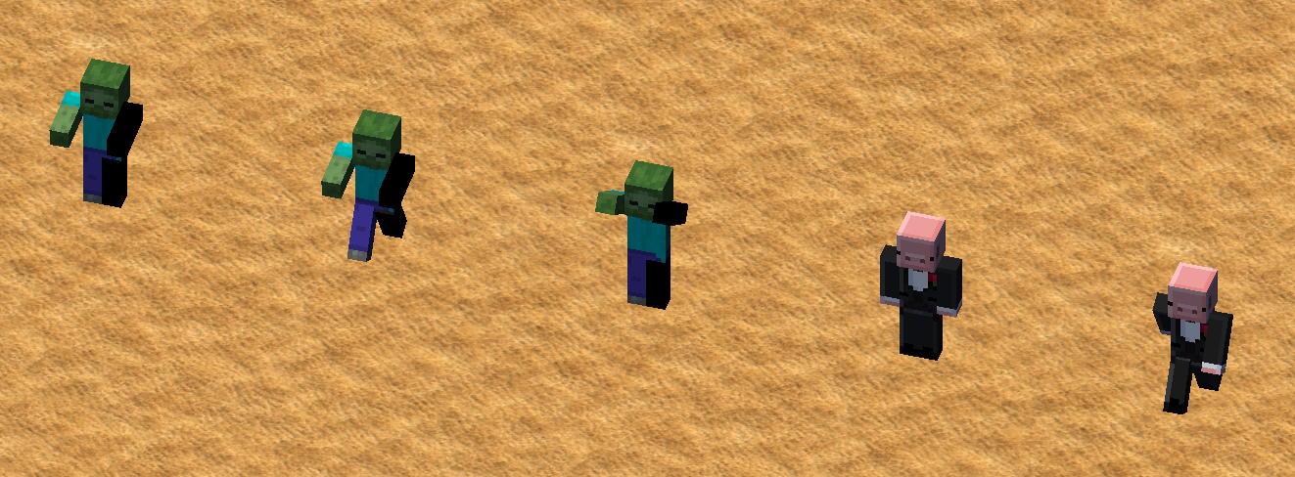
Figure 1. Player and zombie models across idle, walking and attack poses.
const auto makeLimbModel = [&feet](const glm::vec3& joint,
const glm::vec3& size, float angle) {
glm::mat4 model = glm::translate(feet, joint);
model = glm::rotate(model, angle, glm::vec3{1.0F, 0.0F, 0.0F});
model = glm::translate(model, glm::vec3{0.0F, -size.y * 0.5F, 0.0F});
return glm::scale(model, size);
};

4. Instancing and performance benchmark
The renderer batches each zombie body part across all live zombies. It builds one model matrix per zombie per part, uploads the matrix data once, then issues six instanced draws, one for each part.
For the paired 240-frame captures, the instanced version averaged 72.5 FPS (13.8000 ms/frame), compared with 59.3 FPS (16.8661 ms/frame) before batching. That is a 22.3% FPS increase in this run. Keep resolution, level, camera, lighting, effects, and actor snapshot fixed; warm up for 60 frames before measuring 240 frames.
glBufferData(GL_ARRAY_BUFFER,
static_cast<GLsizeiptr>(instanceModels.size() * sizeof(glm::mat4)),
instanceModels.data(), GL_STREAM_DRAW);
for (std::size_t part = 0; part < partModels.size(); ++part) {
const PlayerPartRange& range = zombiePartRanges_[part];
glDrawArraysInstanced(GL_TRIANGLES, range.firstVertex, range.vertexCount,
static_cast<GLsizei>(zombies.size()));
}
Before optimisation  Per-zombie draws  59.3 FPS | 16.8661 ms/frame | After optimisation  Instanced batches  72.5 FPS | 13.8000 ms/frame
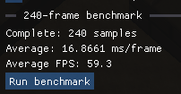 | 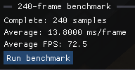
Figure 2. Side-by-side 240-sample captures; the after-optimization result is on the right.

5. Challenge tasks

5.1 Particles

5.1.1 Weapon-hit particles (Member A)
My particle work separates contact feedback from simulation. Gameplay publishes frame-local impacts containing position, weapon, launch-time evolution and blast radius. ParticleEffects consumes each event once and uses an independent visual random generator, so effects do not change enemy generation or weapon outcomes. Bullet contacts emit short warm debris; Laser contacts emit branching cyan electrical arcs, changing to red after evolution. Enemy and wall contacts use the same production event path.
Figure A3 pairs the actual rendered impacts with their implementation. Impact particles use a dedicated instanced pass with per-instance colour and fading alpha. The burst pool is bounded to 2,048 live segments; impacts plus ground fire are bounded to 4,096 visuals. These limits bound the presentation cost without changing damage or collision rules.
INSERT MEMBER A IMAGE A3 HERE
Use the training range: select Bullet or Laser, evolve as needed, enable auto-stop on impact (F), shoot and step with N. Add the actual ParticleEffects::emit code screenshot.
Figure A3. Actual Bullet and Laser impact styles alongside their production implementation.

5.1.2 Bomb blast and rotating ground fire (Member A)
Bomb detonation produces the accepted centre-outward particle burst. For an evolved Bomb, the original ten rising ground-fire cubes remain during its three-second burning area. I preserve their 0.035 half-extent, alternating orange/red colours, original radial distances and upward cycle. Only angular speed changes from 0.8 to 3.2 radians/second, so these original particles themselves rotate around the impact centre to form the vortex. The angular and rise calculations are shown with successive frames in Figure A4.
The evolved Bomb flight trail is the original four-spark effect, retained rather than redesigned. The game and report program call the same ArenaRenderer::drawFirebombTrail helper, with its original sizes, colours, positions and timing. Ground fire is generated by the production ParticleEffects::update and drawn through the original lit-proxy path. The report executable is a playable training range: targets are stationary and invulnerable and weapon levels can be freely set, while projectile collisions and particle rendering use the production game implementation.
Weak coloured local fill lights improve Night visibility without increasing distant brightness or changing Day lighting. At most eight effect lights are uploaded, with distance/lifetime falloff. All effects pause with gameplay and clear on restart or a level change. Burning damage stays in Gameplay (2 damage per second for three seconds); the orbiting visuals do not change that rule.
INSERT MEMBER A IMAGE A4 HERE
In the training range, select Bomb and press E to evolve. Shoot, then use SPACE/F and N to capture the outward burst and two ground-fire ages. Add the actual groundFire_ implementation.
Figure A4. Outward Bomb blast followed by the original rising ground fire in orbital motion, with implementation.

5.2 Ground normal mapping
Member B: describe the normal-map transform and show the material with mapping on/off.

5.3 BRDF terrain materials
The current terrain-lighting pass uses noise-textured sand and blue water, with an IOR 1.33 Fresnel reflection term and a Phong sun highlight.
vec3 specular = distribution * geometry * fresnel  / max(4.0 * nDotV * nDotL, 1e-5);  vec3 diffuseWeight = (vec3(1.0) - fresnel) * (1.0 - metallic);  vec3 diffuse = diffuseWeight * albedo / PI;  return diffuse + specular; | 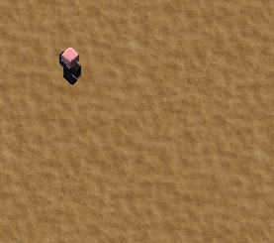  Terrain material and lighting result

6. Contributions and reflection

6.1 Member A
Member A: [insert name and zID]. My responsibility was core gameplay, game-state management and weapon-hit particles. I implemented the combat/progression/state foundations, EXP attraction, full healing on selection, reliable upgrade/outcome handling and full-scene restart, while reusing the supplied movement framework.
I added typed Zombie/Golem/Spider gameplay profiles, encounter ramps, original procedural Golem/Spider skins and the additional enemy-model integration, building on Member C's original player/Zombie model and rendering framework. I implemented body-aware spawning, collision and pursuit; adjusted the local camera and actor scale during playtesting; and fixed rare corner stalls and crowd-induced oscillation. I integrated and tested the team's multi-weapon progression rather than claiming its redesign as entirely my own.
For the particle challenge I added contact-event plumbing, Bullet/Laser/Bomb impact styles, bounded visual buffers, pause/reset integration and local Night effect lights. I preserved the existing evolved-Bomb trail and ground-fire appearance, changing the ground particles' orbital motion in response to feedback. B owns arena layouts/materials and primary lighting; C owns the original character/HUD framework and comparative rendering-performance work. My integration does not claim those results.
Selected delivery references: 5cb86d4 (core combat, EXP and game state); fdd6266 (C++17 initialization fix for MSVC); 91e0e6f (healing, actor proportions and local follow view); e32b7cf (typed encounters); e48f40e (impact effects and corner fix); 5af6183 (original firebomb appearance restored); 2a5ea68 (six-block spawn safety and stable crowd pursuit). Gameplay values use 2a5ea68; the accompanying report workspace shares the current production render functions.
Validation recorded for that version includes a full Linux C++17 build and 48 passing test cases: 17 gameplay, 17 enemy, eight particle, five world and one math. New side-by-side crowd and waiting/resuming queue regressions fail with the old navigation code and pass with the fix, while corner-recovery tests continue to pass. Production-shader Day/Night checks and a 240-frame software-render smoke were also recorded. These do not establish Windows/CSE acceptance or a hardware performance improvement; final platform and full-run balance checks remain team work.
Reflection. A collision-safe recovery is not automatically a stable chase behaviour: treating temporary neighbours like static walls caused routes to reset and actors to retreat repeatedly. Committing grid turns, separating crowd waiting from wall recovery, and testing the same scene before/after the fix made the cause measurable. I also learned to preserve existing visual designs exactly when feedback asks only for a motion change. Clear simulation/presentation boundaries made it possible to revise effects without changing combat rules, and to leave teammates stable snapshots and event interfaces.
INSERT MEMBER A IMAGE A5 HERE
Code screenshot(s): report/member-a/code/Figure5_committed_route.txt and Figure5_wait_and_recovery.txt. Open the cited original Gameplay.cpp lines in Visual Studio. Show committed waypoints, actor waiting and wall-only recovery.
Figure A5. Stable pursuit distinguishes temporary body blockage from wall recovery.

6.2 Member B
Member B: key features, commit references, and individual reflection.

6.3 Member C
I contributed the hierarchical characters and animations, gameplay UI and diagnostics, camera/aim integration, first-pass terrain lighting, and zombie instancing. I also implemented the BRDF challenge and prepared the benchmark comparison.

7. Build and benchmark reproduction
cmake -S . -B build  cmake --build build  ./build/Craft  Use the same actor snapshot for both modes; follow the warm-up and 240-frame measurement above. | 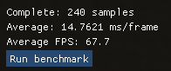  Separate 67.7 FPS capture;

8. Asset and code attribution
All members: list each external asset/library with its exact URL, licence or permission, project file, and use. Verify the skin and texture sources.

Member A attribution note
Member A reuses the supplied movement/camera scaffolding and the team's arena, original player/Zombie rendering, UI, arsenal progression and original firebomb prototype. Those components are credited to the starter/team owners above. The additional Golem/Spider skins are procedurally generated original assets (assets/textures/golem.png and spider.png), reproducible with tools/generate_enemy_skins.py; their design uses no downloaded enemy texture. Current source and evidence: docs/member-a-progress.md, member-a-monsters.md, member-a-effects.md and member-a-validation.md at commit 2a5ea68. The shared external-library/asset licence inventory still needs the other contributors' entries.

