# Software Project Management Plan for “Online HR

**Management System”**

## Introduction

An HRMS (Human Resource Management System) is a type of HR software that enables the management of several HR functions through the use of information technology.

An HRMS aims to improve the productivity and efficiency of the business through the automation of manual and repetitive tasks. This, in turn, also frees up the HR team’s time. The additional bandwidth can then be used to address more strategic, business- critical tasks in the human resource management function.

## Project Overview

Human Resource Management (HRM, or simply HR) is a function in every organization which is designed to increase employee performance in aligning with employer's strategic objectives. Primarily focused on how people are managed within organizations, human resource management is driven by systems and policies. HR involves the following sub-functions and an HRMS helps automate and streamline them.

## Project Deliverables

|  |  |
| --- | --- |
| 1. Preliminary Project Plan | 01.06.2022 |
| 2. Requirements Specification | 14.07.2022 |
| 3. Analysis [Object model, Dynamic model, and User interface] | 26.07.2022 |
| 4. Architecture Specification | 15.08.2022 |
| 5. Component/Object Specification | 1.09.2022 |

6. Source Code 2.09.2022 - 11.10.2022

7. Test Plan 12.10.2022 – 14.12.2022

8. Final Product Demo 14.10.2022 - 15.10.2022

* 1. **Evolution of this document**

This document will be updated as the project progresses. Updates should be expected in the following sections:

* + 1. ***References*** - updated as necessary.
    2. ***Definitions, acronyms, and abbreviations*** - updated as necessary.
    3. ***Organizational Structure*** will be updated as the team leaders are assigned for each phase.
    4. ***Technical Process -*** this section will be revised appropriately as the requirements and design decisions become clearer.
    5. ***Schedule –*** as the project progresses, the schedule will be updated accordingly.

## Revision History

|  |  |  |  |
| --- | --- | --- | --- |
| **Revision** | **Date** | **Updated By** | **Update Comments** |
| 0.2 | 15.10.2022 | Somay Das | Second Draft |

* 1. **References**
* IEEE Std 830-1998: IEEE Recommended Practice for Software Requirements Specifications
* <http://www.ibm.com/developerworks/rational/library/769.html>
* <http://www.cs.iusb.edu/thesis/SLingareddy_thesis.pdf>
* <http://en.wikipedia.org/wiki/Eclipse_(software)>
* <http://www.eclipse.org/org/>

## Definitions, Acronyms, and Abbreviations

* SRS: Software Requirements Specification
* HRMS: Human Resource Management System
* HR: Human Resource
* DBMS :Database Management System

## Project Organization

* 1. **Process Model**

The process used for this project will be iterative waterfall model since all the major requirements has already been formulated in the SRS before design and a rough idea of the product is already known.Since iterative waterfall model has feedback loops from all stages of development, it is efficient to rectify issues in previous stages which might crop up later in development cycle. Since it is well organized less time is consumed on documenting and the team can spend more time on development and designing.

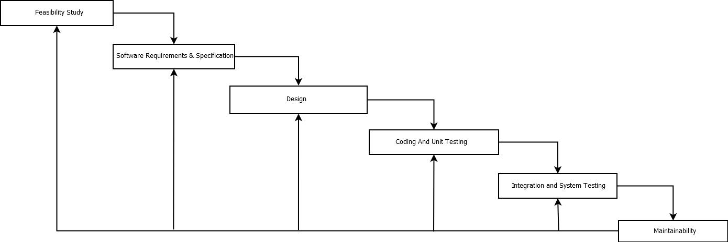

## Organizational Structure

Team Members –

* + 1. Somay Das

|  |  |  |
| --- | --- | --- |
| **Name** | **Organization/ Position** | **Contact Information** |
| Somay Das | Project  Manager | [somaydas02@gmail.com](mailto:somaydas02@gmail.com) 9748537451 |

|  |  |  |  |
| --- | --- | --- | --- |
| **Days** | **Deliverable** | **Team Leader** | **Deliverable Description** |
|  |  |  |  |
| 12 | 1 | Somay Das | Project Plan |
| 19 | 2 | Requirements Specification |
| 8 | 3 | Analysis |
| 28 | 4 | Architecture Specification |
| 14 | 5 | Component/Object Specification |
| 28 | 6 | Source Code |
| 47 | 7 | Test Plan |
| 108 | 8 | Final Deliverable |

## Organizational Boundaries and Interfaces

Team leaders throughout each development of the phases will be responsible for coordinating team meetings, updates, communications, and team deliverables.

## Project Responsibilities

For the most vital responsibilities per phase of each team members, please refer to segment 2.2. Ultimately the project team is responsible for the successful delivery of the product. The team member tasks per deliverable according to expertise and the phases are as given below:

1. Project Plan – Whole Team
2. Requirements Specification – TBD
3. Analysis – TBD
4. Architecture Specification – TBD
5. Component/Object Specification – TBD
6. Source Code – TBD
7. Test Plan – TBD
8. Final Deliverable – Entire Team

|  |  |  |
| --- | --- | --- |
| **Name** | **Organization/ Position** | **Role/Responsibilities** |
| Somay Das | HRMS Manager | Managing and leading the project team.  Developing and maintaining a detailed project plan.  Monitoring project progress and performance. Managing project evaluation and dissemination activities.  Develop corrective actions  when necessary. |
| HRMS  Analyst | Prepare reports on project plans, status, progress, risks, deadlines and resource requirements.  Develop and perform work flow analysis to find out the difficulties in reaching goals. Provide project cost estimates. |
|  | HRMS  Designer | Propose effective design solutions to meet project goals.  Prepare design layouts and sketches according to company design standards.  Keeping of records and files. |

1. Analysis – TBD

|  |  |  |
| --- | --- | --- |
| Somay Das | HRMS Staff | Documentation of daily activities.  Making kick-off meeting reports.  In-charge of materials needed for team building activities. |

# Managerial Process

* 1. **Management Objectives and Priorities**

The management objective is to deliver the product in time and of high quality. The PM and QAM work together to achieve this by respectively checking that progress is made as planned and monitoring the quality of the product at various stages.

# Assumptions, Dependencies, and Constraints

In this project plan, a number of factors are taken into account. The following list shows the way milestones on various project phases have been scheduled:

* + - The team budget of 1 persons x 1088 hours = 1088 hours
    - The project deadline of December 15th.
    - The final presentation is on December 1th.
    - The peer evaluation deadline is on December 30th.
    - Other days the weekends holiday is closed (August 15, August 19, September 20, October 2-4, October 25, November 10).

NOTE: Due to the deadline of 1st December 2022, running out of time will have its reflection on the product. By assigning a priority to every user requirement, a selection can be made of user requirements that may be dropped out if time runs out.

# Risk Management

This section mentions any potential risks for the project. Also, schedules or methods are defined to prevent or to reduce the risks as below:

1. Technology risk
2. People risk
3. Financial risk
4. Market Risk

The following are the possible risks to be encountered during the development of the project and how they can be prevented.

* 1. Miscommunication

*Prevention*: Team members should not hesitate to ask and

re ask questions if things are unclear. Team members should have a written copy of the tasks assigned to them every meeting. *Correction*: When it becomes clear that miscommunication is causing problems, the team members should gather in a meeting to clear things up.

* 1. Time shortage

*Prevention*: Care is taken to plan enough spare time. *Correction*: When tasks fail to be finished in time or when they are finished earlier than planned the project planning is adjusted

* 1. Illness or absence of team members

*Prevention*: Team members should warn their team leader or the PM timely before a planned period of absence.

*Correction*: Work can be taken over quickly by someone else or be distributed among the team members if a person gets ill.

Monitoring and Controlling Mechanisms:

The monitoring of progress is done by the PM using the following means: Project Kick-off Meetings

The project group meetings take place within the class room or through chat. These meetings are meant to inform each other of the progress made on various tasks and to assign new tasks.

Progress Report

Progress report is done every Friday. This is meant to inform and show the progress in the development of the project and how things are going.

# Monitoring and Controlling Mechanisms

The monitoring of progress is done by the PM using the following means:

1. Weekly project status meetings
2. Shared document repository
3. Project tracking by MS project plan
4. Tracking utilizing baselines in MS project

# Technical Process

* + 1. **Methods, Tools, and Techniques**

The project will be implemented utilizing V-model methodology, and tools such as Dreamweaver, Microsoft Project, Star UML, Java, MySQL, QTP, and Load Runner will be utilized. The risks for each category are listed to complete the project successfully. For each risk, a description, a probability of occurrence, the associated action and the impact of the risk are given.

# Software Documentation

Documentation such as Project Charter, Business Requirement Document, Functional Specification document, Cost Benefit Analysis, Technical Specification document, Detail Design Document, Test Plan, Implementation Plan, Detailed Project Report, and Benefit Realization document.

# Project Support Functions

All project support documents will be completed in applicable phases.

# Work Elements, Schedule, and Budget

* + 1. The project is accounted for project resources, technologies and tools required to whole analysis, implementation, and test of the application.
    2. The project lead will be rotated for each phase within 5 team members.
    3. The document for all phases will be revised in subsequent phases if applicable.

Budget and Resource Allocation

|  |  |
| --- | --- |
| Salary | 300,000.00 |
| Office Operations/Supplies/Equipment/Consumables | 56,000.00 |
| Miscellaneous | 25,000.00 |
| Total | Rs. 3,81,000.00 |

|  |  |
| --- | --- |
| Schedule |  |

