This dataset contains 4 years of electrical consumption, generation, pricing data for Spain. In this data analysis, a comparison between different energy sources including fossil fuel-based generation units, renewable generation units, and thermal power sources are presented. First in Fig.1, all data related to fossil fuel-based generation units are visualized. As shown, fossil gas fuel has more contribution in generation electrical energy, and it is around 197MW (Mega Watt). While the fossil oil fuel based has the lowest in generation electric energy among them. It is about 10MW. Also, this chart shows the fossil hard coal has portion around 149MW.
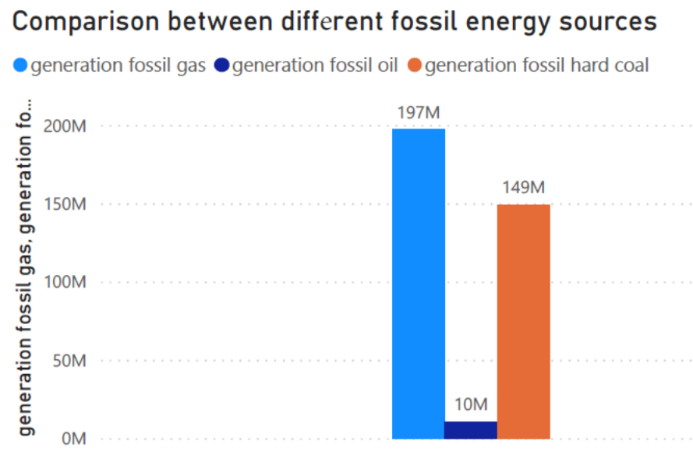
Fig.1
Moreover, in figure 2 a comparison between different thermal generation resources including energy generation from fossil fuel, nuclear power, and waste generation are given. As illustrated the generation portion of fossil fuel is higher than two other sources. As shown, nuclear power also contributes significantly to energy generation among different thermal generation units.
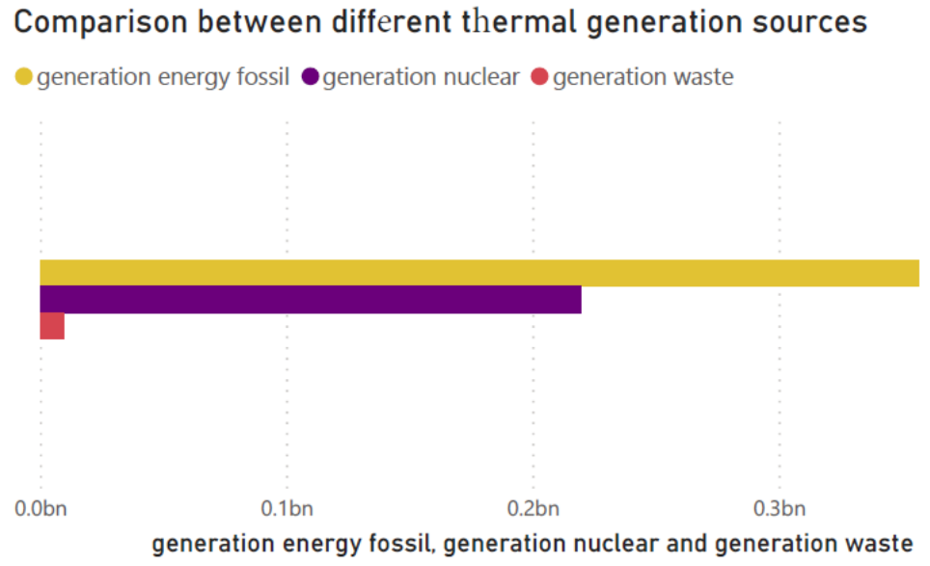
Fig.2

In order to understand how much energy is generated by renewable energy resources, in figure3 a comparison between energy generation from biomass, solar, and onshore wind is presented.
This pie chart shows around 75% of total energy from renewable resources in Spain are belong to onshore wind. It means that the potential of utilization of wind power is higher than solar and biomass resources. Moreover, it shows that there is low investment in biomass energy units.

According to obtained data analysis in figure4, it shows that only 26.41% of total energy generation in Spain comes from renewable energy sources. While energy generation of fossil fuel is higher portion compare to nuclear power and renewable energy. It means that there should be more investment in renewable energy sector to satisfy global energy requirement and provide more clean energy. Therefore, according to figures 3&4 in order to reduce dependency to fossil fuel energy, there should be more investment on onshore wind and solar energy sources.
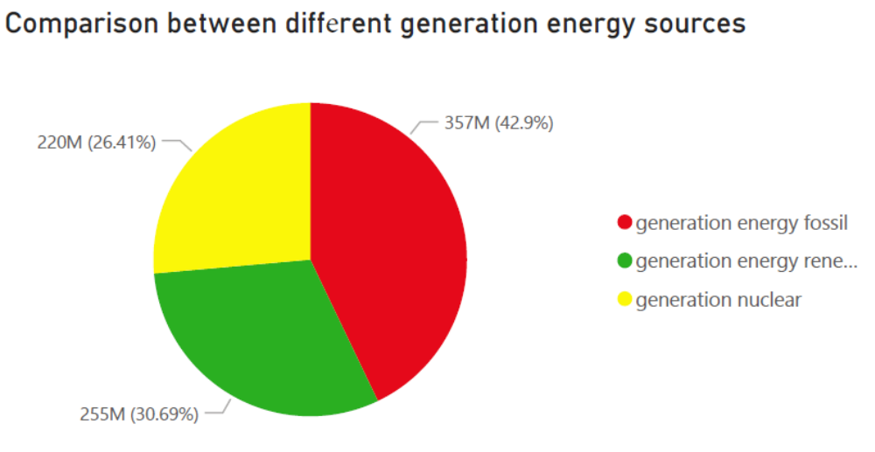

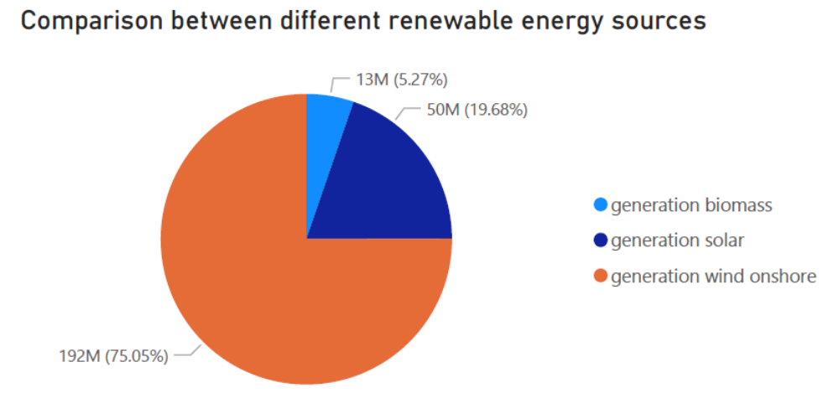
Fig.4

In figure5 the electrical load growth for years from 2015 -2018 presented. It shows that electrical load consumption is increasing every year. Moreover, it illustrates forecasting method predicts total load accurately and as shown from 2017 the result is more satisfactory.

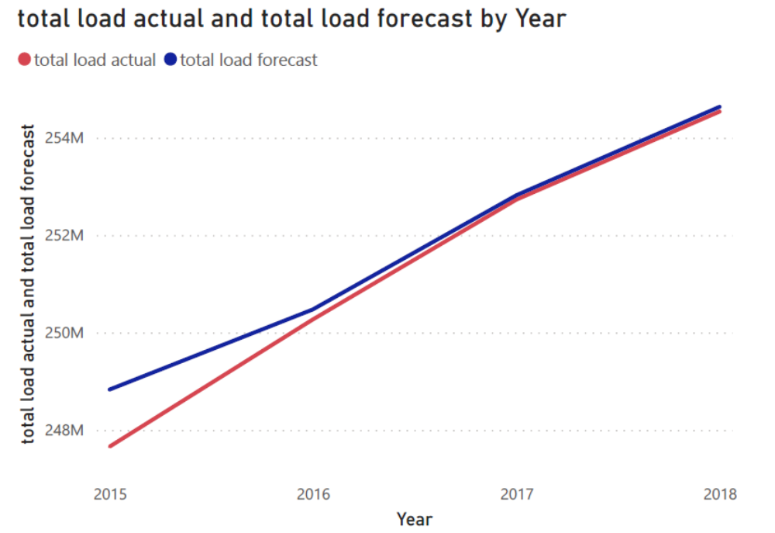
Fig.5

The same analysis is given for energy price forecasting in figure6. As presented, actual energy price changes differently during these four years. First, between 2015-2016 energy price is decreasing. The reason behind of this could be observable in figure7 which shows the demand for energy generation from fossil fuel is also decreasing. Therefore, the energy price decreases.
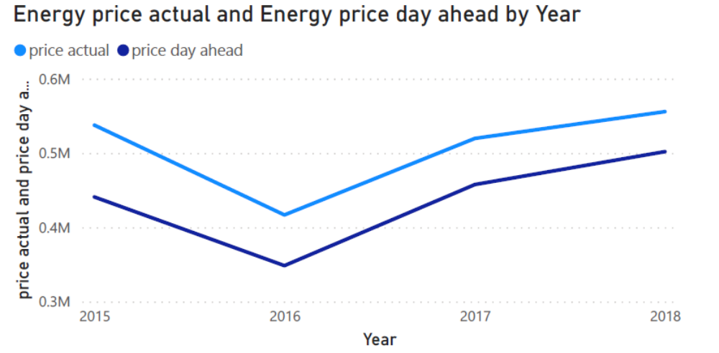
Fig.6

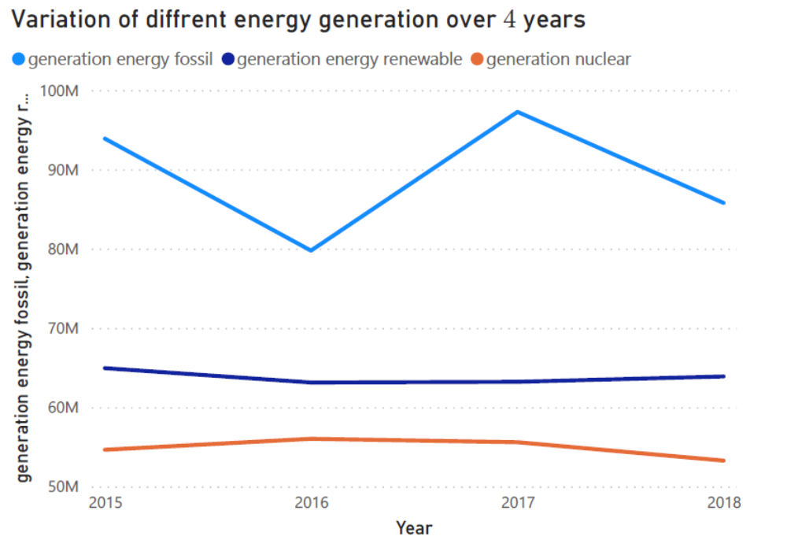
Fig.7
Then by comparing figure 5,6&7, it is observed by increasing the actual load, the demand for energy generation from fossil fuel increase and the energy price goes up consequently. Moreover, from figure 6 it is clear that the forecasting method is not able to predict the energy price accurately.

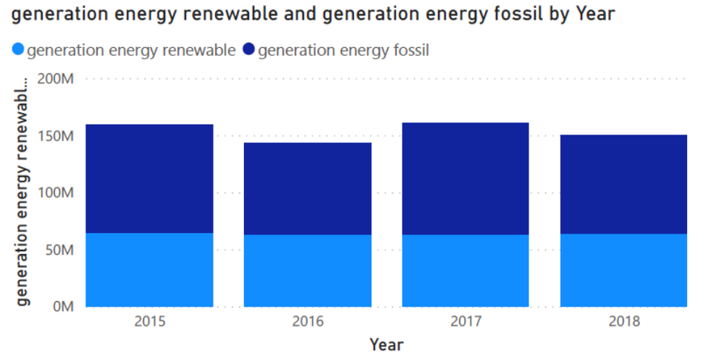
Fig.8
From figure 7 & 8 it is obtained the energy generation from renewable and nuclear resources almost constant during four years and the power plants based on fossil fuel compensate the required energy demand.

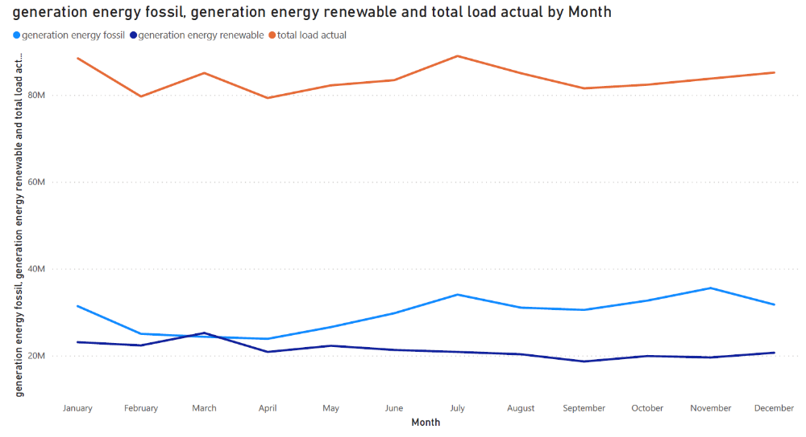
Fig.9
To investigate the monthly energy analysis, in figure 9, energy generation data information from fossil fuel and renewable energy are given. As illustrated, only between February till April, the generated energy from renewable resources are higher than fossil fuel power plants. The reason for that the wind speed in these months are high and onshore wind power plant can generate more power.

