AN INTERNSHIP REPORT
OF
MARTECHADDA STARTUP INTERNSHIP PROGRAM 2026
Product Engineering Internship
Submitted
To
School of Computer Science and Engineering
IILM University, Greater Noida, U.P.

In partial fulfilment of the requirement of degree of
B-Tech (CSE)
By
Roll Number of Student:- 2410030914
Name of Student: SOM BAJPAI
Batch: 2024-28
Internship Duration: 6 Weeks
Mode: Remote
Date of Certificate Issue: 05 August 2026

CANDIDATE'S DECLARATION
I, SOM BAJPAI, do hereby declare that the internship report titled “MarTechAdda Startup Internship Program 2026 – Product Engineering Internship” has been completed by me to fulfil the requirement for the award of the degree of Bachelor of Technology in Computer Science and Engineering.
I affirm that this report presents the learning, responsibilities, and internship scope reflected in the internship certificate issued by MarTechAdda. The report has been prepared for academic submission and has not been submitted to any other institute for any degree/diploma requirement.
I further declare that the work described in this report is based on my internship experience and the information stated on the internship certificate. I shall be solely responsible for any kind of copyright violation in this regard.

Student Name: SOM BAJPAI
Roll No.: 2410030914

ACKNOWLEDGEMENT
I take this opportunity to express my sincere gratitude to everyone who supported me during my internship. I am thankful for the guidance, constructive feedback, and encouragement that helped me learn and contribute throughout the internship period.
I would like to thank MarTechAdda for providing me the opportunity to participate in the MarTechAdda Startup Internship Program 2026 as a Product Engineering Intern. The internship provided exposure to product development, front-end engineering, feature implementation, UI/UX improvements, and software development initiatives.
I am also grateful to my institute, IILM University, Greater Noida, and the faculty of the School of Computer Science and Engineering for their continuous academic support and encouragement.
Finally, I express my gratitude to my parents and everyone who supported me during this learning experience.

Student Name: SOM BAJPAI
Roll No.: 2410030914

TABLE OF CONTENTS
1. Candidate's Declaration i
2. Acknowledgement ii
3. Internship Completion Certificate 1
4. Project Description 2
4.1 Introduction 2
4.2 Organization Profile 3
4.3 Internship Role and Responsibilities 4
4.4 Problem Statement 4
4.5 Project Objectives 5
4.6 Scope of the Internship 5
4.7 Technologies and Tools Used 6
4.8 Product Engineering Workflow 6
4.9 Methodology 7
4.10 Learning Outcomes 8
4.11 Certificate and Completion Details 8
5. Bibliography/References 9

3. INTERNSHIP COMPLETION CERTIFICATE
The internship certificate issued by MarTechAdda confirms that Som Bajpai successfully completed a 6-week internship as a Product Engineering Intern under the MarTechAdda Startup Internship Program 2026. The internship was conducted remotely, and the certificate records contributions to product development, front-end engineering, feature implementation, UI/UX improvements, and software development initiatives.
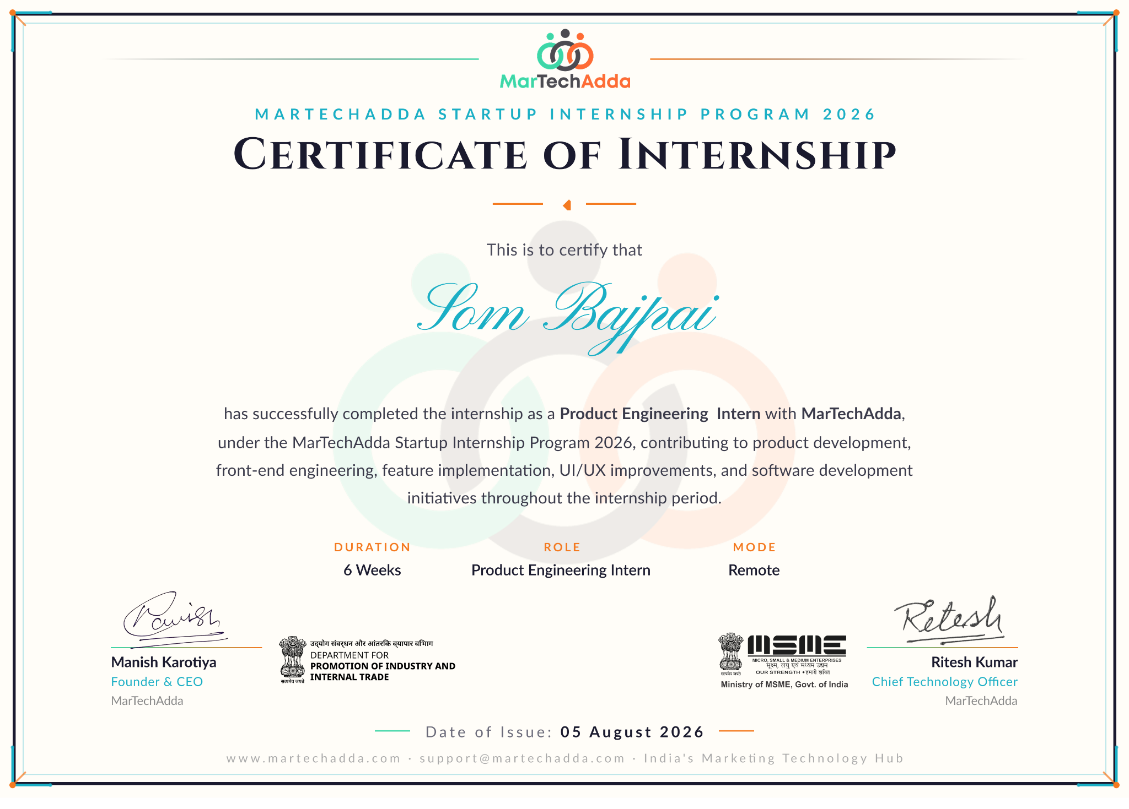

4. PROJECT DESCRIPTION
4.1 Introduction
This report presents an account of the 6-week Product Engineering Internship completed under the MarTechAdda Startup Internship Program 2026. According to the internship certificate, the role was Product Engineering Intern and the mode of work was remote.
The internship focused on practical product engineering activities, including product development, front-end engineering, feature implementation, UI/UX improvements, and software development initiatives. The experience provided an opportunity to understand how software features are planned, implemented, improved, and integrated into a product-oriented development environment.
The internship certificate was issued on 05 August 2026 and records successful completion of the internship.
4.2 Organization Profile
MarTechAdda is identified on the internship certificate as the organization conducting the MarTechAdda Startup Internship Program 2026. The certificate also identifies Manish Karotiya as Founder & CEO and Ritesh Kumar as Chief Technology Officer.
The internship was structured around practical product engineering responsibilities. Based on the certificate, the organization provided exposure to product development, front-end engineering, feature implementation, UI/UX improvements, and software development initiatives.

4.3 Internship Role and Responsibilities
The internship role was Product Engineering Intern. The certificate specifically mentions the following areas of contribution:
- Product development activities.
- Front-end engineering.
- Feature implementation.
- UI/UX improvements.
- Software development initiatives.
4.4 Problem Statement
Modern software products require continuous development and improvement to provide useful, usable, and reliable experiences to users. A key challenge in product engineering is converting product requirements into working features while maintaining a clear user interface and consistent software quality.
The internship addressed this practical challenge by providing exposure to product development and front-end engineering tasks, together with feature implementation and UI/UX improvement activities. The work environment helped connect software development concepts with product-oriented implementation.
4.5 Project Objectives
- Understand the practical product engineering lifecycle.
- Gain hands-on exposure to front-end engineering.
- Understand the process of implementing software features.
- Develop awareness of UI/UX improvement practices.
- Strengthen practical software development skills.
- Understand how engineering activities contribute to product development.

4.6 Scope of the Internship
The scope of the internship covered product-oriented software engineering activities. As stated on the certificate, the work included product development, front-end engineering, feature implementation, UI/UX improvements, and software development initiatives. The internship was remote and lasted for six weeks.
The certificate does not specify particular programming languages, frameworks, libraries, databases, or development platforms. Therefore, this report does not assign specific tools that are not documented on the certificate.
4.7 Technologies and Tools Used
Area | Technology / Tool Detail
Front-end Engineering | Front-end development technologies used during product work; specific technologies are not stated on the certificate.
Product Development | Software development practices and product implementation activities.
Feature Implementation | Implementation and integration of product features.
UI/UX | Interface improvement and user-experience enhancement activities.
Development Environment | Remote internship environment; exact platform/tools are not stated on the certificate.
4.8 Product Engineering Workflow
- Understand the product requirement or feature objective.
- Plan the implementation and identify the relevant product area.
- Develop or modify the required front-end/software components.
- Implement the feature and integrate it with the product.
- Review UI/UX aspects and make improvements where required.
- Test and refine the implementation before completion.

4.9 Methodology
The internship followed a practical product engineering approach. The work can be summarized through the following stages:
1. Requirement Understanding: Understanding the purpose of a feature or product improvement before implementation.
2. Planning: Breaking the requirement into manageable development tasks.
3. Implementation: Working on front-end engineering, feature development, and software components.
4. UI/UX Improvement: Reviewing the interface and improving usability and presentation where required.
5. Testing and Refinement: Checking the implemented work and making necessary corrections or improvements.
6. Completion: Finalizing the development work as part of the internship's product development initiatives.
4.10 Learning Outcomes
- Improved understanding of product engineering and software development.
- Practical exposure to front-end engineering activities.
- Better understanding of feature implementation and integration.
- Awareness of UI/UX improvement principles in product development.
- Experience of working in a remote internship environment.
- Improved ability to approach software work from a product-oriented perspective.
4.11 Certificate and Completion Details
The certificate records the successful completion of a 6-week Product Engineering Internship under the MarTechAdda Startup Internship Program 2026. The mode of the internship was Remote, and the date of issue shown on the certificate is 05 August 2026.

INTERNSHIP SUMMARY
The MarTechAdda Startup Internship Program 2026 provided a practical introduction to product engineering through a six-week remote internship. The assigned role was Product Engineering Intern. The certificate specifically records contributions in product development, front-end engineering, feature implementation, UI/UX improvements, and software development initiatives.
The internship helped strengthen practical software development understanding by connecting academic concepts with product-oriented engineering work. It also provided exposure to the importance of implementing useful features, maintaining a good user experience, and continuously improving software products.
Overall, the internship was a valuable learning experience that contributed to the development of practical product engineering skills and a better understanding of software development in a startup environment.

5. BIBLIOGRAPHY / REFERENCES
1. MarTechAdda, “MarTechAdda Startup Internship Program 2026 – Certificate of Internship,” issued to Som Bajpai, Product Engineering Intern, 05 August 2026.
2. MarTechAdda official website: www.martechadda.com.
3. IILM University, Greater Noida – academic programme and student details provided in the original internship report.
4. Product engineering, front-end engineering, UI/UX, and software development concepts referenced as part of the internship scope stated on the certificate.

