**AP PRACTICAL FILE**

*By SOMBIR*

*CSE 11911025*

**Experiment 1** - Creating an HTML Web Pages forms

#### HTML File

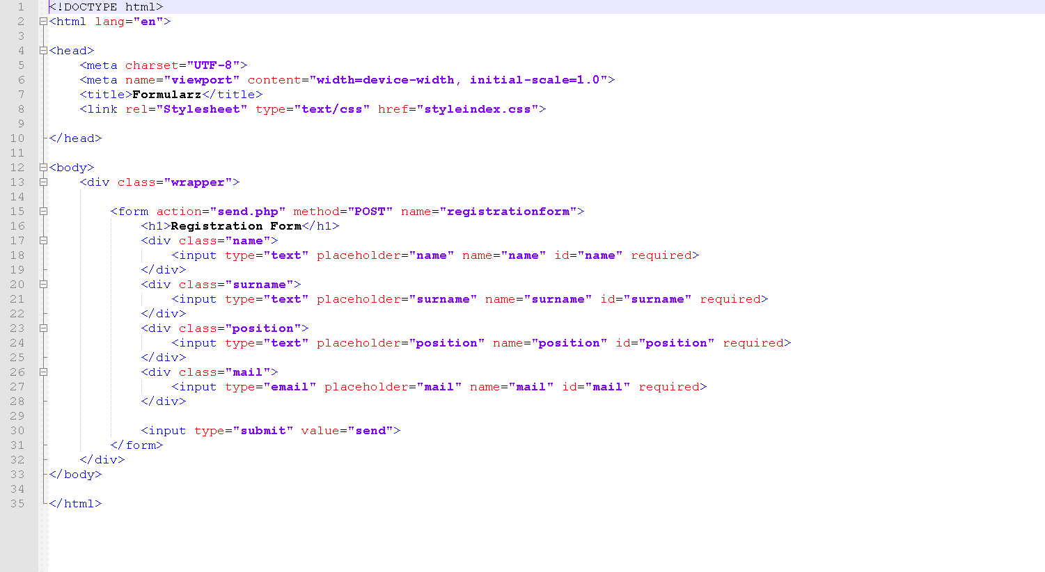

CSS File

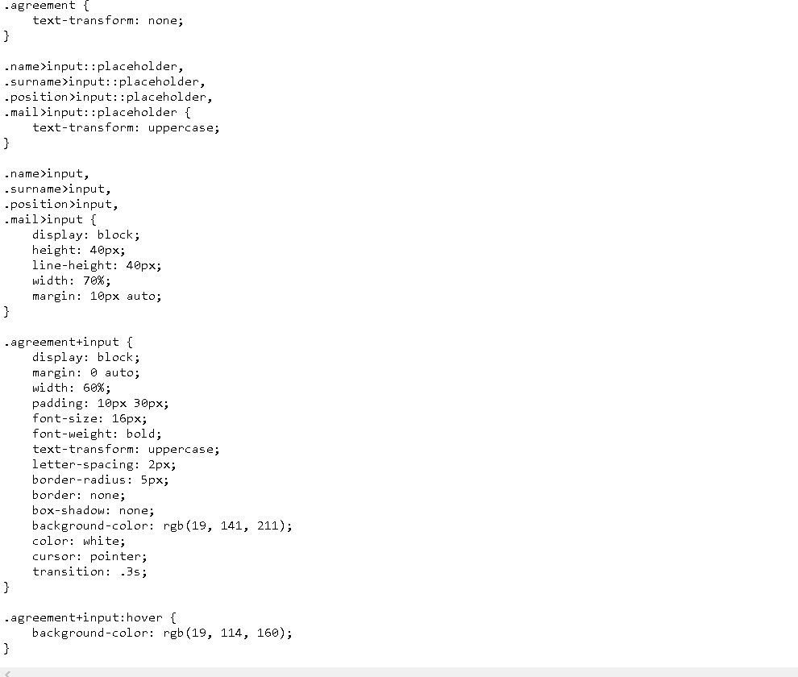

stylei ndex - N otepad

File Edi t Format Vi ew Hel p

margin: 0;

pa d d1 n g: 0;

box-sizing: border-box;

body {

background-color: rgb(19, 141, 211);

.wrapper {

position: absolute; top: 50%;

left: 50%;

transform: translate(-50%, -50%);

form {

pa d d1 n g: 35 px;

text-transform: uppercase;

font-family: Arial, Helvetica, sans-serif; background-color: white;

border-radius: 20px; color: #999;

text-transform: uppercase; font-size: 22px;

margin-bottom: 30px; text-align: center; color: #444;

.name,

.surname,

.position,

.agreement,

.mail {

display: block; width: 100%; margin: 10px auto;

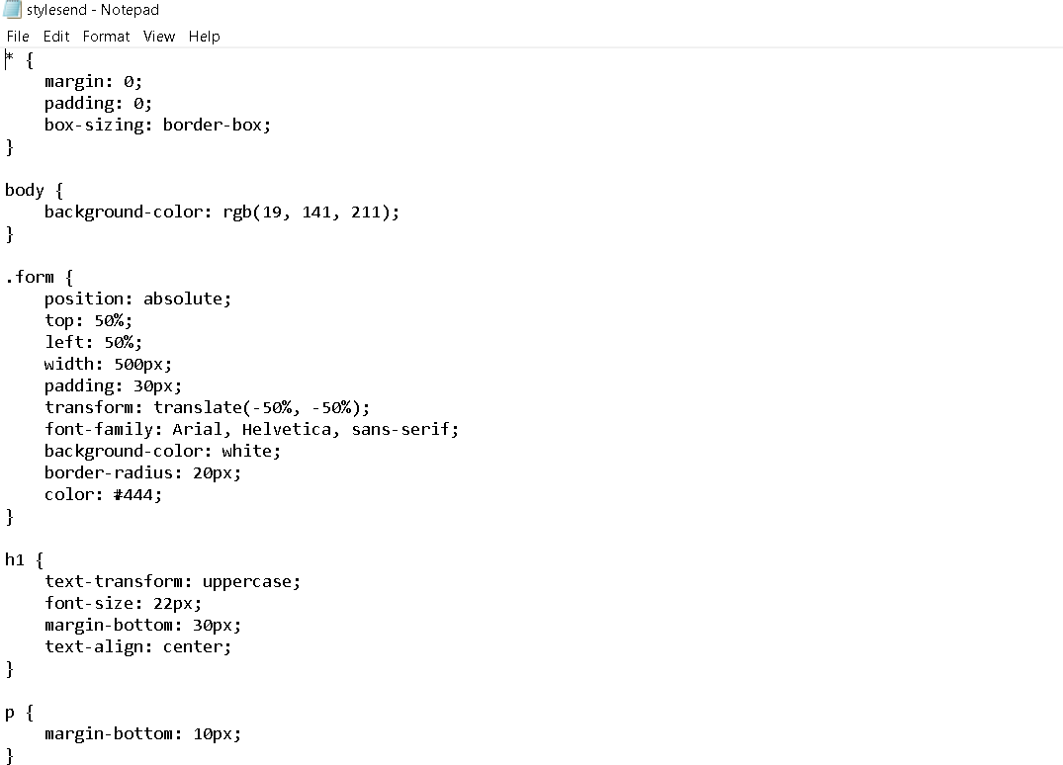

### OUTPUT

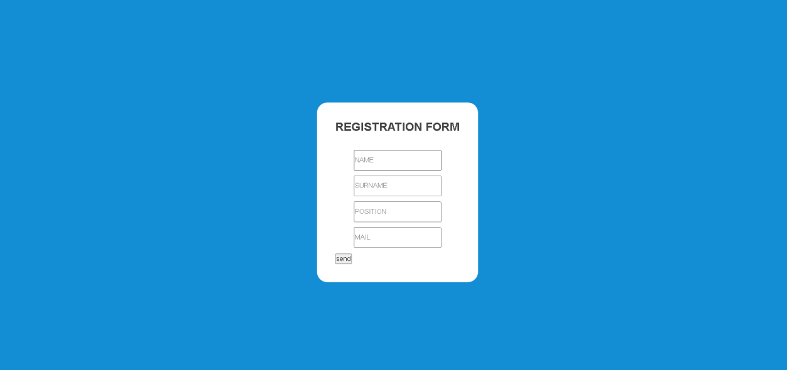

**Experiment 2 -** Creating Home Page Using HTML

## HTML Files

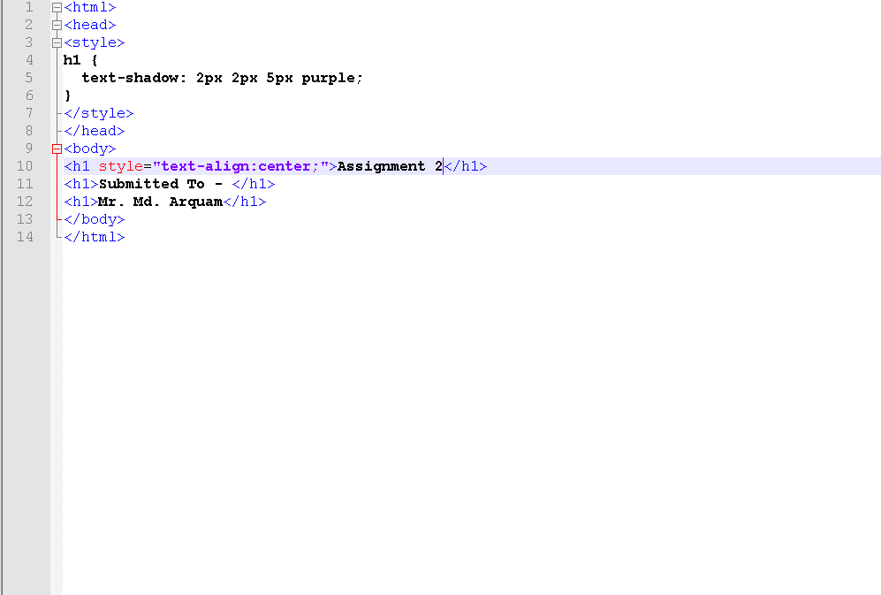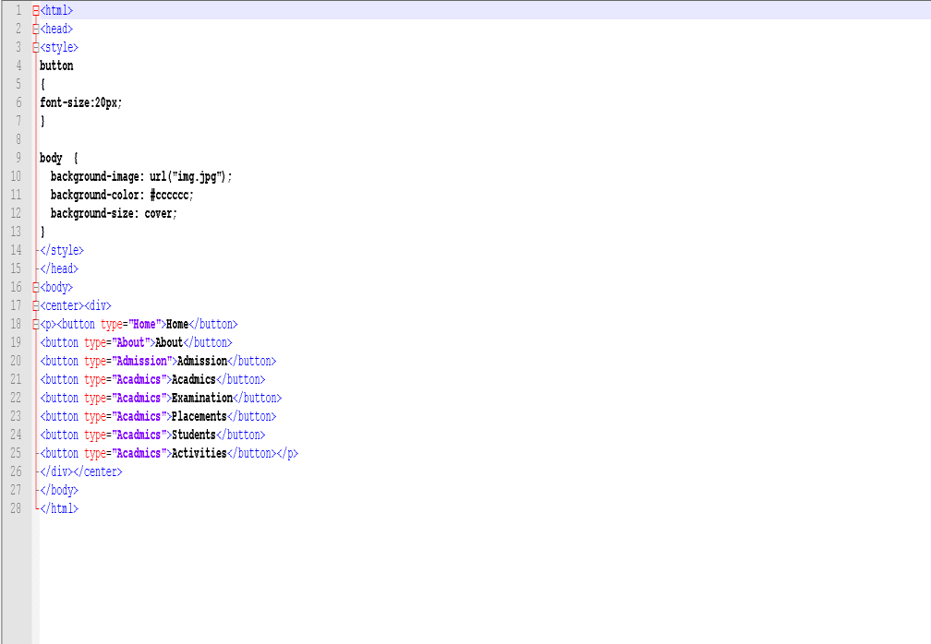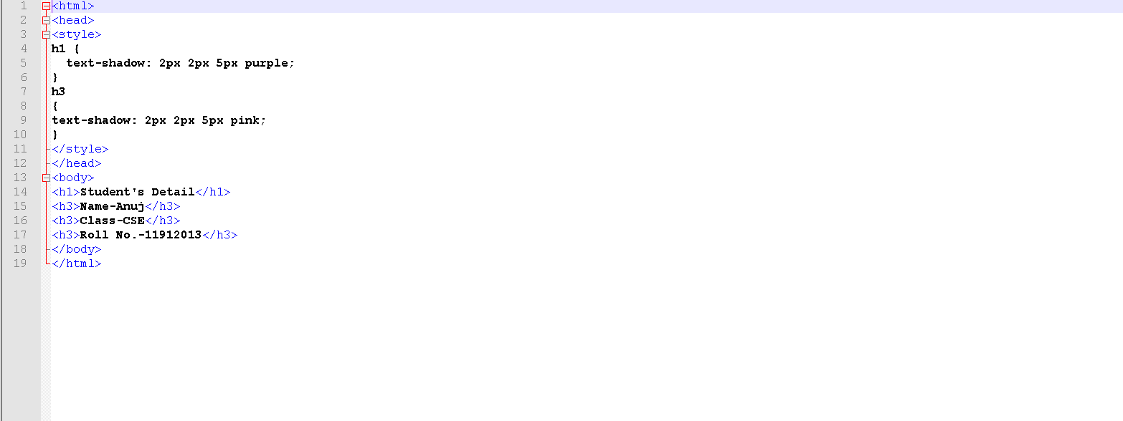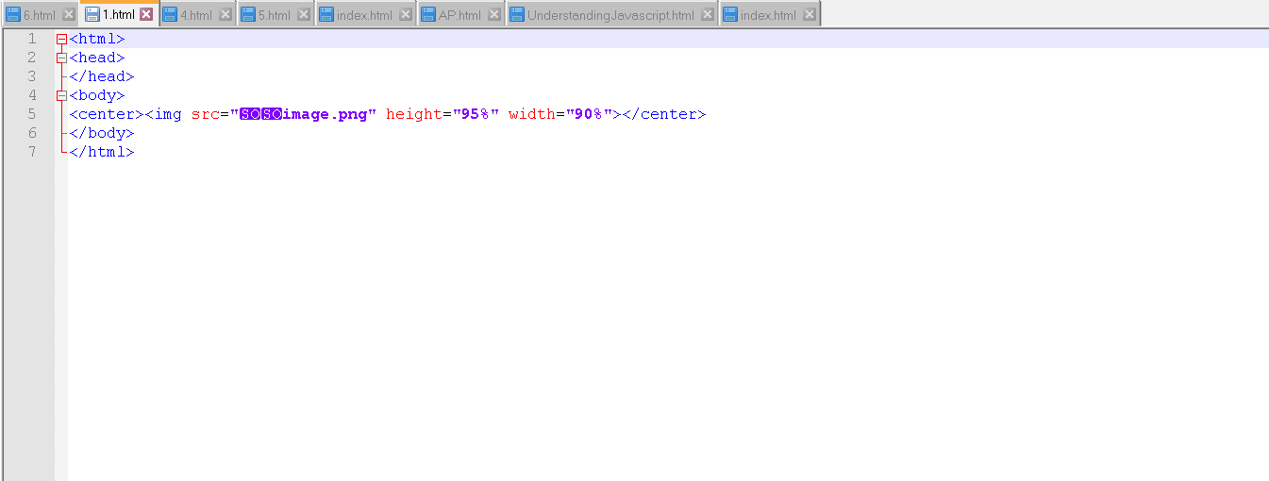

**Experiment 3** - Creating XHTML and CSS and Understanding its use in creating web Pages

#### HTML Files

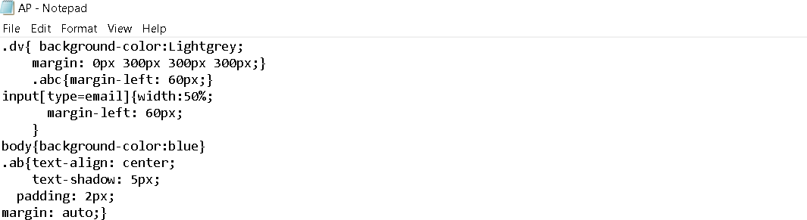

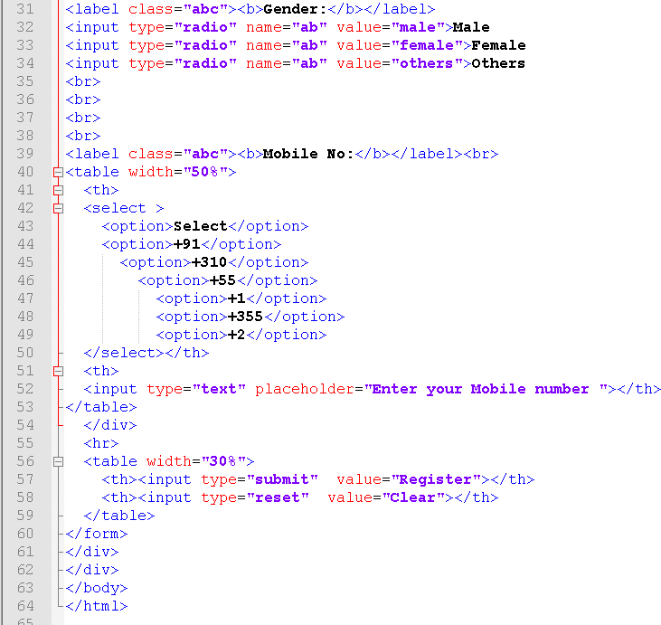

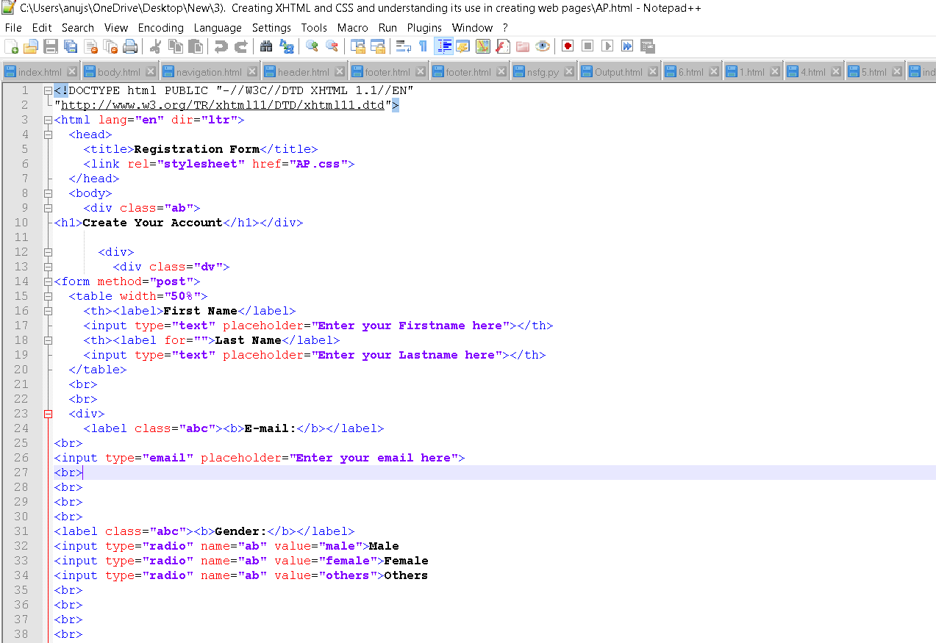

**OUTPUT**

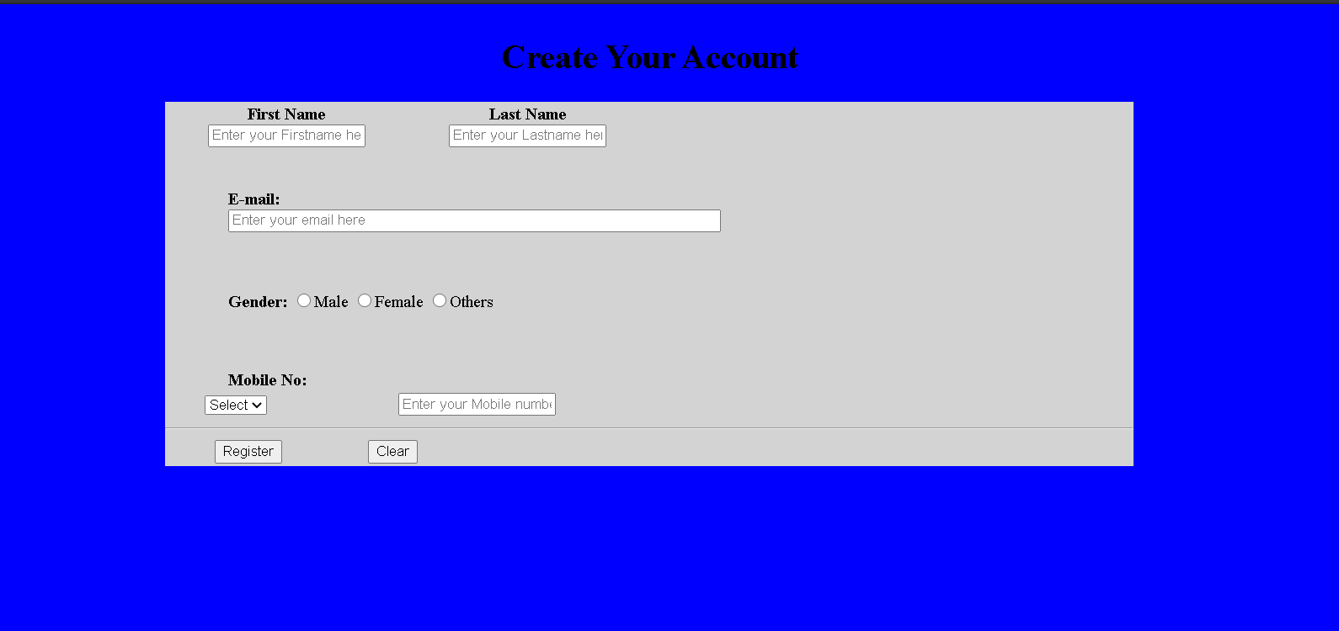

**Experiment 4** - Setting up and configuration of Apache Tomcat Server

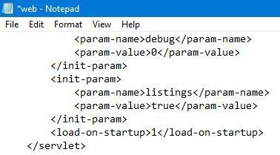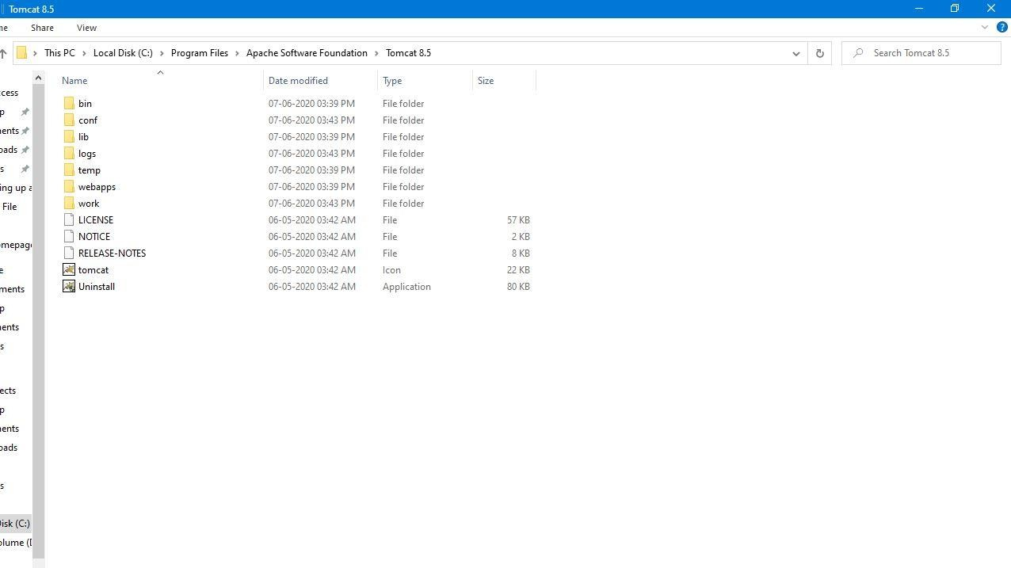



localhost

*@* Coca ihost

Ap ps

Cmail ' \ouTube

JavaScript Tutorial @ DSSSB Exam Coachi...

Python Tutorial

C + + .Frog °aa ming...

Ei

##### This site can’t be reached

localhost refuse d t con neck.





Rdoad

‹!-- A ”Connector” represents an endpoint by which requests are received

and responses are returned. Documentation at : Java HTTP Connector: /docs/config/http.html Java AMP Connector: /docs/config/ajp.html

APR (HTTP/AJP) Connector: /docs/apr.html

Define a non-SSL/TLS HTTP/1.1 Connector on port 9999

<C onnec tor port=" 9999" p POfDCD1-"HTTP/1. 1" connec th onT ice out=" 20B00 " redi*rectPo* rt=" 8443 " / ›

<!-- A ”Connector” using the shared thread pool-->

DC onnec tor executor-"tomc atThreadPoo1"

po rt=" 9999 " protoco1="HTTP/1. 1 " connec IN onTioeout = " 20B00 "

redirectPor I=" 8443" /›



Apa cue Tomcat Examples

C

@ iocaihost

YouTude

'avascript Tutorial

Apache Tomcat Examples

* Sm lets examples
* JSP Examples
* \Veb5ocket Examples



Home Documentation Configuration Examples Wiki Mailing Lists

Apache Tomcat/8.5.55

Recommended Reading: Security Considerations How-To Manager Apolicafion How-To

Clustering/Session Reolication How-To

Find Help







Developer .Quick Start



Managing Tomcat





Release Notes

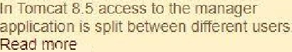

Reelms & AAA



Documentation



Tomcat 8 5 documentation Tomcat 8 5 Configuration Tomcat Wiki



Deveiooers may 'De interested in





Getting Help

FAQ and Mailing Lists

The following. mailing lisls are avail a'bI'e.





User suppon and d ecus sion Tar Apacne ”ag Ds.

Mtoratioñ Cutde

Oev elopment mailing list, menu din g commtl

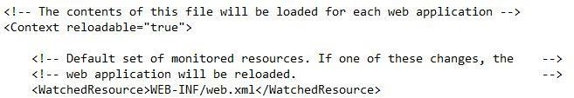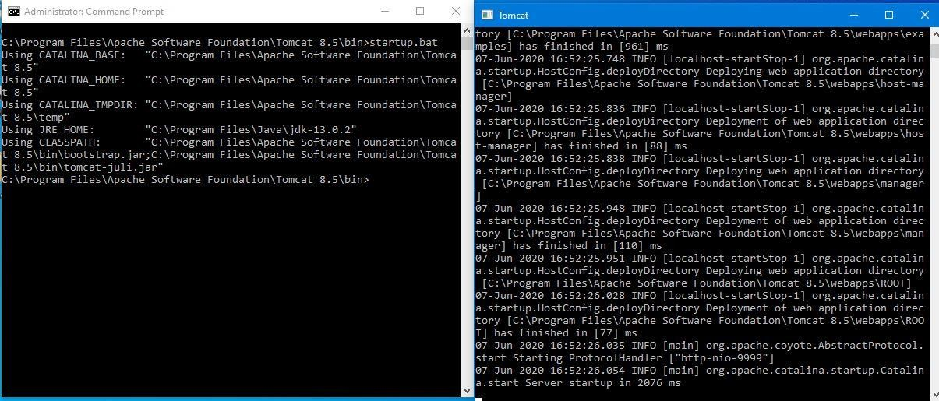

**Experiment 5** - Understanding modification of Web.XML

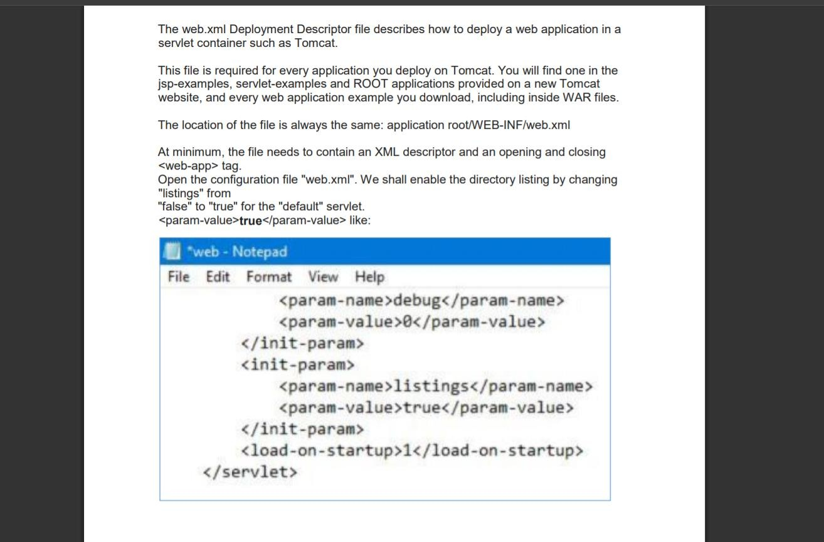

**Experiment 6** - Creating Web Sites Using PHP

## PHP Files

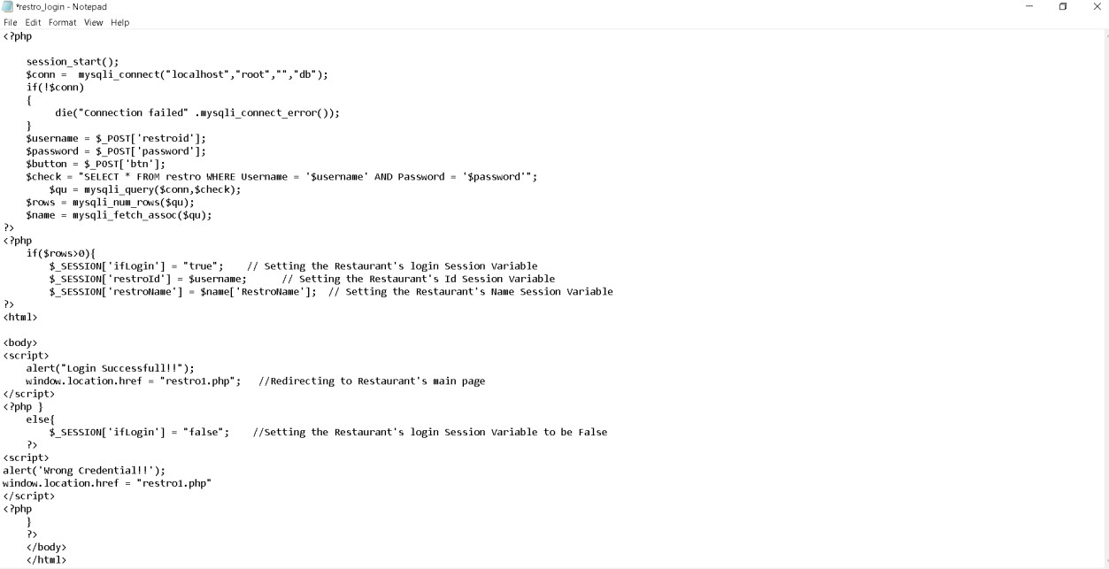

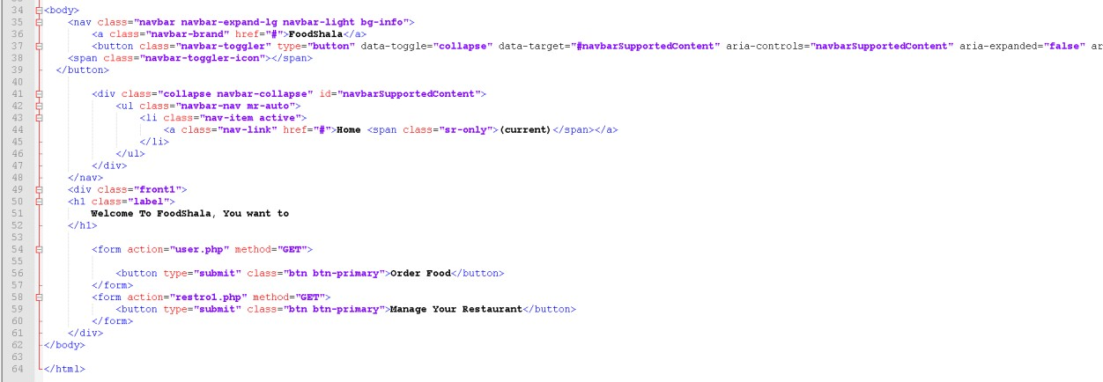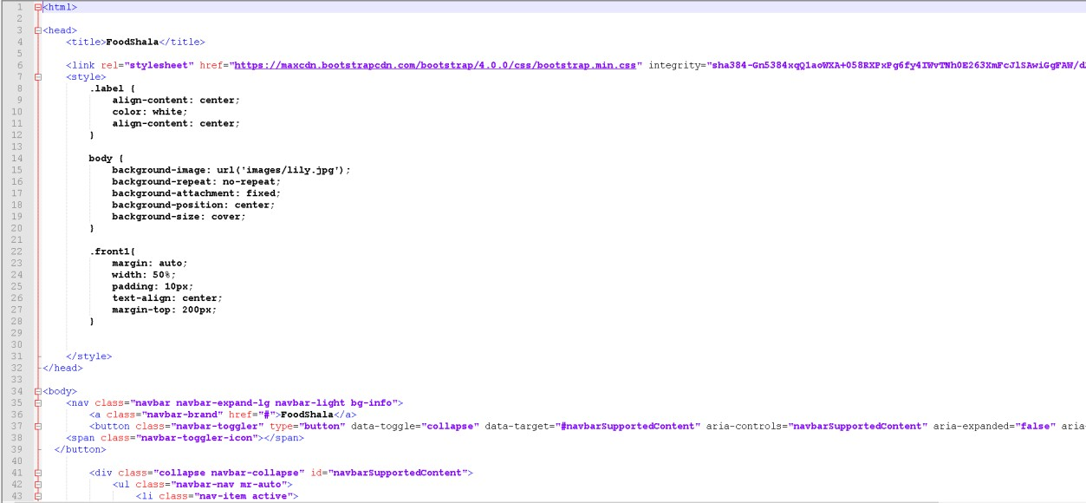

**OUTPUT**

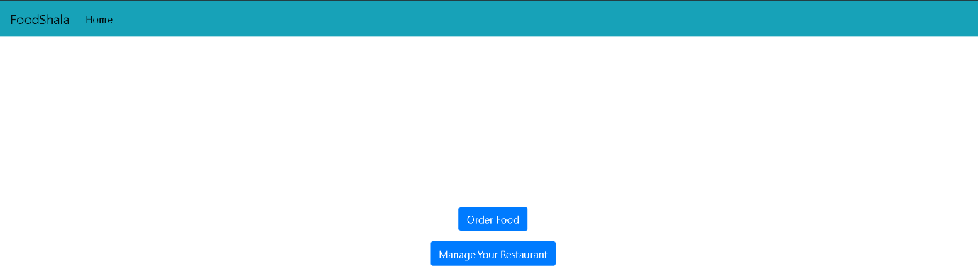

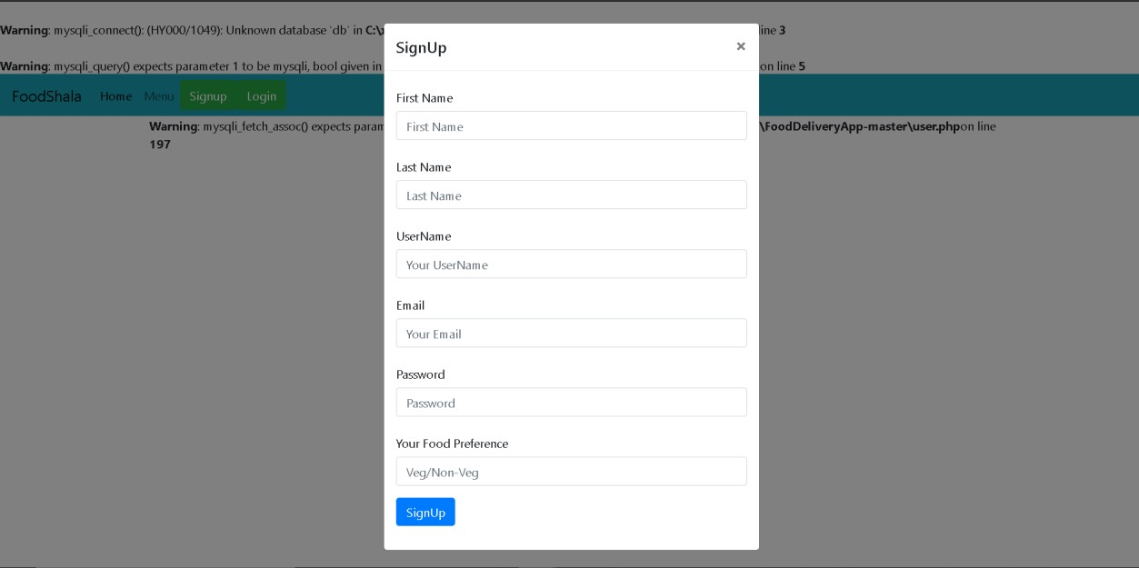

**Experiment 7** - Understanding JavaScript

## Java Script File

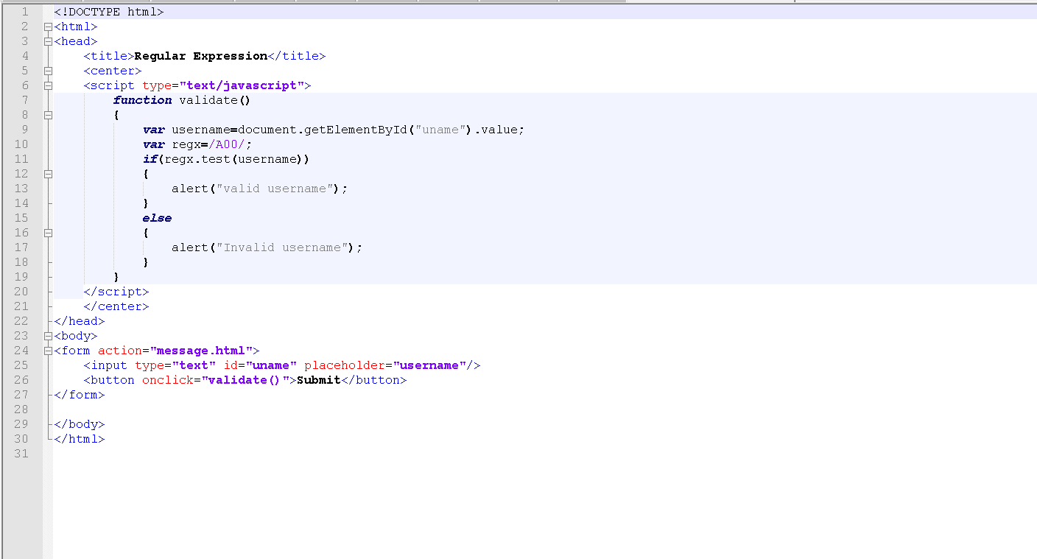

**OUTPUT**

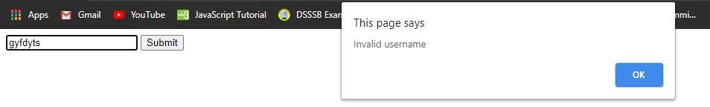

**Experiment 8** - Creating a Web Page with back end in PHP and Front end in JavaScript and hosting it on Apache Tomcat Server

PHP File

‹ input type=" text" id=" st we am" name=" st we am" pequ? ped›



‹ la beI for= “ contac I“ › ‹ span c la s s=“ ma nd“ › * ‹/ spa n › con tae t Humb e c: ‹ / la be I ›

‹ label -for=" s kit T" › ‹ span c Pass="mand" ›” ‹/ span›Youn s kit T s: ‹/ Gabe T›

‹texta pea id=" ski T1" pas=" 7" c ads=" 76" p Tae eholde p=" Te T T us you p Sk? T s in pnogpamm ing! " ›





echo "‹h3›E-mail: ".Semail."‹/ha›";

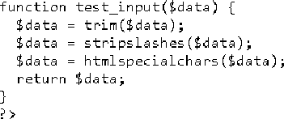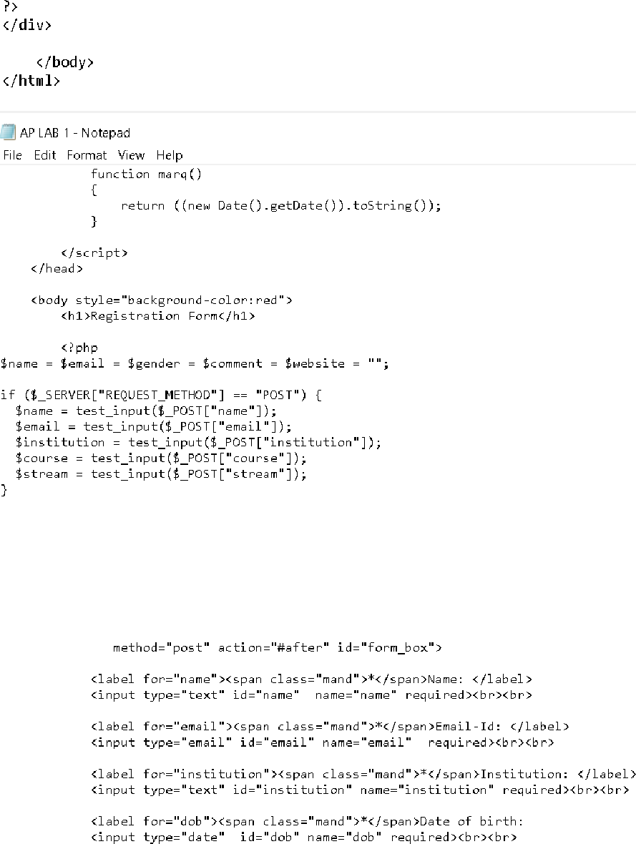

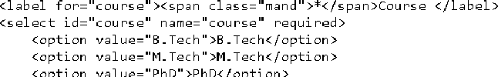



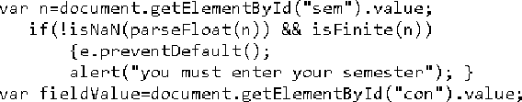



AP LAB - N otepad

File E d I Format Vi ew He a

(and- (a miip : Connie S a n s M5 ;





border: lpx solid rgb(131, 8, 8);



b a rd en: 2px s oL? d rgb (5 00, 0, 0) ;

—z And ex: 9999; pa dd i ng : 5 px 5 pxj



transition: background-color 0.2s, color 0.2s;



b a nd e n- na d? us : 5 air; pa dd i n g: 5 px 5 pxj

c u ns an: poi n te n;



border: lps solid white; texta sea : hover,

border: lps solid rgb(l3l, 8, 8);



va r No rm Exa rrpL e = d ocumen I . get El efren tBy I d ( "fo rm_b ax" ;

formExample.submit();

dac umenI . geI EN em en tBy I d ( "to mm b ox" ) . on s ub md I - I un c tt on ( e) { va r +T eL d Va L u e-d oc umen I . geI EL emen tBy I d ( "n a me " ) . va L ue;

i I ( fi eL d Va L u e==n uL I | +T eLd Va L u e== " " )

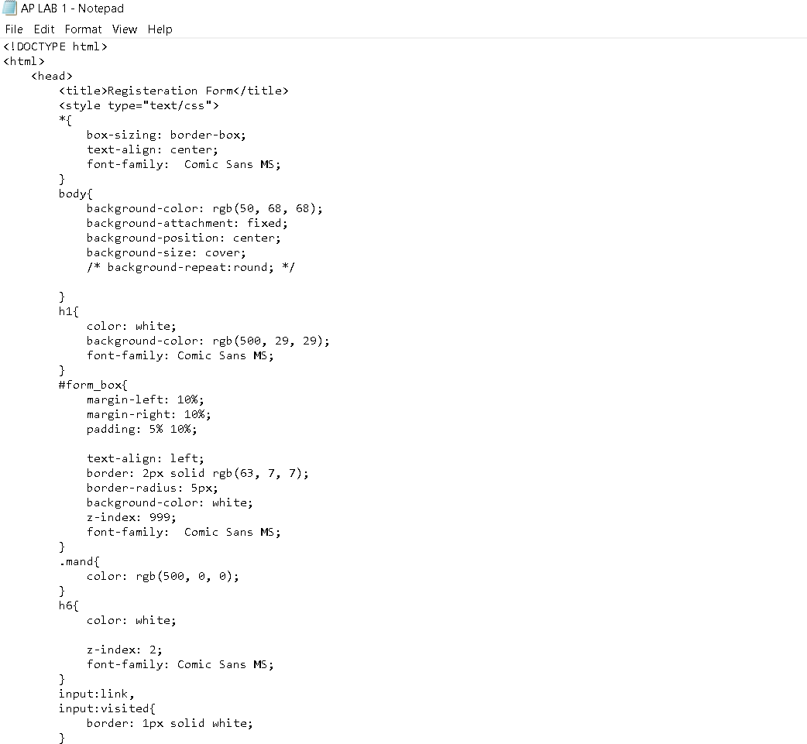

# OUTPUT

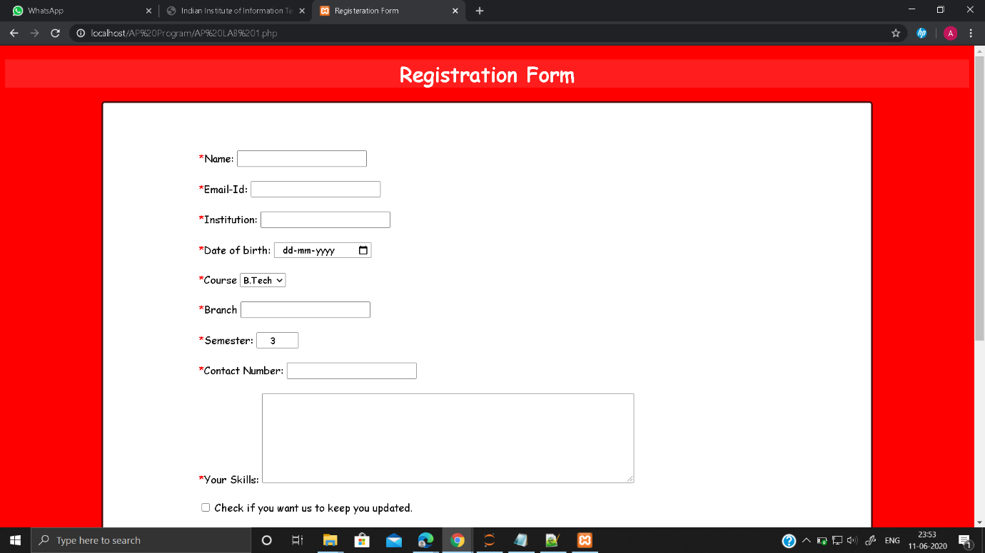

**Experiment 9** - Writing and Understanding Program in Python

# Python File

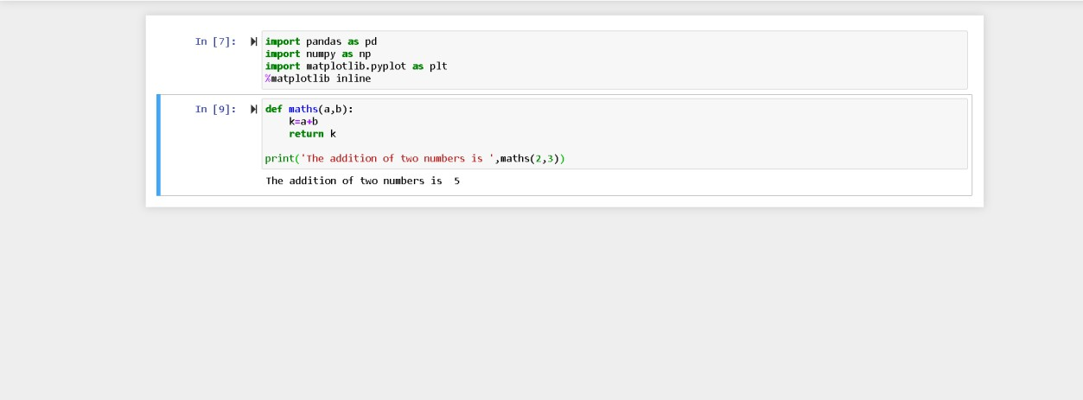

**Experiment 10** - Use python Libraries like Math’s statistics to create

## program for Scientific Computations

**Python File**

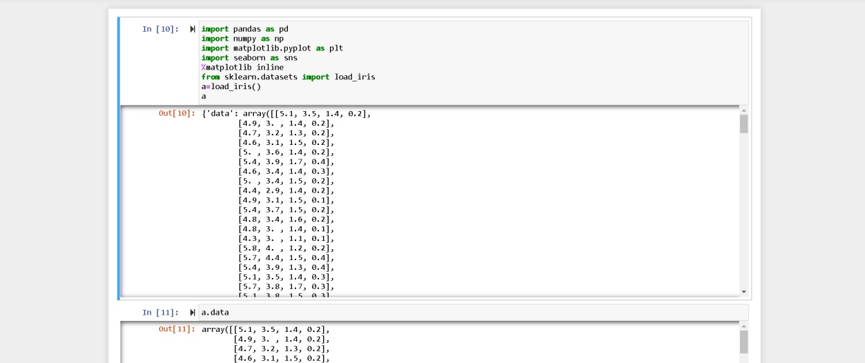

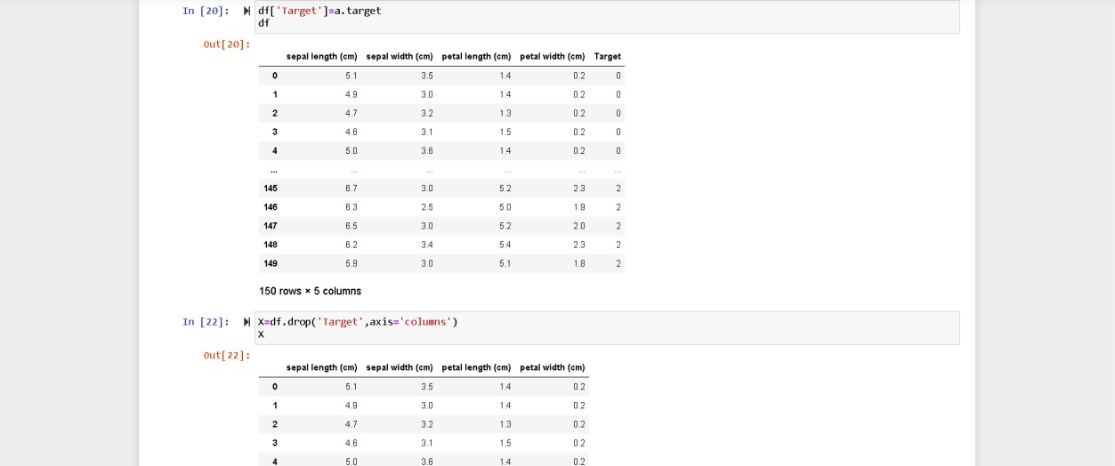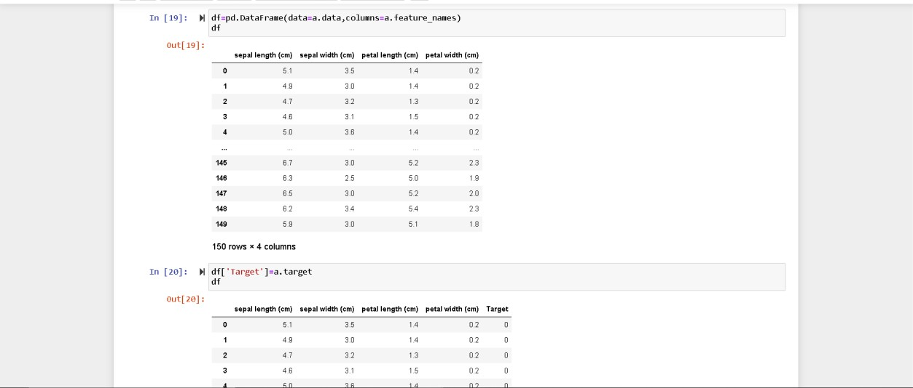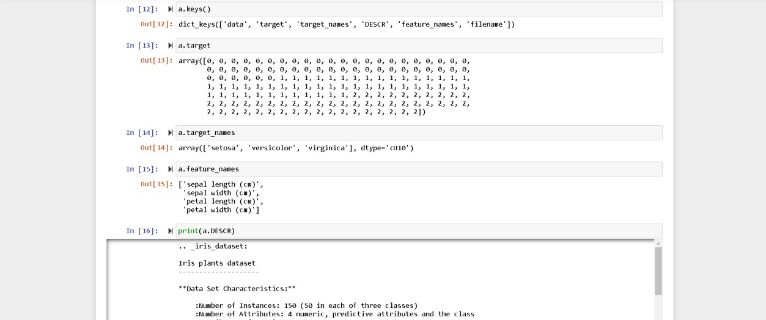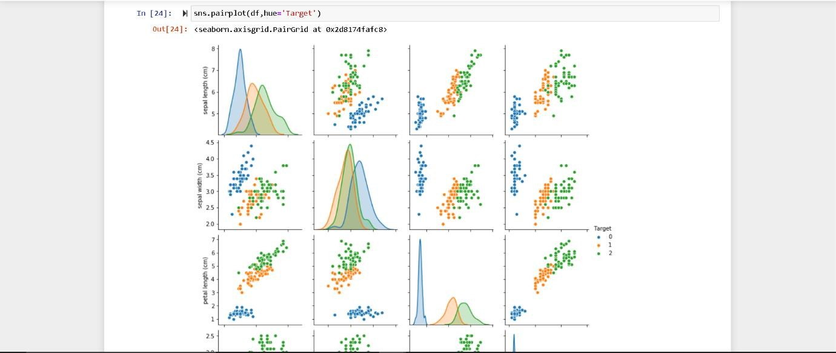

**OUTPUT**

j u pyter AP Project 1 Last Checkpoint: 9 minutes ago (unsaved changes)

File Edit View Insert Cell Kernel Widgets Help gj •t• 8< @ @ •h I



N Run M C ' Code

, Logout

Trusted Python 3 0

I n [ 24 ] : N

s n s . pa Mr plot (df, h ue= ' Ta r get ' )

Out [ 24 ] : ‹ s ea bor n . axis gr id . Pa 1rG r id at 0x2d8 174fa fc 8›

###### 

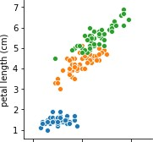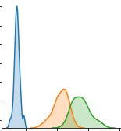• • •

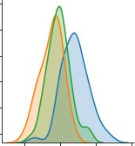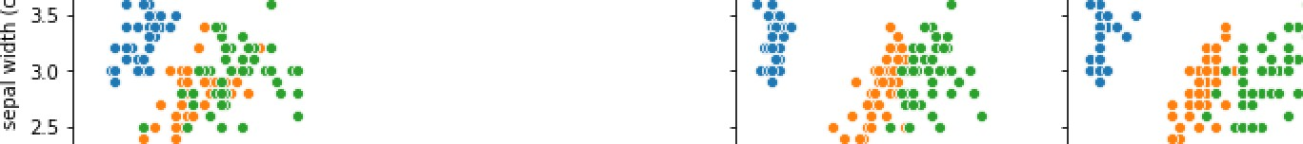

4.5



L0 - •-• •--

0.5 • •° •

0.0

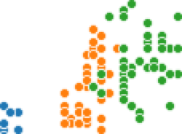

Ta rget

* + 1

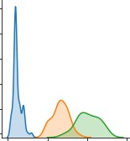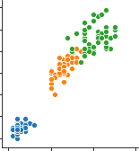

* + 2

4 6

sepaT Teugth (cm)

2 3 4 5

sepaT width fern)

2 4 6 8 0

petal length fern)

1 2 3

petal width (cm)

