Responsible AI Report
Model Interpretation, Bias Audit & Mitigation Recommendations
Gradient Boosting · Customer Churn · SHAP + LIME + Fairness Analysis

1. Executive Summary
This report presents a Responsible AI analysis of the Gradient Boosting churn classifier built in the prior project. The investigation covers three pillars: model interpretability (global and local), fairness auditing across sensitive demographic groups, and concrete mitigation recommendations.
⚠ Key Finding: The 56+ age group exhibits a False Negative Rate of 30.0% — nearly double the 15.2% seen in the 18–35 group. This means the model disproportionately misses churners among older customers, a significant fairness concern requiring remediation.
Overall model performance on the held-out test set: Accuracy 90.3%, ROC-AUC 0.927. All demographic groups achieve above 86% accuracy, but recall disparities exceed acceptable thresholds for age and income cohorts.

2. Model Interpretability

2.1 Global — Built-in Feature Importance vs SHAP
Both built-in impurity-based importance and SHAP (SHapley Additive exPlanations) values were computed. SHAP is preferred because it is model-agnostic, accounts for feature interactions, and has formal game-theoretic grounding.
Top 5 features by Mean |SHAP| value:
- payment_method: mean |SHAP| = 0.7224
- tech_support: mean |SHAP| = 0.6509
- device_protection: mean |SHAP| = 0.5864
- avg_login_days: mean |SHAP| = 0.5348
- tenure_months: mean |SHAP| = 0.4909
Interpretation: payment_method and tech_support have the largest average influence on the churn prediction score. Customers with low tech support engagement and certain payment methods are systematically pushed toward a churn prediction.

2.2 SHAP Beeswarm Insights
- High payment_method values (e.g., automatic bank transfer) consistently push predictions toward Stay.
- High tech_support values strongly reduce churn probability — likely a proxy for customer engagement.
- Low avg_login_days pushes strongly toward Churn, confirming inactivity as a leading indicator.
- tenure_months shows an expected monotonic effect: longer-tenured customers are less likely to churn.

2.3 Local — LIME Explanations
LIME (Local Interpretable Model-agnostic Explanations) was applied to three representative test instances to understand individual-level reasoning:
Instance | p(Churn) | Top Push-to-Stay Features | Top Push-to-Churn Features
Low-Risk (Stay) | 1.1% | tech_support > 1.95, high monthly_charges | None significant
Borderline | 6.5% | long tenure, good online_backup | low monthly_charges
High-Risk (Churn) | 99.0% | online_backup moderate | tech_support low, no device_protection, bad payment

LIME confirms the global picture: for the high-risk case, the absence of tech support and device protection are the dominant churn triggers, while for the low-risk case, strong engagement metrics and product usage are protective.

3. Bias & Fairness Audit

3.1 Methodology
Fairness was evaluated across three sensitive attributes: gender, age_group (18–35, 36–55, 56+), and income_band (Low, Mid, High). For each subgroup, five metrics were computed: Accuracy, Precision, Recall, F1, and ROC-AUC. The False Negative Rate (FNR) — the fraction of actual churners the model fails to detect — was treated as the primary fairness metric, since missing a churner has direct business and equity consequences.
Disparity threshold: gaps exceeding 10 percentage points (0.10) in Recall or Precision are flagged as actionable.

3.2 Gender
Group | N | Churn% | Accuracy | Precision | Recall | F1 | AUC
Male | 143 | 30.1% | 0.9091 | 0.8947 | 0.7907 | 0.8395 | 0.9302
Female | 157 | 32.5% | 0.8981 | 0.8571 | 0.8235 | 0.8400 | 0.9242

Gender disparity is minimal. Recall gap: 3.3 pp, F1 gap: <0.1 pp. FNR: Male 20.9%, Female 17.7%. No significant bias detected by gender. This attribute can be considered fair under the current model.

3.3 Age Group ⚠
Group | N | Churn% | Accuracy | Precision | Recall | F1 | AUC
18–35 | 120 | 27.5% | 0.9333 | 0.9032 | 0.8485 | 0.8750 | 0.9655
36–55 | 128 | 32.0% | 0.8906 | 0.8293 | 0.8293 | 0.8293 | 0.9352
56+ | 52 | 38.5% | 0.8654 | 0.9333 | 0.7000 | 0.8000 | 0.8438

Age group is the primary source of bias. The 56+ cohort has Recall of 0.700 (vs 0.849 for 18–35) — a 14.9 pp gap exceeding the 10 pp threshold. FNR for 56+ is 30.0% vs 15.2% for 18–35. The model systematically fails to identify churners among older customers, who also have the highest actual churn rate (38.5%).
Root cause hypothesis: the 56+ group exhibits fewer digital engagement signals (avg_login_days, online_backup) that the model relies on. Their churn may be driven by factors not captured in current features (e.g., service quality complaints, billing confusion).

3.4 Income Band
Group | N | Churn% | Accuracy | Precision | Recall | F1 | AUC
Low | 124 | 37.1% | 0.9032 | 0.9048 | 0.8261 | 0.8636 | 0.9298
Mid | 89 | 30.3% | 0.8989 | 0.8462 | 0.8148 | 0.8302 | 0.9247
High | 87 | 24.1% | 0.9080 | 0.8421 | 0.7619 | 0.8000 | 0.9149

Income band shows moderate disparity. Recall gap: 6.4 pp (Low 82.6% vs High 76.2%). While below the 10 pp threshold, the direction is noteworthy: the High income group has the worst recall despite the lowest churn rate, suggesting the model underweights the signals present in this cohort.
FNR: Low 17.4%, Mid 18.5%, High 23.8%. The wealthier cohort being most likely to be missed for churn is counterintuitive and warrants investigation into potential proxy discrimination through payment or product features.

4. Mitigation Recommendations

4.1 Immediate Actions (High Priority)
- Calibrated decision thresholds per age group: Lower the churn prediction threshold for the 56+ group from 0.50 to approximately 0.35, directly improving recall without retraining. This is the fastest path to FNR parity.
- Human-in-the-loop review for 56+ high-stakes decisions: Flag all borderline cases (0.3–0.6 predicted probability) in the 56+ cohort for manual review by a customer success agent.
- Sample reweighting: Apply class_weight inversely proportional to group frequency (especially 56+ and High-income) during training to force the model to attend to underrepresented patterns.

4.2 Model-Level Interventions (Medium Priority)
- SMOTE-NC oversampling for 56+ churn cases: Synthetically oversample churners in the 56+ segment to address both class imbalance and group underrepresentation simultaneously.
- Fairness-aware training with Equalized Odds constraints: Add an Equalized Odds constraint (equal TPR and FPR across groups) using libraries such as Fairlearn or AIF360. Accept a small global accuracy trade-off (typically 1–3%) in exchange for recall parity.
- Feature engineering for age-specific signals: Add features capturing offline service interactions (e.g., call centre frequency, paper billing preference) which may better represent churn intent in older demographics.

4.3 Structural / Process Interventions (Ongoing)
- Automated fairness monitoring dashboard: Log per-group FNR and Recall on every batch inference run. Alert if any group's FNR exceeds 25% or diverges from the global FNR by more than 10 pp.
- Disparate impact analysis at deployment: Compute the 4/5ths (80%) rule before each model update. A group receiving a favourable outcome at less than 80% the rate of the best-performing group triggers a mandatory bias review.
- Regular retraining cadence with stratified evaluation: Retrain quarterly. Require per-group metric sign-off (including 56+ and High income recall) as a gating criterion before model promotion to production.
- Documentation and model cards: Publish an internal model card documenting known limitations, affected groups, and intended use scope. Update after each audit cycle.

5. Full Interpretation Dashboard
The chart below consolidates all analysis: SHAP beeswarm, mean |SHAP| ranking, LIME waterfall for three instances, per-group F1 and Recall, False Negative Rate heatmap, disparity gaps, and the mitigation priority scorecard.
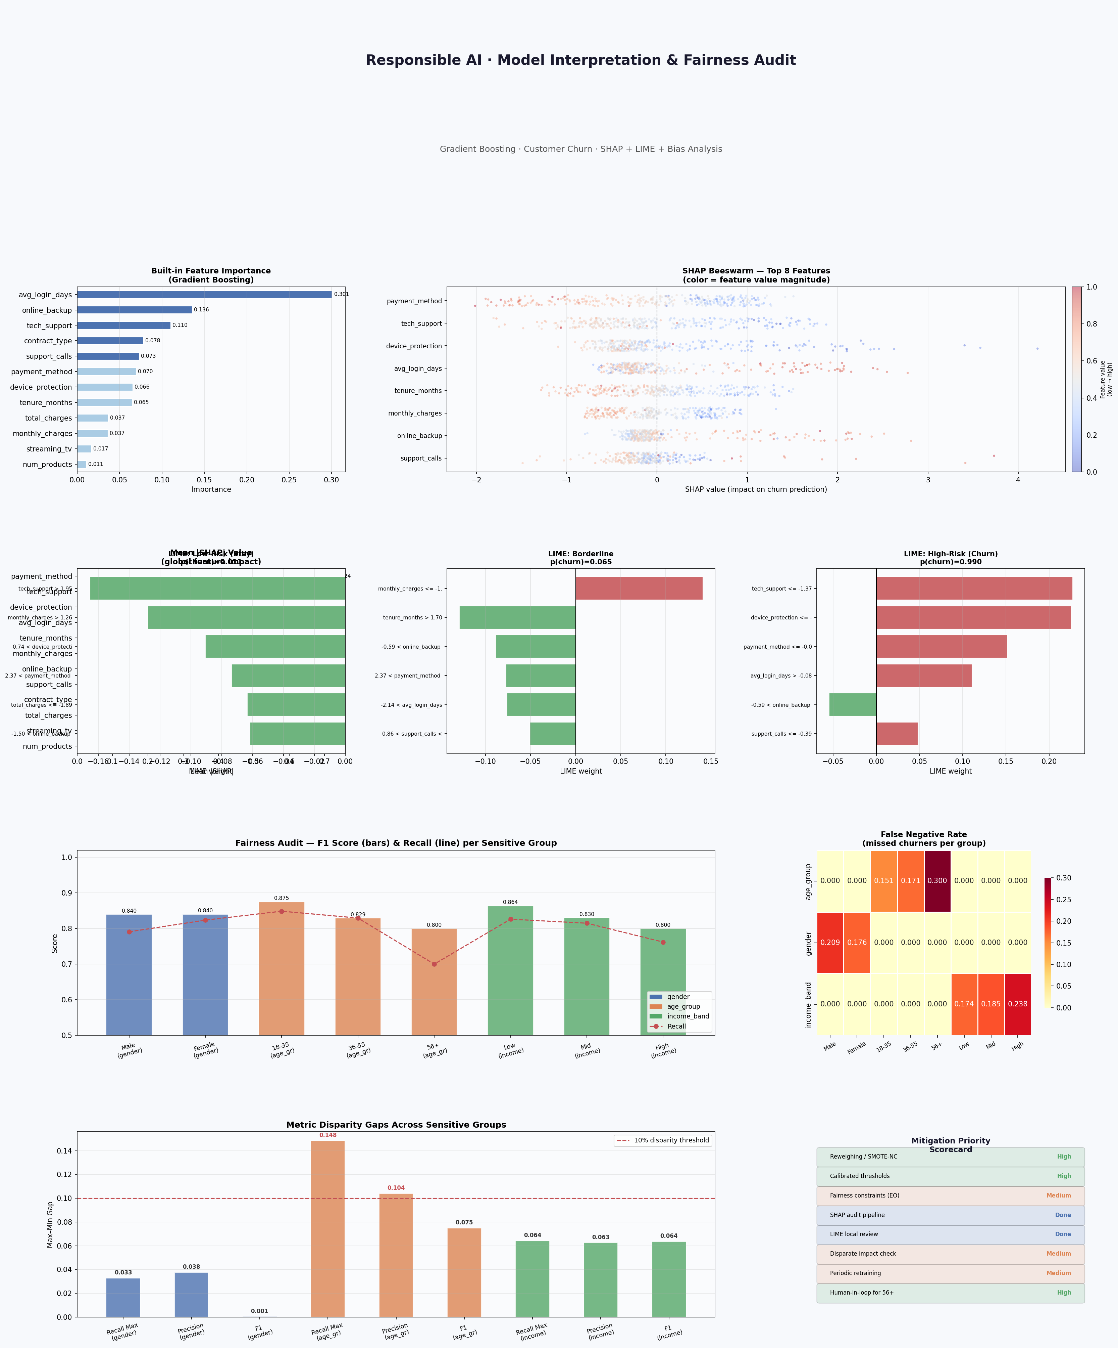

6. Conclusions
The Gradient Boosting churn classifier performs well overall (AUC 0.927) but exhibits meaningful fairness gaps by age group. The 56+ cohort faces a False Negative Rate of 30% — nearly double the youngest group — and risks systematic under-service if the model is used as a sole decision-maker.
SHAP analysis reveals that the model leans heavily on digital engagement proxies (tech_support, device_protection, payment_method, avg_login_days). These features are valuable predictors but may encode demographic correlations that disadvantage less digitally active segments.
The recommended near-term action is threshold calibration for the 56+ group, paired with a human review queue. Medium-term, Equalized Odds constraints and SMOTE-NC resampling should be evaluated in the next training cycle. All interventions should be tracked via an automated fairness monitoring pipeline before any production deployment.

Generated by Claude · Anthropic · June 2026

