**AIM:**

To determine the synthesis of Aspirin and it’s decomposition.

**Introduction:**

Aspirin is the common name for the compound acetylsalicylic acid, widely used as a fever reducer and as

A pain killer. Salicylic acid, whose name comes from Salix, the willow family of plants, was derived from

Willow bark extracts. In folk medicine, willow bark teas were used as headache remedies and other

Tonics. Nowadays, salicylic acid is administered in the form of aspirin which is less irritating to the

Stomach than salicylic acid. To prepare aspirin, salicylic acid is reacted with an excess of acetic

Anhydride. A small amount of a strong acid is used as a catalyst which speeds up the reaction. In this

Experiment, phosphoric acid will be used as the catalyst. The excess acetic acid will be quenched with

The addition of water. The aspirin product is not very soluble in water so the aspirin product will

Precipitate when water is added. The synthesis reaction of aspirin is shown below.

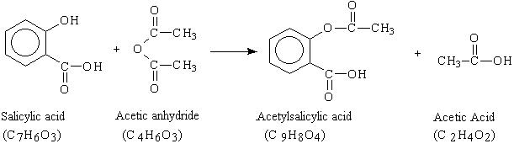

Since acetic acid is very soluble in water, it is easily separated from the aspirin product. The aspirin

Isolated in this step is the “crude product”. A “purified product” can be obtained through

Recrystallization of the crude product in hot ethanol. In this experiment, the crude product will be the

Desired product. The percent yield of the crude product will be determined for this reaction. The purity

Of the product will also be analyzed. The product will be analyzed by three different methods: melting

Point, titration, and spectroscopic assay.

The melting point range of pure aspirin is 138-140 C and the melting point range of the salicylic acid

starting material is 158-161 C. If impurities are present in your crude sample, the melting point range

for your product will be lower than the range of pure aspirin. Also, your melting point range may be

greater than 2 degrees.

From the titration of your sample, the moles of acetylsalicylic acid present can be determined assuming

that there is not a large percentage of an acid impurity present in your crude sample**.**

The spectroscopic analysis of aspirin will involve the complexing of iron(III) to the deprotonated form of

Salicylic acid (salicylate ion) to give a purple solution. Only the salicylate ion complexes to iron(III). Your

Aspirin product as well as a commercial aspirin tablet will be compared to a standard 0.15% ferric-

Salicylate solution. In the presence of moisture, aspirin may decompose (hydrolysis) into salicylic acid

And acetic acid. This reaction is the reverse of the synthesis reaction. The maximum allowable amount of

Free salicylic acid in an aspirin sample is 0.15% salicylic acid.

**Equipment and reagents**

First Period

Salicylic acid buret clamp burner

Acetic anhydride stand with iron ring distilled water

85% phosphoric acid wire gauze ice bath

50 mL flask beaker of tap water filter paper

Büchner funnel aspirator

Second Period

Shell Vial melting point apparatus capillary tubes

Third Period

125 mL Flask phenolphthalein indicator buret

* 1. M NaOH mortar and pestle aspirin tablets

Forth Period

3 x 50 mL test tubes ferric chloride dropper

1. x 50 mL beakers ethanol hot plate

Mortar and pestle aspirin tablets 50 mL graduated cylinder

Parafilm spec 20 cuvettes

Distilled water centigram balance shell vial

Filter funnel filter paper stand with iron ring

**Procedure**

Day 1 – Synthesis

1. Use a centigram balance to weigh a 50 mL Erlenmeyer flask. Place about 2 g of sylicylic acid in

The flask and weigh again. In the fume hood, the instructor will transfer 5.0 mL of acetic

Anhydride from a buret into the flask. Add 5 drops of 85% phosphoric acid (catalyst) to the flask.

1. Clamp the flask in a beaker of tap water supported on a ring stand over a burner flame. Stir if

Needed to dissolve the salicylic acid. Heat the water to boiling, and shut off the flame. Keep the

Flask in the hot water bath for 10 more minutes.

1. While the flask is still in the water bath, slowly add 2 mL of distilled water to the flask to

Decompose any excess acetic anhydride.

1. After a minute, remove the flask from the water bath and add 20 mL of distilled water. Let the

Flask cool to room temperature. As the solution cools, crystals of aspirin will appear. Cool the

Solution further by placing the reaction flask in an ice bath. Chill 5-10 mL of distilled water in a

Separate container.

1. Weigh a watch glass and filter paper on the centigram balance.
2. Set up a Büchner funnel on a vacuum flask connected to a water aspirator. Place the filter paper

In the funnel and moisten with distilled water from a squirt bottle. Turn on the aspirator and

Transfer the aspirin slurry into the funnel. Wash the crystals with 5 mL of the cold DI water**.**

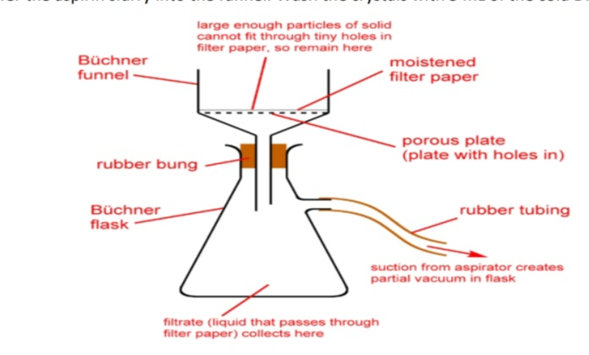

1. Transfer the filter paper and aspirin to a pre-weighed watch glass and allow to air dry in your

Locker until the next lab period.

1. It is safe to discard of the filtrate down the sink with water.

Day 2 – Analysis/Melting Point

1. Weigh the dry product to obtain the yield of the reaction. Calculate the theoretical yield and

Percent yield of the reaction.

1. Pack a few crystals of your aspirin product in a melting point capillary tube. Your instructor will

Demonstrate how to use the melting point apparatus. Allow the temperature of the melting

Point apparatus to increase 1 C per minute starting from 120 C. Measure the melting point

Range of the aspirin product. The melting point range is the temperature when you first notice

The aspirin crystals melting up until the temperature when no crystals remain.

Day 3 – Titration Analysis

1. Accurately weigh between 0.10-0.15 g of the aspirin product into a 125 mL Erlenmeyer flask.

Add 15 mL of 95 % ethanol and swirl to dissolve. Add 2 drops of phenolphthalein indicator to the

Flask.

1. Record the exact concentration of the standard 0.1 M NaOH solution. Fill a buret with the

Standard NaOH solution and record the initial volume. Titrate the sample until a faint pink end

Point is reached. The pink color should last for at least 30 seconds after swirling**.**

1. Repeat the titration with 0.10-0.15 g of a crushed aspirin tablet. You may need to use a mortar

And pestle to crush the tablet.

Day 4 – Spectroscopic Analysis

1. Obtain three 50 mL test tubes. Mark them A, B, C with labeling tape.
2. With a clean dropper, add 20 drops of a ferric chloride solution to each tube.
3. Reagent A – Weigh 1.00 g of the aspirin product into a 50 mL beaker. Add 10 mL of ethanol and

Gently warm the mixture on a hot plate to dissolve. Do not use a Bunsen burner because ethanol

Is flammable. Transfer 20 drops of this aspirin-ethanol solution into tube A.

1. Reagent B – Weigh 1.00 g of the crushed aspirin tablet into a 50 mL beaker. Add 10 mL of

Ethanol and gently warm the mixture on a hot plate to dissolve. The solution may appear cloudy

Due to additives in the commercial aspirin. Filter this solution into a shell vial and transfer 20

Drops of this aspirin-ethanol solution into tube B.

1. Reagent C – Transfer 20 drops of the standard 0.15% salicylic acid solution into tube C.
2. Transfer 48 mL of DI water into each tube and seal the top with parafilm. Invert the tube several

Times to mix the solution.

1. Your instructor will show you how to operate the spectrometer. Allow the spectrometer to warm

Up for 10 minutes. Fill a cuvette 2/3 full with the ferric chloride blank solution. Set the spec 20 to

A wavelength of 530 nm and zero the spectrometer (zero absorbance) with a ferric chloride

Blank solution. Fill a clean cuvette 2/3 with solution A and measure the absorbance reading.

Repeat the process for solutions B and C. Clean and return the cuvettes once you are done with

The readings so others can take readings.

Report

Report the theoretical yield and the percent yield of the aspirin product.

Compare the melting point of you aspirin product to the theoretical melting point (138-140 C). Is

The crude product above of below this mark? Explain why this is the case.

Determine the moles of aspirin from the titration and calculate the percent purity of the crude

Aspirin product from the titration analysis.

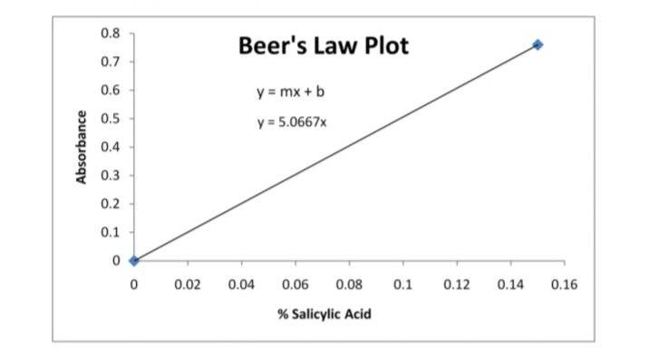

Plot a Beer’s Law graph of the standard 0.15% salicylic acid solution © on excel with Absorbance (y-

Axis) vs % salicylic acid (x-axis). To make a Beer’s Law plot, enter % Salicylic Acid into one column on

The excel spread sheet (0 and 0.15) and absorbance into the next column (0 and the absorbance

Reading). Highlight the data and select insert, and scatter (w/ only markers). Right click a data point

And select add trend line. Now set the y-intercept to 0 and check the display equation box. To add

Titles to the plot, select layout, axis titles, and then chart titles.

|  |  |  |
| --- | --- | --- |
| **Sl NO** | **CONTENTS** | **Pg No** |
|  |  |  |
|  |  |  |