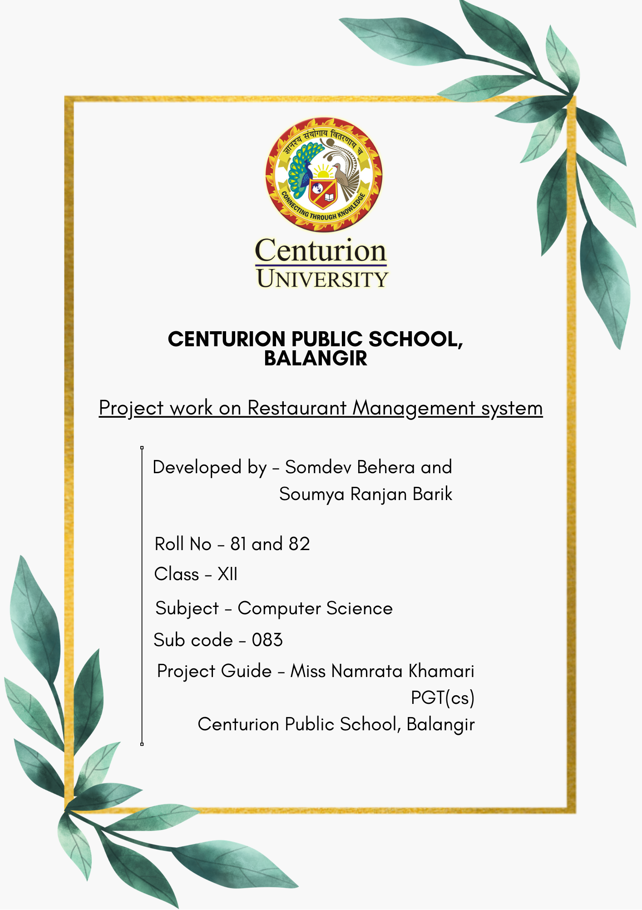

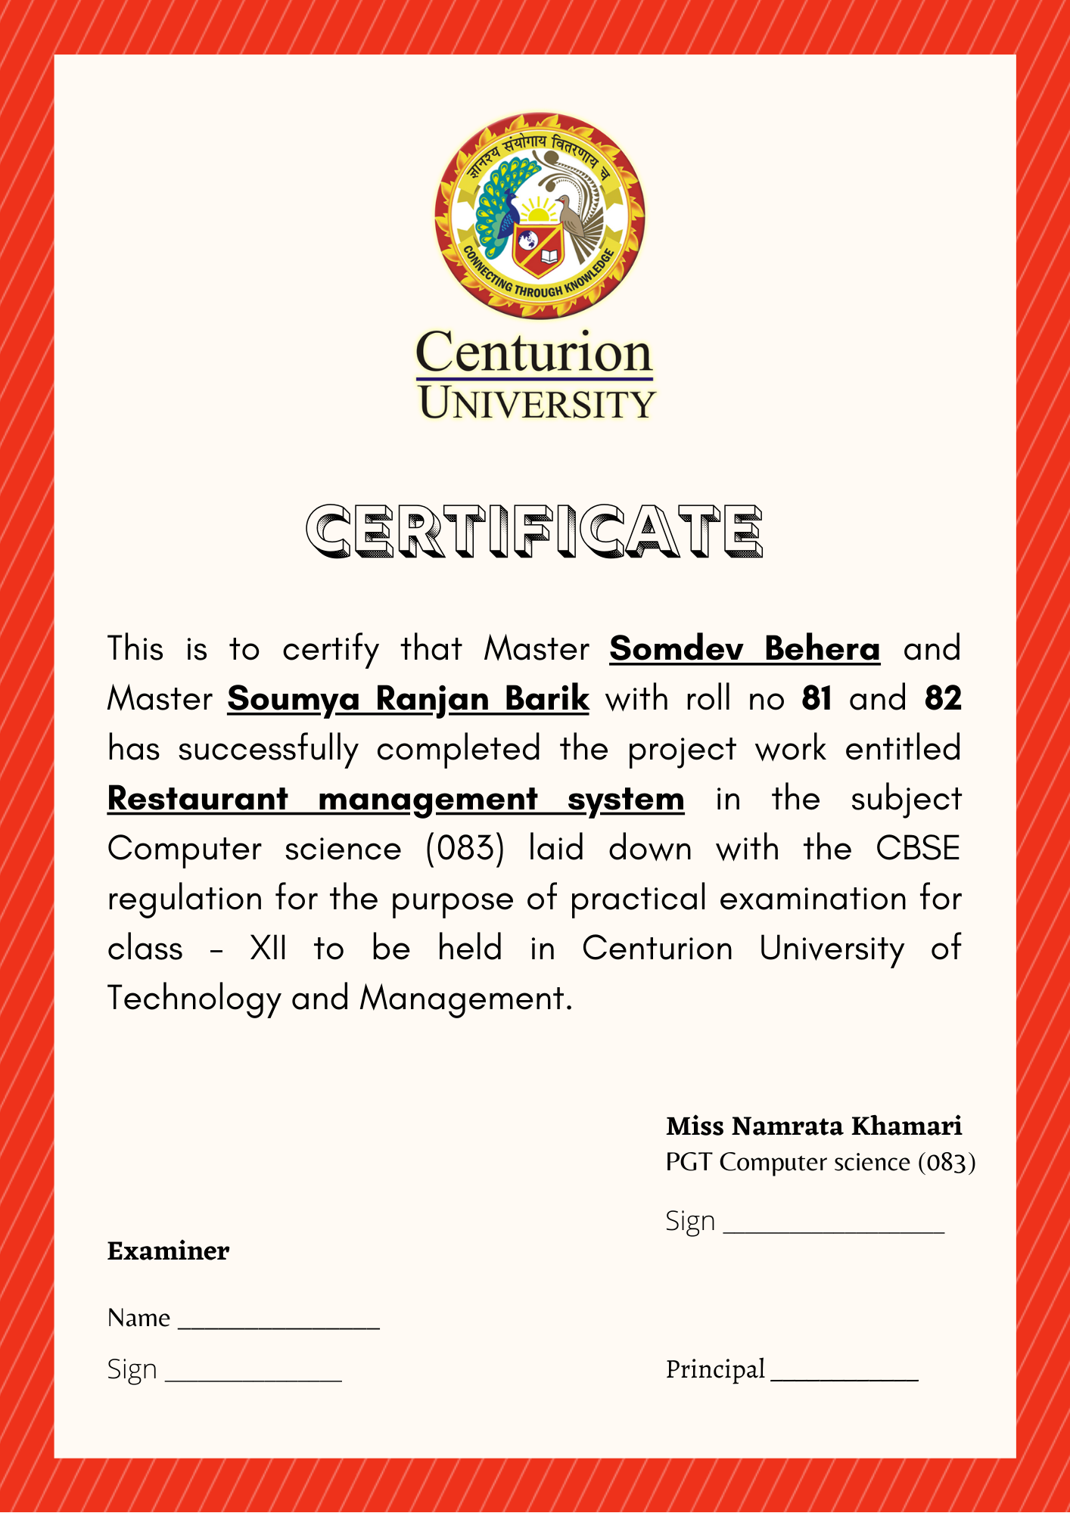

# ACKNOWLEDGMENTS

Apart from the efforts of us, the success of this project depends largely on the encouragement, guideline and support of many others. We would like to take this opportunity to express our gratitude to all the people who have been instrumental and motivating in the successful completion of this project.

We express our heartfelt gratitude to our lovable parents who always had been there with us during the course of this project.

We express gratitude and acknowledge the contribution of all the individuals who contributed in the project to real who always looked after us despite our flaws.

We express a deep sense of gratitude and respect to the Honorable Principal, Centurion Public School who never stayed back in motivating and extending their helping hands to us.

We sincerely thanks to **Miss Namrata Khamari** , master-in-charge, a guide, mentor and all the above a friend, who played a very crucial role in the success of this project by suggesting us ideas and reviewing us in our project.

The guidance and support from all the people who contributed and who are contributing was vital for the success of this project. We would like to thanks each and every individual who helped us in the course of this project.

Apart from everyone, the internet played a very major and crucial role for the success for this project. We were able to get the required resources and ideas from the internet. We would also like to acknowledge and thank Shashank Ashish Kumar Saxena Youtube channel from where we got the idea to develop this project.

At last, each and every source from where we received help, motivation, dedication, guidance, ideas and judgement are deeply acknowledged without whom this project would not have been possible.

With regards,

Somdev Behera

Soumya Ranjan Barik

# DECLARATION

We hereby declare that the project work entitled “**Restaurant Management System**” is developed under the extreme guidance of **Miss. Namrata Khamari** is being submitted as the Computer science project under the CBSE guidelines for our class - XII project work which is a part of CBSE board curriculum. This project work is a record of original work done by us. We further declare that this project record or any part of this has not been submitted for any other task.

Somdev Behera

Soumya Ranjan Barik

Class - XII

|  |  |  |
| --- | --- | --- |
| **SERIAL NO.** | **DESCRIPTION** | **PAGE NO.** |
| 1. | ACKNOWLEDGEMENT | 03 |
| 2. | DECLARATION | 05 |
| 3. | INTRODUCTION | 07 |
| 4. | OBJECTIVE OF THE PROJECT | 07 |
| 5. | PROPOSED SYSTEM | 07 |
| 6. | SYSTEM DEVELOPMENT LIFE CYCLE | 08 |
| 7. | PHASES OF SDLC | 09 |
| 8. | FLOW CHART |  |
| 9. | SOURCE CODE |  |
| 10. | TESTING |  |
| 11. | HARDWARE AND SOFTWARE RQUIREMENTS |  |
| 12. | BIBLIOGRAPHY |  |

## RESTAURANT MANAGEMENT SYSTEM

#### INTRODUCTION

The restaurant management system is basically a graphical and database based project developed with the help of python programming language and MySQL relational database management system. This project is designed to be helpful for the restaurant managers to keep a count on the items purchased by the customers. This project can be modified further for other purposes.

#### PROJECT OBJECTIVES

The main goal or objective of this project is to let students apply the programming knowledge into the real world problems and expose students to know various ideas to let them apply to solve problems by developing a useful software.

Major objectives are :

* Develop programs using modern software tools.
* Write effective codes with proper procedures to solve small to medium size problems.
* Apply the principles of object oriented programming concept while developing projects.
* Students will be exposed to the modern world of computer science and apply its concept to solve problems of software development.
* Students will be able to demonstrate the ability to conduct researches requiring writing and presenting skills in computer science.

### PROPOSED SYSTEM

Today one cannot rely on the traditional systems where every task require humans to accomplish. Today almost everyone wants to save there time anyhow. Today as the requirement of new technology is increasing, one cannot depend on the old style of human involvement in every task. So, to keep pace with time, to bring about greater efficiency with much better results without malfunctioning so to replace the traditional style of files storing data in files with the much sophisticated hard disk of a computer.

To pace up with time one must use the data management software, to replace the old style of storing data, so that storing larger data will be more convenient, with a much reduction in data inconsistency and redundancy. With the help of this data management systems, modern software are not much more efficient in doing their jobs. This has helped in reducing the time, cost and man-power. Most of the modern companies have replaced their old paper works with data management software.

Using modern data management software to store data and programming techniques to implement every proposed ideas in form of a highly efficient software can be very useful in many ways. In the future it is going to help in many more ways. Moreover, it’s the age of computers and now it’s time to take the existing technologies to the next level.

## SYSTEM DEVELOPMENT LIFE CYCLE

The system development life cycle refers to the project management technique in which complex problems are subdivided into smaller segments which are easy to manage and handle. Segmenting projects allows the user to verify the efficiency and successful completion of the different phases before allocating them to the main phase. The software development projects basically involves initiation, planning, design, development, testing, implementation and maintenance.

For example, initial project activities might be designated as request, requirement-definition, and planning phases. End users of the system under development should be involved in reviewing the output of each phase to ensure the system is being built to deliver the needed functionality.

The system development life cycle is used in the construction of server appliance.

**Planning**

**Analysis**

**Design**

**Implementation**

**Support**

Construction, testing and software development

(Consisted of three iteration on different hardware platforms)

## PHASES

### Initiation phase

The initiation phase begins when a business sponsor or developer identifies a need or an opportunity.

Initiation phase purpose is to :

* Identify and validate an opportunity to improve business success of the organization or a deficiency related to the business need.
* Identify significant assumptions and constraints on solutions to that need.
* Recommend the alternative concepts and methods to satisfy the need including questioning the need for that technology.
* Assure executive business and executive technical sponsorship. The sponsor hires a concept designer and the concept is documented to the designer.
* A successful concept proposal results in a project management procedure. This outlines the authority of the project manager to begin the project.

Careful oversight is required to ensure project support strategic business objective and resources are effectively implemented. The initiation phase basically begins when when an opportunity to add, improve, or correct a system is identified and formally requested through the presentation of a business case. The business case of course meet some criteria. This basically includes the idea of why the proposal is needed, its purpose, identify expected benefits and explain how the proposed system support one’s business strategies. The business case also must provide the alternative solution as a lot of other informal, functional, and network requirements are also possible.

### CONCEPT DEVELOPMENT PHASE

Once the business case is validated by the agency program Leadership and the agency CIO.

The purpose of the system concept development phase is to :

* Determine the feasibility and appropriateness of the alternatives.
* Identify system interfaces.
* Identify basic functional and data requirements to satisfy the business need.
* Establish system boundaries, identify goals, objectives and performance measures.
* Evaluate costs and benefits of alternatives approaches to satisfy the basic functional requirements.
* Develop high level technical architecture, process model, data model, initiate risk migration actions. This phase also explores the potential technical solutions.
* Evaluates project risks.
* It may include several trade-off decisions such as to use COTS software products or the decision to use an incremental delivery versus a complete, onetime deployment.
* Construction of executable prototypes are also encouraged to evaluate technology to support the business process. The system boundary document serves as an important reference document to support Information Technology Project Request(ITRP) process.
* The ITRP must be approved by the state CIO before the project can move forward.

### PICTORIAL REPRESENTATION OF SYSTEM DEVELOPMENT LIFE CYCLE

**Design**

**Implementation**

**Maintenance**

**Planning**

**Analysis**

### PLANNING PHASE

The planning phase is known to be the most critical step in completing development, acquisition, and maintenance of projects. Careful planning, particularly in the early stages of a project, is necessary to coordinate activities and manage project risks effectively. Project plans refine the information gathered during the initiation phase by further identifying the specific activities and resources required to complete a project.

A critical part of a project manager’s job is to coordinate discussion between user, audit, security, development and network personnel to identify and document as many functional, security and network requirements as possible. During this phase, a plan is developed that documents the approach to be used and includes a discussion of methods, tools, tasks, resources, projects schedule, and target dates are established.

A project management plan is created with a bunch of components like acquisition planning, configuration management planning, quality assurance planning, concept of operation, system security, verification and validation and system engineering management planning.

### ANALYSIS PHASE

This phase formally defines the detailed functional user requirements using high-level requirements identified in initiation, system concept and planning phases. It also figure out requirements related to data, system performance, security, and maintainability requirements for the system. The requirements are defined in this phase to a level of detail sufficient for system design to proceed. The requirements need to be measurable, testable, and relate to the business need.

The purposes of this phase are :

* Define and refine the functional and data requirements and document them in the requirement document.
* Complete business process re-engineering of functions to be supported.
* Develop detailed data and process models. (system input, output and the process)
* Develop the test and evaluation requirements that will be used to determine acceptable system performance.

### DESIGN PHASE

The design phase involves converting the informational, functional, and network requirements identified during the initiation and planning phases into an unified design that developers use to script programs during the development phase. Designer first use the top-down approach and link the major program components and interfaces then expends the connections and link smaller subsystems and connections. Using a bottom-up approach designers first identifies and link minor program components and interfaces, then expends large layouts as they identifies and link larger subsystems and connections. Contemporary design techniques often use prototyping tools that build mock-up design of items such as application screens, database layouts and system architecture. End user, designers, developers, database managers, and network administration should review and refine the prototype designs in an iterative process until they agree to an acceptable design. During this phase, the system is designed to satisfy the functional requirements identified in the previous phases. Since problems in the design phase could be very expensive to solve in the later stage of the the software development, a variety of elements are considered in the design to mitigate risk.

These includes :

* Identifying potential risk and defining mitigating design features.
* Performing a security risk assessment.
* Developing a conversion plan to migrate current data to the new system.
* Determining the operating environment.
* Defining major subsystems and their inputs and outputs.
* Allocating processes to resources.
* Preparing detailed logic specifications for each software module. The result is a draft system document which captures the preliminary design for the system.
* Everything requiring user input or approval is documented and reviewed by the user. Once these documents have been approved by the Agency CIO and Business sponsor, the final system design document is created to serve as the main design for the program.
* The document receives a review by the agency technical and functional representatives to ensure it satisfies the requirements. Later the agency project manager begins development for the implementation plan, operation and maintenance manual and the training plan.

### DEVELOPMENT PHASE

The development phase involves converting the actual design plan into executable programs. Effective development standards includes requirements that programmers and other project participants discuss design specification before programming begins. The procedures help ensure programmers clearly understand program design and functional requirements. Programmers use various techniques to develop computer programs. The large transaction oriented programs associated with financial institutions use procedural programming techniques. Procedural programming involves the line-by-line scripting of logical instructions that are combined to form a program. Effective completion of previous phases is a key factor in the success of the development phase. This phase consist of :

* Translating the detailed requirements and design into system components.
* Testing individual elements for usability.
* Preparing for integration and testing of the IT system.

### INTEGRATION AND TEST PHASE

* Subsystem integration, system, security, and user acceptance testing is conducted during the integration and test phase. The user with those responsible for quality assurance, validates that the functional requirements, as defined in the functional requirement document, are satisfied by the developed system. OIT security staff assesses the system security and issue a security certificate and accreditation prior to installation.

*Multiple levels of testing are performed including :*

* Testing at the development facility by the contractor and by the end user.
* Testing at a deployed system with end users and contract personnel.
* Operational testing by end user alone performing all functions. Requirements are traced throughout testing, a final independent verification and validation evaluation is performed and all documentation is reviewed and accepted prior to acceptance of the system.

### OPERATION AND MAINTENANCE PHASE

The system operation is ongoing. The system is monitored for continued performance in accordance with user requirements and needed system modification are incorporated. Operation continue as long as the system can be effectively adapted to the respond to organization need. When modification or changes are identified, the system may re-enter the planning phase.

Purpose of planning phase is to :

* Operate, maintain and enhance the system.
* Certify that the system can process sensitive information.
* Conduct periodic assessments of the system to ensure the functional requirements continue to be satisfied.
* Determine when the system needs to be modernized, replaced or retired.