Spring Boot

1. Validations in Spring Boot:

In Spring Boot, validations are done using the Java Bean Validation framework, typically with Hibernate Validator as the default implementation. You define validation rules by adding annotations such as @NotNull, @Size, or @Email directly on the fields of your data transfer objects (DTOs). When a controller method receives input, you use the @Valid or @Validated annotation on the method parameter to tell Spring to automatically check these rules. If the input violates any validation constraint, Spring throws an exception like MethodArgumentNotValidException. To provide clear and consistent error responses, you can handle these exceptions globally using a class annotated with @RestControllerAdvice and methods annotated with @ExceptionHandler.
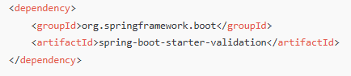

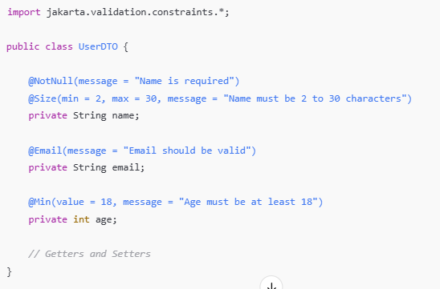

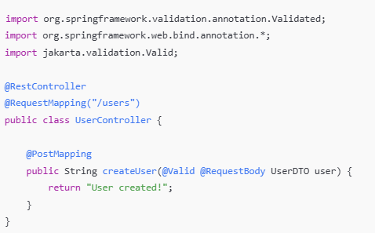

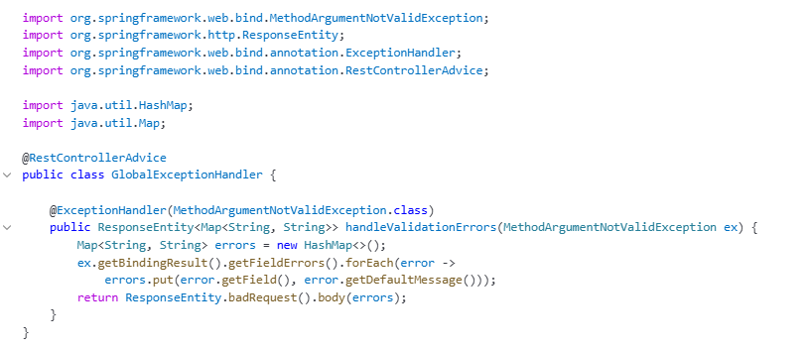

2. @RestControllerAdvice:

@RestControllerAdvice is a specialized annotation in Spring Boot used to handle exceptions globally across all @RestController classes.
It is a combination of:
- @ControllerAdvice (for global exception handling),
- and @ResponseBody (to return data as JSON/XML instead of a view).
3. @ControllerAdvice :

@ControllerAdvice is a special annotation in Spring that allows you to handle exceptions and apply common logic across multiple controllers in one place. It acts like a global interceptor for controllers.
When you annotate a class with @ControllerAdvice, you can define methods with @ExceptionHandler, @InitBinder, or @ModelAttribute annotations inside it. These methods will apply to all controllers (or a subset if you configure it) in your application.

4. Relaxed Binding:

Spring Boot uses some relaxed rules for binding Environment properties to @ConfigurationProperties beans, so there does not need to be an exact match between the Environment property name and the bean property name. Common examples where this is useful include dash-separated environment properties (for example, context-path binds to contextPath), and capitalized environment properties (for example, PORT binds to port).
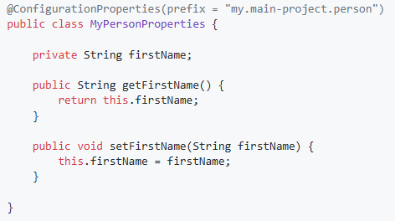

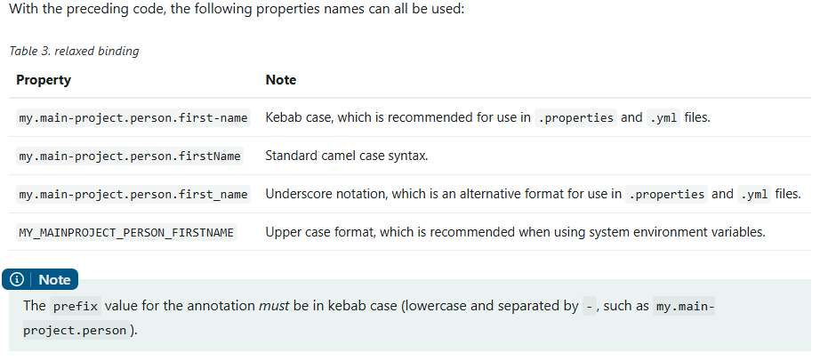
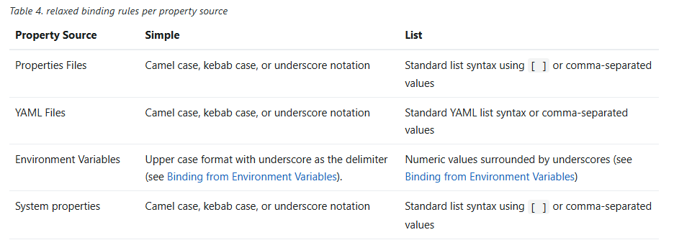
5. application.properties vs application.yml:

yml is more beneficial. Because it has Cleaner Structure, Less Repetition, Better Grouping, Useful for Complex Configs, More Human-Friendly.
If both .properties and .yml files exist Spring Boot merges them, but if the same key is present in both, .properties usually overrides .yml unless explicitly prioritized.
Means: whichever get loaded later it overrides the other one.

We can change the order of loading:

- spring.config.location → most direct control over file priority:

- @PropertySource → manually load .properties into the context
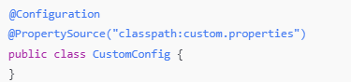

This gives the loaded file lower priority than application.properties and application.yml

6. Order of loading:

Spring Boot uses a very particular PropertySource order that is designed to allow sensible overriding of values, properties are considered in the the following order:

- Command line arguments.
- Java System properties (System.getProperties()).
- OS environment variables.
- @PropertySource annotations on your @Configuration classes.
- Application properties outside of your packaged jar (application.properties including YAML and profile variants).
- Application properties packaged inside your jar (application.properties including YAML and profile variants).
- Default properties (specified using SpringApplication.setDefaultProperties).

7. Spring Profiles:
In Spring Boot, profiles let you define different configurations for different environments — like dev, test, or prod — and load them automatically based on which profile is active.

8. @Profile:
@Profile is used to load specific beans only when a matching profile is active. It works with spring.profiles.active, which activates the environment.

9. What is cyclic dependency in Spring?
A cyclic dependency occurs when two or more beans depend on each other, leading to a circular reference that Spring cannot resolve during bean creation. This can lead to errors during application startup unless proxy-based dependency injection (like @Lazy) is used.
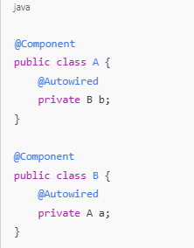

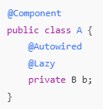

10. Internal working of @Lazy:
Spring reads the @Lazy annotation on field B b.
It does not inject the real B into A immediately.
Instead, it injects a proxy object (like a shell) that acts like B but doesn’t trigger its construction yet.
Spring creates A first (no problem, because it only injected a proxy for B).
Then it creates B and injects A into B as normal.
When any method of A is called Spring sees that the proxy for B is being used.
It now creates the real B bean (just-in-time).
Then it forwards the method call to the real object.
11. Advantages of singleton beans:
Spring creates the object only once, and whenever the application needs it, Spring reuses the same object instead of creating a new one.
This is useful because it saves memory (no need to create multiple copies), and the performance is better (object is ready to use). It's also easier to maintain because all parts of the application use the same instance, so if something changes in that object, it reflects everywhere.
Singleton is best when the bean does not hold any user-specific or request-specific data — like a logging service, database connector, or utility class.

12. Spring AOP:

AOP stands for Aspect-Oriented Programming.
It helps us separate cross-cutting concerns (like logging, security, transactions) from the main business logic.
Think of it as a way to inject behavior before, after, or around method calls, without changing the actual code.

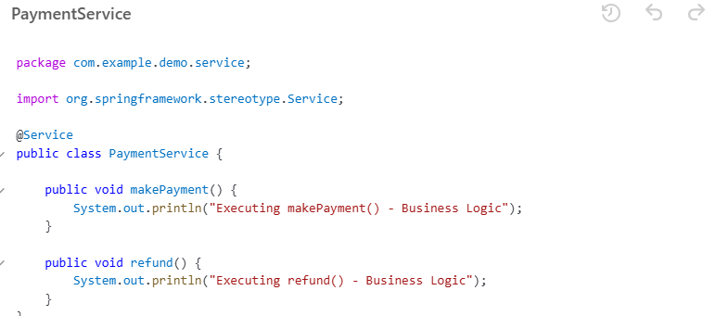
Aspect: Class where you define extra behavior (e.g., logging, security).
Advice: The action taken by the aspect (e.g., code that runs before or after a method).
Join Point: A point in your program (usually a method) where advice can be applied.
Pointcut: Expression that matches join points (e.g., all methods in a package).
Weaving: Linking aspects to other parts of your code at runtime.

Join Point:
These two methods (makePayment(), refund()) are join points—specific points where AOP code can run.

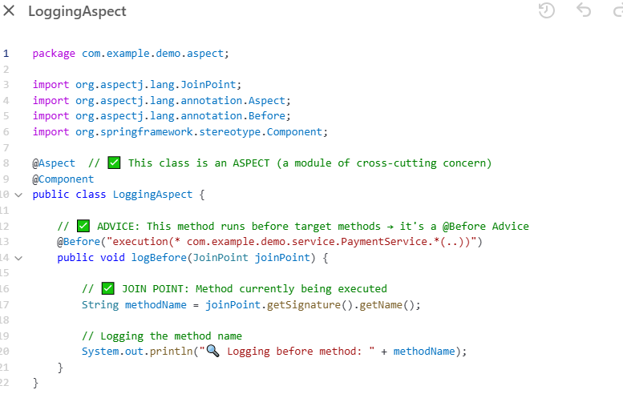

Pointcut:
"execution(* com.example.demo.service.PaymentService.*(..))"
This is the pointcut expression. It matches all methods in PaymentService.
Advice:
The logBefore() method is the advice. It runs before the matched method is executed.
Weaving:
Spring AOP does weaving at runtime—it connects the LoggingAspect to PaymentService methods when the app runs.

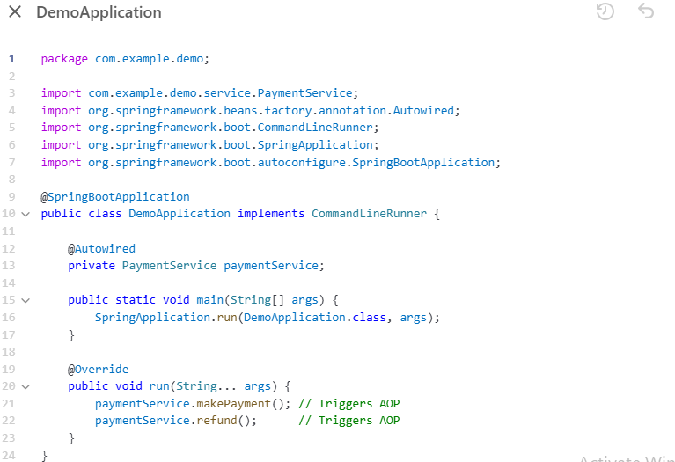

13. Actuator:
Spring Boot Actuator is a built-in tool that provides ready-to-use endpoints to monitor and manage your Spring Boot application in production.

Feature | What It Does
/actuator/health | Shows app health (up/down)
/actuator/info | Shows custom info (version, name, etc.)
/actuator/metrics | Shows memory, CPU, GC, HTTP requests, etc.
/actuator/beans | Lists all Spring beans
/actuator/env | Shows environment properties (env, props)
/actuator/loggers | View or change logging levels at runtime
/actuator/mappings | Shows all URL endpoints in your app

14. How to handle mulitple beans in spring boot?/@Qualifier and @Primary:

@Primary and @Qualifier can be used to resolve ambiguity when multiple beans of the same type are available for injection.

@Primary is used to mark one bean as the default when multiple beans of the same type exist. @Qualifier is used when you want to inject a specific bean by name.

**
@Primary = “If you don’t say anything, pick me.”
@Qualifier = “I want this specific bean, no matter what.”
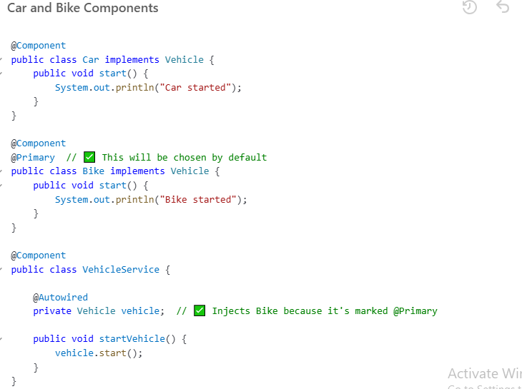

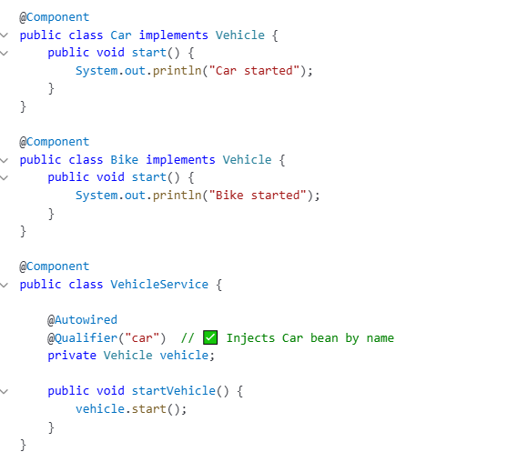
NB: @Qualifier can override @Primary

17. How can you validate two specific conditions in a YAML property file when creating a bean in Spring Boot?

To validate multiple YAML properties when creating a Spring bean, you can use @ConditionalOnExpression.

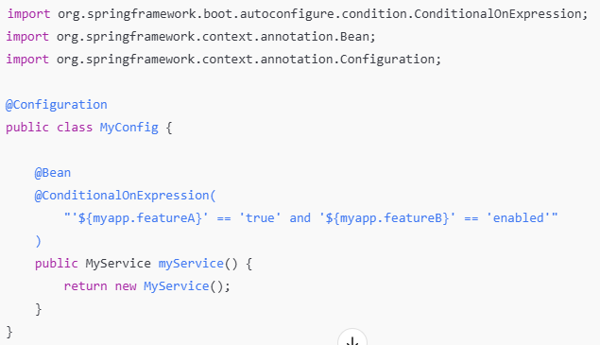
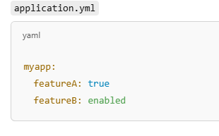

NB: Make sure to wrap the ${} values in quotes ' to treat them as strings in the expression.

**Other conditions:
Here are simple examples for each conditional annotation shown in your image:

✅ 1. @ConditionalOnProperty
Use when: You want to create a bean only if a specific property is set.
application.yml:
app.feature.enabled: true
Java:
@Bean
@ConditionalOnProperty(name = "app.feature.enabled", havingValue = "true")
public FeatureService featureService() {
return new FeatureService();
}

✅ 2. @ConditionalOnClass
Use when: You want to create a bean only if a specific class is present in the classpath.
Java:
@Bean
@ConditionalOnClass(name = "com.mysql.cj.jdbc.Driver")
public DataSource mysqlDataSource() {
return new HikariDataSource();
}

✅ 3. @ConditionalOnMissingBean
Use when: You want to create a bean only if a bean of the same type does NOT already exist.
Java:
@Bean
@ConditionalOnMissingBean(UserService.class)
public UserService userService() {
return new DefaultUserService();
}

✅ 4. @ConditionalOnBean
Use when: You want to create a bean only if another bean already exists.
Java:
@Bean
@ConditionalOnBean(UserRepository.class)
public UserReportService userReportService() {
return new UserReportService();
}

✅ 5. @ConditionalOnExpression
Use when: You want to create a bean based on SpEL (Spring Expression Language) conditions.
application.yml:
app.mode: prod
Java:
@Bean
@ConditionalOnExpression("'${app.mode}' == 'prod'")
public ProdOnlyService prodOnlyService() {
return new ProdOnlyService();
}

✅ 6. @ConditionalOnMissingClass
Use when: You want to create a bean only if a class is NOT on the classpath.
Java:
@Bean
@ConditionalOnMissingClass("com.external.LibraryX")
public BackupService backupService() {
return new BackupService();
}

📌 Summary Table
Annotation | Condition | Example Use Case
@ConditionalOnProperty | Property value check | Feature toggle
@ConditionalOnClass | Class exists | Load bean if JDBC driver is present
@ConditionalOnMissingBean | No existing bean of type | Provide fallback/default bean
@ConditionalOnBean | Bean exists | Dependent bean setup
@ConditionalOnExpression | SpEL expression is true | Complex logic using properties
@ConditionalOnMissingClass | Class is absent | Avoid loading beans if library is missing

Let me know if you'd like me to bundle these into a single runnable Spring Boot project!

**Custom condition:
create a bean only if the current day is Monday.
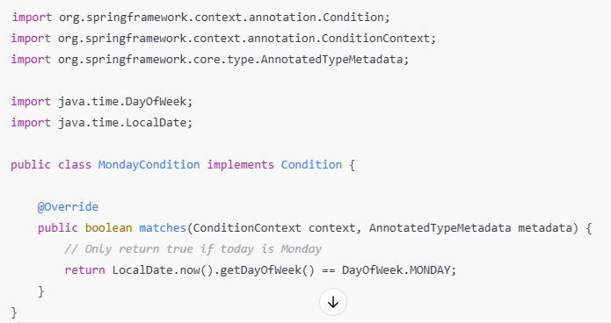

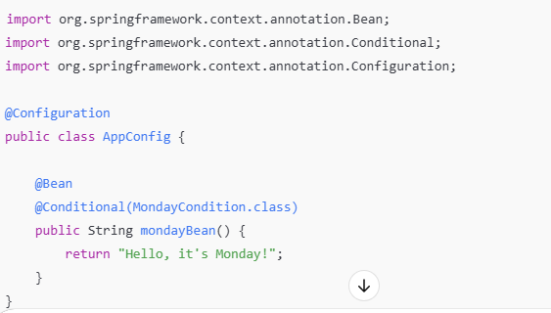
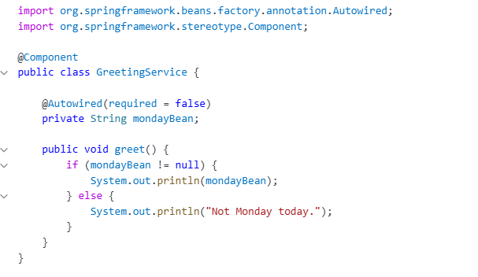

18. Can you use multiple bean Configurations in Spring Boot?

Yes. Just have to use below annotation in main class
@ComponentScan(basePackages = {"com.yourapp", "com.other.configpackage"})

19. How to make a bean optional?
@Autowired(required = false)

20. Suppose your spring application is is experiencing performance issues under high load. What steps would you take to diagnose and resolve the issue?

We can different types of profiling and monitoring for real time metrics(memory, CPU etc.)

Types of Profiling to Use:
- CPU Profiling – Find methods using too much CPU.
- Thread & Memory Profiling – Detect memory leaks, thread locks.
- Database Profiling – Spot slow/unindexed queries.
- Log Analysis – Identify hidden issues or patterns.
- Real-Time Monitoring – Get alerts as issues occur.
- Transaction Tracing – Track a request across services to locate delays.

Tools to Use:
- JProfiler – Analyze CPU and memory usage.
- VisualVM – Live monitoring of memory and threads.
- Spring Boot Actuator + Micrometer – Get application metrics.
- Zipkin – Trace requests across microservices.

21. How to define custom annotation in spring boot?
You can define a custom annotation in Spring Boot when you want to apply reusable logic across multiple classes or methods, such as logging, validation, or security. You define it using @interface, and then use AOP or custom logic to handle its behavior at runtime.

eg.
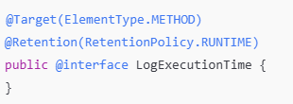

22. what is Caching in spring boot?
Caching in Spring Boot is used to store the result of method calls so that repeated calls with the same input return the stored result instead of recalculating or hitting the database again. This helps in improving performance and reducing load on services or databases.
Spring Boot provides built-in support for caching using annotations like @Cacheable, @CachePut, and @CacheEvict. You can use in-memory caches like ConcurrentHashMap, or integrate with external ones like Redis, Ehcache, etc.
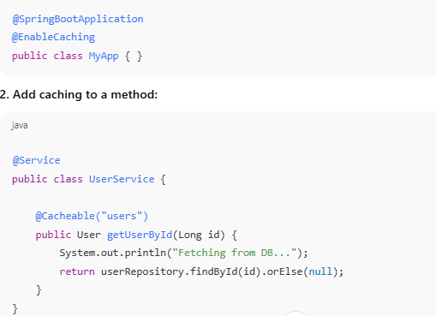

23. How inter communication happens in microservices? give example with RestTemplate with eureka
Microservices communicate either synchronously (via HTTP using REST clients) or asynchronously (using messaging systems like Kafka, RabbitMQ).
Using Eureka for service discovery, microservices don’t need to know exact URLs — they call each other using service names, and Eureka resolves the correct instance.
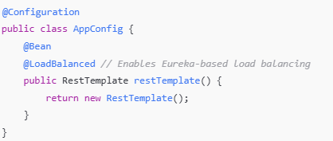

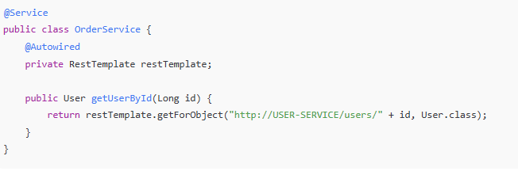

24. How can we customize automatic configuration in spring boot?
Spring Boot comes with auto-configuration, which configures components based on the dependencies in the classpath.
You can customize it in several ways:
- Override default beans using @Bean
- Use @ConditionalOnMissingBean to let your beans take priority
- Use application.properties or application.yml to override settings
- Exclude auto-config classes using @SpringBootApplication(exclude = …)
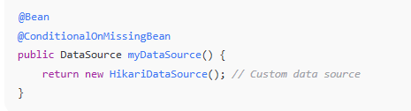

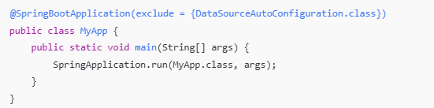

25. Explain iffernet scopes available in spring boot?
Spring Boot supports multiple bean scopes:
Scope | Description
singleton | (Default) One instance per container
prototype | New instance each time it's requested
request | One instance per HTTP request (Web)
session | One per HTTP session (Web)
application | One per ServletContext
websocket | One per WebSocket session

26. How to create custom scope in sprint boot?

To create a custom scope, implement the org.springframework.beans.factory.config.Scope interface and register it using CustomScopeConfigurer.

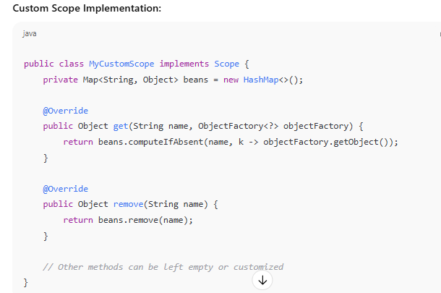
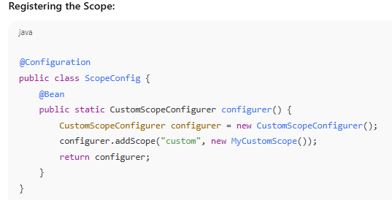
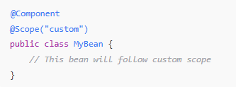

27. What is the difference between service registry and service discovery?
In a microservices architecture, services need to find and communicate with each other. Since services can scale up/down or change IPs, we can't hardcode their locations. This is where Service Registry and Service Discovery come into play.

1. Service Registry
- It’s like a phone book for microservices.
- It stores the network locations (host and port) of each service instance.
- When a service starts, it registers itself with the registry.
Example tools: Eureka Server, Consul, Zookeeper

2. Service Discovery
- It’s the process of looking up a service’s location using its name.
- A service (or a load balancer) queries the registry to discover the address of another service.
Can be of two types:
- Client-side discovery: Client gets instance list and makes request (e.g., Netflix Eureka with RestTemplate)
- Server-side discovery: A proxy (e.g., Zuul or API Gateway) handles discovery

28. explain saga design pattern
The Saga Pattern is a microservices transaction management pattern used to maintain data consistency across multiple services without using distributed transactions.
Instead of locking resources across services, Saga breaks a transaction into a series of local transactions. Each service performs its own part and either proceeds or compensates (rolls back) based on success or failure.
29. Explain Idempotency in microservices.
Idempotency means that making the same request multiple times will have the same effect as making it once. It's a key concept in microservices to ensure safety, consistency, and fault tolerance — especially in scenarios involving retries or network issues.
Without idempotency, the same operation could be processed multiple times, leading to incorrect results — like multiple payments, duplicate records, etc.
GET, PUT, DELETE → are idempotent
POST → is not idempotent (but can be made idempotent)
30. how to achieve loose coupling between two microservices services?
Loose coupling means microservices are independent — changes in one service don’t break or tightly affect others. This is essential for scalability, independent deployment, and better fault tolerance in microservices architecture.

Techniques to Achieve Loose Coupling

1. Use REST APIs with well-defined contracts
2. Use Asynchronous Communication (Event-driven) like kafka
3. Use API Gateway
4. Service Discovery with Eureka
5. Avoid Direct Database Sharing
6. Use Interface-based Communication

31. Explain fault tolerance
Fault tolerance is the ability of a system to continue operating properly even when one or more of its components fail.
In a microservices architecture, where many services interact over the network, failures are inevitable — services may go down, become slow, or return errors. A fault-tolerant system detects these failures and handles them gracefully to maintain overall system reliability and availability.
Without fault tolerance:
- A single failed service can crash the entire application.
- Cascading failures may happen when one service’s failure causes others to fail.

Common Fault Tolerance Techniques

1. Circuit Breaker
Stops calling a failing service for a period of time. Prevents repeated failures from overwhelming the system.
📦 Tools: Resilience4j, Hystrix (legacy)
java
CopyEdit
@CircuitBreaker(name = "inventoryService", fallbackMethod = "fallbackInventory")
public Product getProduct() {
return restTemplate.getForObject("http://INVENTORY-SERVICE/product", Product.class);
}

public Product fallbackInventory(Throwable t) {
return new Product("Default", 0);
}

2. Retries
Automatically retry the request a few times before failing.
java
CopyEdit
@Retry(name = "paymentService", maxAttempts = 3)
public PaymentResponse pay() {
// call external service
}

3. Timeouts
Avoid waiting indefinitely for a response. Define a maximum wait time.
properties
CopyEdit
# application.yml
resilience4j.retry.instances.paymentService.waitDuration=2s

4. Fallback
Provide an alternative response or default behavior if the main service fails.
java
CopyEdit
public Product fallbackInventory(Throwable t) {
// return a default product if service fails
return new Product("Fallback Product", 0);
}

5. Bulkhead Pattern
Isolate failures by partitioning system resources. One service's failure won’t affect others.
Example: Separate thread pools for different services.
32. Difference between hashmap and concurrent hashmap.
HashMap is faster in single-threaded environments. It allows one null key and multiple null values
ConcurrentHashMap is optimized for multi-threading, using bucket-level locking (a technique called lock striping) instead of locking the entire map like Collections.synchronizedMap(). It doesn’t support null values or keys
33. How will you remove duplicates and maintain the insertion order from duplicate array?
To remove duplicates while maintaining insertion order, you can use LinkedHashSet in Java.
34. Explain Volatile keyword.
The volatile keyword is used in Java to make a variable always visible to all threads.
Normally, when multiple threads use a shared variable, each thread may keep a copy of the variable in its own memory (cache). So if one thread changes the variable, the others may still see the old value.
When a variable is marked as volatile, Java ensures that:
- Every read of the variable gets the latest value from main memory
- Every write to the variable is immediately visible to other threads
35. Explain vertical scaling and horizontal scaling
When your application needs to handle more load (like more users or data), you can scale it in two main ways:
Vertical: Moving from a 4-core server to a 16-core server, Increasing RAM from 8 GB to 32 GB
Horizontal:
You add more machines (or instances) to handle the load.
You're running the same application on multiple servers.
Example:
- Deploying your Spring Boot app on 3 servers behind a load balancer
- Adding more pods in Kubernetes
36. == vs .equals
== Checks if both references point to the exact same object in memory. It does not compare the content.
.equals Compares the actual content or values inside the objects.

