Spring Boot

1. Validations in Spring Boot:

In Spring Boot, validations are done using the Java Bean Validation framework, typically with Hibernate Validator as the default implementation. You define validation rules by adding annotations such as @NotNull, @Size, or @Email directly on the fields of your data transfer objects (DTOs). When a controller method receives input, you use the @Valid or @Validated annotation on the method parameter to tell Spring to automatically check these rules. If the input violates any validation constraint, Spring throws an exception like MethodArgumentNotValidException. To provide clear and consistent error responses, you can handle these exceptions globally using a class annotated with @RestControllerAdvice and methods annotated with @ExceptionHandler.
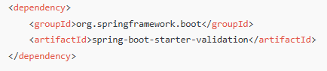

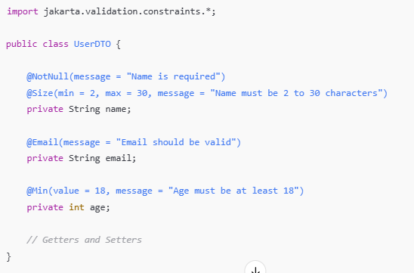

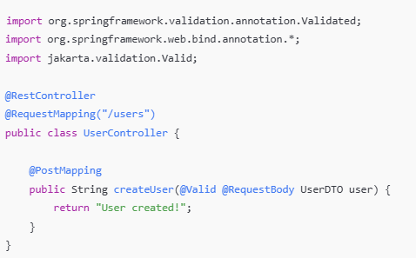

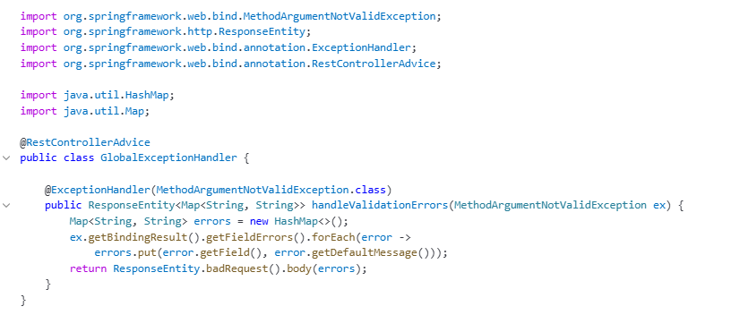

2. @RestControllerAdvice:

@RestControllerAdvice is a specialized annotation in Spring Boot used to handle exceptions globally across all @RestController classes.
It is a combination of:
- @ControllerAdvice (for global exception handling),
- and @ResponseBody (to return data as JSON/XML instead of a view).
3. @ControllerAdvice :

@ControllerAdvice is a special annotation in Spring that allows you to handle exceptions and apply common logic across multiple controllers in one place. It acts like a global interceptor for controllers.
When you annotate a class with @ControllerAdvice, you can define methods with @ExceptionHandler, @InitBinder, or @ModelAttribute annotations inside it. These methods will apply to all controllers (or a subset if you configure it) in your application.

4. Relaxed Binding:

Spring Boot uses some relaxed rules for binding Environment properties to @ConfigurationProperties beans, so there does not need to be an exact match between the Environment property name and the bean property name. Common examples where this is useful include dash-separated environment properties (for example, context-path binds to contextPath), and capitalized environment properties (for example, PORT binds to port).
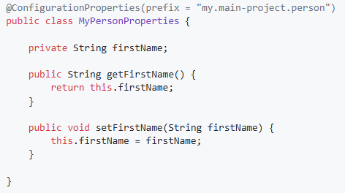

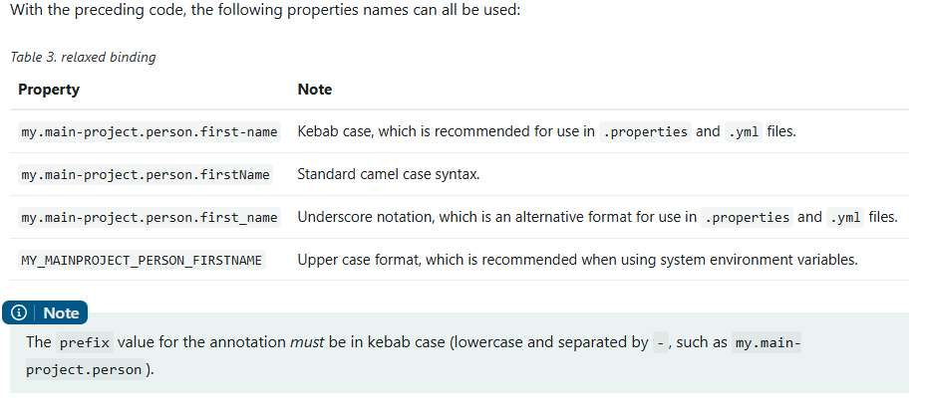
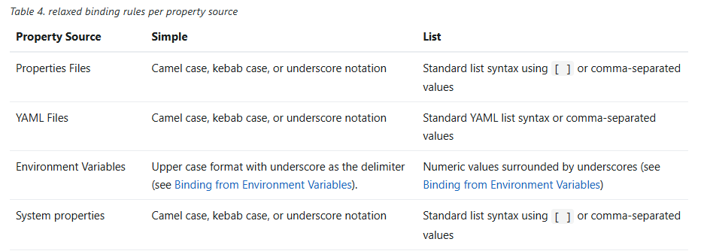
5. application.properties vs application.yml:

yml is more beneficial. Because it has Cleaner Structure, Less Repetition, Better Grouping, Useful for Complex Configs, More Human-Friendly.
If both .properties and .yml files exist Spring Boot merges them, but if the same key is present in both, .properties usually overrides .yml unless explicitly prioritized.
Means: whichever get loaded later it overrides the other one.

We can change the order of loading:

- spring.config.location → most direct control over file priority:

- @PropertySource → manually load .properties into the context
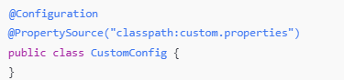

This gives the loaded file lower priority than application.properties and application.yml

6. Order of loading:

Spring Boot uses a very particular PropertySource order that is designed to allow sensible overriding of values, properties are considered in the the following order:

- Command line arguments.
- Java System properties (System.getProperties()).
- OS environment variables.
- @PropertySource annotations on your @Configuration classes.
- Application properties outside of your packaged jar (application.properties including YAML and profile variants).
- Application properties packaged inside your jar (application.properties including YAML and profile variants).
- Default properties (specified using SpringApplication.setDefaultProperties).

7. Spring Profiles:
In Spring Boot, profiles let you define different configurations for different environments — like dev, test, or prod — and load them automatically based on which profile is active.

8. @Profile:
@Profile is used to load specific beans only when a matching profile is active. It works with spring.profiles.active, which activates the environment.

9. What is cyclic dependency in Spring?
A cyclic dependency occurs when two or more beans depend on each other, leading to a circular reference that Spring cannot resolve during bean creation. This can lead to errors during application startup unless proxy-based dependency injection (like @Lazy) is used.
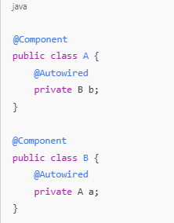

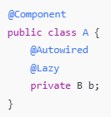

10. Internal working of @Lazy:
Spring reads the @Lazy annotation on field B b.
It does not inject the real B into A immediately.
Instead, it injects a proxy object (like a shell) that acts like B but doesn’t trigger its construction yet.
Spring creates A first (no problem, because it only injected a proxy for B).
Then it creates B and injects A into B as normal.
When any method of A is called Spring sees that the proxy for B is being used.
It now creates the real B bean (just-in-time).
Then it forwards the method call to the real object.
11. Advantages of singleton beans:
Spring creates the object only once, and whenever the application needs it, Spring reuses the same object instead of creating a new one.
This is useful because it saves memory (no need to create multiple copies), and the performance is better (object is ready to use). It's also easier to maintain because all parts of the application use the same instance, so if something changes in that object, it reflects everywhere.
Singleton is best when the bean does not hold any user-specific or request-specific data — like a logging service, database connector, or utility class.

12. Spring AOP:

AOP stands for Aspect-Oriented Programming.
It helps us separate cross-cutting concerns (like logging, security, transactions) from the main business logic.
Think of it as a way to inject behavior before, after, or around method calls, without changing the actual code.

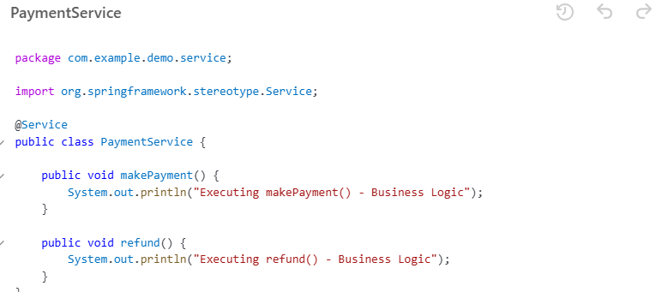
Aspect: Class where you define extra behavior (e.g., logging, security).
Advice: The action taken by the aspect (e.g., code that runs before or after a method).
Join Point: A point in your program (usually a method) where advice can be applied.
Pointcut: Expression that matches join points (e.g., all methods in a package).
Weaving: Linking aspects to other parts of your code at runtime.

Join Point:
These two methods (makePayment(), refund()) are join points—specific points where AOP code can run.

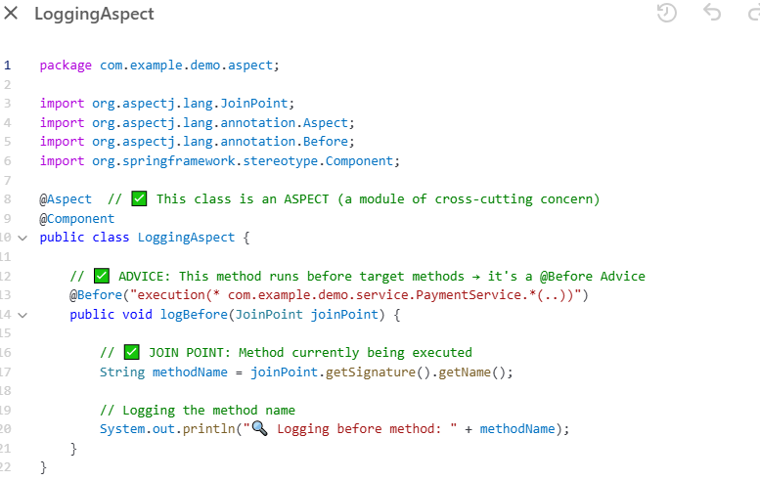

Pointcut:
"execution(* com.example.demo.service.PaymentService.*(..))"
This is the pointcut expression. It matches all methods in PaymentService.
Advice:
The logBefore() method is the advice. It runs before the matched method is executed.
Weaving:
Spring AOP does weaving at runtime—it connects the LoggingAspect to PaymentService methods when the app runs.

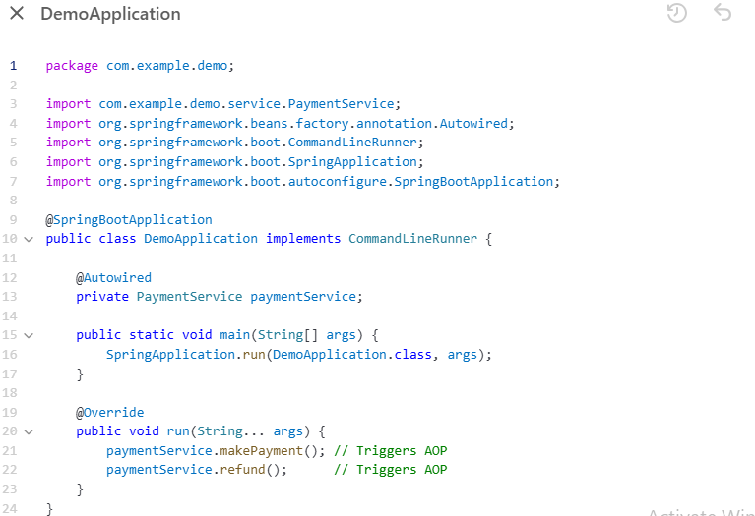

13. Actuator:
Spring Boot Actuator is a built-in tool that provides ready-to-use endpoints to monitor and manage your Spring Boot application in production.

Feature | What It Does
/actuator/health | Shows app health (up/down)
/actuator/info | Shows custom info (version, name, etc.)
/actuator/metrics | Shows memory, CPU, GC, HTTP requests, etc.
/actuator/beans | Lists all Spring beans
/actuator/env | Shows environment properties (env, props)
/actuator/loggers | View or change logging levels at runtime
/actuator/mappings | Shows all URL endpoints in your app

14. @Qualifier and @Primary:

@Primary and @Qualifier can be used to resolve ambiguity when multiple beans of the same type are available for injection.

@Primary is used to mark one bean as the default when multiple beans of the same type exist. @Qualifier is used when you want to inject a specific bean by name.

**
@Primary = “If you don’t say anything, pick me.”
@Qualifier = “I want this specific bean, no matter what.”
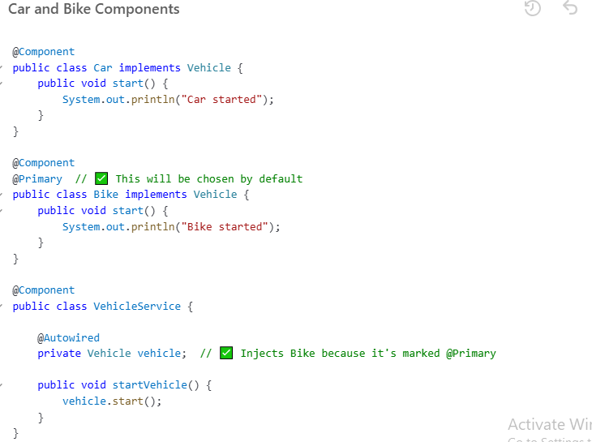

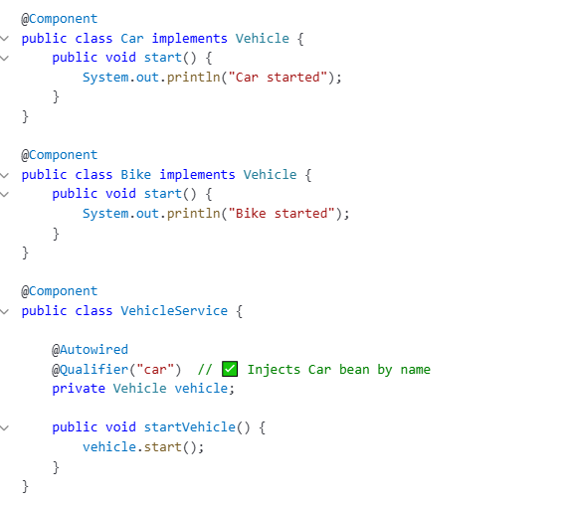
NB: @Qualifier can override @Primary

15. FixedDelay and FixedRate:

16. Cron Expression:

17. How can you validate two specific conditions in a YAML property file when creating a bean in Spring Boot?

To validate multiple YAML properties when creating a Spring bean, you can use @ConditionalOnExpression.

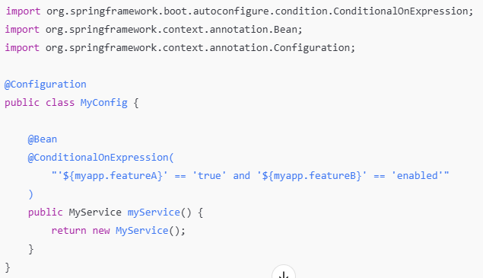
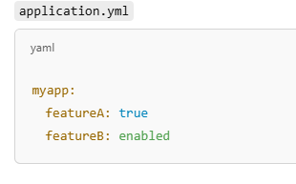

NB: Make sure to wrap the ${} values in quotes ' to treat them as strings in the expression.

18. Can you use multiple bean Configurations in Spring Boot?

Yes. Just have to use below annotation in main class
@ComponentScan(basePackages = {"com.yourapp", "com.other.configpackage"})

**Other conditions:
Here are simple examples for each conditional annotation shown in your image:

✅ 1. @ConditionalOnProperty
Use when: You want to create a bean only if a specific property is set.
application.yml:
app.feature.enabled: true
Java:
@Bean
@ConditionalOnProperty(name = "app.feature.enabled", havingValue = "true")
public FeatureService featureService() {
return new FeatureService();
}

✅ 2. @ConditionalOnClass
Use when: You want to create a bean only if a specific class is present in the classpath.
Java:
@Bean
@ConditionalOnClass(name = "com.mysql.cj.jdbc.Driver")
public DataSource mysqlDataSource() {
return new HikariDataSource();
}

✅ 3. @ConditionalOnMissingBean
Use when: You want to create a bean only if a bean of the same type does NOT already exist.
Java:
@Bean
@ConditionalOnMissingBean(UserService.class)
public UserService userService() {
return new DefaultUserService();
}

✅ 4. @ConditionalOnBean
Use when: You want to create a bean only if another bean already exists.
Java:
@Bean
@ConditionalOnBean(UserRepository.class)
public UserReportService userReportService() {
return new UserReportService();
}

✅ 5. @ConditionalOnExpression
Use when: You want to create a bean based on SpEL (Spring Expression Language) conditions.
application.yml:
app.mode: prod
Java:
@Bean
@ConditionalOnExpression("'${app.mode}' == 'prod'")
public ProdOnlyService prodOnlyService() {
return new ProdOnlyService();
}

✅ 6. @ConditionalOnMissingClass
Use when: You want to create a bean only if a class is NOT on the classpath.
Java:
@Bean
@ConditionalOnMissingClass("com.external.LibraryX")
public BackupService backupService() {
return new BackupService();
}

📌 Summary Table
Annotation | Condition | Example Use Case
@ConditionalOnProperty | Property value check | Feature toggle
@ConditionalOnClass | Class exists | Load bean if JDBC driver is present
@ConditionalOnMissingBean | No existing bean of type | Provide fallback/default bean
@ConditionalOnBean | Bean exists | Dependent bean setup
@ConditionalOnExpression | SpEL expression is true | Complex logic using properties
@ConditionalOnMissingClass | Class is absent | Avoid loading beans if library is missing

Let me know if you'd like me to bundle these into a single runnable Spring Boot project!

**Custom condition:
create a bean only if the current day is Monday.
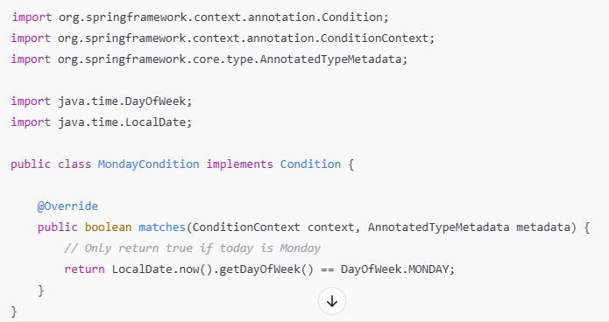

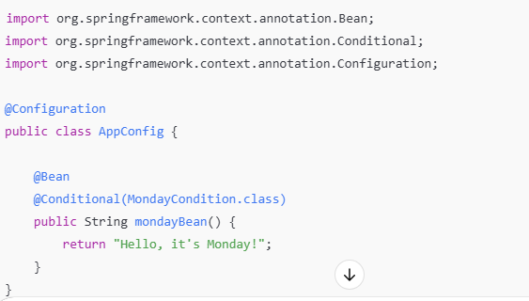
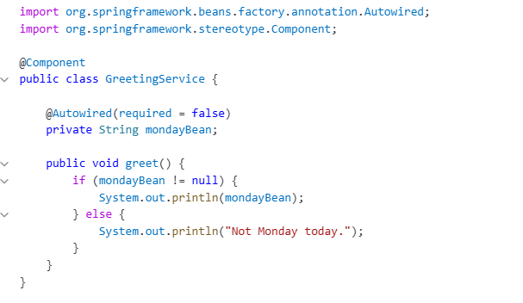

19. How to make a bean optional?
@Autowired(required = false)

20. Suppose your spring application is is experiencing performance issues under high load. What steps would you take to diagnose and resolve the issue?

We can different types of profiling and monitoring for real time metrics(memory, CPU etc.)

Types of Profiling to Use:
- CPU Profiling – Find methods using too much CPU.
- Thread & Memory Profiling – Detect memory leaks, thread locks.
- Database Profiling – Spot slow/unindexed queries.
- Log Analysis – Identify hidden issues or patterns.
- Real-Time Monitoring – Get alerts as issues occur.
- Transaction Tracing – Track a request across services to locate delays.

Tools to Use:
- JProfiler – Analyze CPU and memory usage.
- VisualVM – Live monitoring of memory and threads.
- Spring Boot Actuator + Micrometer – Get application metrics.
- Zipkin – Trace requests across microservices.

