Reinforcement learning course
Report on assignment HA1

based on work in a group: Alessia Knauss, Piergiuseppe Mallozzi, Tomasz Kosinski
(group 27 plus the report author)

MDP

a. mathematical expression relating the Q-value function Q (s, a) to the value function V (s)

Given
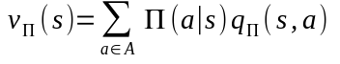and 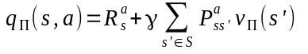

we can write