Reinforcement learning course
Assignment HA1

Report draft

MDP

a. mathematical expression relating the Q-value function Q (s, a) to the value function V (s)

Given
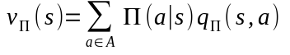and 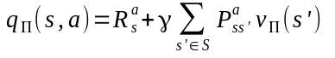

we can write