**Daily Scrum or Standup Meeting**

Team name: Group 3

Scrum Master: Hagen Larsen

Date: Feb 24, 2022

|  |  |  |  |
| --- | --- | --- | --- |
| **Team Member** | **What did you do since the last scrum?** | **What do you plan to do before the next scrum?** | **What obstacles do you have?** |
| Jade Blunt | Issues 55 and 58 | Issues 56, 72, 52 | None |
| Hagen Larsen | Issues 54 and 53 | Issue 50 | None |
| Jacob Haight | Issue 57 | Issues 60, 42, and 59 | None |
| Bennett DenBleyker | Issue 63 | Issues 68 and 62 | None |

# Burndown

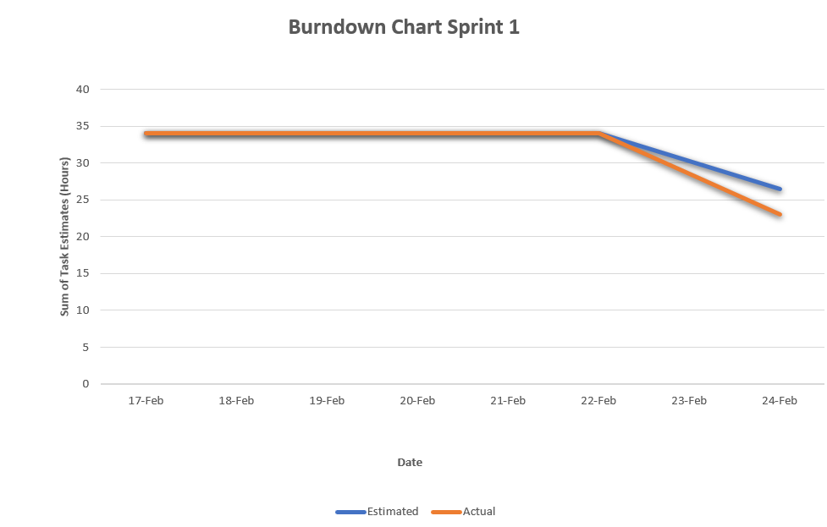

# Screenshot of you project board

