**Daily Scrum or Standup Meeting**

Team name: Group 3

Scrum Master: Hagen Larsen

Date: March 1, 2022

|  |  |  |  |
| --- | --- | --- | --- |
| **Team Member** | **What did you do since the last scrum?** | **What do you plan to do before the next scrum?** | **What obstacles do you have?** |
| Jade | Issues 56, 52 | Issue 72 | None |
| Hagen | Issue 50 | Issues 49, 51 | None |
| Bennett | Issues 68, 64, 61 | Issue 62 | None |
| Jake | Issues 60, 59 | Issue 42 | None |

# Burndown

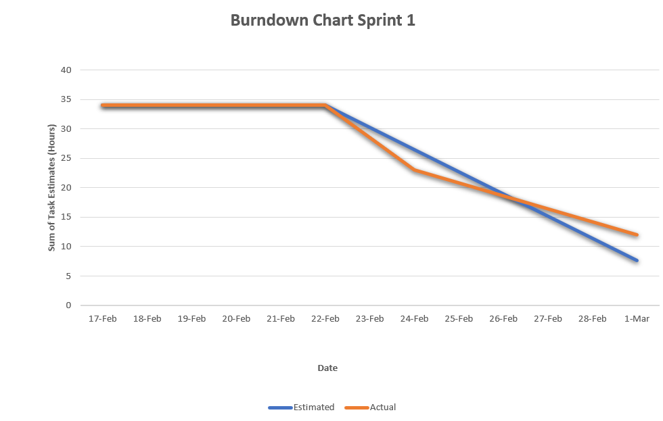

# Screenshot of you project board

