EECS 510 Final Project Report

Part 1: Design

Purpose
The purpose of this language is to multiply two binary numbers together. When a valid string is processed, the result with no extraneous characters (blank spots on either side of the result are fine) should be left on the tape.

Alphabet
Because this is a Turing machine, there will be a language alphabet and an auxiliary alphabet. When a string is processed, the intended behavior is that the input and output will consist exclusively of characters in the language alphabet; all characters outside of the language alphabet may be used for any purpose, though they should be removed before the output is returned.
For the language alphabet, since we are simply multiplying two binary numbers, we will simply have ‘0’, ‘1’, and the asterisk ‘*’ to indicate the operator for multiplication.
For our auxiliary alphabet, we will have four characters to represent numbers that have been read: ‘A’, ‘B’, ‘X’, and ‘Y’. The former two will be used to indicate that a number has been read, though we might want to do things with it later, and the latter two indicate that the value should not be changed until we wish to return the value. X and A map to 0, and B and Y map to 1.
In addition, we use two additional characters, ‘S’ and ‘E’. These characters are used to surround the output before reversing its order. When this reversing process reaches E, we know that we have finished reversing the string and simply need to remove S and E before halting.

Semantics
An input accepted by the language should consist of a string of binary numbers with non-zero length, followed by an asterisk, followed by another string of binary numbers. No more than one asterisk is allowed in an input string. In addition, the input should have no whitespace.
Examples of valid input strings:
- 0*0
- 1*1
- 00*00
- 110101*011101
Examples of invalid input strings
- 1101*
- *0
- 111*111 11
- 1 * 1

Part 2: Grammar
When I initially implemented my automata, I originally designed it as a Turing machine. I have converted that Turing machine to a grammar here.

Part 3: Automaton
This is a graph I generated using GraphViz. I’m not particularly experienced with any graph creation programs, so it’s not perfect. That being said, I think it’s at least serviceable. The graph and the gv file used to create it can be found on GitHub.
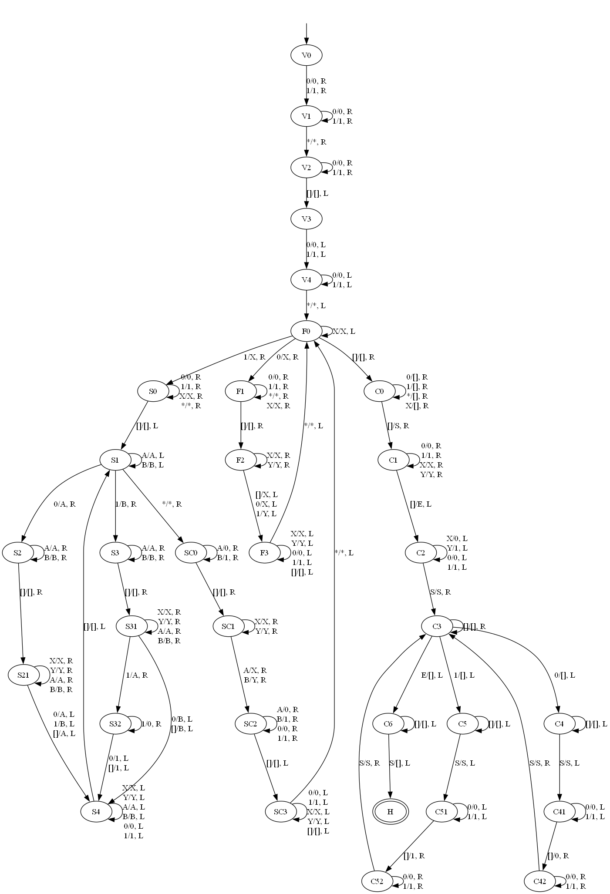

Part 4: Code Notes
The code can be run with python3 on main.py. It requires two additional arguments: a path to the automata, and a file containing test input strings. In addition, a flag “-human” can be appended to the end to show the output of the string and make the results more readable (as opposed to simply “accept” and “reject”).
When I made and tested my code, I used Python version 3.12.3.
Because recursively enumerable languages have a chance to not halt, there is a limit to the number of transitions one can take. This limit is a function of the length of the input string: $f\left(l\right)=16l^{2}+16$
For your convenience, this is the prompt that I used:
python3 main.py ./TestInputs/BinaryMultiplier.aut ./TestInputs/BinaryInputs.txt

File Formatting
Regular and recursively enumerable languages are supported by my code. To signify that a language is regular, the first line of the input file should be “REG”. If the machine is recursively enumerable, the first line should be “TUR”.
Comments are supported throughout the file, except for the first line, which must always be the machine type. To use a comment, simply make the first character in the line a pound sign ‘#’.
If a transition is not defined and the machine would need to use that transition, the machine will simply reject the input.

Regular Formatting
Line Number | Contents of line
1 | Type of machine “REG”
2 | Language alphabet
3 | List of states
4 | List of accepting states. All states listed here must appear in line 3 as well.
5 and onwards | All transitions, with the following format:  [FROM] [CONSUMED] [TO]

Turing-Specific Formatting
Line Number | Contents of line
1 | Type of machine “REG”
2 | Language alphabet
3 | List of states
4 | List of accepting states. All states listed here must appear in line 3 as well.
5 and onwards | All transitions, with the following format:  [FROM] [CONSUMED_CHAR] [REPLACED] [DIRECTION] [TO]  For the purpose of the consumed and replaced characters, an empty string represents a blank, and ‘L’ and ‘R’ represent directions.

Input Formatting
The file containing the input strings is simply a list of strings, separated by newline. Comments are not supported.

