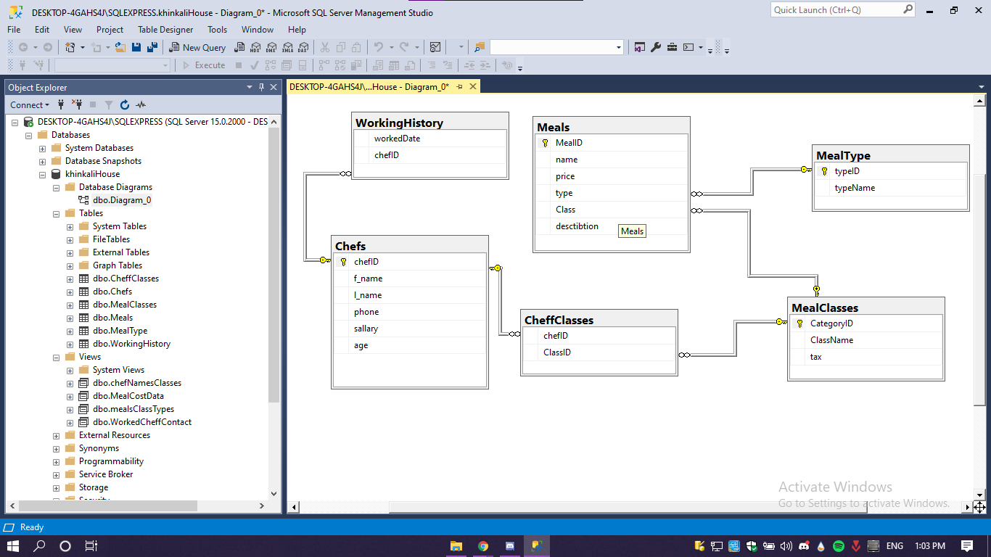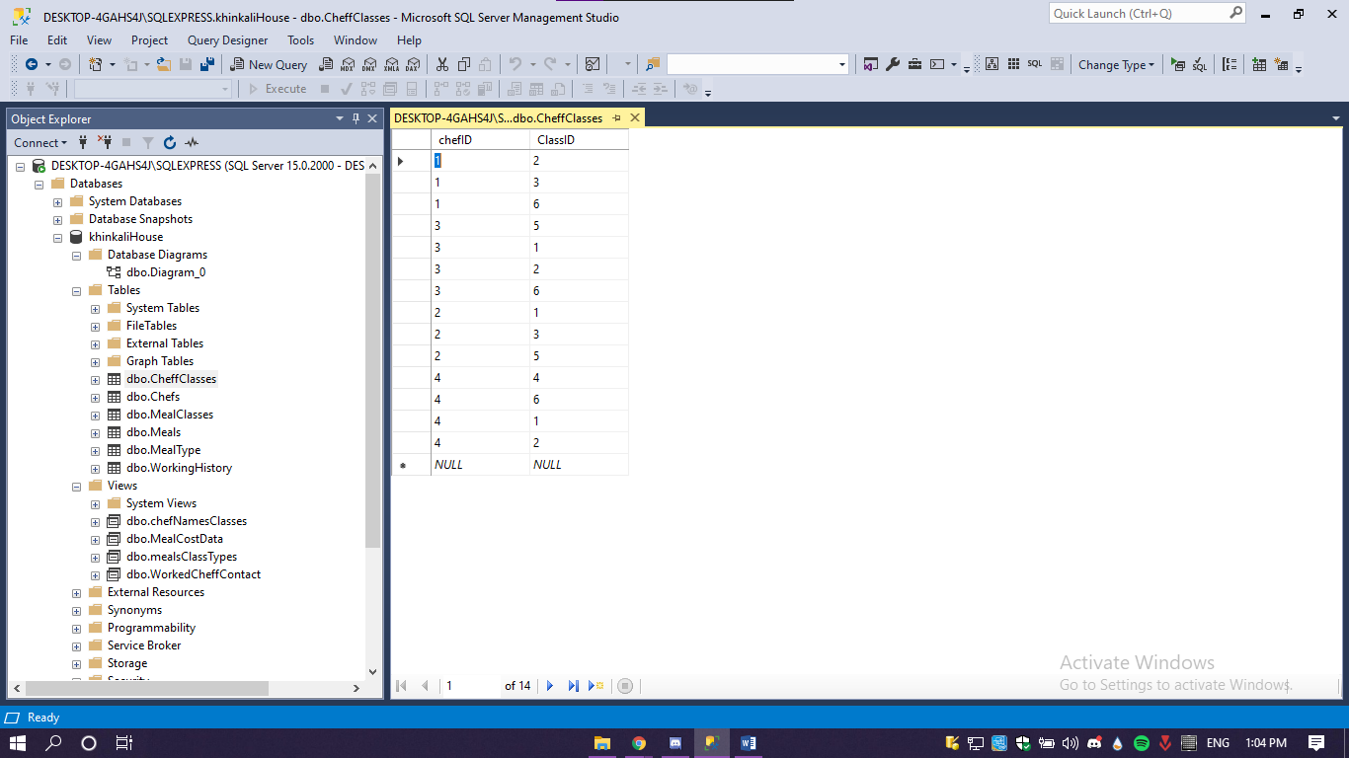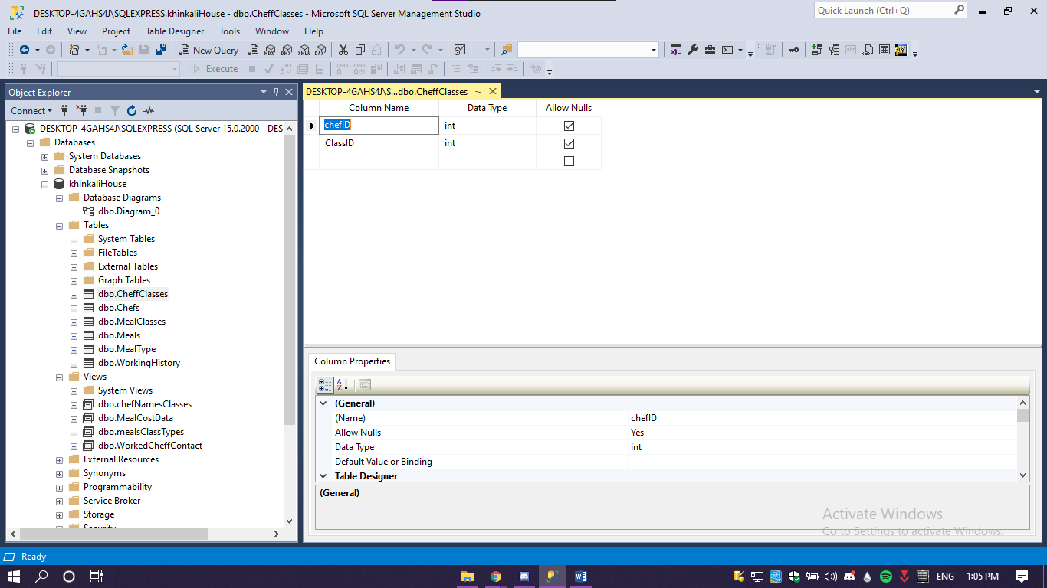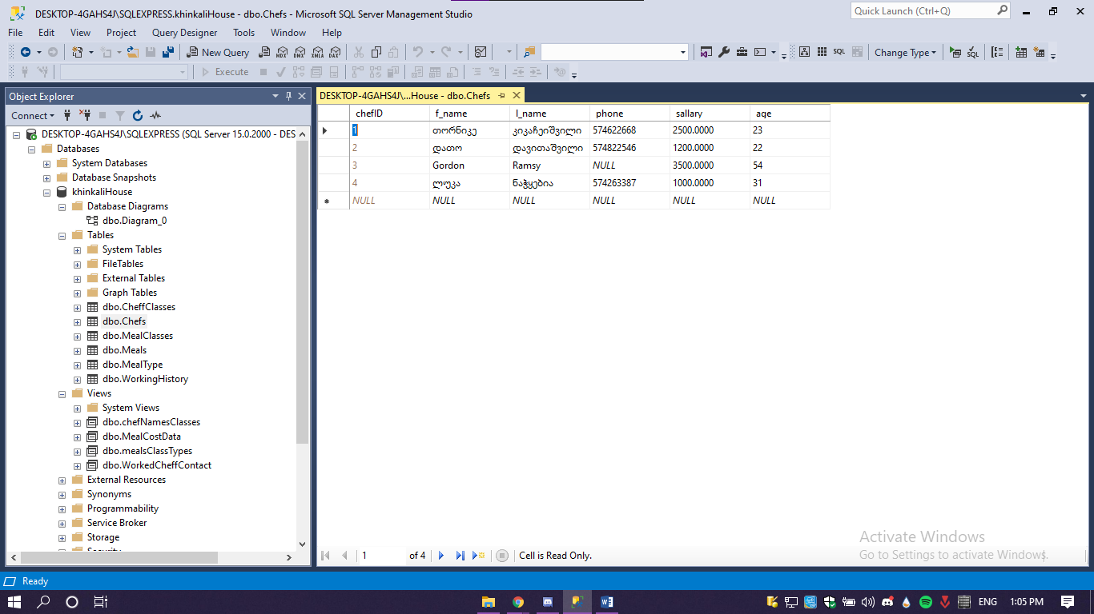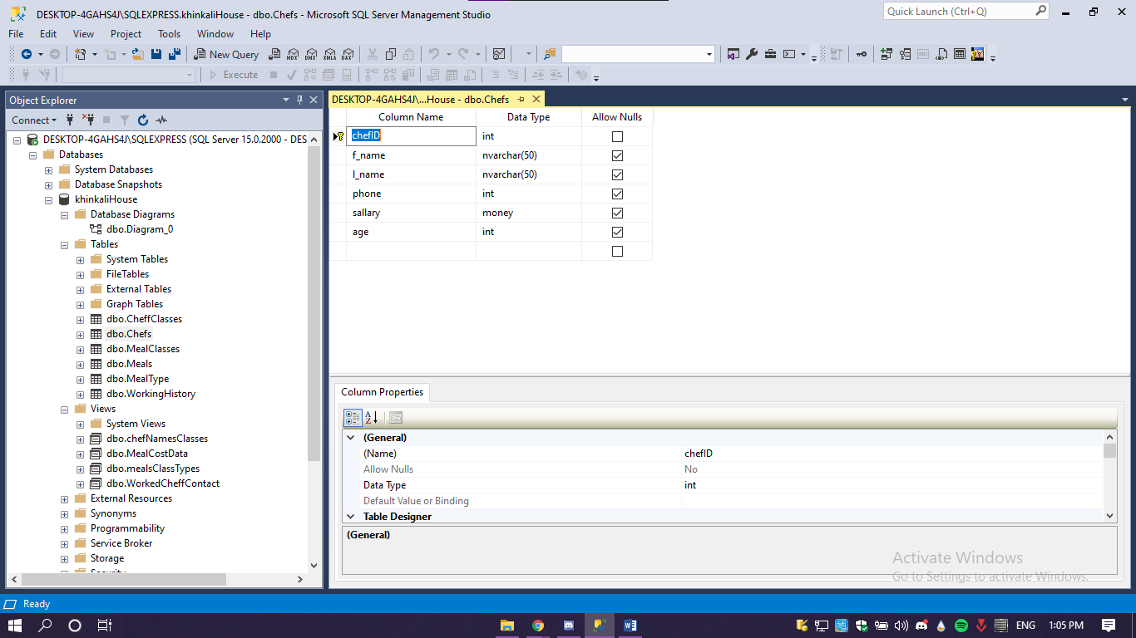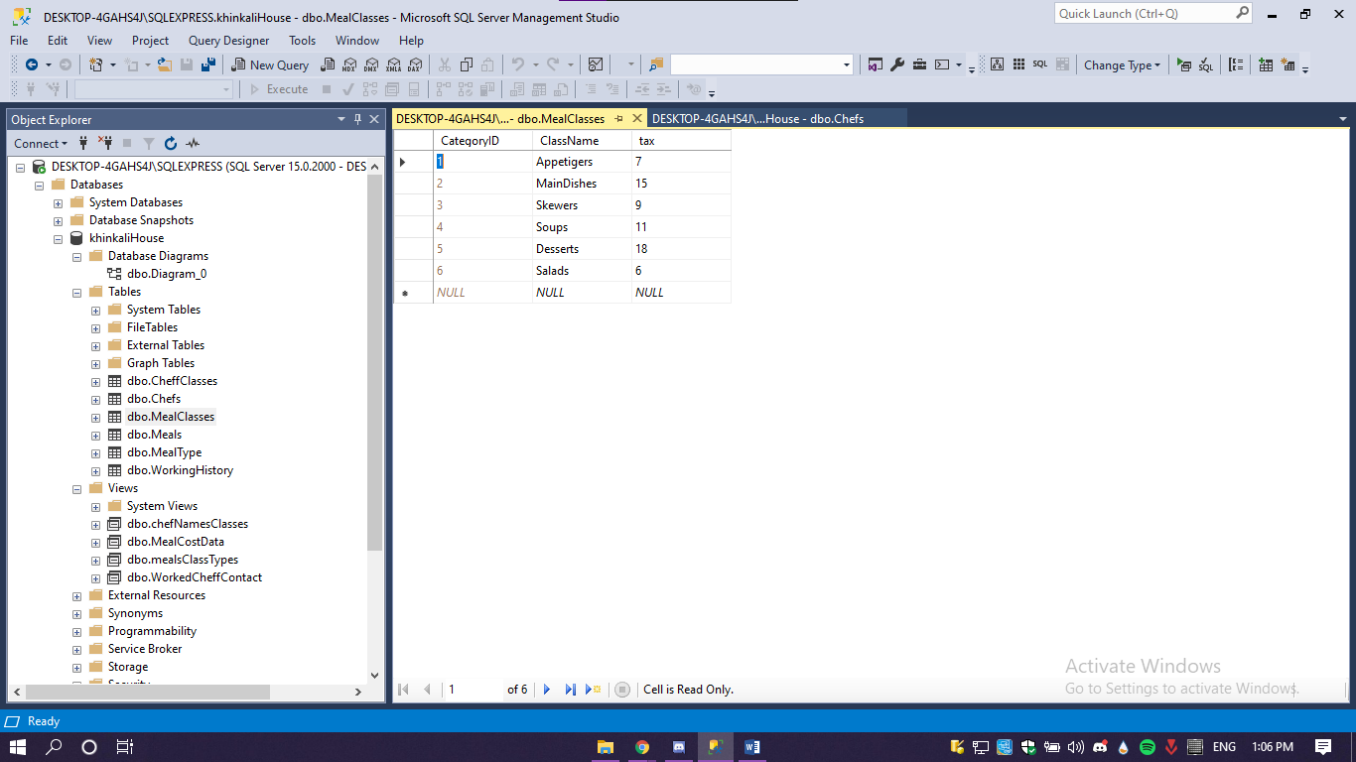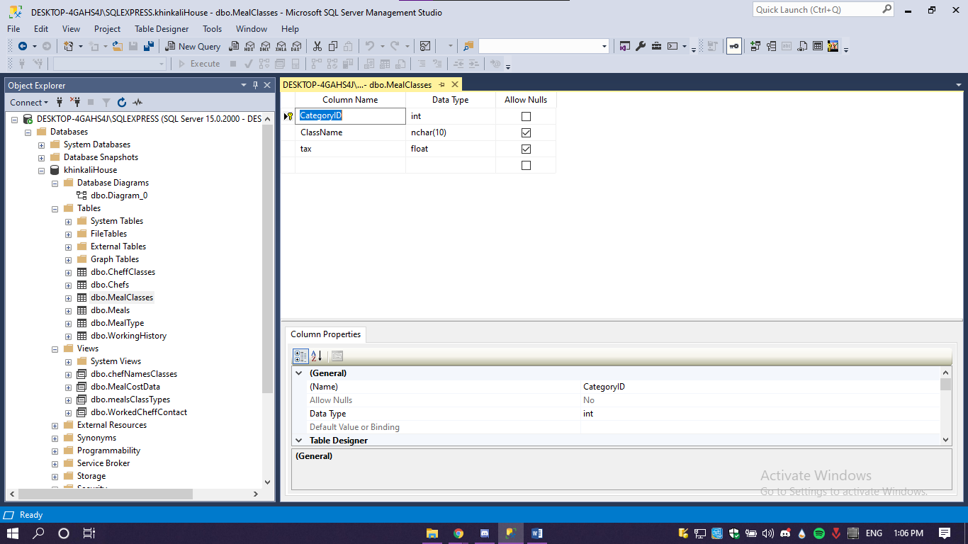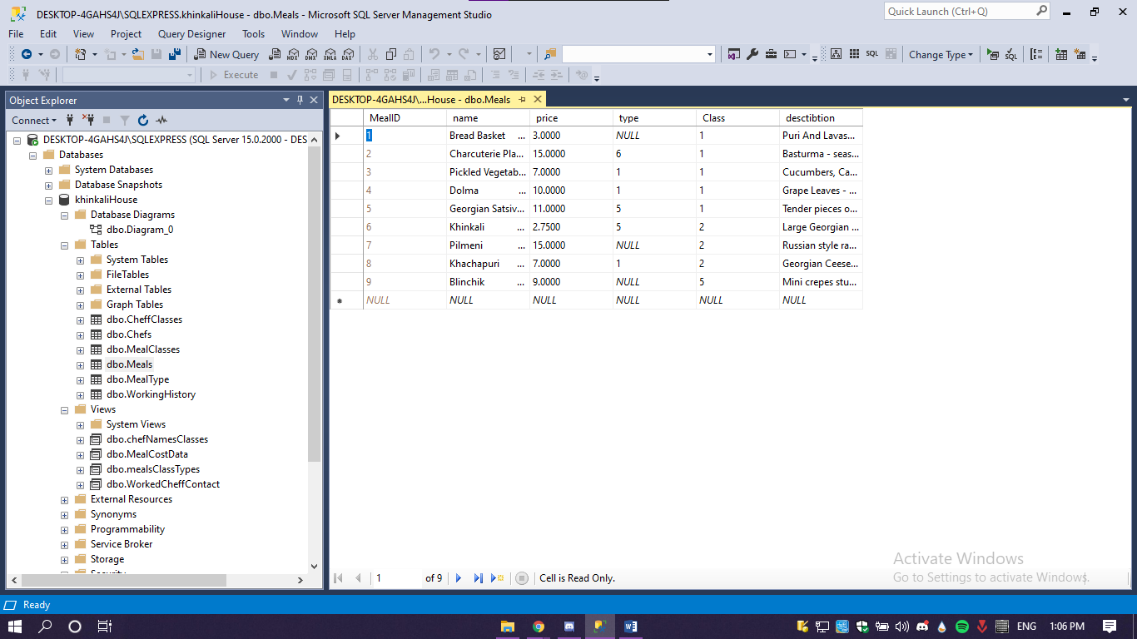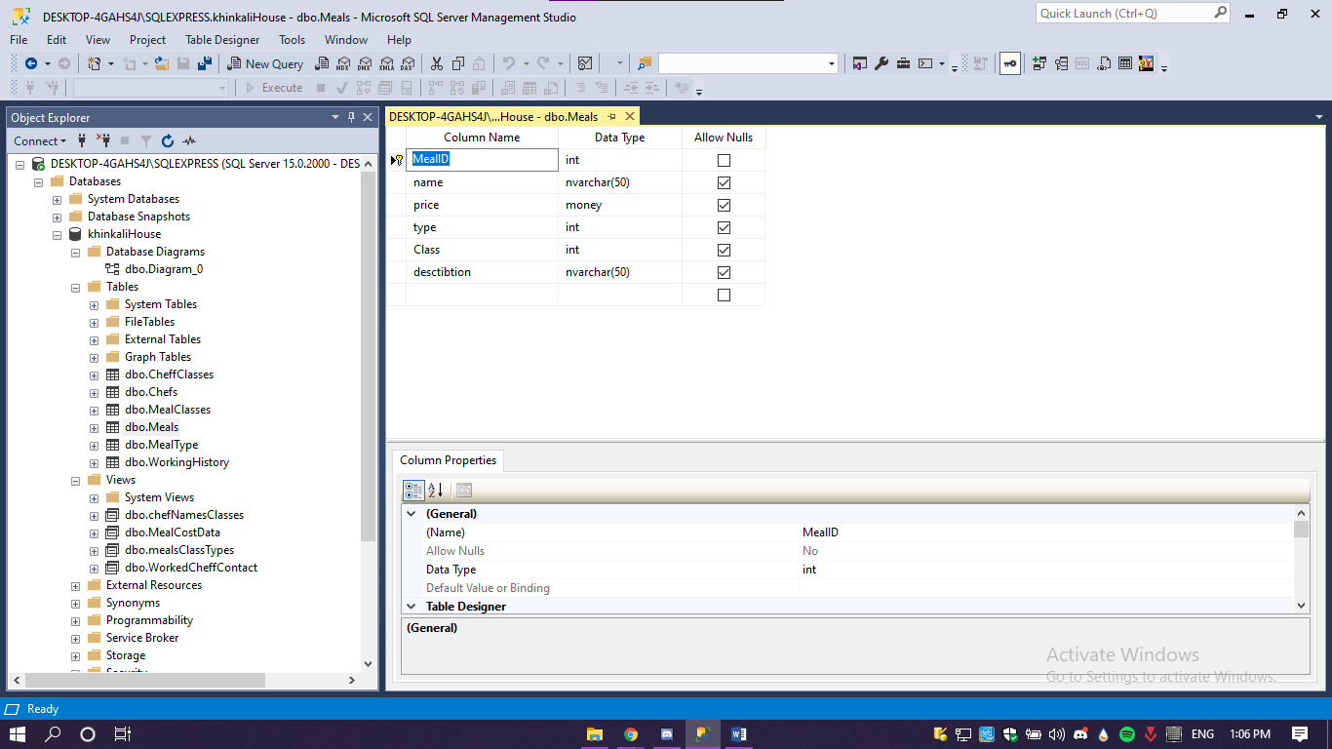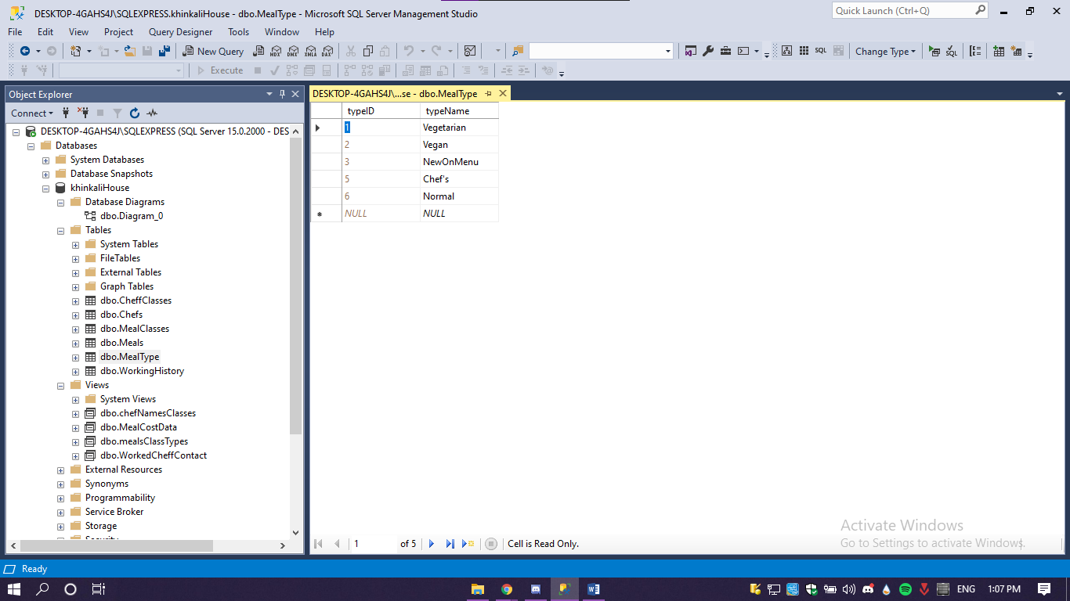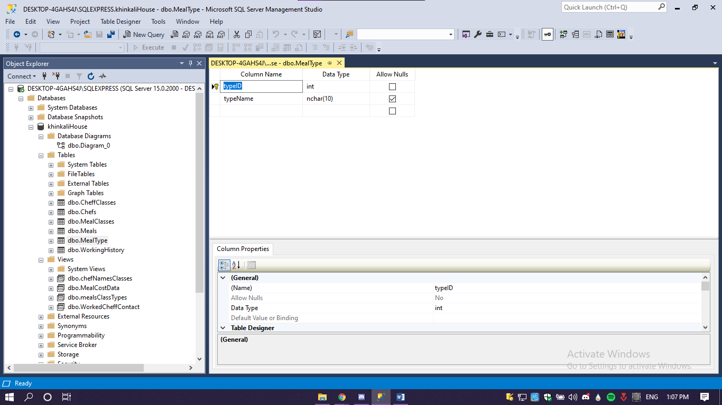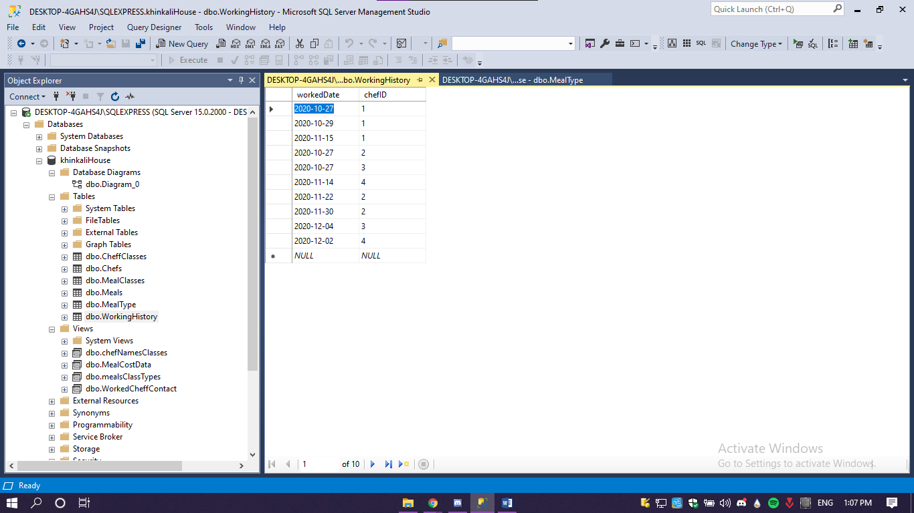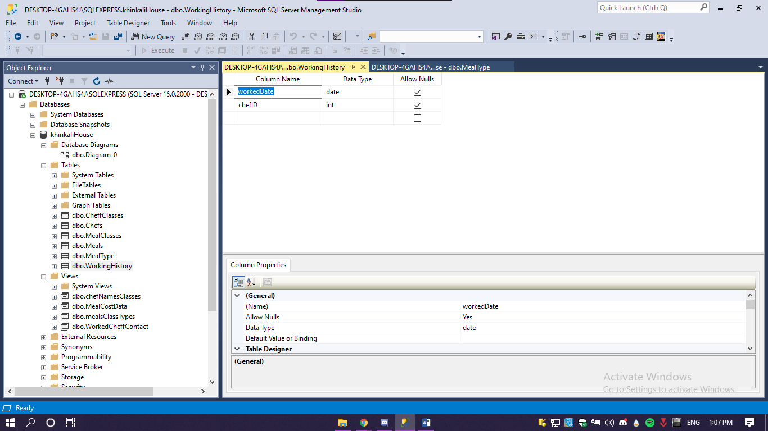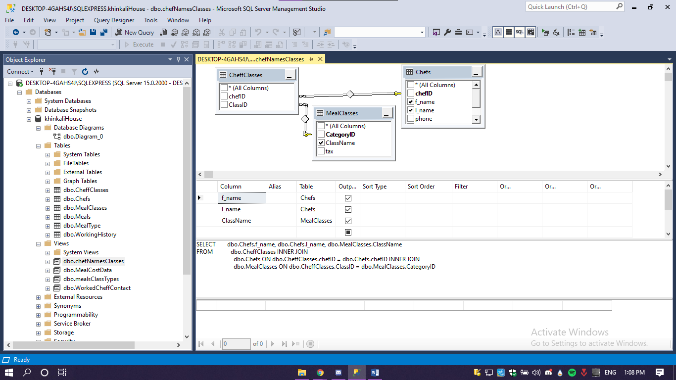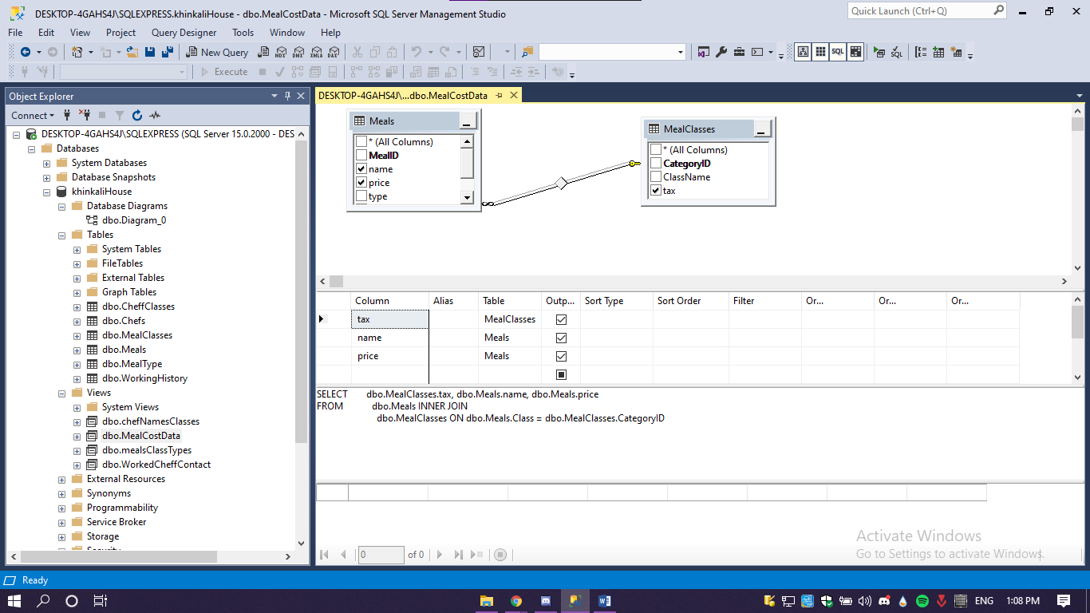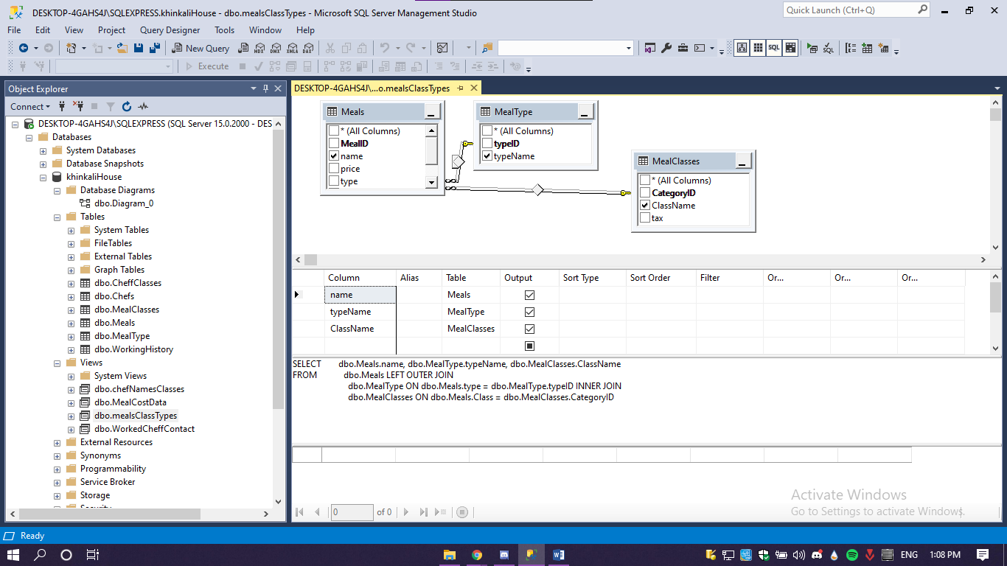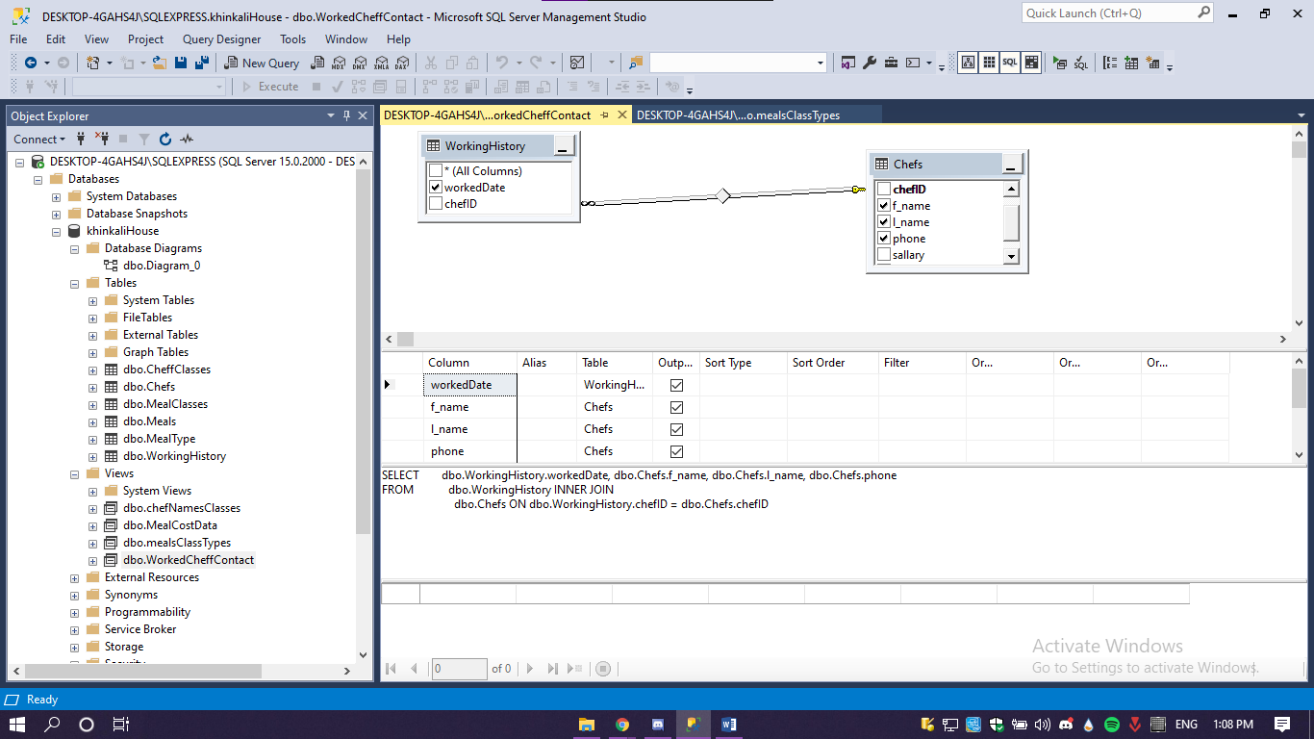

USE khinkaliHouse

SELECT *

FROM Chefs

WHERE sallary > 1500

SELECT f_name, l_name

FROM Chefs

WHERE l_name LIKE N'%ლი'

SELECT DISTINCT ch.f_name, ch.l_name

FROM CheffClasses cc

INNER JOIN Chefs ch ON ch.chefID = cc.chefID

SELECT f_name, l_name, age

FROM Chefs

WHERE age BETWEEN 30 AND 60

SELECT me.name, mt.typeName

FROM Meals me

INNER JOIN MealType mt ON me.type = mt.typeID

WHERE mt.typeName IN ('Vegetarian', 'Vegan')

SELECT SUM(sallary) AS total

FROM Chefs

SELECT TOP 3 *

FROM Meals

ORDER BY price DESC

SELECT AVG(price) AS avaragePrice

FROM Meals

SELECT ClassName, count(ClassName) ClassCount

FROM Meals me

INNER JOIN MealClasses mc ON mc.CategoryID = me.Class

GROUP BY ClassName

SELECT f_name, COUNT(f_name)

FROM CheffClasses cc

INNER JOIN Chefs ch ON cc.chefID = ch.chefID

INNER JOIN MealClasses mc ON cc.ClassID = mc.CategoryID

GROUP BY f_name

SELECT MAX(age) Oldest

FROM Chefs

SELECT me.name, ClassName, me.desctibtion

FROM MealClasses mc

LEFT JOIN Meals me ON mc.CategoryID = me.Class

WHERE MealID IS NOT NULL

SELECT ClassName, f_name, l_name

FROM MealClasses mc

LEFT JOIN CheffClasses cc ON cc.ClassID = mc.CategoryID

INNER JOIN Chefs ON Chefs.chefID = cc.chefID

SELECT typeName

FROM MealType

LEFT JOIN Meals ON Meals.type = MealType.typeID

WHERE MealID IS NULL

SELECT ClassName,COUNT(ClassName) AS ChefCount

FROM MealClasses mc

LEFT JOIN CheffClasses cc ON cc.ClassID = mc.CategoryID

INNER JOIN Chefs ON Chefs.chefID = cc.chefID

GROUP BY ClassName

SELECT ClassName,COUNT(ClassName) AS ChefCount

FROM MealClasses mc

LEFT JOIN CheffClasses cc ON cc.ClassID = mc.CategoryID

INNER JOIN Chefs ON Chefs.chefID = cc.chefID

GROUP BY ClassName

HAVING ClassName LIKE 'S%'

SELECT workedDate, f_name, l_name

FROM WorkingHistory wh

INNER JOIN Chefs cf ON cf.chefID = wh.chefID

SELECT UPPER(DATENAME(MONTH, workedDate)) workedMonth, f_name, l_name

FROM WorkingHistory wh

INNER JOIN Chefs cf ON cf.chefID = wh.chefID

SELECT f_name, l_name, YEAR(DATEADD(YEAR, -age, GETDATE())) birthYear

FROM Chefs

SELECT TOP 3 f_name, l_name, DATEDIFF(DAY, workedDate, GETDATE()) dayPassed

FROM WorkingHistory wh

INNER JOIN Chefs cf ON cf.chefID = wh.chefID

ORDER BY dayPassed

SELECT desctibtion, LEN(desctibtion) charLength

FROM Meals

ORDER BY charLength

SELECT desctibtion, RIGHT(desctibtion, LEN(desctibtion)/2) halfRightText

FROM Meals

SELECT LOWER(desctibtion) describtion, UPPER(LEFT(desctibtion, LEN(desctibtion)/2)) halfLefttText

FROM Meals

SELECT f_name, l_name, CONVERT(nvarchar(20), workedDate, 106) as WorkedDate

FROM WorkingHistory

INNER JOIN Chefs ON Chefs.chefID = WorkingHistory.chefID

SELECT name, FORMAT(price, 'C', 'ka') price

FROM Meals

SELECT f_name, l_name

FROM chefNamesClasses

WHERE ClassName = 'MainDishes'

SELECT *

FROM mealsClassTypes

WHERE typeName IN ('Vegetarian', 'Vegan') OR ClassName = 'MainDishes'

SELECT ClassName, COUNT(name) MenuVariety

FROM mealsClassTypes

GROUP BY ClassName

SELECT f_name, COUNT(workedDate) TotalDaysWorked

FROM WorkedCheffContact

GROUP BY f_name

SELECT DISTINCT f_name, l_name

FROM WorkedCheffContact

WHERE phone IS NULL

SELECT name, FORMAT(price, 'C', 'ka') price, FORMAT(tax/100, 'p') tax, FORMAT((price * (100 + tax)/100), 'C','ka') total

FROM MealCostData

WHERE tax < 10 OR tax = 18

UPDATE Chefs

SET f_name = 'დათო'

WHERE chefID = 4;