S32K144ZENKIT
How to test this kit?

If you want to test S32K144ZENKIT you need some things. It is:
- S32K144 EVB
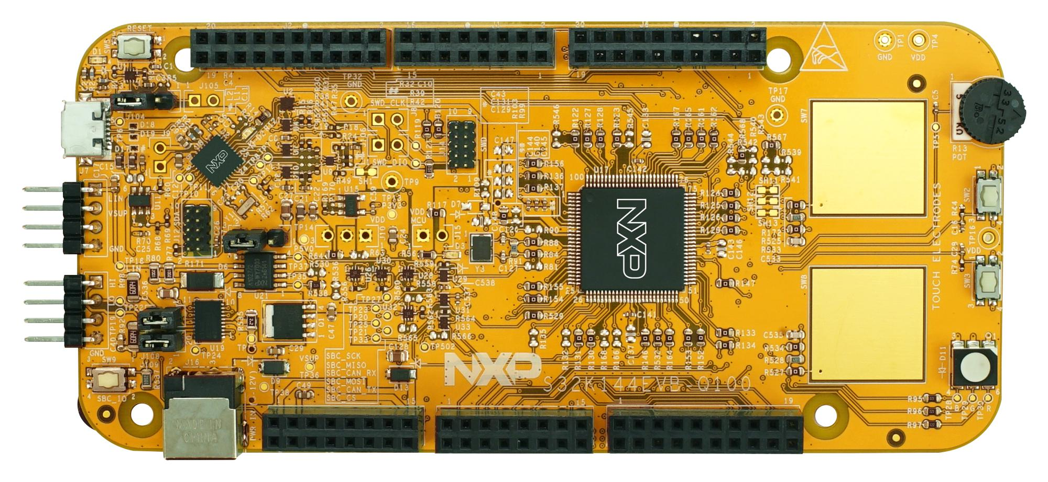

- USB-UART TTL Converter
It may be device based FTDI, CH340G or PL2303 or something else. It must work with Linux via tty-driver.
FTDI | CH340G | PL2303
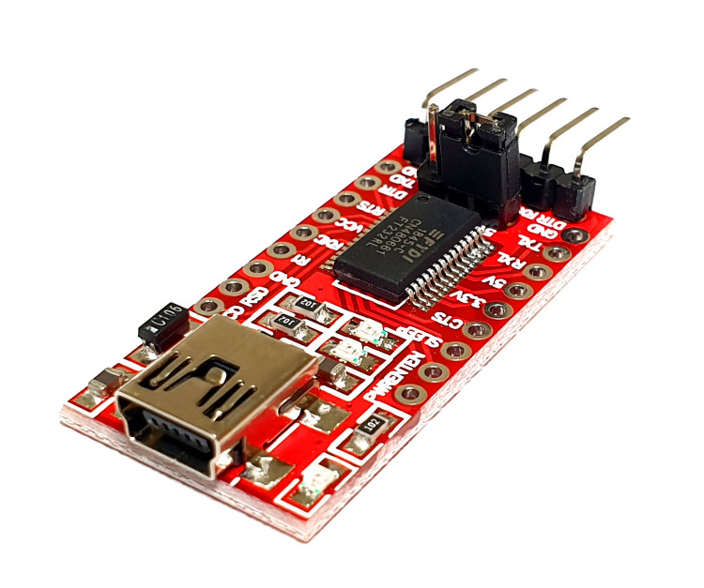 | 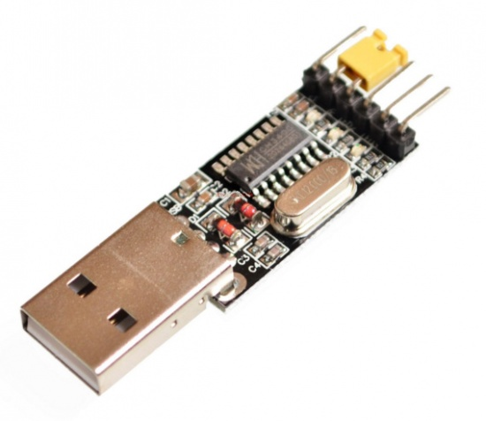 | 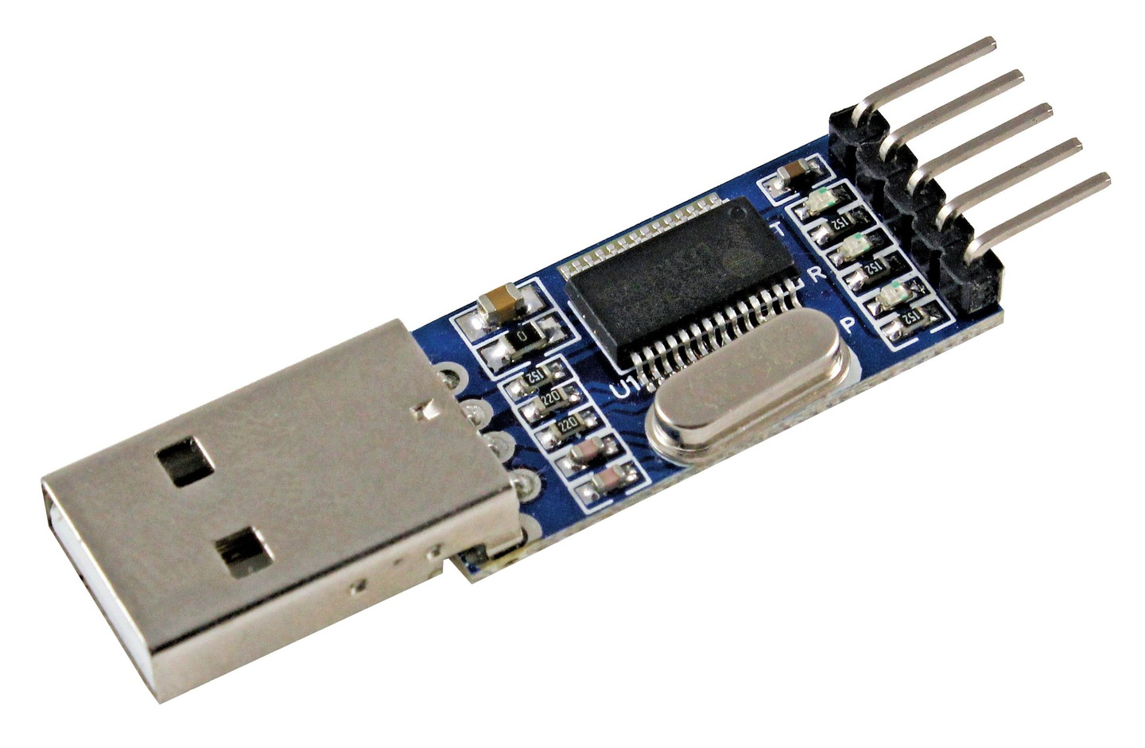
- Linux Computer and S32DS IDE. S32DS IDE may download from nxp.com


If you have all needed, connect those together.
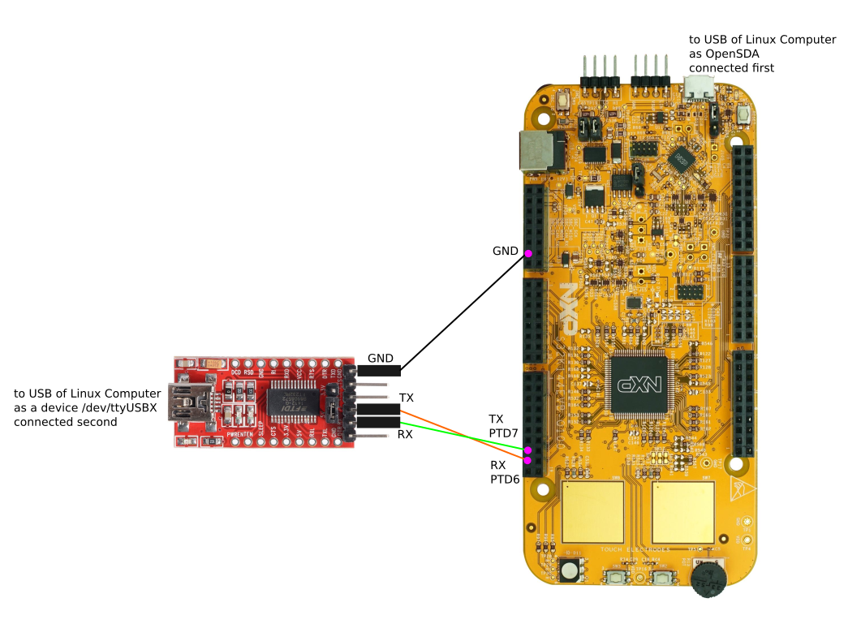
When you install S32DS IDE you must set a directory as workspace, example ~/workspace/s32ds_arm_v2.2
Create a project using S32DS IDE: File → New → S32DS Application Project
Choose Family S32Kxxx/S32K144
Enter “Project name”: bootloader
Next & Finish
The result will be project in the directory: ~/workspace/s32ds_arm_v2.2/bootloader

Next step need starting terminal and entry execute follow commands:
> cd ~/workspace/s32ds_arm_v2.2
> git clone https://github.com/somebyte/S32K144ZENKIT
> cd bootloader/src
> ../../S32K144ZENKIT/s32ds_bootload.sh

Add to main.c follow lines:
#include "S32K144.h"
#include "bootload/bootload.h"
/* See ../tty/uart.h to choose needed uart & pins */
#define UARTCFG UART_IFC2|UART_PIN_RX1|UART_PIN_TX1|UART_B921600 /* UART2, RX: PTD6, TX: PTD7 */
// Other example: #define UARTCFG UART_IFC0|UART_PIN_RX1|UART_PIN_TX1|UART_B115200 /* UART0, RX: PTB0, TX: PTB1 */
int
main (void)
{
BOOTLOAD(UARTCFG);
}

You can run mcu application (bootloader) via S32DS IDE as Release_FLASH, now.
Come back to the terminal and try work with mcu:
> sudo dmesg # define what tty device is used by mcu, example it is /dev/ttyUSB1
> cd ../../S32K144ZENKIT/linux
> make
> sudo ./uploader /dev/ttyUSB1 921600 ../evb/hello_clocks_blue__0x0000B000.srec
> sudo ./uploader /dev/ttyUSB1 921600 ../evb/hello_clocks_red___0x0000F000.srec
> sudo ./uploader /dev/ttyUSB1 921600 ../evb/hello_clocks_green_0x00013000.srec
> sudo ./ttydebug /dev/ttyUSB1 921600
jump 0x000B000 # blink blue
# push reset button of mcu
jump 0x000F000 # blink red
# push reset button of mcu
jump 0x0013000 # blink green
quit
Also you can try uploading evbterminal:
> sudo ./uploader /dev/ttyUSB1 921600 ../evb/evbterminal_0x0000B000.srec
> sudo ./ttydebug /dev/ttyUSB1 921600
jump 0x000B000
led red on
adc 0 12 # you can see voltage on PTC14 where seted POTENTIOMETER of EVB
help # for seeing all commands

