SugaDroid – Developers documentation

Introduction
Welcome to the SugaDroid developers documentation. Its aim is to help anyone who would like to understand or improve SugaDroid to quickly get his hands on the code.
SugaDroid is a prototype that was written in two weeks (learning Android included), and as such, one might do some things differently if starting over. Still, the code is quite clean, and I hope quite clear. In March 2009, my company asked me to create an Android client to the Web Services of SugarCRM. They did not want to support all SugarCRM features, and decided to keep things simple, displaying only contacts, accounts and meetings.
Releasing a project to the Open Source community requires some extra work on it, even for a prototype. But they decided that is was worth it. You are very welcome to ask questions and give feedback on this prototype, and of course improve it.
Of course, this prototype is adapted to suit our needs, and you would probably want to modify it before using it. Do not hesitate to contact us if you need a custom version.
One last thing : we are currently using the 4.5.1 version of SugarCRM. But we wanted the prototype to be also compatible with 5.2. That is the reason why I had to write some hacks in SugaDroid to deal with both versions (not so crappy, as I tried to be as generic as possible).

License
SugaDroid is released under the GNU General Public License v3, see the file COPYING.txt for more details.
The copyright 2009 is owned by eBusiness Information - Excilys group. You can contact them at ebi@ebusinessinformation.fr .
The author is Pierre-Yves Ricau (http://www.piwai.info), you can contact him at py.ricau+sugadroid_doc@gmail.com .
All the icons used in SugaDroid were created by Everaldo Coelho (http://www.everaldo.com/), and are released under the LGPL. More details at http://www.everaldo.com/crystal/?action=license .

Installing instructions
These instructions are made for anyone who would want to improve SugaDroid, or make any change needed. If you want to use SugaDroid without modifying anything, then you just need to install the provided package SugaDroid.apk on your phone, and have an instance of SugarCRM running.

Preparing the environment
First, you need to install SugarCRM. Download it here: http://www.sugarcrm.com/crm/download/sugar-suite.html . You will find the installing instructions here: http://www.sugarcrm.com/crm/index.php?option=com_docs&edition=OS&Itemid=375 .

SugaDroid should work with SugarCRM 4.5.1 and 5.2, and should be working with all versions starting from 4.5 (or at least with only a few changes).
You can then download Android here: http://developer.android.com/sdk/1.1_r1/index.html . To develop with Android, you need to install it and to install the ADP plugin for eclipse: http://developer.android.com/sdk/1.1_r1/installing.html .
Please notice that if you install SugarCRM on your own computer, the Sugar Soap URL entered in SugaDroid on the emulator should not contain “http://localhost/...” but “http://your_network_ip_address/...” or “http://10.0.0.2/”

Installing and launching SugaDroid
You just need to import the project in Eclipse, and hit “Run as > Android Application” on the SugaDroid project. To view the logs, hit “Window > Show View > Other > Android > LogCat .

Deploying SugaDroid on a real phone
To deploy SugaDroid, you need to create a signed .apk file, and then follow the usual instructions to install applications for your phone. You will learn more about signing an application here: http://developer.android.com/guide/publishing/app-signing.html . To sum up, there are only 3 commands to use:
keytool -genkey -keystore my-release-key.keystore -validity 10000 -alias some_alias
jarsigner -keystore my-release-key.keystore SugaDroid.apk some_alias
jarsigner -verify SugaDroid.apk

One last thing: remember to add /soap.php to your usual SugarCRM URL, when you enter it into SugaDroid parameters.

Understanding the architecture
Although being “only a prototype”, SugaDroid already holds about 50 classes. Therefore, one might find difficult to understand what does what, and the purpose of this chapter is to give you some insights about how SugaDroid was written.

Standard Android applications
If you have never tried Android before, then you should start here : http://developer.android.com/guide/index.html . I also advise you to read “Hello, Android” from Ed Burnette, available here: http://www.pragprog.com/titles/eband/hello-android . This book really helped me getting started, and a lot of the prototype code is inspired from the book examples.

Web Services constraints
Accessing to resources through the network can be quite time consuming, and an Android application should not be freezing while a web service is being called. The solution is to use threads that runs the code to access to web services, and update the UI through callbacks to the activity. In SugaDroid, those runnables are called “tasks” and are available in the package com.excilys.sugadroid.tasks . They take an activity as a parameter in their constructor, so that they can call back methods on this activity. However, the callbacks need to run on the UI thread to update the UI, and this is done using the runOnUiThread() method in the callbacks.

Dealing with the session
The session informations (session_id, username, url, user_id) are stored in a singleton instance of SessionBean. This enables any activity to access the Session informations, and to always access the same session instance.
As 3G mobiles do not keep a permanent connexion, they change their IP quite often. But SugarCRM assumes by default that a session id should always belong to the same IP, even for the Web Services. In version 5.2, this behavior can be disabled in the configuration. However, for 4.5, we had to modify the file soap/SoapSugarUsers.php at line 127 in function validate_authenticated : we removed && $_SESSION['ip_address'] == $_SERVER['REMOTE_ADDR'] from the if test.

Navigation through SugaDroid
This navigation diagram shows how the user navigates through the activities and tasks. Please note that tasks do not directly forward to activities, by calling callbacks on their callers (nice sentence huh ?) that forward to these activities (e.g. an activity instance of ContactDetails calls a task instance of GetAccountDetails which in turn calls a forwarding callback method on the ContactDetails instance that forward to an instance of the activity AccountDetails).
The intents are calls outside of SugaDroid range, i.e. calls to other applications (like the GPS, or the phone dialler).
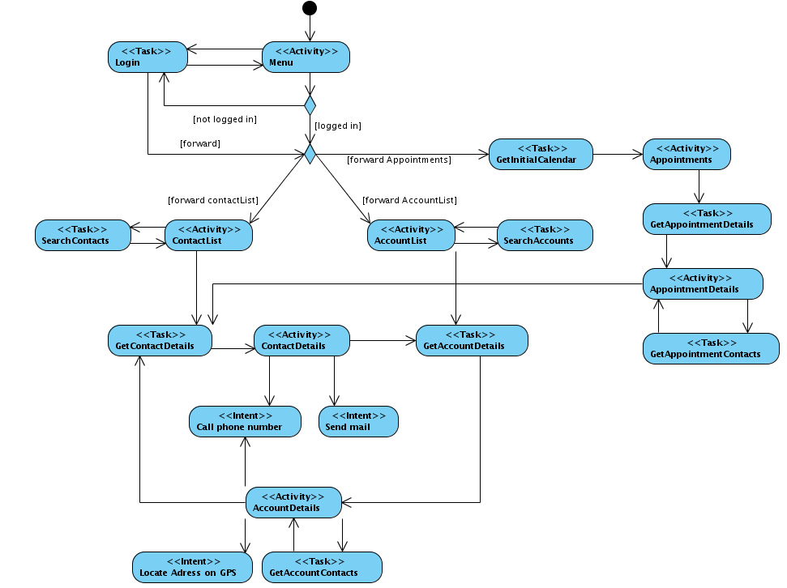

Third party libraries
SugaDroid uses two third party libraries : Ksoap2 and Joda Time. Ksoap2 is used to access SOAP Web Services in an embedded context, and Joda Time is used to easily deal with times and dates in Java.
Joda Time is included as a JAR, whereas Ksoap2 is included as source files.

Ksoap2
The reason why Ksoap2 is included as source file is that I had to customize it a little bit. First of all, the standard version of Ksoap2 does not currently works with Android.
Here is the solution (found here: http://android.amberfog.com/?p=45) :
Download ksoap2 source files :
ksoap2-src-2.1.1.zip (http://sourceforge.net/project/showfiles.php?group_id=158028&package_id=176860)
Download kxml2 source files :
kxml2-src-2.3.0.zip (http://sourceforge.net/project/showfiles.php?group_id=9157&package_id=58653)
put in your source folder:
ksoap2-src-2.1.1.zip
/src/org/ksoap2/
/src_j2se/org/ksoap2/

kxml2-src-2.3.0.zip
/src/org/kxml2/

Take missed kObjects files from here: http://kobjects.cvs.sourceforge.net/viewvc/kobjects/kobjects/src/org/kobjects/
/org/kobjects/base64/Base64.java
/org/kobjects/isodate/IsoDate.java

Got enough customization ? Well, I had to do a little more to get SugaDroid working with HTTPS. For some obscure reason (seems to be a missing implementation of a hash algorithm on Android), I had the following IOException: Hostname <xxx.com> was not verified. The certificate was well signed, by a valid CA, but Android didn't seem to like it (by the way, you need to know that if your certificate is not signed – ie, self-signed- it won't work).
I finally come to writing my own Transport class : HttpClientTransportAndroid, which handles HTTPS better using an HttpClient. The advantage is that I can easily tweak the HttpClient to accept any Hostname, or even better, to accept any certificate. Quite useful when developing applications and using self-signed certificates.
The drawback of this patch is that it clearly brings a security breach in case of Man In The Middle attack. If anyone find a better approach, please let me know.

Joda Time
When compiling the project, you might realize that you get the following warning: Ignoring InnerClasses attribute for an anonymous inner class that doesn't come with an associated EnclosingMethod attribute. (This class was probably produced by a broken compiler.)
This warning seems to be linked to Joda Time, and probably means that a JavaSE class used by Joda Time is not included in Android. However, I couldn't find anything missing, and I didn't encounter any bug at runtime. So be warned, SugaDroid might explode some day, even thought it didn't occurred yet. Again, please let me know if you identify the source of the warning, or find a solution.

The Web Services client
The classes that do all the work with the web services are located in the package com.excilys.sugadroid.services . I used dependency injection to create the service beans, so that the rest of the application manipulates the services classes using interfaces. The aim is to be able to change the implementation of the web services if necessary (e.g. replacing Ksoap2 by another Soap lib). The actual implementations are located in the package com.excilys.sugadroid.services.impl.ksoap2 .

Translating SugaDroid
All the strings used in SugaDroid are externalized in the file res/values/strings.xml . So you can change any of the application strings modifying only this file. Please do not hesitate to give some feedback if you think some expressions should be changed to more appropriate ones. If you want to create a translation for SugaDroid in your language, just create a folder res/values-xx and put your own version of strings.xml inside (of course, xx should be replaced by your language letters, like values-fr for a French translation). You will find more informations here: http://developer.android.com/guide/topics/resources/resources-i18n.html

How to add fields from SugarCRM
As SugaDroid is clearly a prototype, it might not suit your own needs. What would you need to do to add support for more informations in SugaDroid ? Let say you would want to show the field phone_fax of a contact in the contact detail activity. First, you need to add the setter and getter for phone_fax in the class ContactBean.
Be careful : the setter should be named exactly setPhoneFax, since SugaDroid uses reflection to find the right setters.
Than you need to change the method getContactDetails in the class ContactServicesKsoap2 to tell the Web Service that you want to retrieve the field phone_fax. Just add
t.add(“phone_fax”); after t.add(“account_id”);
Now you just need the change the views to show the phone fax number. I won't give you the whole piece of code, but I think you should change only two files: res/layout/contact_details.xml (the view itself) and ContactDetailsActivity.java (which controls the behaviour of your application).

Improvements
A lot of improvements could be made on SugaDroid. But considering it as a prototype, we decided to stop adding stuff, and release it open source as soon as possible. So for now, adding new feature is also up to you!
First of all, you might have noticed that the “My appointments” part is not fully functional. It loads X days before today and Y days after today at once (X and Y can be set in the “General settings”), and then nothing more. With a little more work, we could have access to any date in the year. The components are designed for this, it just need some work on it.
I starting developing with Android with a Java background, but I had not much idea about how to develop on embedded platforms. The response time of the interface is not really a problem, compared to the time taken by the communication with the web services. But if you want to optimise the code, then maybe you should start by reading this: http://developer.android.com/guide/practices/design/performance.html .
Last but not least, maybe you realised that there is no cache at all in SugaDroid. Even worst, when you switch from vertical to horizontal (keyboard) view, the dynamic lists are reloaded. This could certainly be improved, by working on the life cycle of the activities.

Troubleshooting

“When compiling the project, I have the following warning: Ignoring InnerClasses attribute for an anonymous inner class that doesn't come with an associated EnclosingMethod attribute. (This class was probably produced by a broken compiler.).”
=> Please read the part related to Joda Time in this document.

“SugarCRM is accessible through HTTPS, and when I try to connect, I get the following IOException: Hostname <xxx.com> was not verified.”
=> Please read the part related to Ksoap2 in this document.

“SugarCRM is accessible through HTTPS, and when I try to connect, I get a CA not trusted exception (or something like this).”
=> It probably means that your certificate is not signed by a trusted CA, for instance if you use self-signed certificates. Check in the BeanHolder class code, and you will find how to solve this.

“My login is valid in SugarCRM, but is said not to be valid in SugaDroid.”
=> Do you have Apache compiled with libmcrypt ? We had this trouble with SugarCRM 4.5.1 installed on a Red Hat server, and we realised that the web services would not allow any login until libmcrypt is installed.

“SugaDroid tells me I am logged in, but when I try to retrieve information, I get an invalid session error.”
=> If you are using SugaDroid on your mobile phone, this is probably due to the IP check done by SugarCRM. Please read “Dealing with the session” in this document.

