DATA SCIENCE INTERNSHIP
WEEK 4
COMPREHENSIVE DATA SCIENCE REPORT
AND INSIGHTS PRESENTATION PLAN
Retail Sales Prediction Using Machine Learning
Prepared by: Ankit Kumar
Week 4 Internship Submission

1. Executive Summary
This report presents a practical plan for using data science and machine learning to help a retail business understand and predict future sales. The main idea is simple: instead of depending only on guesswork or past experience, the business can use historical sales information and relevant business factors to make more informed decisions.
The proposed approach starts by understanding the business problem and the available data. The data is then prepared by checking missing values, duplicate records, inconsistent entries and unusual observations. Relevant features are selected before suitable regression models are considered.
The models would be trained and compared using Mean Absolute Error (MAE), Mean Squared Error (MSE) and Root Mean Squared Error (RMSE). Validation would then check whether the selected model can perform well on data it has not seen before. If the model is reliable, it can be used to support future sales estimates.
2. Business Problem and Objective
Retail sales can change over time because customer demand, promotions, prices, seasonality and market conditions may change. This creates a practical problem for managers: they need to plan inventory and resources before they know exactly how much they will sell.
In this hypothetical project, the objective is to develop a machine learning model that can estimate future sales from historical sales data and relevant business factors. The project treats sales prediction as a regression problem because the target is a numerical value.
BUSINESS NEED
↓
Historical Sales + Business Factors
↓
Machine Learning Model
↓
Future Sales Estimate
↓
Better Planning & Decisions

3. Methodology Overview

The project follows a clear step-by-step data science workflow. Each stage has a practical purpose, from defining the problem to turning model output into business insights.
Define Problem
↓
Understand Data
↓
Preprocess Data
↓
Select Features
↓
Select Models
↓
Train Models
↓
Evaluate
↓
Validate
↓
Deploy & Monitor
↓
Business Insights

4. Data Understanding
Before building a model, the dataset needs to be understood properly. We need to know what each variable means, which variable is the target and whether the data contains quality issues.
Variable | Type | Role | Business Meaning
Sales | Numerical | Target | Value to be predicted
Date/Month | Date | Feature | Captures time patterns
Promotion | Category/Numeric | Feature | Shows promotional activity
Price | Numerical | Feature | Price information
Store/Category | Categorical | Feature | Business segment
Previous Sales | Numerical | Feature | Historical sales information

5. Data Preprocessing
Data preprocessing is where raw data is prepared for modelling. The aim is to handle data-quality problems without changing useful information unnecessarily.
Raw Dataset
↓
Check Missing Values
↓
Handle Duplicates
↓
Check Outliers
↓
Correct Inconsistencies
↓
Encode Categories
↓
Scale if Required
↓
Prepared Dataset

- Missing values should be identified and handled using suitable removal or imputation methods.
- Duplicate records should be checked so repeated observations do not distort the analysis.
- Inconsistent values should be corrected or standardised where necessary.
- Outliers should be investigated to decide whether they are genuine business events or data errors.
- Categorical variables should be converted into a suitable numerical format when required.
- Irrelevant or redundant variables should be removed to keep the model simpler and more useful.
- The prepared data should be divided into training and testing sets.

6. Feature Selection
Feature selection means choosing the variables that are most useful for predicting sales. We do not want to give the model every available column. We want to focus on information that has a meaningful business relationship with sales.
Available Variables
↓
Check Business Relevance
↓
Check Relationship with Sales
↓
Remove Irrelevant/Redundant Variables
↓
Final Feature Set

7. Model Selection and Training
After preprocessing, suitable regression models can be considered. A simple baseline can be compared with models that can capture more complex relationships.
Model | Simple explanation | Purpose
Linear Regression | Looks for a simple relationship between inputs and sales. | Baseline model
Decision Tree Regression | Uses decision rules and can capture non-linear patterns. | More flexible model
Ensemble Model | Combines multiple models/trees. | Potentially stronger performance
Prepared Data
↓
Candidate Models
↓
Train Each Model
↓
Generate Predictions
↓
Compare Performance
↓
Select Suitable Model

Hyperparameter tuning may be used to test different model settings and improve performance where appropriate.

8. Evaluation Metrics
Because sales is a numerical target, regression metrics are appropriate.
Metric | In simple words | Better result
MAE | Average absolute difference between actual and predicted sales. | Lower is better
MSE | Squares errors, giving larger errors more importance. | Lower is better
RMSE | Error measure in the same unit as sales. | Lower is better
Actual Sales
↓
Model Prediction
↓
Calculate Errors
↓
MAE / MSE / RMSE
↓
Compare Models
↓
Select Better Performer

9. Model Validation
Model validation answers a practical question: will the model still work when it sees new data? A model can perform very well on training data but poorly on unseen data. Validation helps us identify that problem.
Complete Dataset
↓
Training Data
↓
Train Model
↓
Testing Data
↓
Predict Unseen Data
↓
Check Error Metrics
↓
Reliable Performance?

9.1 Cross-validation
Cross-validation can make evaluation more reliable. The training data is divided into different parts, and different parts are used for testing in turn. This helps us see whether performance is reasonably consistent.
Training Data
↓
Fold 1 Test
↓
Fold 2 Test
↓
Fold 3 Test
↓
Repeat Across Folds
↓
Compare/Average Results
Overfitting: If the model is excellent on training data but poor on new data, it may have memorised the training examples instead of learning patterns that generalise.

10. Model Deployment and Monitoring
Once the model has been tested and validated, it can be made available for use in a real business environment. Deployment means using the trained model to estimate future sales from new information.
Validated Model
↓
Deploy for Business Use
↓
Enter New Data
↓
Generate Sales Prediction
↓
Use Prediction for Planning
The model should also be monitored because customer behaviour, market conditions and sales patterns can change over time.
Deployed Model
↓
Monitor Predictions
↓
Check New Data
↓
Accuracy Acceptable?
↓
Continue / Retrain
↓
Updated Model

11. Insights and Analysis
The final report should turn model output into business meaning. The following charts are mock-ups showing the type of visual that could be used once actual data and model results are available.
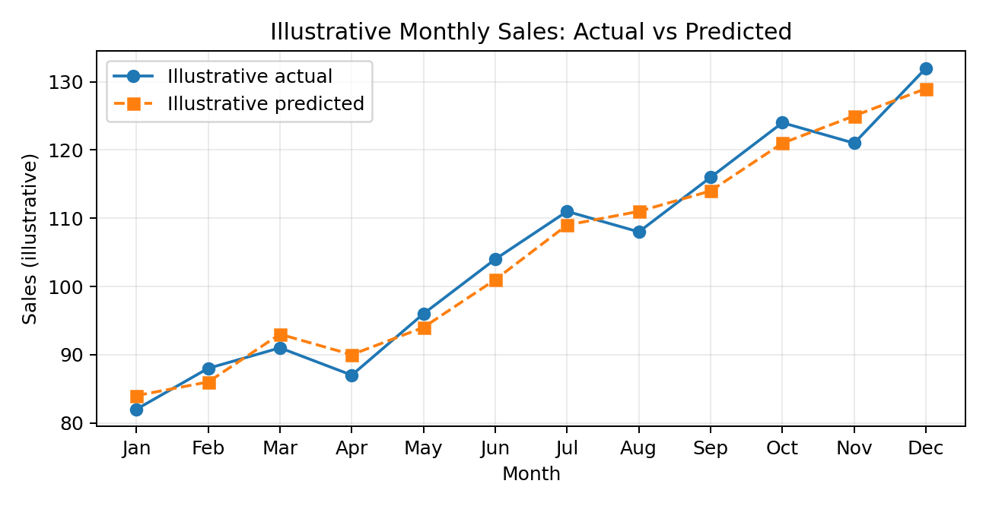
Figure 1. Illustrative monthly actual vs predicted sales — mock-up only.
This chart would help a manager quickly see whether predicted sales follow the overall movement of actual sales and where the largest differences occur.
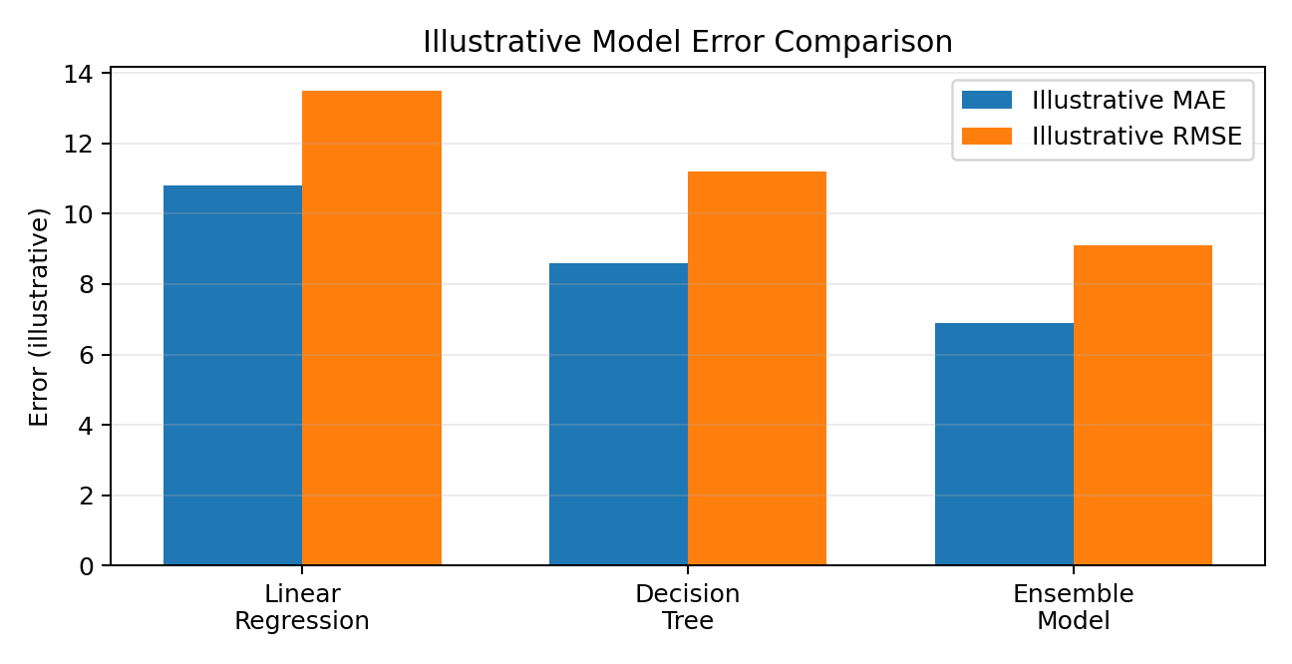
Figure 2. Illustrative model error comparison — mock-up only.
- Sales trend: identify periods of increasing or decreasing demand.
- Seasonality: look for repeated changes across months or periods.
- Anomalies: investigate unusually high or low observations.
- Actual vs predicted: identify periods where the model differs noticeably from actual sales.
- Model comparison: present MAE, MSE and RMSE clearly for management.
Important: The numerical values in the two charts are illustrative examples only. They must be replaced with actual calculated results if real model training is performed.

12. Presentation Strategy
The presentation should avoid starting with technical formulas or code. A non-technical stakeholder usually wants to know what the problem is, what the data shows, whether the prediction is reliable and what action should be taken.
Business Problem
↓
What Data Shows
↓
What Model Predicts
↓
How Reliable?
↓
Business Meaning
↓
Recommended Action
Visual | Show | Explain
Sales trend | Sales movement over time | Main direction and unusual periods
Actual vs predicted | Prediction compared with actual | How closely the model follows reality
Model comparison | MAE/MSE/RMSE | Which model has lower error
Workflow | End-to-end flowchart | How the conclusion was reached

13. Recommendations
- Use a structured sales prediction process instead of depending only on intuition.
- Prefer the model that gives reliable validation performance with reasonable complexity.
- Use sales predictions as one input for inventory and resource planning.
- Monitor model accuracy after deployment because business conditions can change.
- Retrain the model when performance drops and newer data becomes available.
- Communicate results using simple charts and business language.

14. Future Scope
More Historical Data
↓
Additional Business Variables
↓
Better Feature Engineering
↓
Model Tuning
↓
Regular Monitoring
↓
Updated Predictions
↓
Improved Business Support
Future work could include richer business information, additional modelling approaches, better feature engineering and a simple dashboard for managers. These improvements should follow a stable basic workflow and good data quality.

15. Conclusion
This Week 4 plan brings together the analytical and strategic sides of data science. The project starts with a clear business problem—predicting future retail sales—and follows a structured path through data understanding, preprocessing, feature selection, model selection, training, evaluation, validation and deployment.
The main learning is that a machine learning project is not only about building a model. The model must also be checked on unseen data, explained in simple business language and monitored after deployment. This connects data science with practical management decision-making.
Final takeaway: A good data science solution turns data into a useful, understandable and actionable business decision.

Appendix: Visuals Included
- Business need → prediction → decision flow
- End-to-end data science workflow
- Data preprocessing flowchart
- Feature selection flowchart
- Model selection and training flowchart
- Evaluation metrics flowchart
- Model validation flowchart
- Cross-validation flowchart
- Deployment flowchart
- Continuous monitoring flowchart
- Illustrative actual vs predicted sales chart
- Illustrative model comparison chart
- Presentation storytelling flowchart

