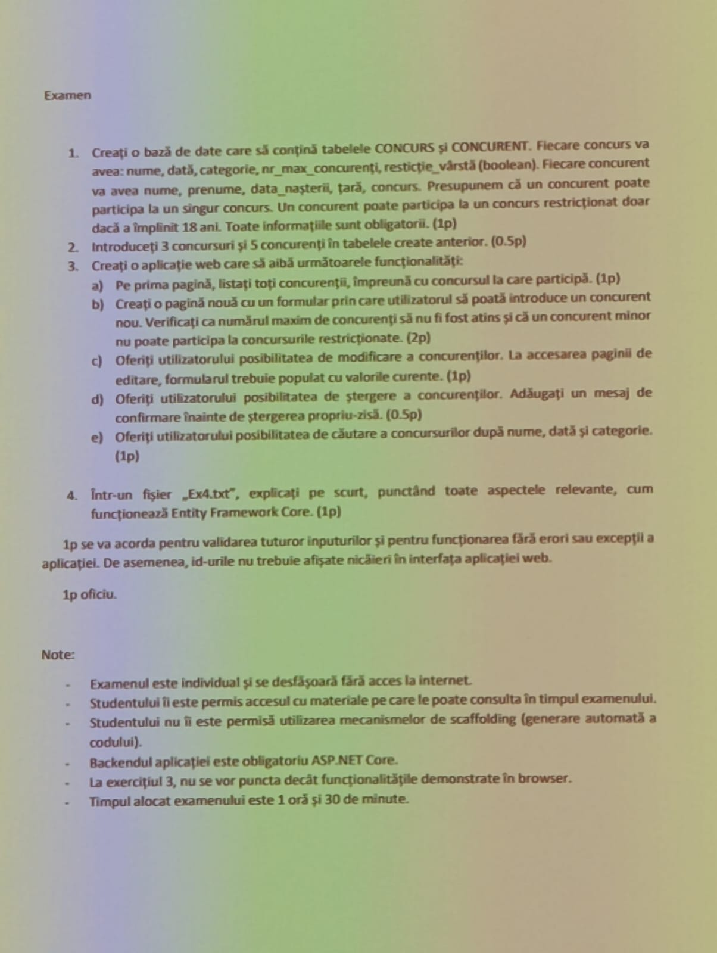

- Creare modele: (EXERCITIUL 1)
- Punem in Models clasele corespunzatoare din cerinta,scriem datele membre publice din cerinta in fiecare clasa: id, nume,…. IMPORTANT: cu get, set fiecare
namespace pegatire.Models
{
public class Concurs
{
public int id { get; set; }
public string nume { get; set; }
public DateTime data { get; set; }
public string categorie { get; set; }
public int nr_max_concurenti { get; set; }
public bool restrictie_varsta { get; set; }
}
}

- Cand avem o relatie intre modele, punem si id-ul (cheia externa) si un obiect in clasa respectiva
namespace pegatire.Models
{
public class Concurent
{
public int id { get; set; }
public string nume { get; set; }
public string prenume { get; set; }
public DateTime data_nasterii { get; set; }
public string tara { get; set; }
public int ConcursId { get; set; }
public Concurs? concurs { get; set; }
}
}

- Configurare baza de date:
- Instalare pachete: Tools -> NuGet Package Manager -> manage NuGet package for solution -> Browse. Aici instalam: EntityFrameworkCore (apasam pe el, bifam project, install -> apply -> I accept). La fel pentru EntityFrameworkCore.SQLServer, EntityFrameworkCore.Tools.
- Crearea contextului:
- In Models, cream o noua clasa numita (ClasaPrincipala)Context. Clasa trebuie sa mosteneasca DbContext
(POSIBILA EROARE: E subliniat DbContext cu rosu, de aceea trebuie importat EntityFramework. SOLUTIE: Dam hover peste DbContext -> show possible fixes).
- Adaugam constructorul cu un singur parametru de tipul DbContextOptions<Clasa principalaContext> cu numele options. Acesta trebuie sa apeleze constructorul clasei de baza, deci dupa parametrii constructorului punem doua puncte base (options).
- Inainte de constructor, vom avea campuri publice de tipul DbSet<Modelele noastre> care vor reprezenta tabelele din baza de date. Conventie: numele campului este numele modelului, dar la plural. IMPORTANT: tot cu get, set !!!!
using Microsoft.EntityFrameworkCore;

namespace pegatire.Models
{
public class ConcursContext : DbContext
{
public DbSet<Concurs> Concursuri { get; set; }
public DbSet<Concurent> Concurenti { get; set; }
public ConcursContext(DbContextOptions<ConcursContext> options) : base(options)
{
}
}
}

- Connection String
- Dam pe View -> SQL Server Object Explorer -> SQL Server -> cautam localdb si dam click dreapta -> Properties -> gasim Connection String-ul si copiem valoarea lui
- In appsettings.json, introducem in
“ConnectionStrings” : {
“ClasaPrincipala”: “AICI COPIEM CONNECTION STRING-UL”
}
IMPORTANT: In ConnectionString schimbam valoarea lui Initial Catalog din master in NUMELE CLASEI PRINCIPALE LA PLURAL. OBS: aici, fara spatii la egal. IMPORTANT2: Cand scriem in ConnectionStrings, sa ne asiguram ca avem virgule !!! Daca nu punem, eroare.

Exemplu din examen:
"ConnectionStrings": {
"Concursuri": "Data Source=(localdb)\\MSSQLLocalDB;Initial Catalog=concursuri;Integrated Security=True;Connect Timeout=30;Encrypt=False;Trust Server Certificate=False;Application Intent=ReadWrite;Multi Subnet Failover=False"
}

- Program.cs
- In fisier, punem urmatoarea linie de cod FIX dupa builder.Services…..:
builder.Services.AddDbContext<ClasaPrincipalaContext>(options=>options.UseSqlServer(builder.Configuration.GetConnectionString(“ClasaPrincipala”)));
Exemplu din examen:
builder.Services.AddDbContext<ConcursContext>(options => options.UseSqlServer(builder.Configuration.GetConnectionString("Concursuri")));

- Migrari
- Tools -> NuGet Package Manager -> Console -> scriem Add-Migration Init
- Posibile probleme:
- nu recunoaste Add-Migration
- nu apare codul de generare al tabelelor in migrare
- Posibila cauza + rezolvare:
- Nu a fost instalat un pachet cum trebuie (cel mai probabil .Tools). Verifica daca ai instalat toate pachetele bine.
- Am uitat sa punem DbSet
- OBS: baza de date nu este creata pana nu rulam comanda Update-Database
- OBS2: totul e bine daca consola nu a avut un output rosu si scrie done la final
- Daca ceva nu a mers bine si nu stim exact cauza, stergem folder-ul Migrations si reluam punctul f)
- IMPORTANT: daca nu apare codul generat, ceva nu e bine.

- Verificare baza de date
- View -> SQL Server Object Explorer -> SQL Server -> localdb -> Databases -> numele bazei de date pe care am creat-o -> Tables -> si vedem ca avem vcreate tabelele corespunzatoare.
- IMPORTANT: DACA NU APARE BAZA DE DATE, DAM REFRESH!!!!!!!!!!!!!!!!!!

- Introducere date (EXERCITIUL 2)
- Pt a adauga informatii/edita/sterge, click dreapta pe tabelul dorit -> View Data si introducem datele.
- IMPORTANT: daca nu putem edita sau adauga intr-un tabel, dam refresh!!!!!!!!!!

- Listarea obiectelor (EXERCITIUL 3, pct a) )
- In pagina HomeController.cs, adaugam private readonly ClasaPrincipalaContext _context:
Exemplu din examen: private readonly ConcursContext _context;
- Injectarea serviciilor in constructor: mai adaugam un parametru la constructor de tipul ClasaPrincipalaContext numit context si in corpul acestuia punem _context = context.
Exemplu din examen:
public HomeController(ILogger<HomeController> logger, ConcursContext context)
{
_logger = logger;
_context = context;
}
- In Index.cshtml, adaugam @model List<Clasa pe care vrem sa o afisam>, apoi un @foreach (ClasaPeCareOAfisam variabila(acelasi nume) in Model)
{
<section>
<h2> Nume camp1: @variabila.camp1 @variabila.camp2 </h2>
<p> Nume camp 3: @variabila.camp3 </p>
<p> Nume camp4: @variabila.camp4 </p>
</section>
}
Exemplu din examen:

@model List<Concurent>
...
@foreach(var concurent in Model)
{
<section>
<h2><a asp-action="ConcurentPage" asp-route Id="@concurent.id">Nume: @concurent.nume Prenume: @concurent.prenume</a></h2>
<p>Data nasterii: @concurent.data_nasterii</p>
<p>Concurs: @concurent.concurs.nume</p>
</section>
}
- In HomeController.cs, in functia IActionResult Index(), adaugam urmatoarele linii:
var nume_clasa_pe_o_afisam = _context.nume_clasa_pe_care_o_afisam_Include(c => c.clasa_cealalta).ToList();
return View(nume_clasa_pe_care_o_afisam);

Exemplu din examen:
var concurenti = _context.Concurenti.Include(c => c.concurs).ToList();
return View(concurenti);

- Introducere obiect in baza de date prin frontend
- In HomeController.cs, facem o metoda adnotata cu
[HttpGet]
public IActionResult AdaugaObiect()
{
ViewBag.Options = _context.ClasaADoua.Select(a=>
new SelectListItem
{
Value = a.Id.ToString(),
Text = a.Nume
} ).ToList();
return View();
}
[HttpPost]
public IActionResult AdaugaObiect(Obiect ob)
{
If(ModelState.IsValid)
{
_context.TabelulInCareAdaug.Add(ob);
_context.SaveChanges();
return RedirectToAction(“Index”);
} else
{
ViewBag.Options = _context.ClasaADoua.Select(a=>
new SelectListItem
{
Value = a.Id.ToString(),
Text = a.Nume
} ).ToList();
return View();
}
// restrictii, de exemplu cum e cel din sub de examen
}
Exemplu din examen:
[HttpGet]
public IActionResult AdaugaConcurent()
{
ViewBag.Options = _context.Concursuri.Select(a =>
new SelectListItem
{
Value = a.id.ToString(),
Text = a.nume
}).ToList();
return View();
}

[HttpPost]
public IActionResult AdaugaConcurent(Concurent conc)
{
if (ModelState.IsValid)
{
var concurs = _context.Concursuri.FirstOrDefault(c => c.id == conc.ConcursId);
if (concurs == null) return View();
var concurentiLaConcurs = _context.Concurenti.Where(c => c.ConcursId == concurs.id).ToList().Count;
if(concurentiLaConcurs >= concurs.nr_max_concurenti) return View();
var varstaConcurent = DateTime.Now.Year - conc.data_nasterii.Year;
if (varstaConcurent <= 18 && concurs.restrictie_varsta)
{
ModelState.AddModelError("data_nasterii", "Concurentul trebuie sa aiba peste 18 ani pentru a participa la acest concurs.");
ViewBag.Options = _context.Concursuri.Select(a =>
new SelectListItem
{
Value = a.id.ToString(),
Text = a.nume
}).ToList();
return View();
}
_context.Concurenti.Add(conc);
_context.SaveChanges();
return RedirectToAction("Index");
} else
{
ViewBag.Options = _context.Concursuri.Select(a =>
new SelectListItem
{
Value = a.id.ToString(),
Text = a.nume
}).ToList();

return View();
}
}
Modificari pe partea de frontend:
- In _Layout.cshtml, in nav adaugam un <li> care va contine un <a> cu AdaugaObiect care va avea urmatoarele proprietati:
<li class="nav-item">
<a class="nav-link text-dark" asp-area="" asp-controller="Home" asp-action="adaugareObiect">Adauga (Obiect)</a>
</li>
- Exemplu din examen:
- <li class="nav-item">
- <a class="nav-link text-dark" asp-area="" asp-controller="Home" asp-action="AdaugaConcurent">Adauga Concurent</a>
- </li>
- In Views -> Home adaugam un nou view numit AdaugaObiect.cshtml
- In AdaugaObiect.cshtml, scriem codul urmator: (scriu codul din cshtml aici)
Exemplu din examen:
@model Concurent

<form method="post">
<div>
<label>Nume</label>
<input asp-for="@Model.nume">
<span asp-validation-for="@Model.nume" class="text-danger"></span>
<br>
</div>

<div>
<label>Prenume</label>
<input asp-for="@Model.prenume">
<span asp-validation-for="@Model.prenume" class="text-danger"></span>
<br>
</div>

<div>
<label>Tara</label>
<input asp-for="@Model.tara">
<span asp-validation-for="@Model.tara" class="text-danger"></span>
<br>
</div>

<div>
<label>Data</label>
<input asp-for="@Model.data_nasterii">
<span asp-validation-for="@Model.data_nasterii" class="text-danger"></span>
<span asp-validation-for="data_nasterii" class="text-danger"></span>
<br>
</div>

<div>
<label>Concurs</label>
<select asp-for="@Model.ConcursId" asp-items="@ViewBag.Options"></select>
<span asp-validation-for="@Model.ConcursId" class="text-danger"></span>
<br>
</div>

<div>
<button type="submit">Commit</button>
</div>
</form>

- Editare
- In HomeController.cs, facem functia EditeazaObiect (int id).
Exemplu din examen:
- [HttpGet]:
[HttpGet]
public IActionResult EditeazaConcurent(int id)
{
Concurent conc = _context.Concurenti.FirstOrDefault(c => c.id == id);
ViewBag.Options = _context.Concursuri.Select(c =>
new SelectListItem
{
Value = c.id.ToString(),
Text = c.nume
}).ToList();
return View(conc);
}
- [HttpPost]:
[HttpPost]
public IActionResult EditeazaConcurent(Concurent conc)
{
if (ModelState.IsValid)
{
_context.Concurenti.Update(conc);
_context.SaveChanges();
return RedirectToAction("Index");
}
else
{
ViewBag.Options = _context.Concursuri.Select(c =>
new SelectListItem
{
Value = c.id.ToString(),
Text = c.nume
}).ToList();

return View();
}

- In View -> Home adaugam EditeazaObiect.cshtml si aici scriem urmatorul cod: (scriu aici codul din EditeazaConcurent.cshtml – va fi acelasi cod ca si cel din AdaugaObiect, cu o modificare: se adauga subtagul form <input type=“hidden” asp-for=”id”> )
Exemplul din examen:
@model Concurent

<form method="post">
<input type="hidden" asp-for="@Model.id" />
<input type="hidden" asp-for="@Model.data_nasterii" />

<div>
<label>Nume</label>
<input asp-for="@Model.nume">
<span asp-validation-for="@Model.nume" class="text-danger"></span>
<br>
</div>

<div>
<label>Prenume</label>
<input asp-for="@Model.prenume">
<span asp-validation-for="@Model.prenume" class="text danger"></span>
<br>
</div>

<div>
<label>Tara</label>
<input asp-for="@Model.tara">
<span asp-validation-for="@Model.tara" class="text-danger"></span>
<br>
</div>

@* <div>
<label>Data</label>
<input asp-for="@Model.data_nasterii">
<span asp-validation-for="@Model.data_nasterii" class="text-danger"></span>
<span asp-validation-for="data_nasterii" class="text-danger"></span>
<br>
</div> *@

<div>
<label>Concurs</label>
<select asp-for="@Model.ConcursId" asp-items="@ViewBag.Options"></select>
<span asp-validation-for="@Model.ConcursId" class="text-danger"></span>
<br>
</div>

<div>
<button type="submit">Commit</button>
</div>
</form>

- In Index.cshtml, adaugam un buton si scriem urmatoarele linii in foreach(var Obiect in Model):
<a asp-action=”EditeazaObiect” asp-route-id=”@ClasaPrincipala.id”>Editeaza</a>
<a asp-action=”StergeObiect” asp-route-id=”@ClasaPrincipala.id”>Sterge Obiect</a>
Exemplu din examen:
<a asp-action="EditeazaConcurent" asp-route-id="@concurent.id">Editeaza</a>
<a asp-action="StergeConcurent" asp-route-Id="@concurent.id">Sterge</a>
- Stergere
- In HomeController.cs, facem functia StergeObiect (int id).
- [HttpGet]:
[HttpGet]
public IActionResult StergeConcurent(int id)
{
var conc = _context.Concurenti.FirstOrDefault(c => c.id == id);
if (conc == null)
{
return NotFound();
}
return View(conc);
}
- [HttpPost]:
[HttpPost]
public IActionResult StergeConcurentPost(int id)
{
Concurent conc = _context.Concurenti.FirstOrDefault(c => c.id == id);
_context.Concurenti.Remove(conc);
_context.SaveChanges();
return RedirectToAction("Index");
}
- In View -> Home adaugam StergeObiect.cshtml si aici scriem urmatorul cod(exemplu):
@model Concurent

<h2>Sterge concurentul</h2>
<form method="post" asp-action="StergeConcurentPost">
<input type="hidden" asp-for="id" />
<h2>Esti sigur ca vrei sa stergi concurentul?</h2>
<button type="submit">Sterge concurentul</button>
</form>
- Cautare dupa criterii
- In HomeController, actualizam metoda Index sa fie ca mai jos:
public IActionResult Index(string searchString, string sortOrder, string searchNume, DateTime? searchData, string searchCategorie)
{

var concurenti = _context.Concurenti.Include(c => c.concurs).AsQueryable();

if (!string.IsNullOrEmpty(searchNume))
{
concurenti = concurenti.Where(c => c.concurs.nume.Contains(searchNume));
}

if (searchData.HasValue)
{
concurenti = concurenti.Where(c => c.concurs.data.Date == searchData.Value.Date);
}

if (!string.IsNullOrEmpty(searchCategorie))
{
concurenti = concurenti.Where(c => c.concurs.categorie.Contains(searchCategorie));
}
return View(concurenti.ToList());
}
- In Index.cshtml, adaugam form-ul ca mai jos: (schimbam unde e necesar)
<form asp-action="Index" method="get">
<div class="form-group">
<label for="searchNume">Competition Name:</label>
<input type="text" name="searchNume" class="form-control" />
</div>
<div class="form-group">
<label for="searchData">Competition Date:</label>
<input type="date" name="searchData" class="form-control" />
</div>
<div class="form-group">
<label for="searchCategorie">Category:</label>
<input type="text" name="searchCategorie" class="form-control" />
</div>
<button type="submit" class="btn btn-primary">Search</button>
</form>

ALTE EXERCITII POSIBILE
Sortare dupa anumite criterii:
- In HomeController, actualizam metoda Index ca mai jos – adaugam partea de sortare:
public IActionResult Index(string searchString, string sortOrder, string searchNume, DateTime? searchData, string searchCategorie)
{
ViewData["CurrentSort"] = sortOrder == "asc" ? "desc" : "asc";

var concurenti = _context.Concurenti.Include(c => c.concurs).AsQueryable();

if (!string.IsNullOrEmpty(searchNume))
{
concurenti = concurenti.Where(c => c.concurs.nume.Contains(searchNume));
}

if (searchData.HasValue)
{
concurenti = concurenti.Where(c => c.concurs.data.Date == searchData.Value.Date);
}

if (!string.IsNullOrEmpty(searchCategorie))
{
concurenti = concurenti.Where(c => c.concurs.categorie.Contains(searchCategorie));
}

if (sortOrder == "asc")
{
concurenti = concurenti.OrderBy(c => c.nume);
}
else
{
concurenti = concurenti.OrderByDescending(c => c.nume);
}

return View(concurenti.ToList());
}
- In Index.cshtml, adaugam urmatoarea secventa: (div-ul cu sortare, de adaugat)
<div>
<a asp-action="Index"
asp-route-sortOrder="@ViewData["CurrentSort"]"
asp-route-searchNume="@Context.Request.Query["searchNume"]"
asp-route-searchData="@Context.Request.Query["searchData"]"
asp-route-searchCategorie="@Context.Request.Query["searchCategorie"]"
class="btn btn-primary">
Sort by Competitor Name (@(ViewData["CurrentSort"] == "asc" ? "Descending" : "Ascending"))
</a>
</div>
Pagina obiectului principal – redirectionare catre alta pagina:
- In HomeController, punem metoda ObiectPage, precum e cea de mai jos: (de adaugat ConcurentPage ca si exemplu din examen)
[HttpGet]
public IActionResult ConcurentPage(int id)
{
var conc = _context.Concurenti.Include(c => c.concurs).FirstOrDefault(c => c.id == id);
if (conc == null)
{
return NotFound();
}
return View(conc);
}

- In Index.cshtml, in foreach punem un section precum e cel mai de jos:
<section>
<h2><a asp-action="ConcurentPage" asp-route-Id="@concurent.id">Nume: @concurent.nume Prenume: @concurent.prenume</a></h2>
<p>Data nasterii: @concurent.data_nasterii</p>
<p>Concurs: @concurent.concurs.nume</p>
</section>
- Trebuie sa facem un view numit ObiectPage.cshtml care o sa arate similar ca mai jos – exemplul din examen:
@model Concurent

<section class="mb-4">
<h2>@Model.nume @Model.prenume</h2>
<p>@Model.data_nasterii</p>
</section>

