**AVC Progress Report**

*ENGR 101, 2019 T1*

**Name:** Connor de Bruyn

**Student Number:** 300499023

**Lab day & time:** Mondays 10am-12pm (A1)

**Abstract**

Our Autonomous Vehicle Challenge (AVC) is the task at which we design and create a model of a car that can detect obstacles and pathways in order to avoid them. As a team of 5, we will continue to manage and perform tasks through each lab until the completion of the project. So far our project has done …. We will continue to work on the rest of the requirements until the finish of the project. From the results we have gathered at this current moment we can say that the finish line is definitely

*The abstract is a brief summary of the report and contains the scope, motivation, results, the meaning of the results and the conclusion. The abstract is the first thing a person will read in your report. It is important to present the information in a clear, succinct manner to entice the viewer into reading your report.*

**Introduction**

Our AVC project aim is to recreate a realistic model of a “self-driving” car with the given components such as a raspberry pi and a camera. We have divided our team into 3 groups to work on Hardware (designing and creating the car model), Software(programming the raspberry pi to perform tasks) and Testing (monitor progress of car and record results). As a group, we are determined in order to make a working model which can complete all the quadrants in the given timeframe. Through teamwork, we can work together to find solutions for any problems that arise such as faulty design or ineffective coding so that we can fulfill our objective, clearing all quadrants.

*The introduction can be treated as a sequence of subsections containing a scope, motivation, aim, objective and anticipated benefits. The intention is to present the problem to be solved and the motivation behind the problem. The scope defines what will be covered in the study.*

**Background**

Throughout the project, we use multiple tools and resources in order to achieve our objective. These tools include:

* Raspberry Pi - a mini circuit board able to do basic functions that a standard computer is capable of. It is the foundation of the project where the code is to be stored and run. Able to send data/voltages through to inputs in order to perform actions.
* Camera - a 320x240 pixel camera which is able to differentiate colors of a pixel through functions obtained from the E101 library.
* C++ - The programming language that we use to compile and run on the raspberry pi. Run from the “geany” program.
* Servos - Motors that can rotate 360 degrees which can turn the camera and the wheels of the car.

By attaching all the physical components together onto a car chassis, we can then program the car into doing numerous activities (Ie turning, detecting lines, etc).

This would then enable us to complete each quadrants task, whether that’d be following a path or opening gates.

*The background provides an introduction to the subjects that the reader needs to know to understand the report. It need not contain a literature review but it can contrast the alternatives to the approach of this report.*

**Method**

**Hardware**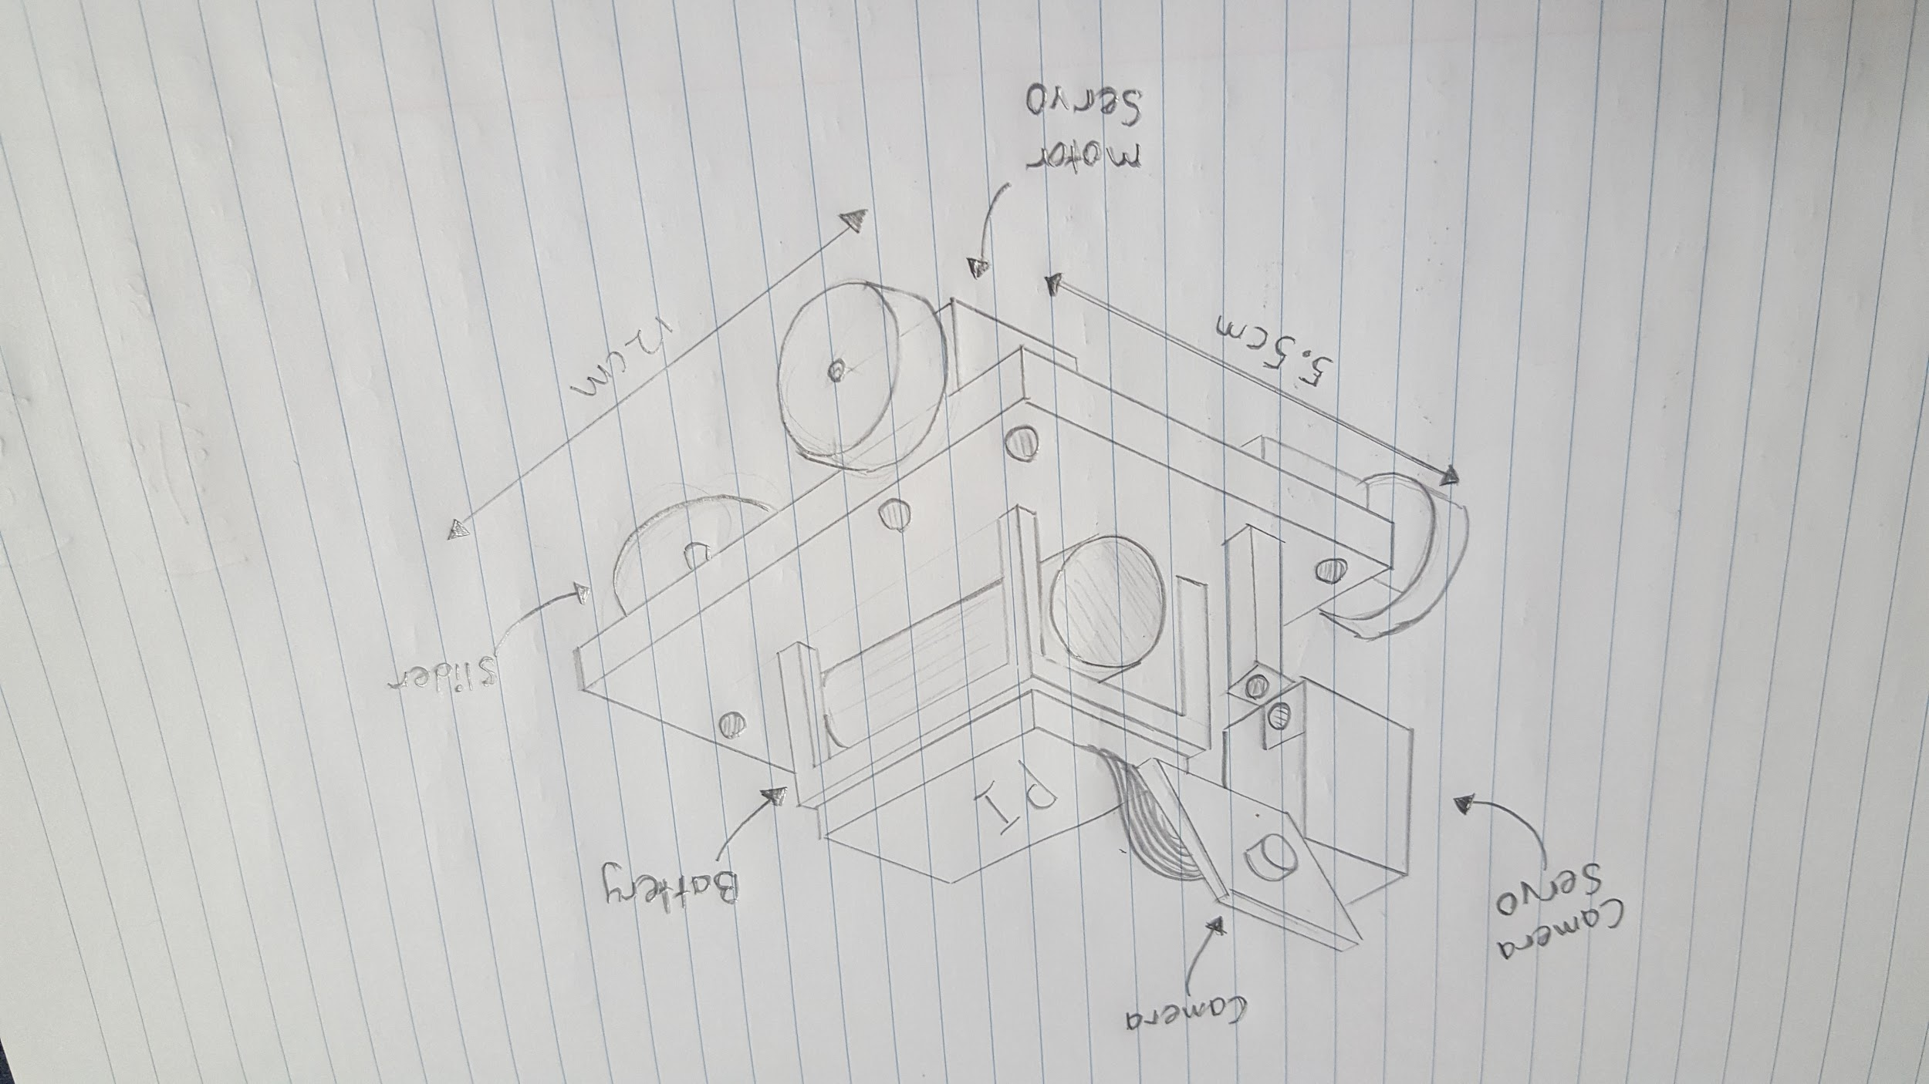

For our hardware, we started by designing a chassis that would fit all the required parts as well as having enough structure to hold them.

We created individual parts by either 3D printing them or by using pre-existing parts that were provided. This allowed us to trial each piece before being added to the design, if some parts didn’t fit or were faulty in any way, then we didn't lose progress. We will know if the design is complete once all the pieces have been attached and the model is able to be functional through the software that will be inputted.

**Software**

**Testing**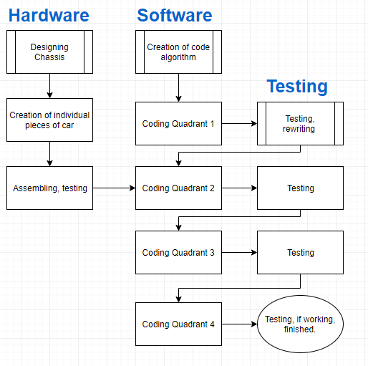

*The method explains how you did the experiment or study or project in sufficient detail that the experiment or project can be reproduced. Diagrams, schematics and pseudo code are often included. It is not to be written as a step-by-step guide.*

# 

**Results**

*The results section should state the results and the important details of the experiment or project. This section may contain tables and graphs of the collected data. If the experiment was to compare simulated results against real life then graphs with both results on the same axis would be useful here.*

**Discussion**

*Normally, the discussion section should explain the results and the position taken on the experiment or project. For example, why was the finish of the printed object stringy? How could the finish be improved? Comparisons against previous studies or expected results can be discussed here.*

**Conclusion**

*This section should state what was found, why it is important, possible benefits and the position the experiment takes.*

**References**

Raspberry pi Official Website

<https://www.raspberrypi.org/help/what-%20is-a-raspberry-pi/>

*Please add good references here using APA referencing style. Some examples are included below to show the expected style.*

*Barlow, C. 2008, Key concepts in computing,* Oxford University Press, Auckland.

Curtis, M. J. 2002, ‘Experimental design’, *Journal of Engineering,* vol. 12, no. 4 , p. 45 *.*

Gregg, B. & Wilkins, R. 2005, ‘The development of skills teaching in engineering, programs in New Zealand universities’. *Education Quarterly,* vol. 36, no. 1, pp. 57-72, (online EBSCO database).