## Hardware Design Photos/discussion points

### Base:

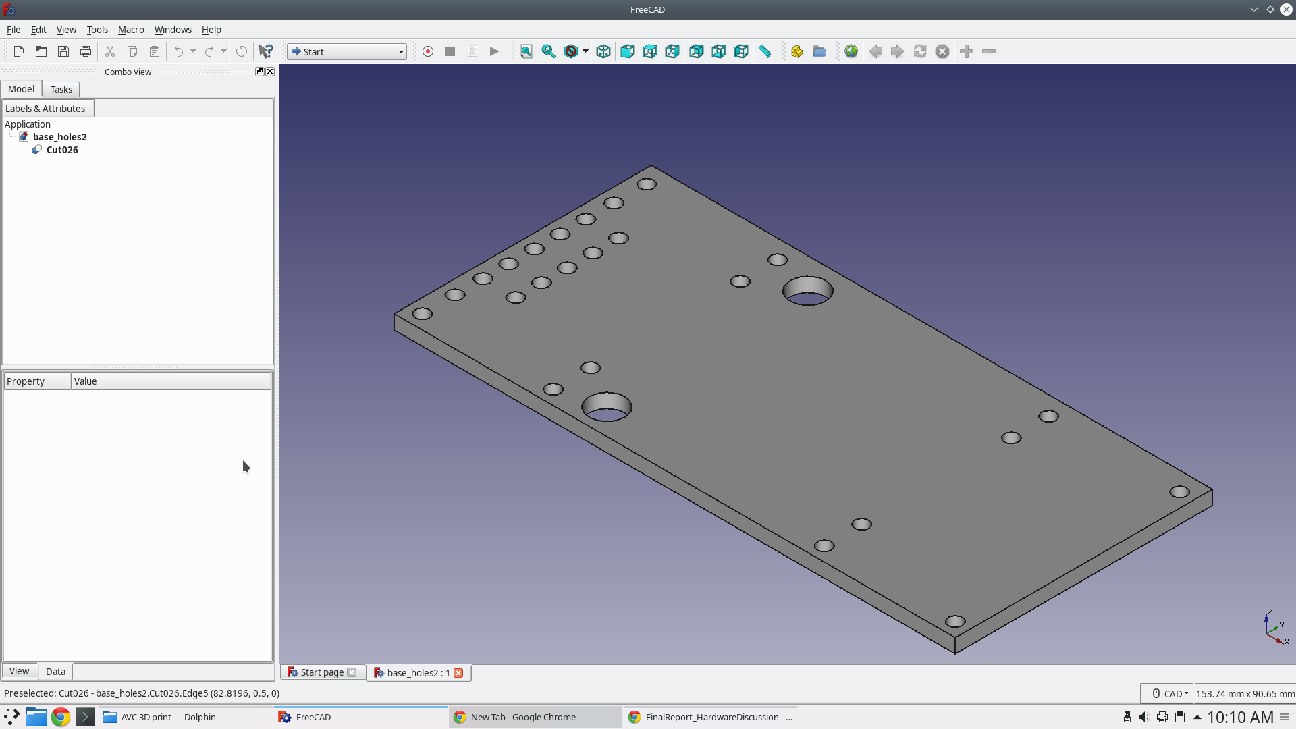

### Top Part Holder:

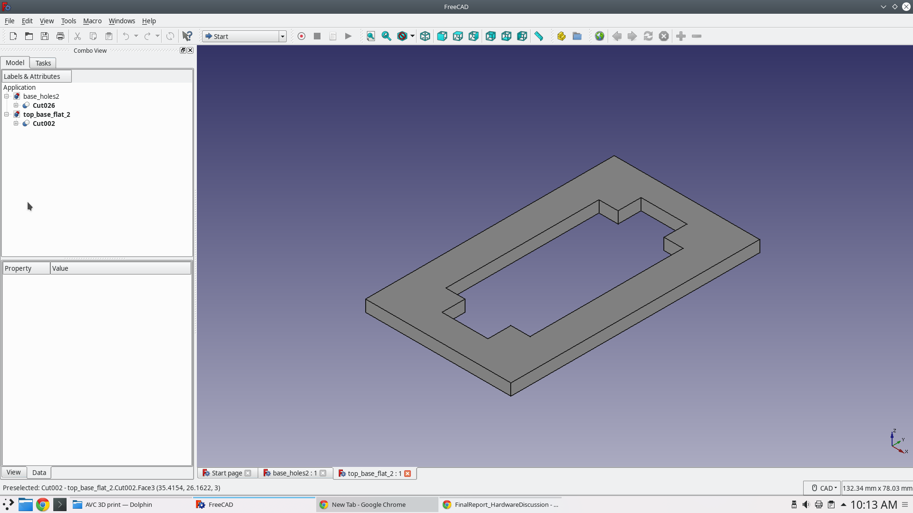

### Wheel Brackets:

The wheel brackets we had trouble with, we can talk about how the weight pushed the tires upwards and snapped the small bits. Progression through design

#### Design 1:

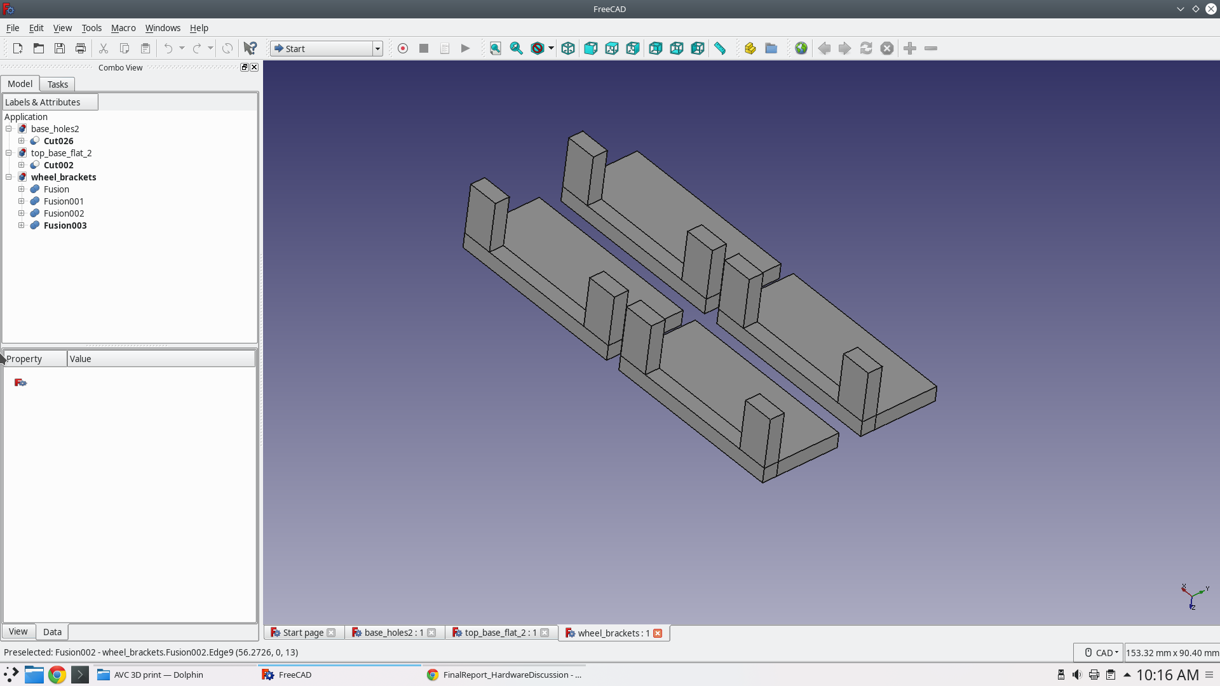

#### Design 2:

Added holes to reduce risk of the design breaking from power drill, reduced height of small bits so less chance of snapping

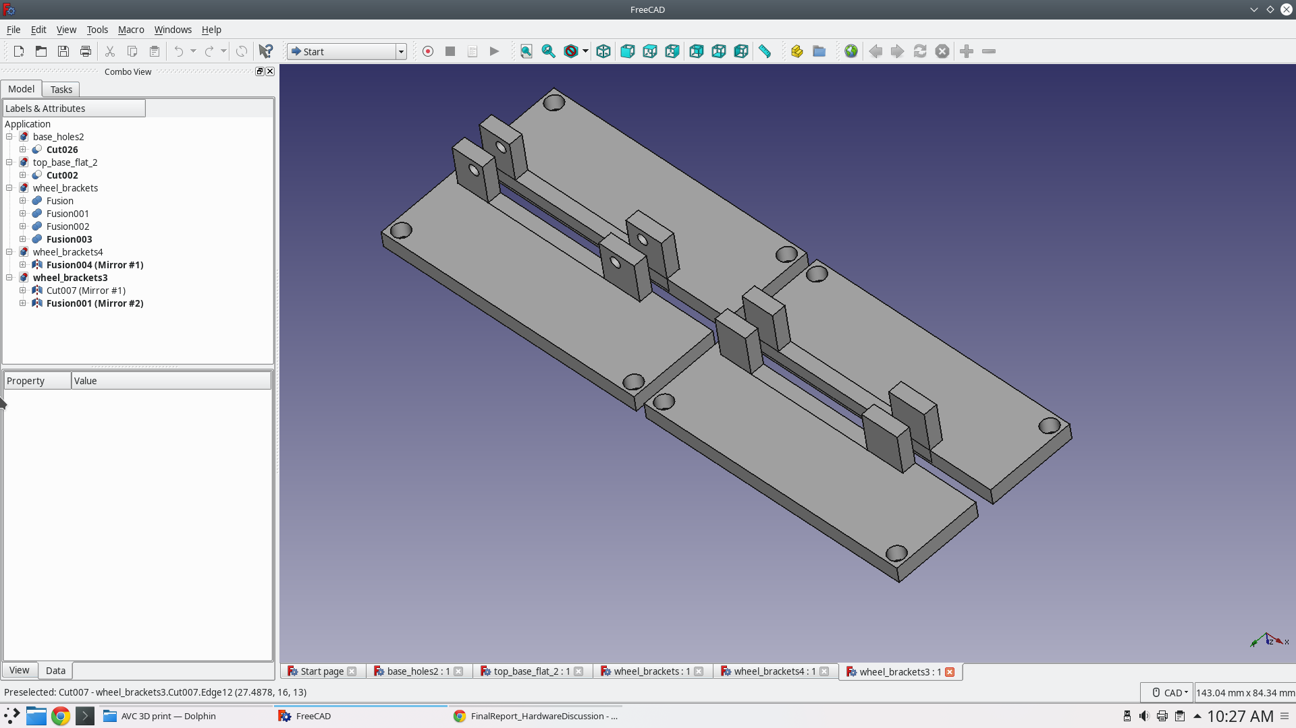

#### Design 3:

Added bottom bit to support weight (stopping it from bending upwards), made the small bits thicker to stop snapping, added side walls to keep the bottom from breaking off

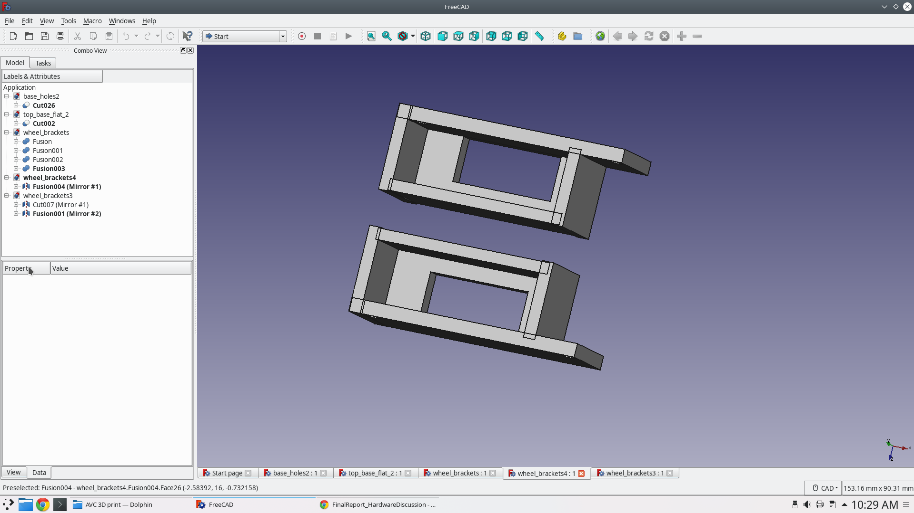

### Corner Brackets

We also had problems with this one. The old design had really small thickness which kept breaking under force of camera servo

#### Design 1:

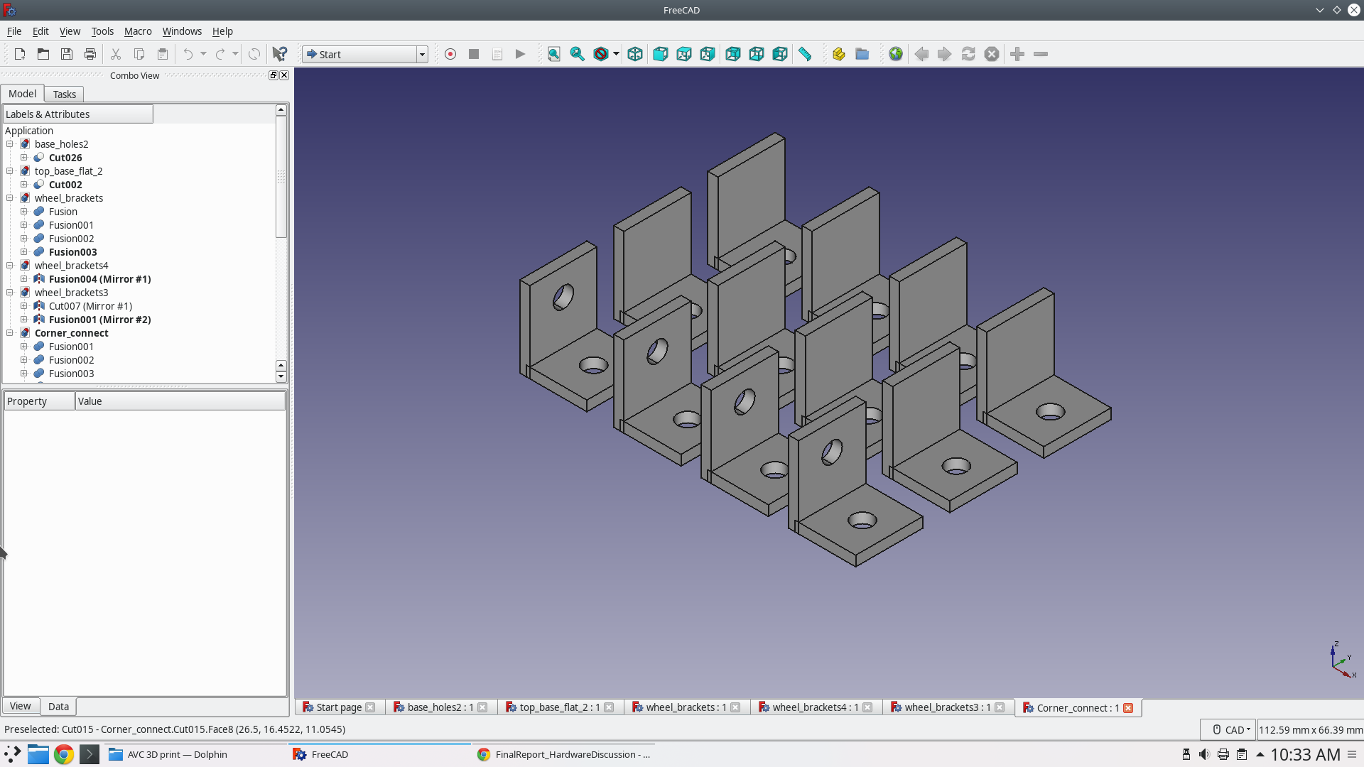

#### Design 2:

Made thicker, added side bits for extra support

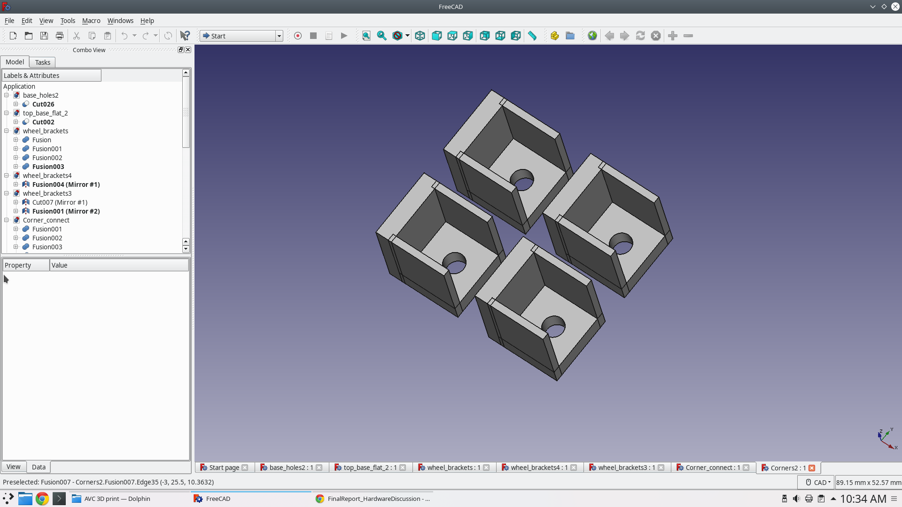

### Camera Mount:

The small cylinders is for the screws, it needs that so it doesn’t push against the parts on camera.

