repl.py
someonesdad1@gmail.com 12 May 2021
The repl.py script provides a REPL (read, evaluate, print, loop) construct similar to the python interpreter that I use as an interactive calculator and python expression evaluator. On the surface, it's use looks similar to a typical python interactive session. Here's an example that calculates the side of a triangle using the expression 29.77*sin(34.5*d2r):
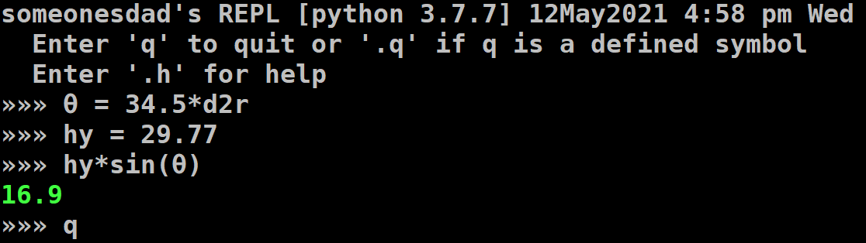
Compare this to using the python interpreter:
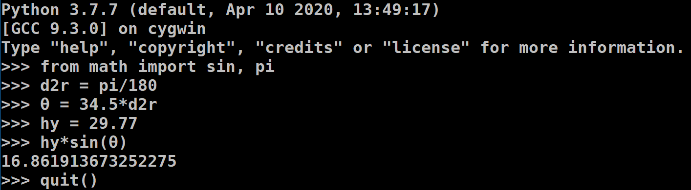
Some differences are:
- The symbols d2r and sin were already in scope.
- The prompt uses »»» instead of >>>.
- The floating point result is in color and is shown to 3 significant figures.
- The command q causes the script to exit.
- Help specific to repl.py can be gotten with the command .h.
The desire of being able to use q to quit the interpreter was what led me to find out how the interpreter works. I found out about the code module. In fact, if you go to /usr/lib/python3.7 and run python code.py, you'll get an interactive session that is nearly identical to interactive python. The only difference is you'll see (InteractiveConsole) on its own line, telling you that it's actually being controlled by the interact method of code.InteractiveConsole. The repl.py script uses an InteractiveConsole instance for its functionality.

repl.py Features
- Floating point and complex numbers
  - Avoiding lots of digits in floating point calculations. You can set the number of significant figures you want to see.
  - Floats and complex numbers are printed to the screen in color to help you identify them.
  - You can choose the type of formatting to use for floats and complex numbers.
  - math and cmath modules' symbols are in scope.
    - You can call common functions with either float or complex arguments and the correct module's function is called.
  - See flt/cpx for more details.
- Other number types
  - The mpmath library's mpf and mpc types are supported if mpmath is installed.
    - mpmath is imported, so you have access to its extensive features.
  - The python uncertainties module is supported if it is installed, letting you do calcuations with random variables using linear uncertainty propagation.
  - Python's decimal.Decimal numbers are supported and use the shorthand D.
  - Python's fractions.Fraction objects are supported and use the shorthand F.
  - The Zn class supports n-bit signed and unsigned integers.
    - These can be used to simulate arithmetic on a processor with a fixed number of bits.
    - Their operations are closed with binary operations with python integers.
    - You can change the number of bits (n attribute) and the signed/unsigned attribute (s attribute).
    - They are derived from integers, so they are technically immutable. However, the i attribute if False lets you change the n and s attributes, which affect how their str() and repr() methods work.
    - Any Zn instance is a factory for a new Zn object of the same number of bits and signed/unsigned type.
- Buffers
  - Buffers contain python code and can be edited with your editor.
  - The main buffer is unnamed. It can be saved to a named buffer.
  - All buffers are saved to disk when you exit and are read back in when the script starts again.
    - This creates a race condition if you have two processes running repl.py. You can save and read repl.py state using the .S and .R commands, which both take a name argument.
    - If you use .R to read a state, a lock is put on that saved state until either you exit repl.py or you issue a save command with .S. To save the data and maintain the lock, use the .SR command.
  - The command .r runs the unnamed buffer or you can run a named buffer by supplying the buffer's name.
- Command history, command editing, and tab-completion are supported if your python installation supports them.
- Matrix and vector operations are supported.
- New commands are easy to add.
- Error messages are printed in color to make them stand out.
- Units
  - Physical units are supported by the u.py module.
  - This is a lightweight tool that lets you convert things to SI units for internal calculations, then convert back to your problem's units at the end of calculations.

flt/cpx

Matrix

Buffer

