Socket Holder
someonesdad1@gmail.com 6 Mar 2020
The python script socket_holder.py helps you design a wooden holder for sockets such as the following:
It doesn't do anything you can't do by hand, but it speeds the process up a bit by letting you pick the distance between each hole edge, the drill sizes to use, and the amount of the socket you want exposed. Note that four of the sockets stand higher than the others; these are sockets I use a lot (you can tell from the black oxide being worn off).
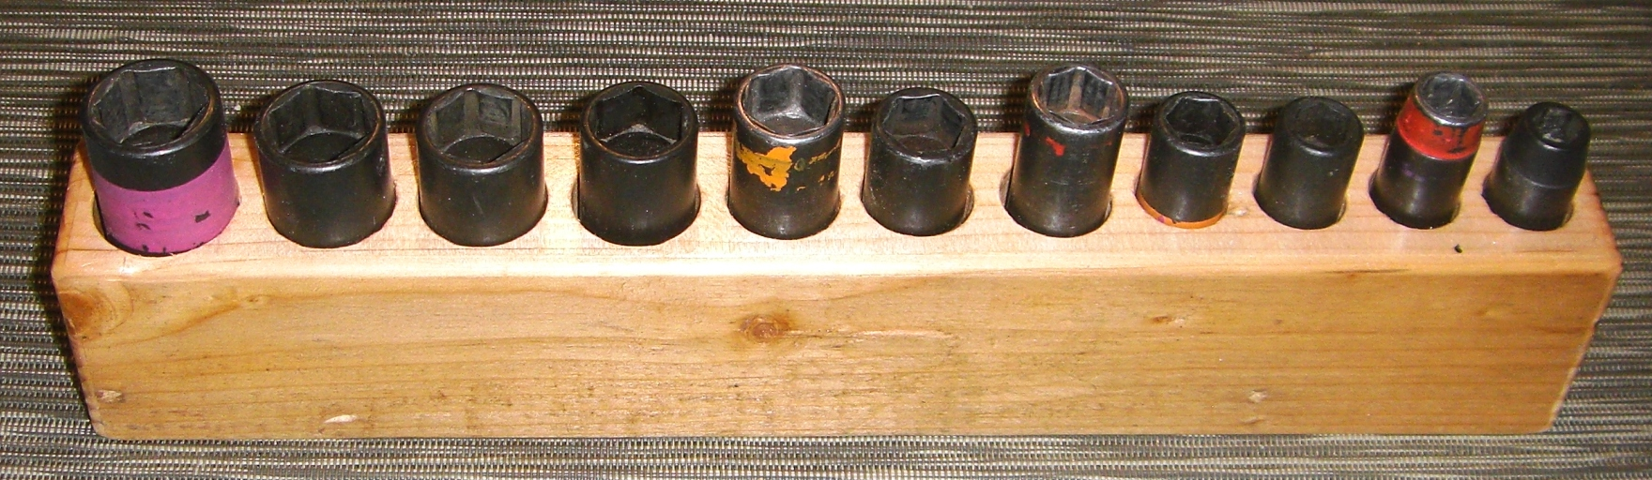Figure 1
Here are the dimensions used to design such a block; note all the socket centers lie on a single line:
To make my block, I first decided what thickness I wanted from the bottom of the block to the bottom of the holes, which is dimension a. Then I decided how much I wanted the normal exposure sockets to stick above the block, dimension Δ. Next I decided how much above the normal height the special sockets would be. These special sockets are ones that get used most frequently, so it's handy to have them stick out a bit. In the above picture, the sockets I use by far the most in this block are the 10, 13, 15, and 19 mm ones, so they are ¼ inch higher than the other sockets (they also get colored bands of acrylic paint to help them stand out).
If you're interested, the reason these sockets get used so much is that they are common on GM cars. My son and I work on a number of GM cars and engines. Other cars,I've worked on used the 10, 12, 14 and 17 mm hex sizes. The painting of the sockets has proved to be a valuable time saver over the years, as I also paint wrenches with these colors.
To use the script, you'll need to edit the data in the script; in particular, the data, Δ, H, a, b, project, and edge_offset variables. b is the distance between the hole edges. Note the default units are mils; if this doesn't suit you, it wouldn't be hard to e.g. change all the variables to be in millimeters (you'll need to change the code in the ReadData and Report functions.

Sample run
For the following data:
data = '''
9 680 2100 0 750
10 680 2100 250 750
11 680 2100 0 750
12 680 2100 0 750
13 680 2100 250 875
14 802 2380 0 875
15 833 2380 250 875
16 895 2380 0 1000
17 958 2620 0 1000
18 991 2620 0 1000
19 1052 2620 250 1125
'''
# Other variables needed
Δ = 700 # Height of normal sockets above block
H = 2000 # Height of block (not used, but documents the design)
a = 200 # Distance from bottom of longest hole to block bottom
project = "Snap-On 3/8 drive 6 point deep impact socket set 6 Mar 2020"
edge_offset = 250 # Distance from block edge to first hole's nearest edge
the script produced the following output:
Socket block design (dimensions in inches)
Project: Snap-On 3/8 drive 6 point deep impact socket set 6 Mar 2020
Variables:
Δ = 0.7 = height of normal sockets above block
H = 2.0 = height of block (not used, but documents the design)
a = 0.2 = distance from bottom of longest hole to block bottom
b = 0.2 = distance between hole edges

Output:
x = distance of hole center from edge of block
Δx = distance from previous hole center

Drill Drill
Socket x Δx depth Diameter
---------- ------- ------- ----- --------
9 0.62 0.62 1.40 0.750
10 1.57 0.95 1.15 0.750
11 2.52 0.95 1.40 0.750
12 3.47 0.95 1.40 0.750
13 4.49 1.01 1.15 0.875
14 5.56 1.08 1.68 0.875
15 6.64 1.08 1.43 0.875
16 7.78 1.14 1.68 1.000
17 8.97 1.20 1.92 1.000
18 10.17 1.20 1.92 1.000
19 11.44 1.26 1.67 1.125

Making the block
The block shown in Figure 1 was made from a scrap 2x4 that had been laying out in the yard since last summer. I laid out the holes manually before writing this script (I've made a number of these blocks over the years and always wanted a script to do the calculational work for me to help avoid errors). After locating the hole centers, I drew the hole diameter in pencil with a compass to verify the layout was reasonable. This edge with the pencil writing was ripped off on the table saw when I was finished, so I was free to write notes on it with the hole depths next to each hole. I rounded off the edges with a roundover bit then sprayed the block with a clear acrylic finish.

