dia.py Utility
someonesdad1@gmail.com 14 Sep 2015
The dia.py script is a python command-line utility that will print out common diameters and lengths used in the shop. Some of the standard size types you may see in the program's output are:
AWG (American Wire Gauge, also called the Brown & Sharpe Gauge)
Birmingham Gauge
British Standard Wire Gauge
Fractions of an inch
Galvanized sheet gauge
Hex nut wrench size
Hypodermic needle
Japanese knitting needle
Manufacturer's standard gauge for steel sheet
Millimeters
Music Wire Gauge
Number drill
Number-sized machine screw
SHCS Allen wrench size (SHCS = socket head cap screw)
SHCS head diameter
SHCS head height
Sheet steel gauge
Stub's Steel Wire Gauge
UK knitting needle
US knitting needle
US knitting needle 10
US pipe
Washburn & Moen wire gauge
Zinc sheet gauge
Internal to the code are attributions to where the data came from, so if you find an apparent error, first check the reference to see if e.g. there was a transcription error.

Example
Suppose I need to bend a piece of wire in a circle of 1.37 inches in diameter. I type in the command
python dia.py 1.37
and see the results
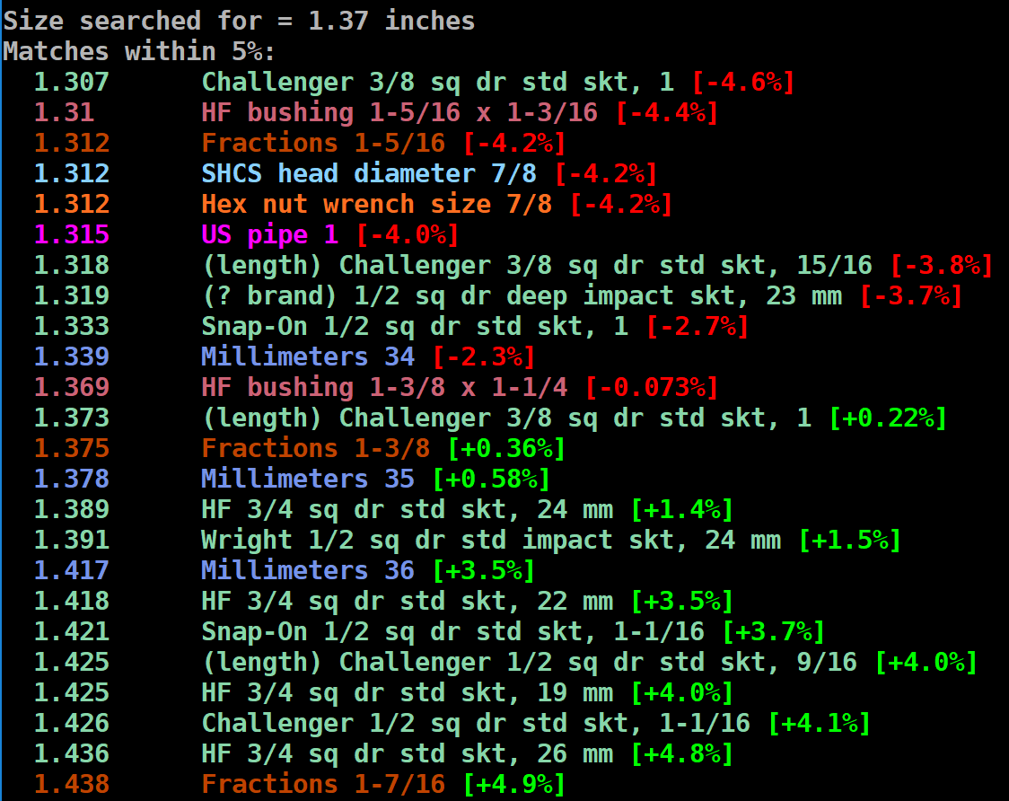
On the left are various diameters or lengths in inches; on the right are their descriptions and the percentage deviation from the requested size.
The color-coded output helps me identify things. The light green color is used for sockets, as these are common shop tools used as a form to bend things around. Note the red and green percentage deviations from the desired size, helping you to select the item to use.
Real wires will exhibit spring-back after bending (see the section Spring-back below for more details). Here, I was going to bend some annealed stainless steel 1 mm diameter safety wire, so I estimated the spring-back would be about 5%. I selected the Challenger socket at the top of the list, as it was about 5% under the desired size. A quick bend around the socket held in the vise gave me a circle with an ID of 1.38 inches as measured by a rule, so this was perfect for my needs.
Since finding a suitable size to bend a piece of metal around is such a common task, the above task could have been done with the command python dia.py -s 5 1.37 and the 5% spring-back would have been taken into account, so you just select the item with the least percentage deviation.
For things like the bushing set and all of my sockets, I measured their diameters and lengths and typed them into the script (this was tedious, but I only had to do it once). The (length) line tells me I have a 3/8 drive Challenger socket with a 1 inch hex that is 1.373 inches long. The dimension is a diameter unless (length) is included.
This feature should work if your console supports 24-bit ANSI escape sequences.

Usage
With no input on the command line, the usage statement is
Usage: dia.py [options] diameter [unit]
Identifies dimensions that might be close to some "standard" size, such as
fractions of an inch, numbered drills, millimeters, or on-hand socket sizes.
Use -f to include the full set of different size systems.

'diameter' is a length and may contain an optional trailing unit (size is
in inches if no unit is given). Expressions for the diameter are
allowed and the math module's symbols are in scope.
Examples:
dia.py 1
Show things within 5% of 1 inch in diameter.
dia.py pi/10 mm
Show things that are within 5% of pi/10 mm in diameter. Note
output diameters are in mm.
Options:
-a Show all of the dimensions stored in the script
-c Don't show results in color
-d The diameter is a dimensionless number; show numbers such as
Renard, E series, etc. that are close to it.
-f Include full set of sizes
-h More detailed help
-k List of on-hand sockets
-n n Number of significant digits [4]
-o u Output unit (default is same unit as used for input)
-s p Spring-back percentage. The diameter used will be reduced by the
indicated percentage.
-t p Tolerance in % for searching [5]
-u u Default measurement unit [inches]
The output units default to those you use on the command line or the program's default setting.
Most commonly-used units are supported, so type your favorite in and it should work. If not, you can easily add it to the u.py module, which is used for unit conversions.

-d: dimensionless numbers
The -d option is used to identify significands from Renard and E series that are close to the entered number. These are preferred number systems. For example, many folks are familiar with the E6 series for electrical component values: 10, 15, 22, 33, 47, and 68.
Use the -d and -a options together to get a listing of all the preferred numbers.

Sockets
A fairly common task in the shop is to bend something around a needed diameter. Sockets from a socket set are convenient for this task, but they are usually oddball sizes. Still, it can be worthwhile to spend the time measuring the diameters and lengths of your sockets to allow the script to print out ones you can use for shop tasks.
Since these are user-specific dimensions, you'll want to edit the Sockets() function to reflect the dimension of your sockets and other specialized stuff.
The length of a socket can be used like a shim. The reported output includes (length) for socket lengths.
It's quite a bit of work to measure and enter all the data, but once it's on-hand, you'll find this script useful for such bending tasks. For example, my wife wanted some custom-bent hooks for some Christmas ornaments to fit a thing she was making and it was easy to go to the shop and bend her up a bag full of these hooks because the script gave me the needed socket sizes.

Spring-back
When bending wire or sheet metal around a form, it's common to see some spring-back after bending. You'll have to empirically determine useful spring-back percentages from some actual bending. The mental model I use is that some of the material near the neutral axis is being deformed in its elastic region, causing a relaxation after the bending stress is removed.
The (simple) model used by the script is that the percentage spring-back given as input is used to reduce the diameter given on the command line. Thus, if you give a 1 inch diameter and specify a spring-back of 10%, the diameter searched for is 0.9 inches.
Here are some measured spring-back percentages from bending various wires around a 0.892 diameter socket (dimensions in inches):
Wire | Diameter | %
12 ga. copper (from a piece of Romex) | 0.92-0.93 | 3.1-4.3
0.04 inch brass (temper unknown) | 0.96-0.97 | 7.6-8.7
0.041 stainless steel safety wire | 1.01-1.02 | 13-14
0.059 soft steel | 0.93 | 4.3
0.071 annealed 1070 steel | 1.18-1.19 | 32-33
0.045 music wire (#20 music wire gauge) | 1.4-1.5 | 57-68
The spring-back is dependent on the state of the material: annealed materials are soft and tend to deform easily, so have low spring-back. Heat treated metals like music wire have lots of spring-back. If you've ever wound springs on a lathe, you'll also know that the spring-back can be dependent on how you do the winding.
For the softer annealed metals, I'll use a spring-back value of 5% for estimation purposes.

