let recipeObj = {
title: "Tomato Pasta",
imgSrc: "https://d1tgh8fmlzexmh.cloudfront.net/ccbp-dynamic-webapps/recipe-img.png",
ingredients: ["Pasta", "Oil", "Onions", "Salt", "Tomato Pasta Sauce", "Cheese"]
}

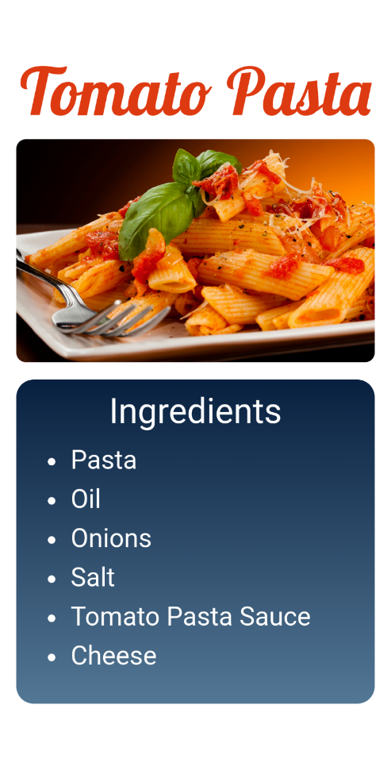

let todoList = [{
text: "Learn HTML"
},
{
text: "Learn CSS"
},
{
text: "Learn JavaScript"
}
];
];

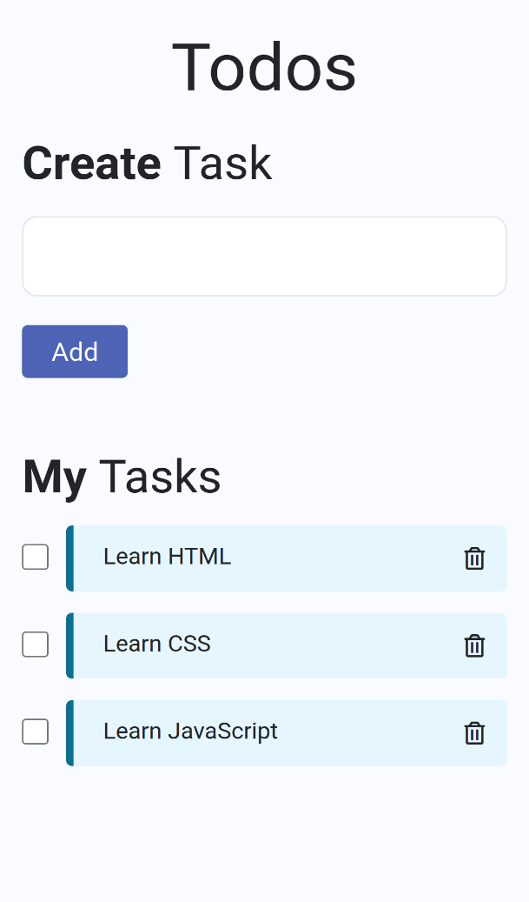

let groceryList = ["Apples", "Boost Drink", "Butterscotch Ice Cream", "Tomato Ketchup", "Dairy Milk Chocolates", "Pasta"];

