**EXP. 10: INSTALL HADOOP 2.X AND CONFIGURE THE NAME NODE AND DATA NODE.**

**AIM:**

**PROCEDURE:**

**Step 7** - Modify Hadoop config files

//Hadoop Environmental variable setting – The following files will be modified

1. ~/.bashrc
2. /usr/local/hadoop/hadoop-2.7.2/etc/hadoop/hadoop-env.sh
3. /usr/local/hadoop/hadoop-2.7.2/etc/hadoop/core-site.xml
4. /usr/local/hadoop/hadoop-2.7.2/etc/hadoop/hdfs-site.xml
5. /usr/local/hadoop/hadoop-2.7.2/etc/hadoop/yarn-site.xml
6. /usr/local/hadoop/hadoop-2.7.2/etc/hadoop/mapred-site.xml.template

$ sudo nano ~/.bashrc

// Add the following lines at the end of the file

|  |
| --- |
| export JAVA_HOME=/usr/lib/jvm/java-8-oracle export HADOOP_HOME=/usr/local/hadoop/hadoop-2.7.2  export PATH=$PATH:$HADOOP_HOME/bin export PATH=$PATH:$HADOOP_HOME/sbin export HADOOP_MAPRED_HOME=$HADOOP_HOME export HADOOP_COMMON_HOME=$HADOOP_HOME export HADOOP_HDFS_HOME=$HADOOP_HOME export YARN_HOME=$HADOOP_HOME  HADOOP_COMMON_LIB_NATIVE_DIR=$HADOOP_HOME/lib/native export HADOOP_OPTS="-D.java.library.path=$HADOOP_HOME/lib" export PATH=$PATH:/usr/local/hadoop/hadoop-2.7.2/bin |

// Configure Hadoop Files

$ cd /usr/local/hadoop/hadoop-2.7.2/etc/hadoop/

$ sudo nano hadoop-env.sh

// Add following line in hadoop-env.sh – Set JAVA variable in Hadoop

# The java implementation to use. export JAVA_HOME=/usr/lib/jvm/java-8-oracle

// Create datanode and namenode

$ sudo mkdir –p /usr/local/hadoop_tmp/hdfs/namenode

$ sudo mkdir –p /usr/local/hadoop_tmp/hdfs/datanode

// Changing ownership to hadoop_tmp

$ sudo chown –R hduser:hadoop /usr/local/hadoop_tmp

// Edit hdfs-site.xml

$ sudo nano hdfs-site.xml

// Add the following lines between <configuration> …… </configuration>

<configuration>

<property>

<name>dfs.replication</name>

<value>1</value>

</property>

<property>

<name>dfs.namenode.name.dir</name>

<value>file:/usr/local/hadoop_tmp/hdfs/namenode</value>

</property>

<property>

<name>dfs.datanode.data.dir</name>

<value>file:/usr/local/hadoop_tmp/hdfs/datanode</value>

</property>

</configuration>

// Edit core-site.xml

$ sudo nano core-site.xml

// Add the following lines between <configuration> …… </configuration>

<configuration>

<property>

<name>fs.default.name</name>

<value>hdfs://localhost:9000</value>

</property>

</configuration>

// Edit yarn-site.xml

$ sudo nano yarn-site.xml

// Add the following lines between <configuration> …… </configuration>

<configuration>

<property>

<name>yarn.nodemanager.aux-services</name>

<value>mapreduce_shuffle</value>

</property>

<property> <name>yarn.nodemanager.aux-services.mapreduce.shuffle.class</name>

<value>org.apache.hadoop.mapred.Shuffle-Handler</value>

</property>

</configuration>

// Edit mapred-site.xmsudo

$ cp /usr/local/hadoop/hadoop-2.7.2/etc/hadoop/mapred-site.xml.template /usr/local/hadoop/hadoop-2.7.2/etc/hadoop/mapred-site.xml

$ sudo nano mapred-site.xml

// Add the following lines between <configuration> …… </configuration>

<configuration>

<property>

<name>mapreduce.framework.name</name>

<value>yarn</value>

</property>

</configuration>

**Step-8** – Format Hadoop File System

$ cd /usr/local/hadoop/hadoop-2.7.2/bin $ hadoop namenode -format

**Step 9** - Start Hadoop

$ cd /usr/local/hadoop/hadoop-2.7.2/sbin

// Starting dfs services

$ start-dfs.sh

// Starting mapreduce services

$ start-yarn.sh

$ jps

**Step 10** - Check Hadoop through web UI

Go to browser type http://localhost:8088 – All Applications Hadoop Cluster

Go to browser type http://localhost:50070 – Hadoop Namenode

**Step 11** - Stop Hadoop

$ stop-dfs.sh

$ stop-yarn.sh

**IMPLEMENTAION:**

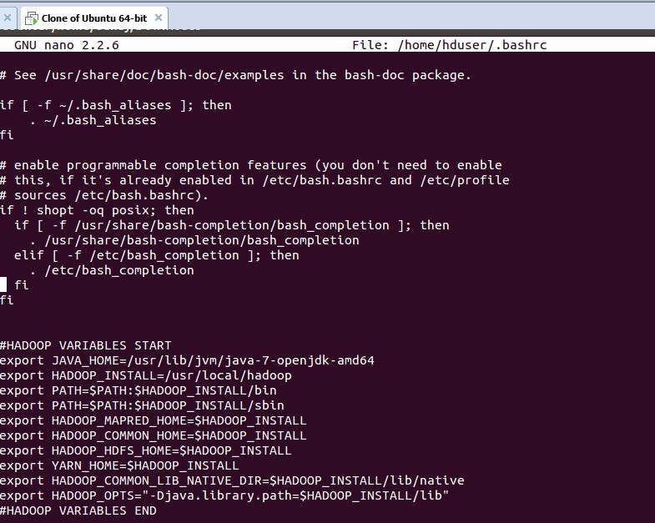

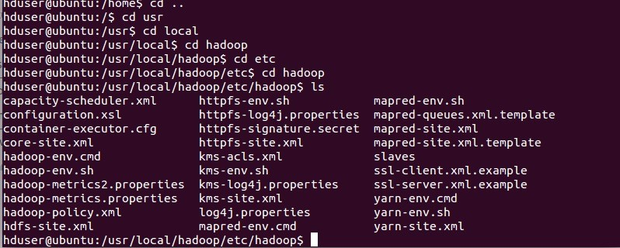

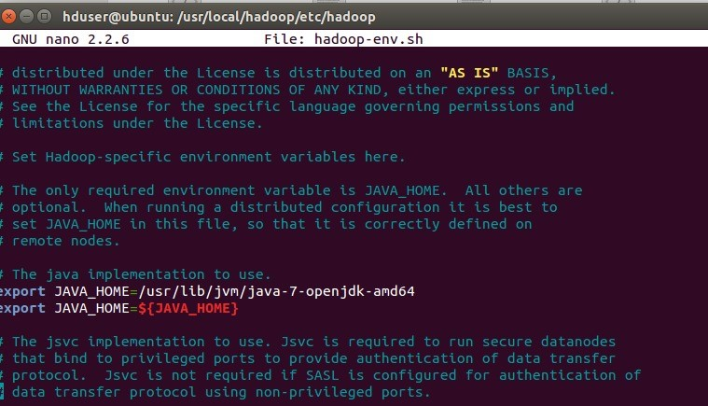

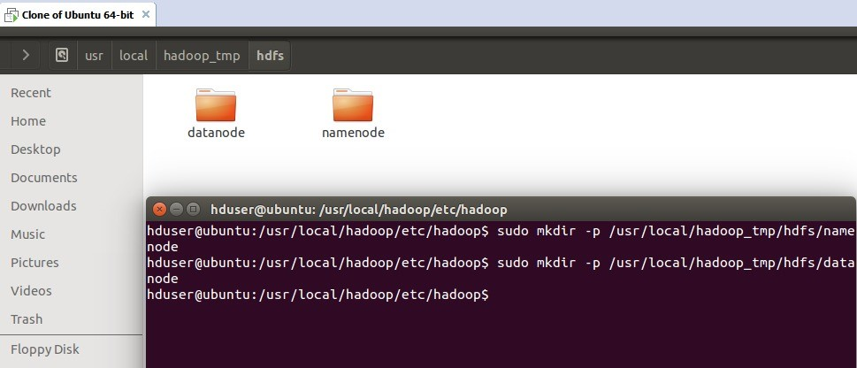

**RESULT:**