**8.CREATE A SQL STORAGE SERVICE AND PERFORM A BASIC QUERY USING**

**ANY PUBLIC CLOUD SERVICE PROVIDER (AZURE/GCP/AWS) TO**

**DEMONSTRATE DATABASE AS A SERVICE (DAAS) AIM:**

**PROCEDURE:**

**IMPLEMENTATION:**

**STEP1: GOTO AZURE AND GOTO SQLDATABASE.**

**STEP 02:- Now Create a Sql Databse**

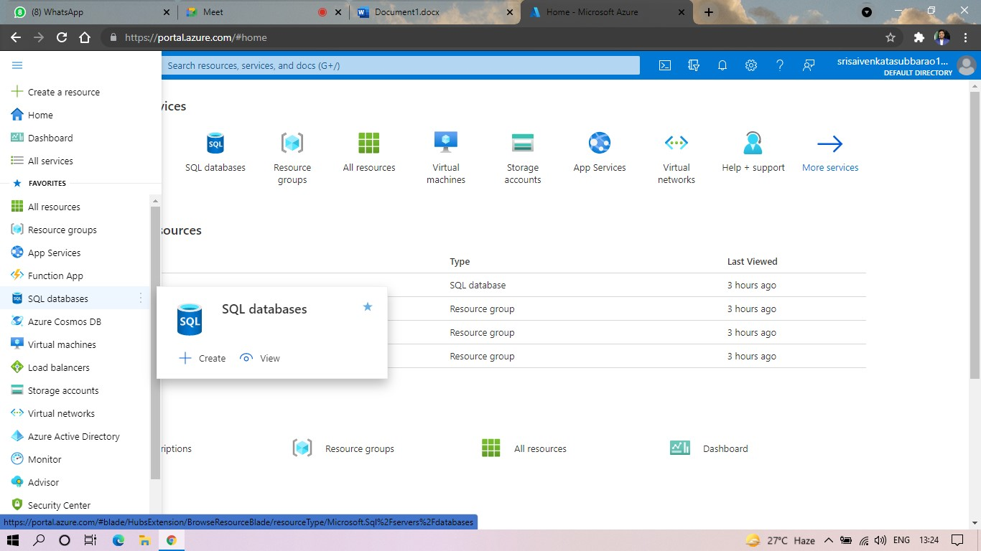

**STEP3: SELECT THE RESOURCE GROUP AND ENTER THE SERVERNAME THAT APPLICABLE.**

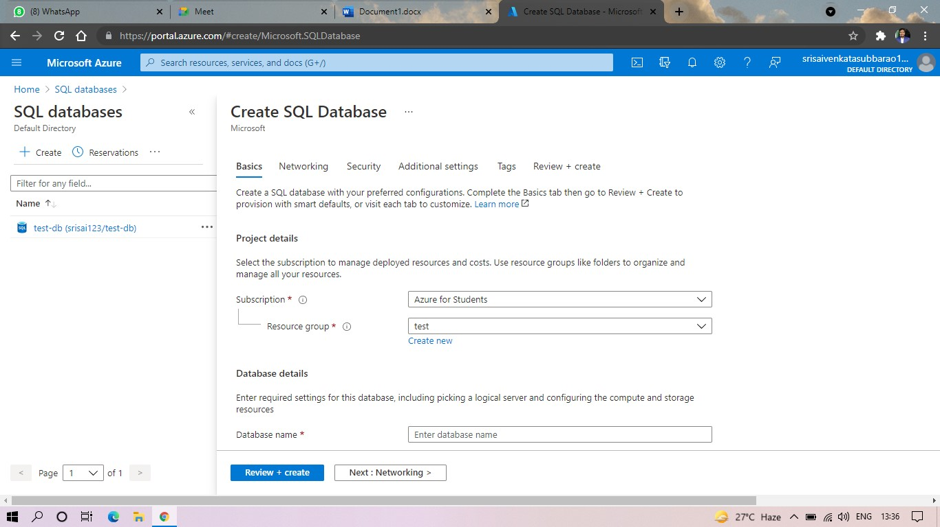

**STEP4: IN NETWORKING SELECT ALLOW AZURE SERVICES AND**

**RESOURCES TO ACCESS THIS SERVER.**

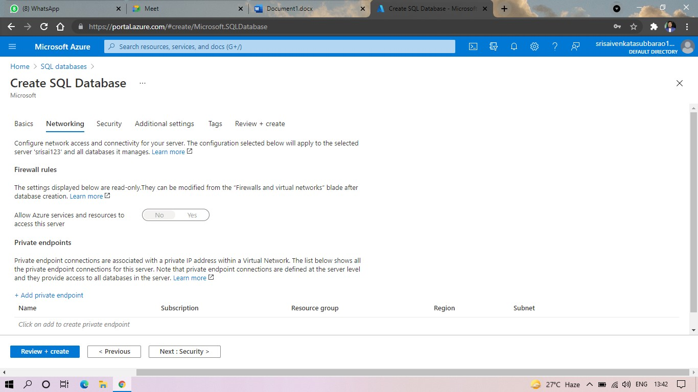

**STEP5: IN ADDITIONAL SETTINGS SELECT SAMPLE.**

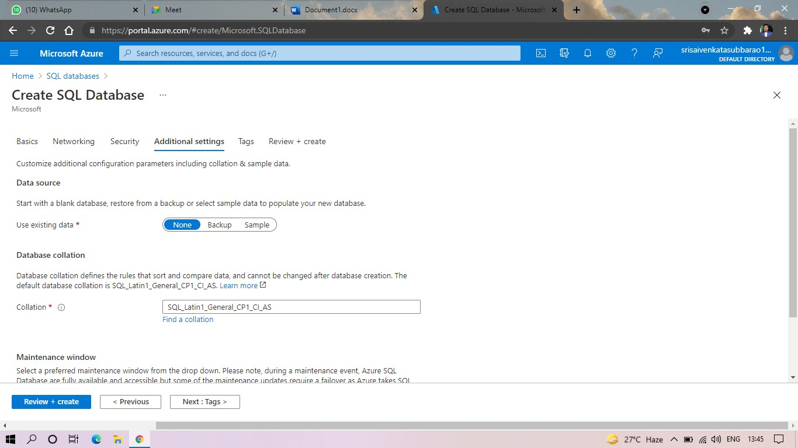

**STEP6:AND THE SQL DATABASE IS DEPLOYED.**

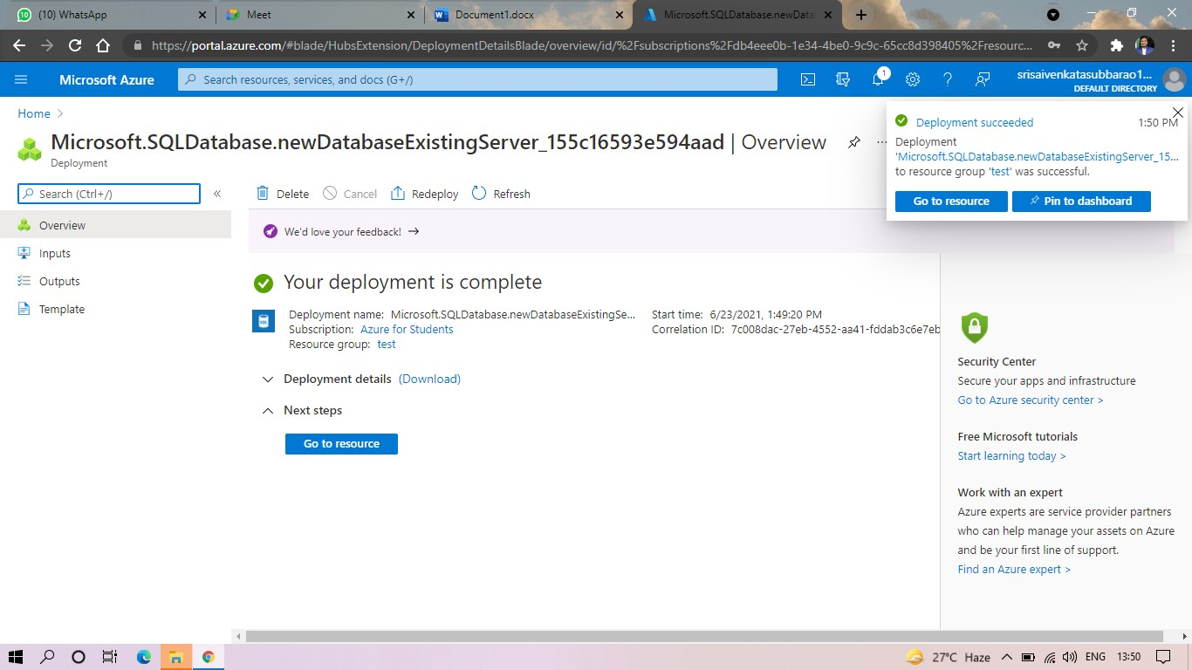

**STEP7:AND NOW GOTO QUERY EDITOR.**

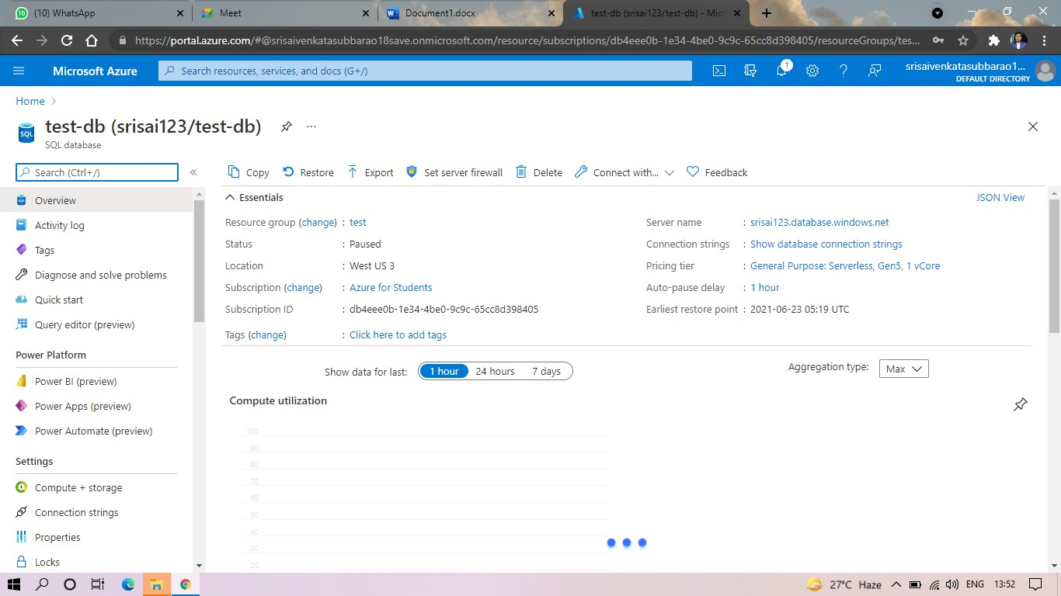

**STEP8:AND NOW AGAIN LOGIN TO THE SQLDATADATABASE**

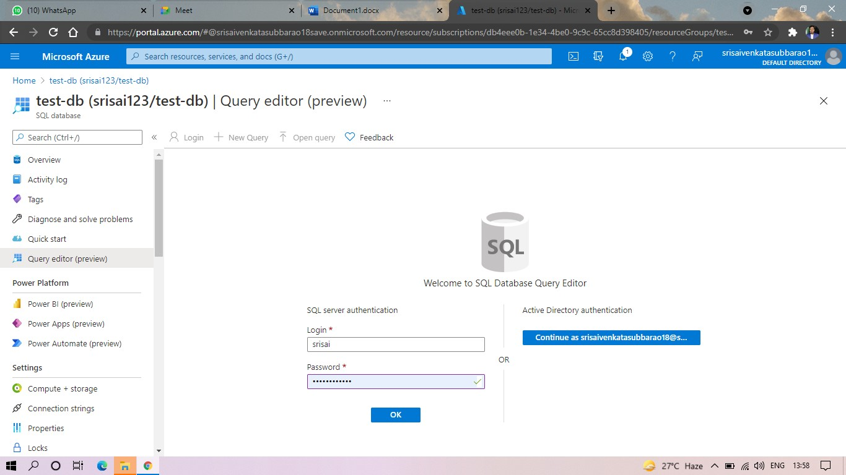

**STEP: AND OUR TABLES WILL SHOWN AND TYPE THE QUERY TO EXCUTED.**

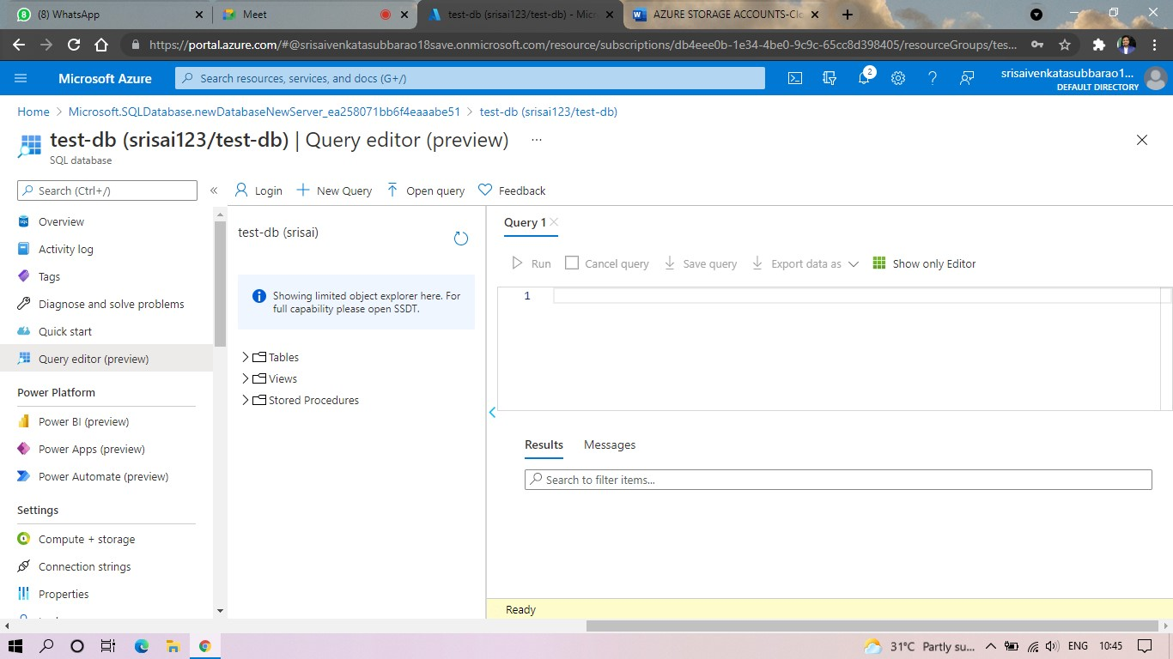

**STEP10: AND OUR OUTPUT IS READY.**

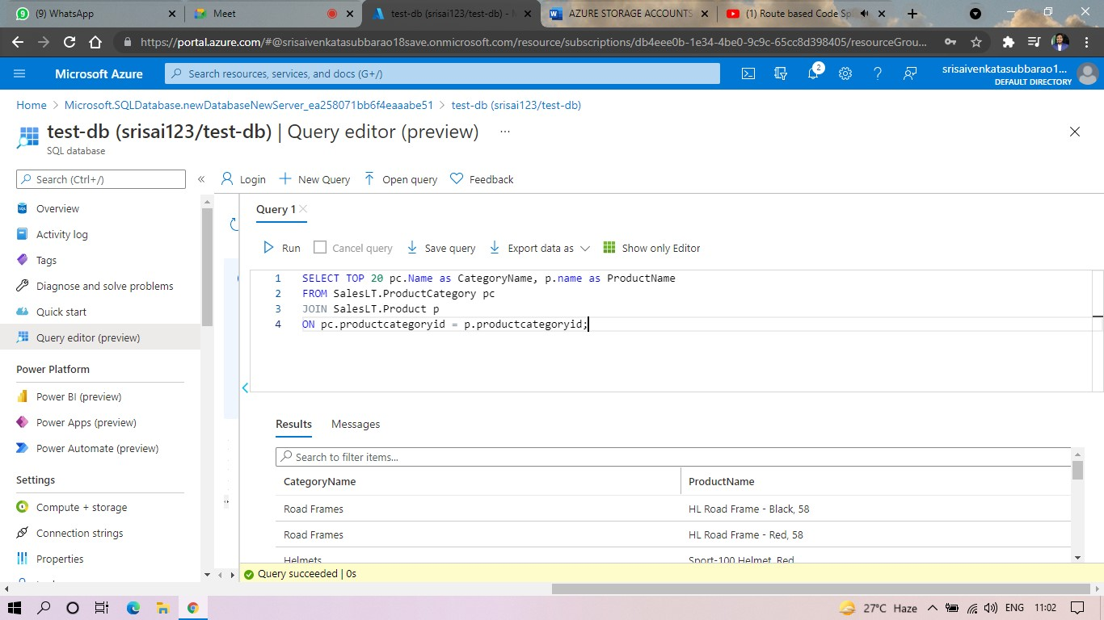

**RESULT:**