**EXP. 9: PERFORM THE BASIC CONFIGURATION SETUP FOR INSTALLING**

**HADOOP 2.X LIKE CREATING THE HDUSER AND SSH LOCALHOST AIM:**

**PROCEDURE:**

**Step 1** – System Update

$ sudo apt-get update

**Step 2** – Install Java and Set JAVA_HOME

//This first thing to do is to setup the webupd8 ppa on your system. Run the following command and proceed.

$ sudo apt-add-repository ppa:webupd8team/java

$ sudo apt-get update

//After setting up the ppa repository, update the package cache as well.

//Install the Java 8 installer

$ sudo apt-get install oracle-java8-installer

// After the installation is finished, Oracle Java is setup. Run the java command again to check the version and vendor.

[or]

$ sudo apt-get install default-jdk $ java -version

**Step 3** – Add a dedicated Hadoop user $ sudo addgroup hadoop

$ sudo adduser --ingroup hadoop hduser

// Add hduser to sudo user group

$ sudo adduser hduser sudo

**Step 4** – Install SSH and Create Certificates $ sudo apt-get install ssh

$ su hduser

$ ssh-keygen -t rsa -P ""

// Set Environmental variables

$ cat $HOME/.ssh/id_rsa.pub >> $HOME/.ssh/authorized_keys

**Step 5** – Check if SSH works $ ssh localhost

**Step 6** – Install Hadoop

// Extract Hadoop-2.7.2

$ sudo tar xvzf hadoop-2.7.2.tar.gz

// Create a folder ‘hadoop’ in /usr/local $ sudo mkdir –p /usr/local/hadoop

// Move the Hadoop folder to /usr/local/hadoop

$ sudo mv hadoop-2.7.2 /usr/local/hadoop

// Assigning read and write access to Hadoop folder

$ sudo chown –R hduser:hadoop /usr/local/hadoop

**Implementation:**

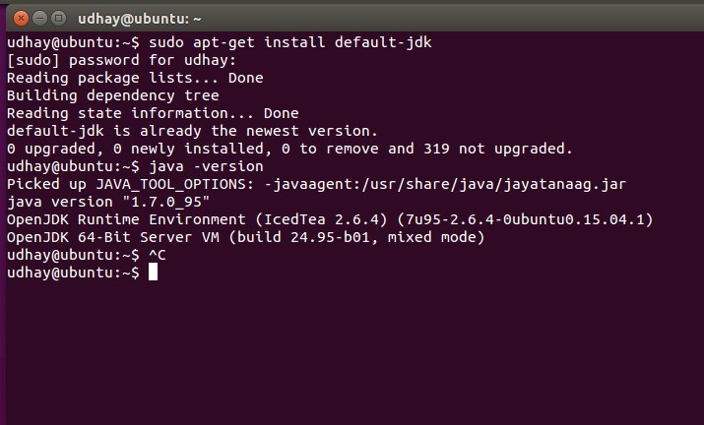

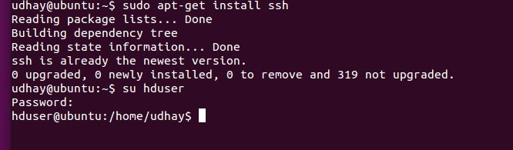

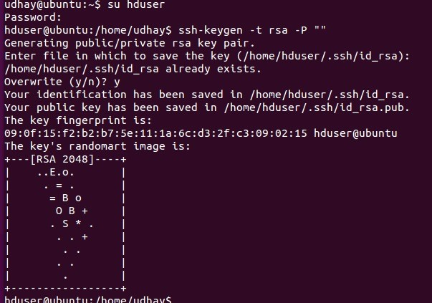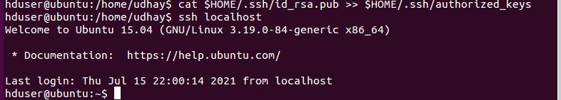

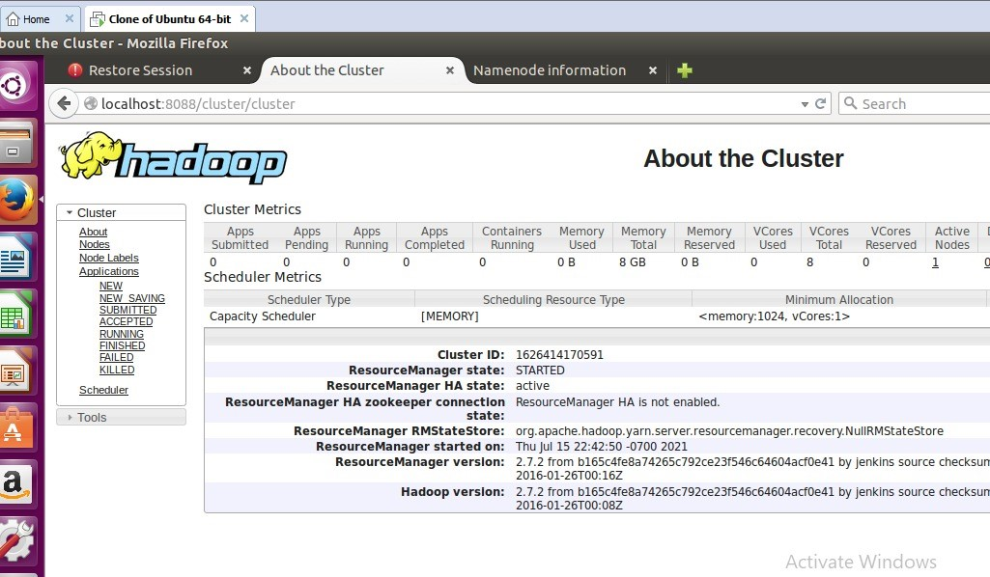

**RESULT:**