OPEN SOURCE TECHNOLOGIES (01CE0618)
Lab Manual
______________________________

Name: | Prem Dafda
Enrolment No: | 92410103017
Class: | 6EC3
Batch: | A

INDEX
Lab | Program | Date | Marks | Signature
1. | Explore GitHub/GitLab for open-source projects with different licenses
2. | Setup Git and explore commands related to Version Control System (VCS)
3. | Create a GitHub/GitLab repository and upload sample code
4. | Use npm / yarn / pip to install and manage packages
5. | Deploy a simple application using Nginx / Apache
6. | Setup Nginx to handle proxy requests and load balancing
7. | Develop a Laravel / Django based web application
8. | Use pytest to test a Python application
9. | Use Selenium to create browser-based tests
10. | Use Postman to test a sample API
11. | Use OWASP ZAP to check security integrity
12. | Modify any open-source desktop application
13. | Contribute to any web-based open-source project
14. | Use source code of an open-source web application and deploy it locally

Experiment 1
AIM: Explore GitHub/GitLab for open-source projects with different licenses.
- React
- Description: React is a JavaScript library for building user interfaces.
- Technologies used:
- Javascript
- JSX
- Virtual DOM
- License type: MIT License
- Use cases:
- Build SPAs (Single-Page Applications).
- Build Cross-Platform Applications.
- Build UI.
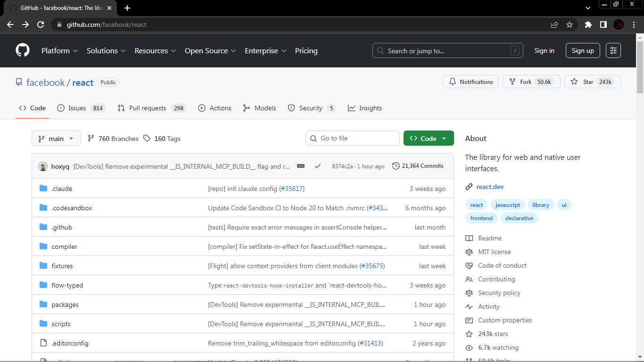

- Flask
- Description: The Python micro framework for building web applications.
- Technologies used:
- Python
- Werkzeug
- Jinja2
- License type: BSD-3-Clause License
- Use cases:
- Building REST APIs and Microservices.
- Rapid Prototyping and MVPs.
- Small to Medium Web Applications.
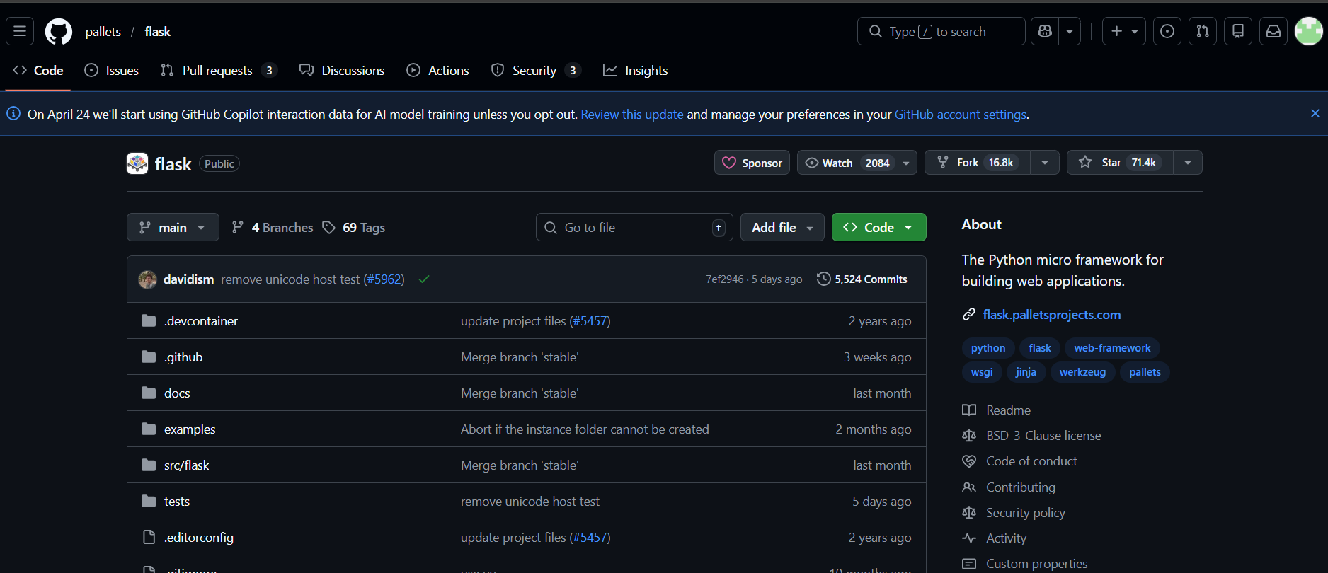

- Superset
- Description: Apache Superset is a Data Visualization and Data Exploration Platform.
- Technologies used:
- Python
- Flask
- MySQL
- License type: Apache-2.0 license
- Use cases:
- Business Intelligence (BI) and Dashboarding.
- Ad-Hoc Data Analysis and Exploration.
- Operational Analytics.
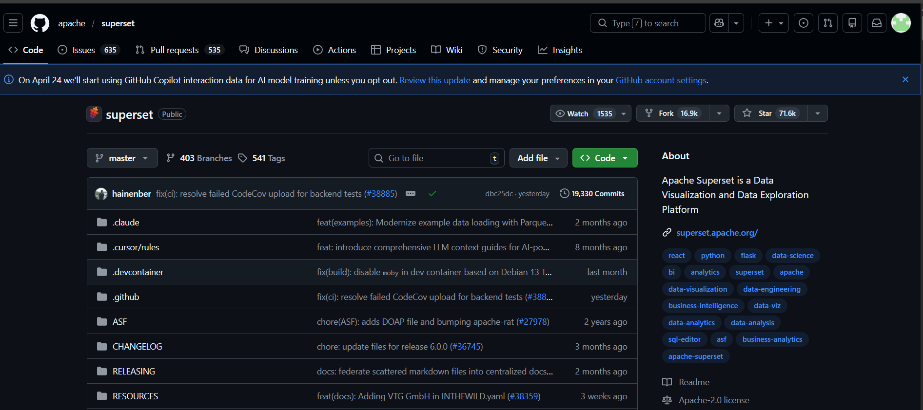

Differences:
React | Flask | Superset
- Maintained by Facebook/Meta | - Maintained by Python Community | - Maintained by Apache
- MIT License | - BSD 3-Clause License | - Apache License 2.0
- Commercial use, modification, and redistribution permitted with attribution | - Commercial use, modification, and redistribution permitted with attribution | - Commercial use, modification, and redistribution permitted with attribution and NOTICE requirements
- No explicit patent grant | - Explicit patent is not granted | - Explicit patent grant with retaliation clause
- Component-based UI library for client-side applications | - Lightweight server-side microframework for web apps and APIs | - Web-based BI and data visualization platform
- Runs in browser environment | - Runs on server-side runtime | - Runs as analytics server connected to databases
- Indirect database interaction via APIs | - Database integration through extensions/ORM | - Direct SQL querying of multiple data sources
- Used for making SPAs. | - Used for making APIs. | - Used for DVA.

Experiment 2
AIM: Setup Git and explore commands related to Version Control System (VCS).
- Go to a search engine and search ‘Git for Windows’ and download git for windows/x64 setup from https://git-scm.com/install/windows.
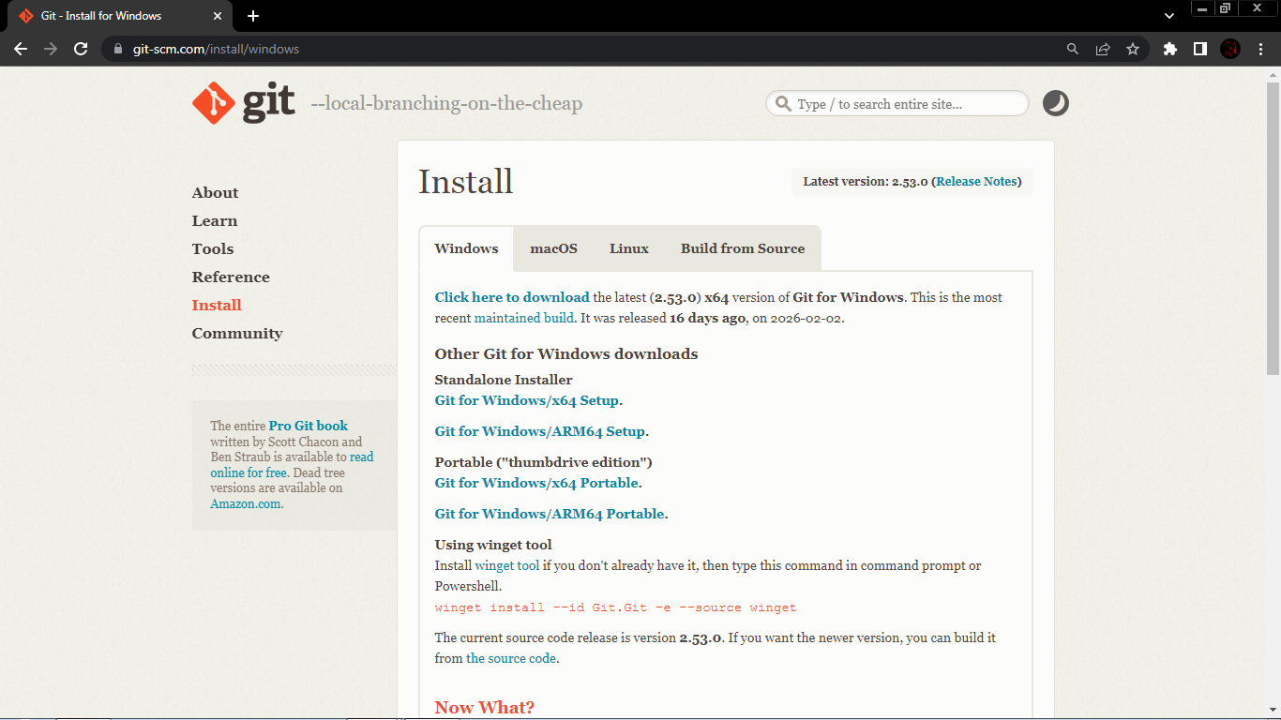
- Open setup and install git. To confirm git was successfully installed in your system, open a command prompt and type ‘git --version’ command. If it shows git version then installation was a success.
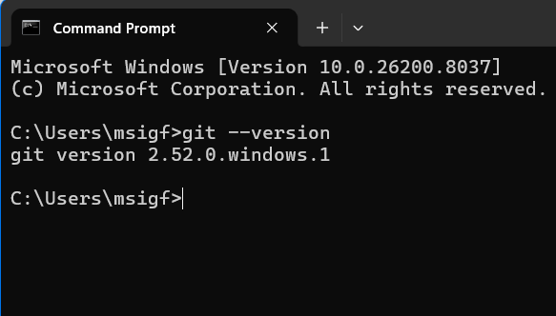

- Now, open a git bash window in desired location and type ‘git config --global user.name “username”’ and ‘git config --global user.email “email address”’ to config git.
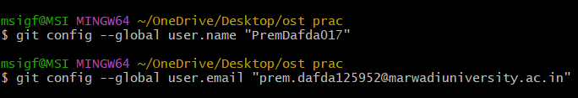
- Now, create a new directory and switch to that new directory.
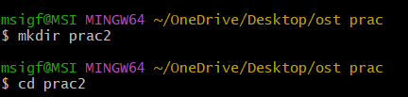
- Now, initial a new local repository by typing ‘git init’.
- Now, type ‘notepad <file name>’ and create two or more files.
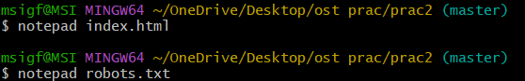
- Now, check unstaged files by typing ‘git status’.
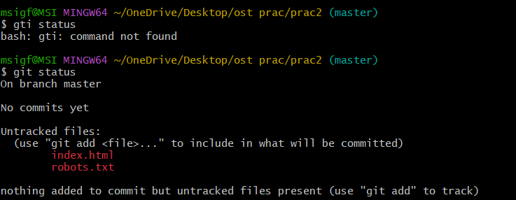

- Now, type ‘git add .’ to bring all the unstaged files to staging phase. Then type ‘git commit -m “Your message”’ to commit the changes. After that check unstaged files. It should say no commits are pending. Then type ‘git log’ to recent commits.
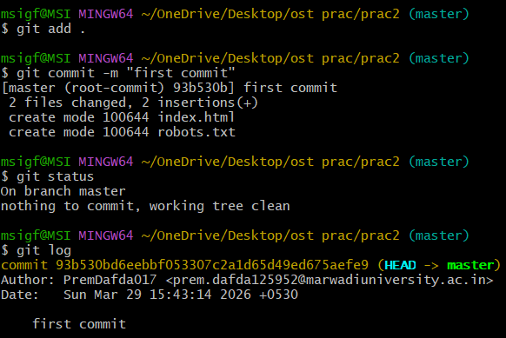
- Now, you can choose to change master branch to “main” by typing ‘git branch -M main’ which is completely optional. Then, connect local repositroy to remote repository by typing ‘git remote add origin <github repository url>’. Then push the changes to remote repository by typing ‘git push -u origin <branch name>’.
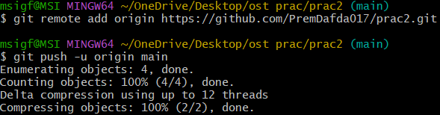

- The changes should now reflect on your remote github repositroy.
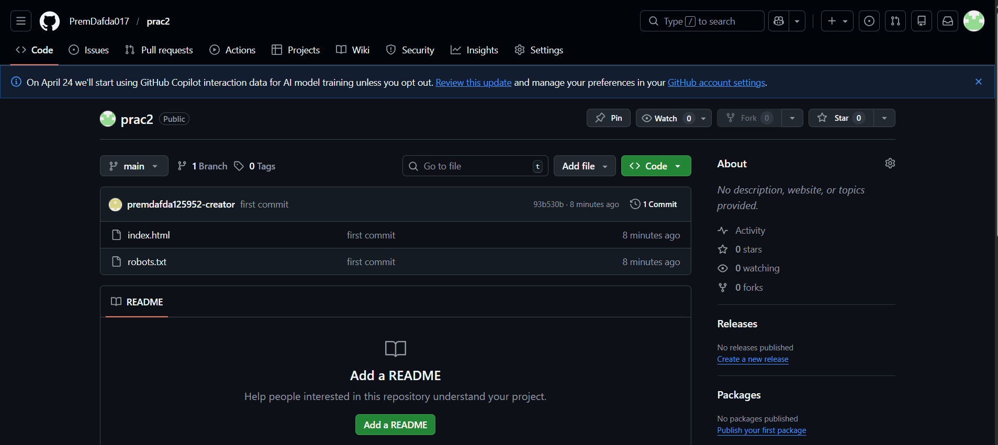
- Next, check current branches by typing ‘git branch --list’. Now, create a new branch called ‘dev’ by typing ‘git branch dev’ and then switch to ‘dev’ branch by typing ‘git checkout dev’.
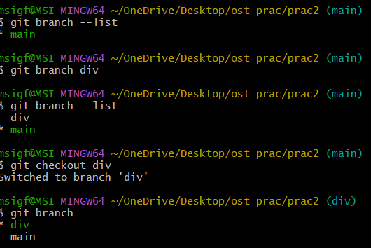

- Now, update existing files on this new branch and check unstaged files.
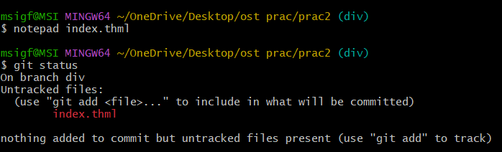
- Then, stage the changes and commit. Check logs, you should see new commit added to the log.
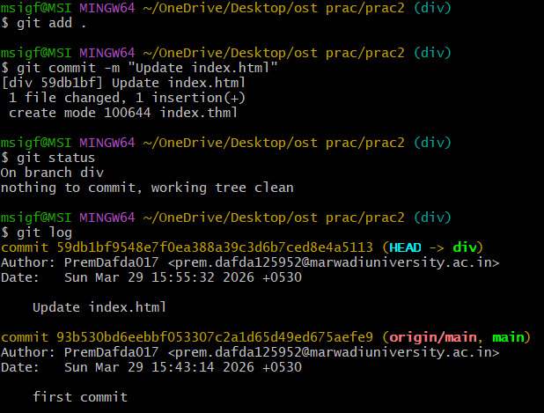

- Now, push the changes to origin dev branch.
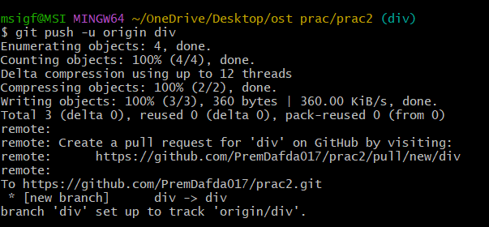
- Now, visit your remote repositroy. You will notice your master/main branch is behind dev branch by 1 commit.
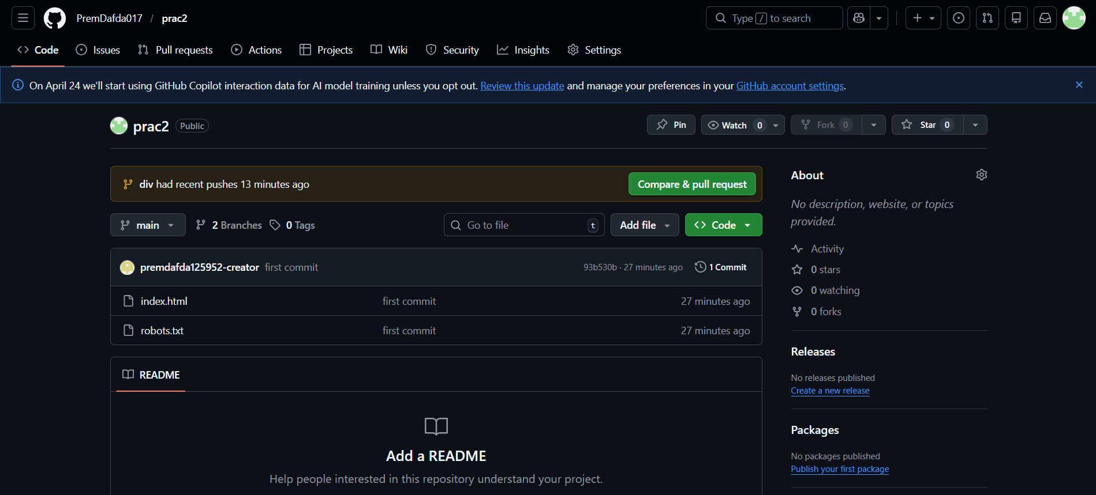

- Now, go to pull requests tab. Click on new pull request. Choose dev branch in compare and click create pull request.
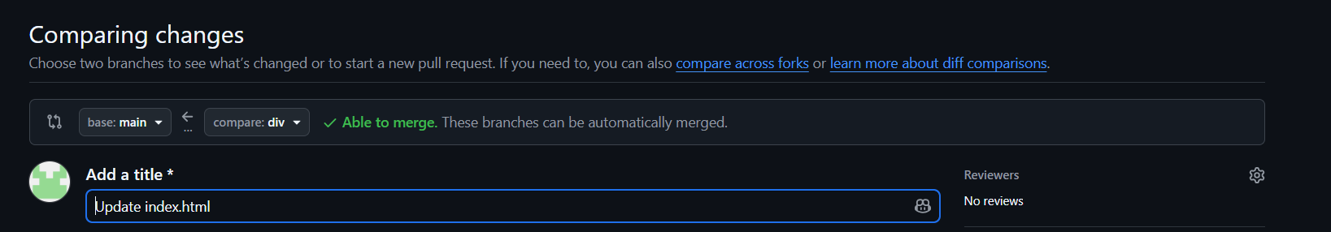
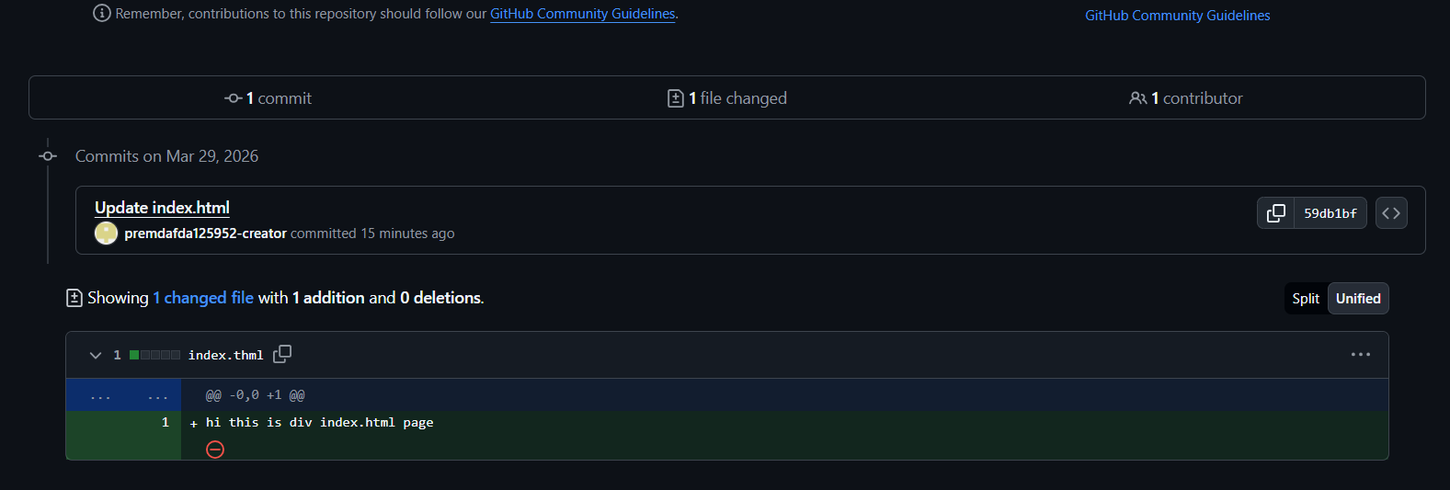

- Now, add a description (optional) then click “Create pull request”.
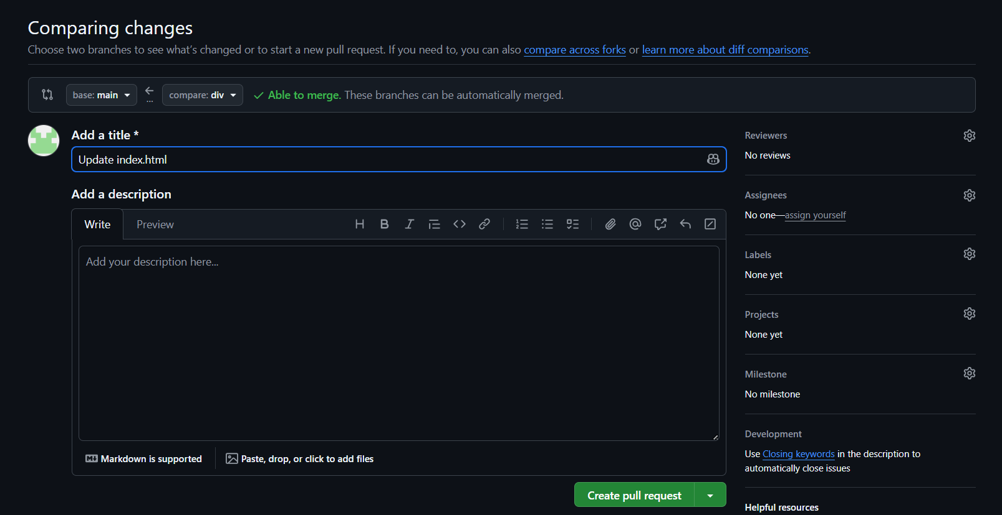

- Now, review the pull request and click on “Merge pull request”.


- Type a commit message (optional) and click “Confirm Merge”.
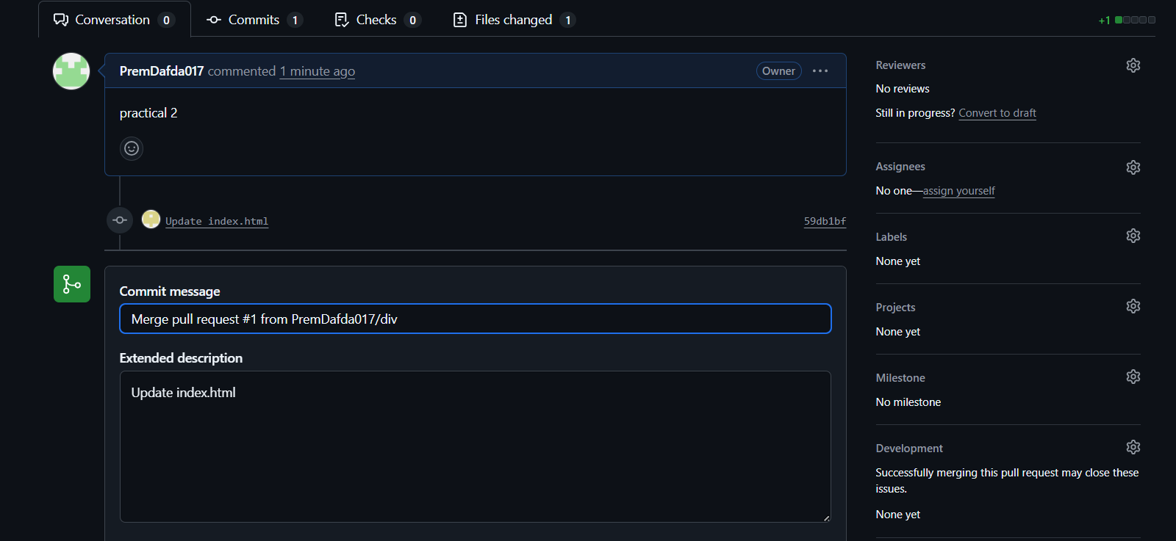

- You should see your pull request has been merged without any conflicts.
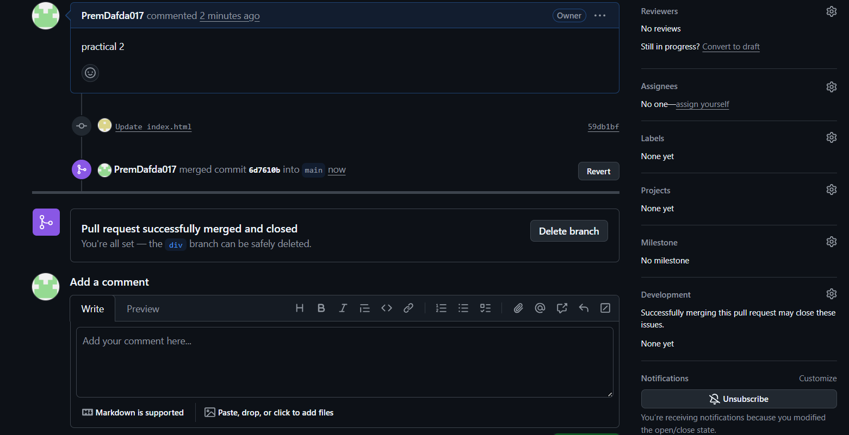
- Now, switch back to master/main branch and check logs. The changes will not reflect from remote yet.
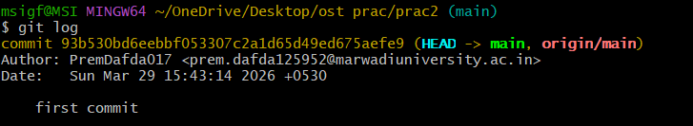

- Let’s reflect the changes. Type ‘git pull’ to fetch and rebase the changes. To confirm you can type ‘git log’. It should now reflect the changes.
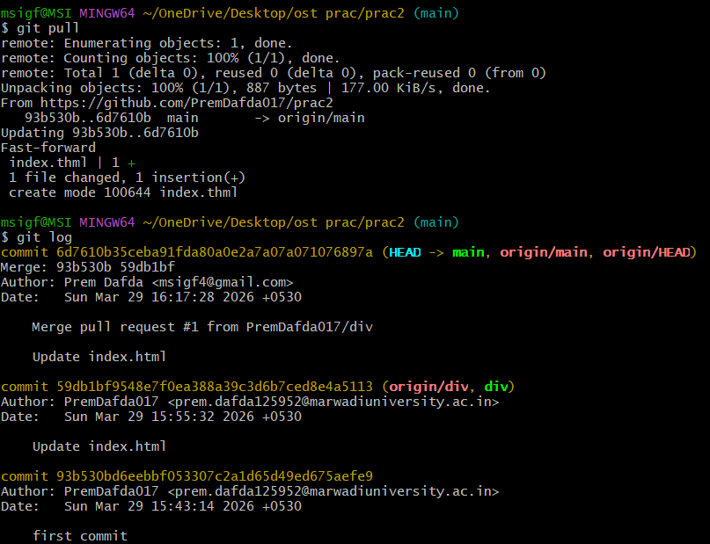
- Now, type ‘git config --list’ to show all the git configurations.
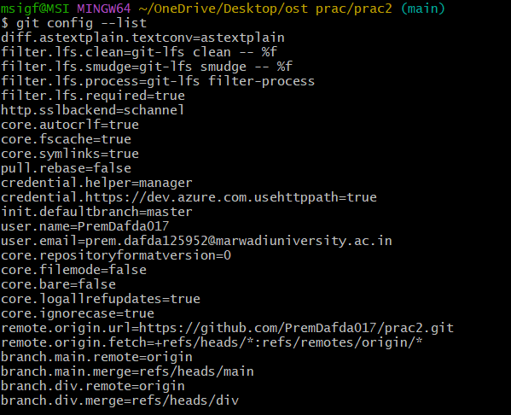

Experiment 3
AIM: Create a GitHub/GitLab repository and upload sample code.
- Go to Github and create a new repository.
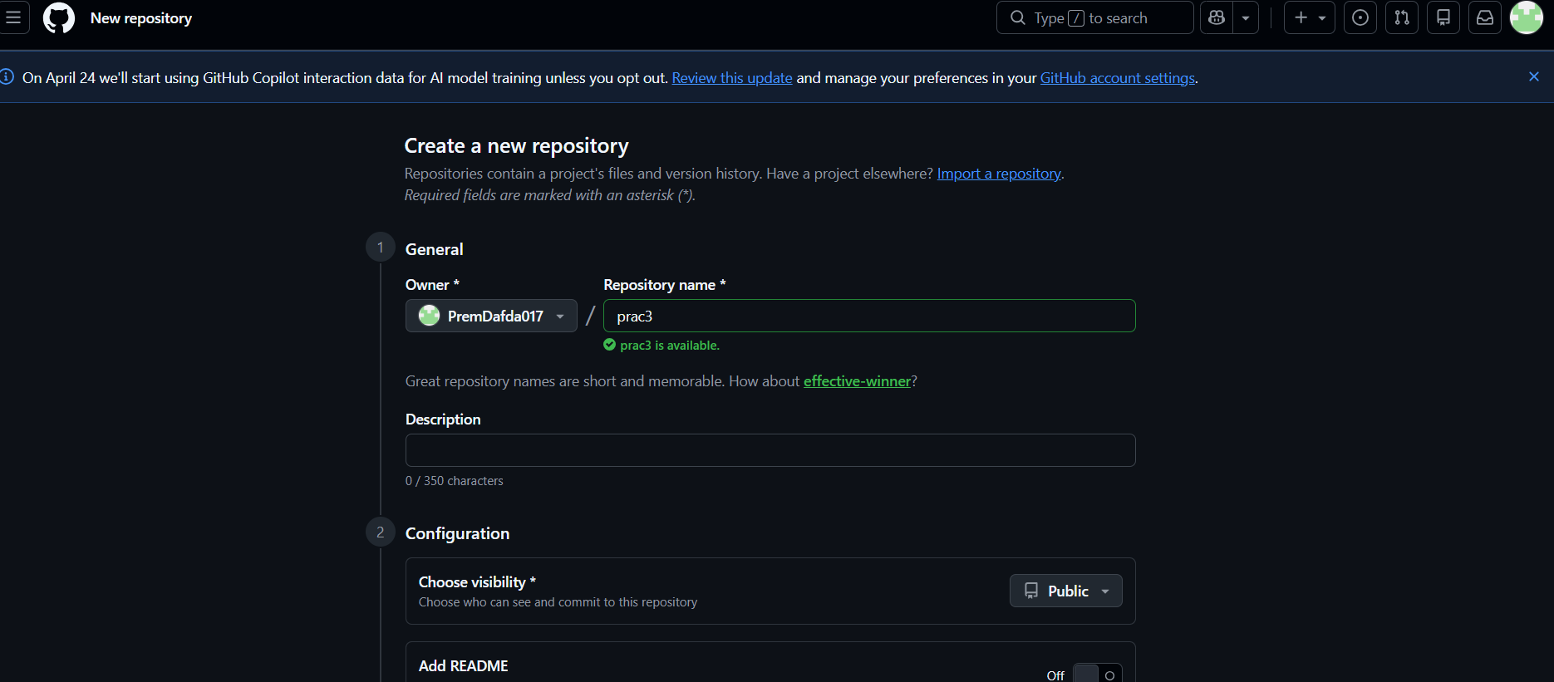
- Now, create a local repository and add a few files. Then connect to remote repository and push the changes.
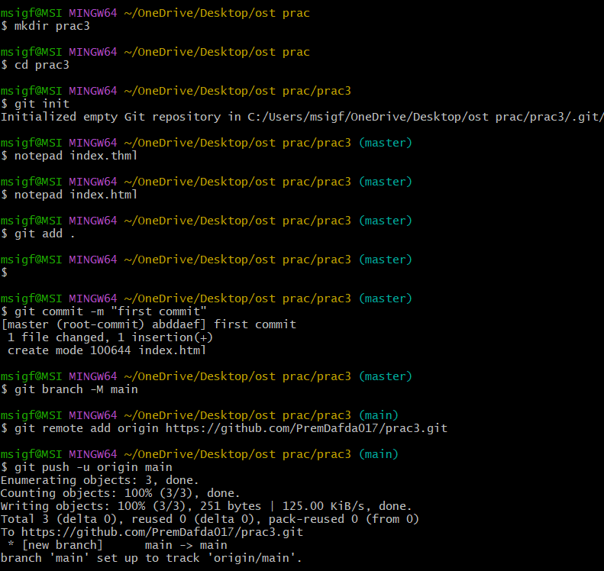
- Create a new branch and add some files to this branch. Then, commit the changes and push the changes to remote repository.
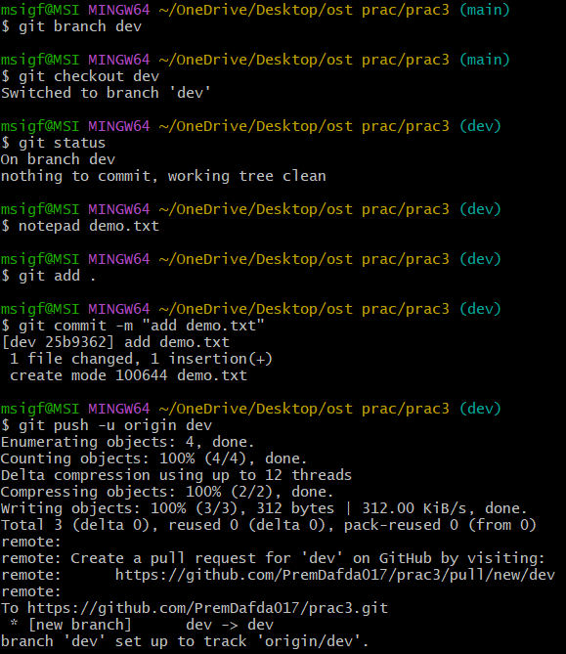
- Go to remote repository and you should now see main branch behind dev branch by 1 commit.
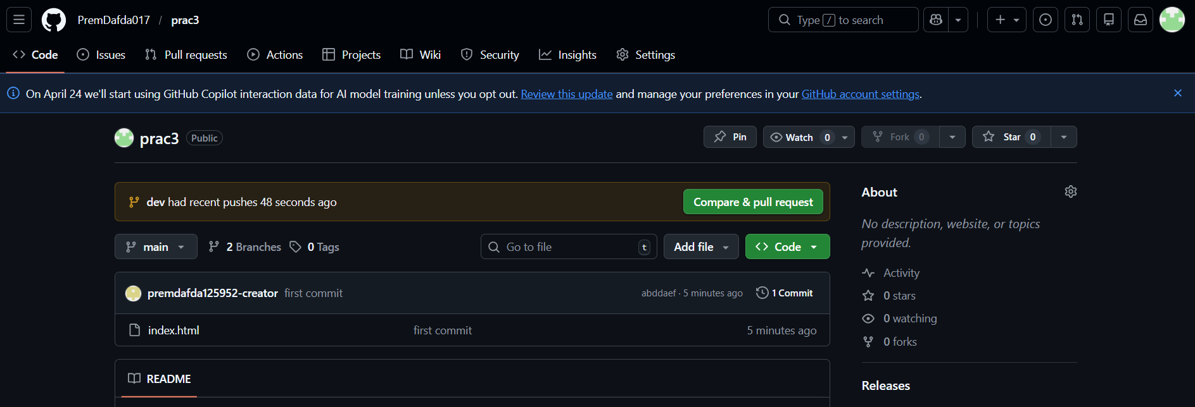

- Open a new pull request. Set compare to dev branch.

- Verify the title and create pull request.
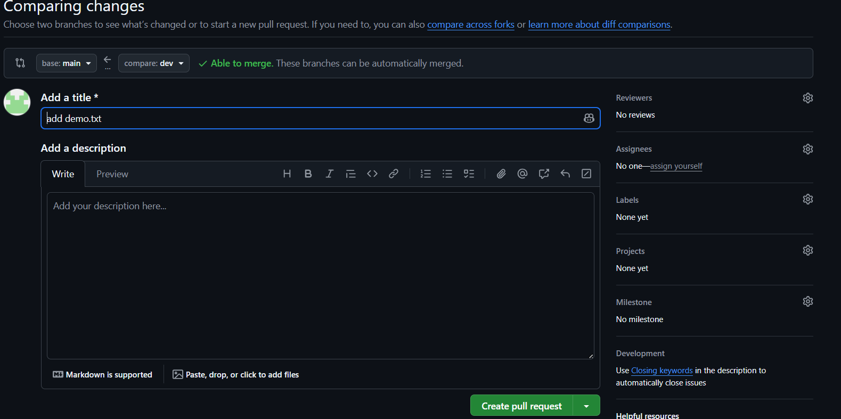

- Now, review the changes and click merge pull request.
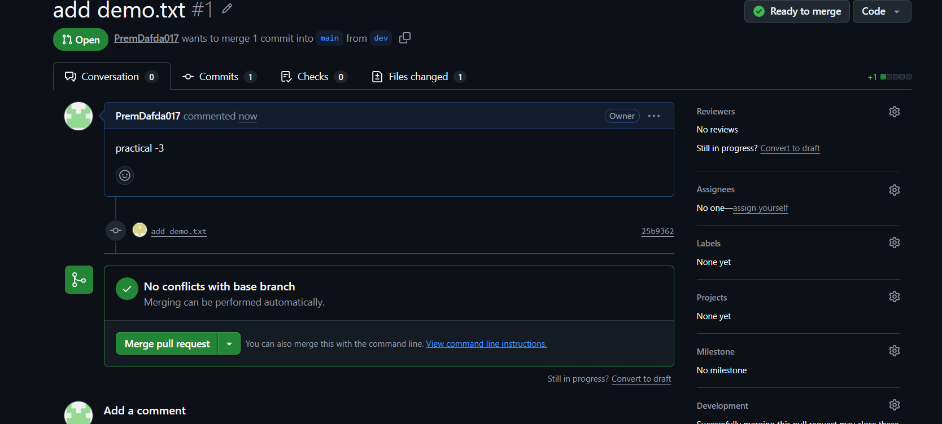
- Confirm commit message and confirm merge.
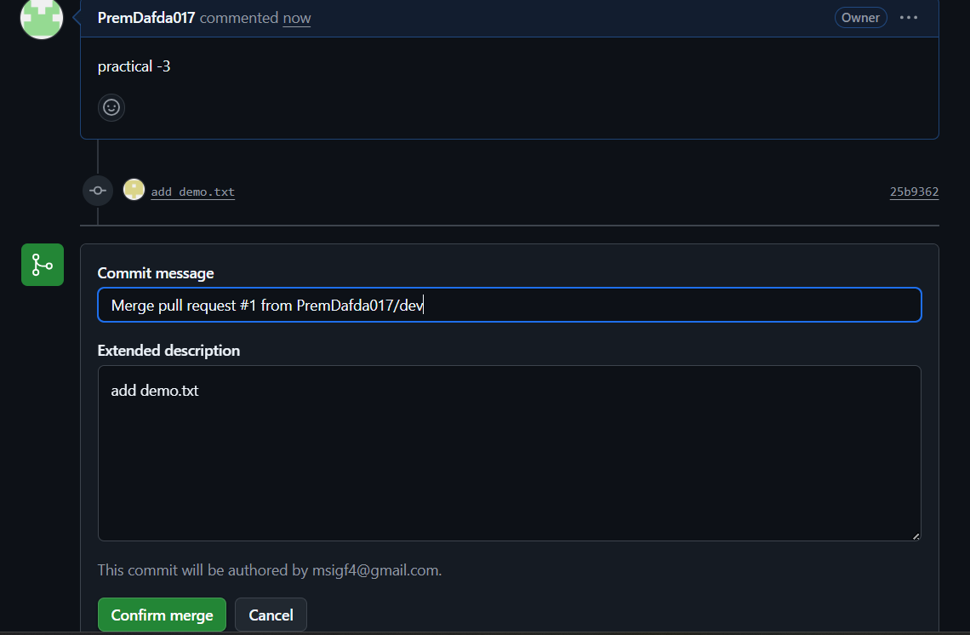

- Pull request has been merged without conflicts.

- Switch to main branch in your local repository and pull the changes.
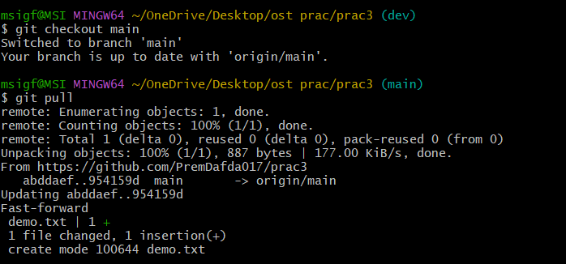

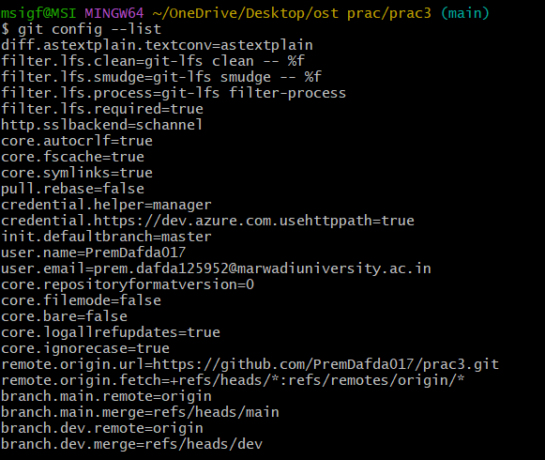

Experiment 4
AIM: Use npm / yarn / pip to install and manage packages.
- Make a new directory, switch to new directory and initialize new package.json file using ‘npm init -y’ command.
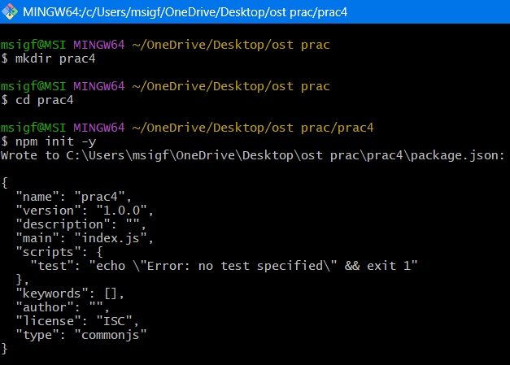
- Install npm packages using ‘npm i <package-name>’. Install express and axios. Then install nodemon as dev dependency using ‘npm i <package-name> --save-dev’.
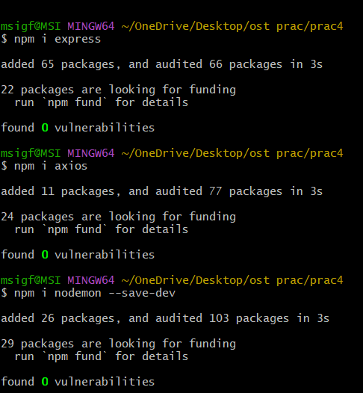
- Create a new index.js file and put the express code to create a simple API. Then edit package.json to include start and dev scripts so you can run environment specific commands. Use command ‘npm run dev’ to run in development environment.
index.js
const express = require("express");
const axios = require("axios");
const app = express();

app.get("/", (req, res) => {
res.send("Hello Open Source Lab");
});

// JSON Route
app.get("/api/info", (req, res) => {
res.json({
name: "NPM Lab",
subject: "Open Source Technology",
semester: "BE 6th Sem"
});
});
// Axios Demo Route
app.get("/api/user", async (req, res) => {
const response = await axios.get("https://jsonplaceholder.typicode.com/users/1");
res.json(response.data);
});

app.listen(3000, () => {
console.log("Server running at http://localhost:3000");
});

package.json
{
"name": "prac4",
"version": "1.0.0",
"description": "",
"main": "index.js",
"scripts": {
"start": "node index.js",
"dev": "nodemon index.js"
},
"keywords": [],
"author": "PremDafda017",
"license": "MIT",
"dependencies": {
"axios": "^1.13.5",
"express": "^5.2.1"
},
"devDependencies": {
"nodemon": "^3.1.14"
}
}

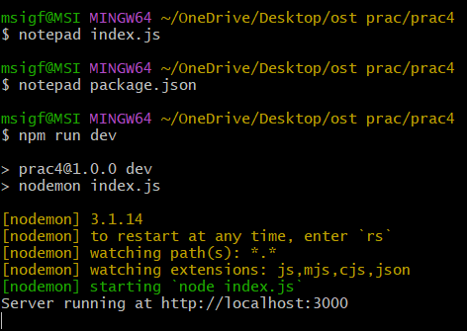
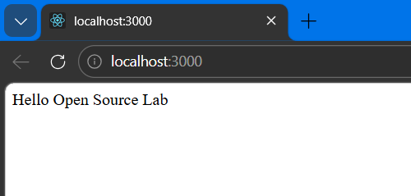
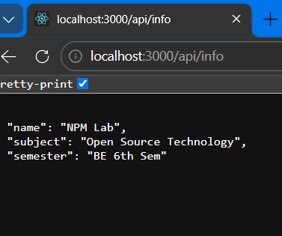
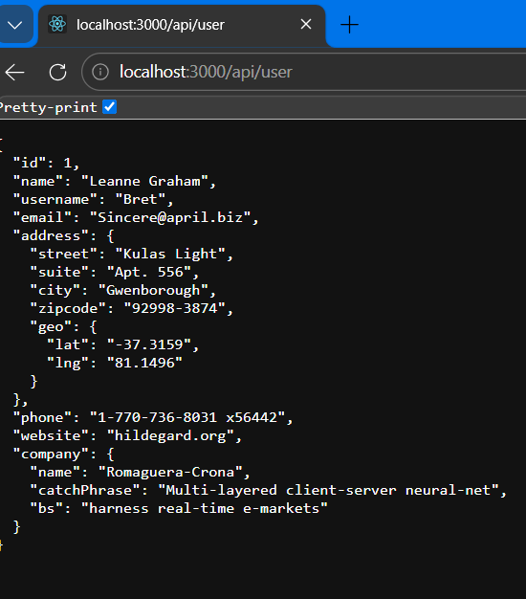

- Now, initialize a new git repository. Add a .gitignore file and add “node_modules” directory to it. Then stage the changes.
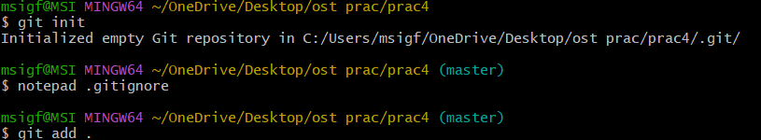
- Now, commit the changes. Switch to main branch, add remote github repository, and push the changes.
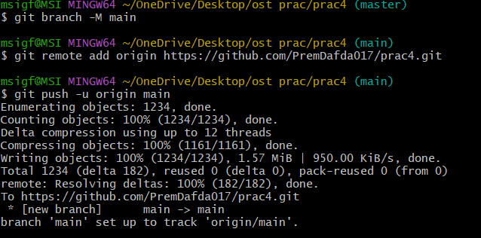
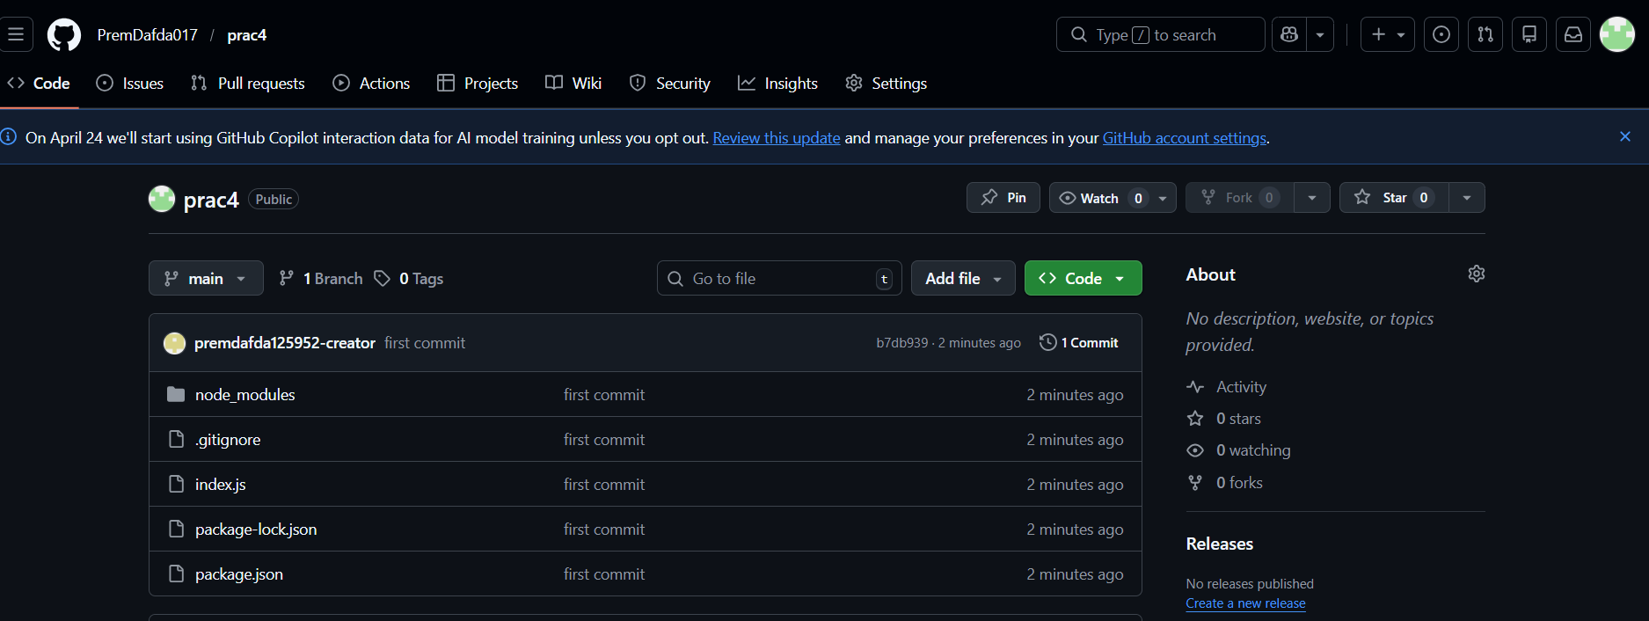
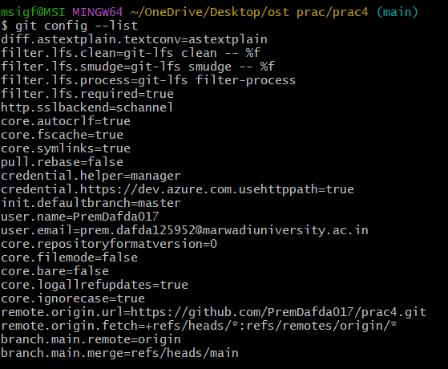

Experiment 5
AIM: Deploy a simple application using Nginx / Apache.
- Make a new directory, switch to new directory, initialize new package.json and install express.
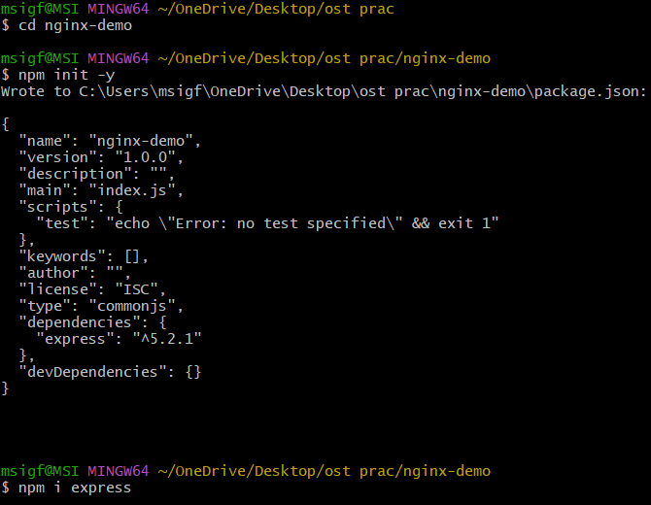
- Create index.js, add basic express js code and run it.
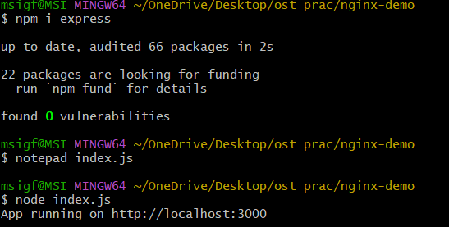
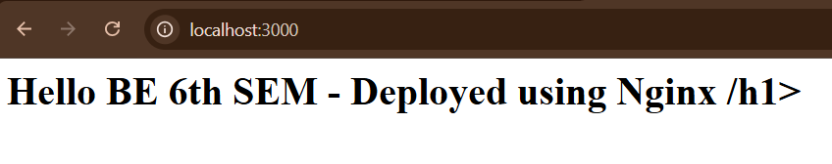
- Open nginx.conf file and change default nginx configuration to proxy localhost:3000.
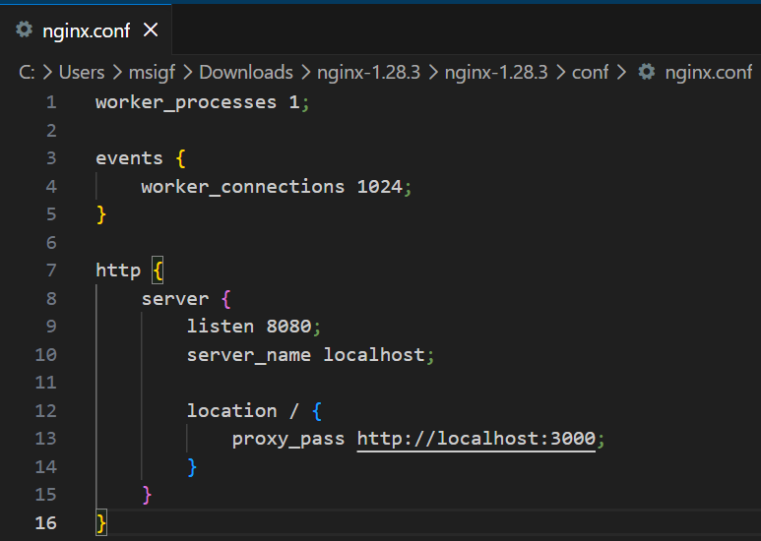
- Open cmd prompt in nginx directory and type ‘nginx -t’ to test configuration. Once verified run nginx using ‘nginx’ command.
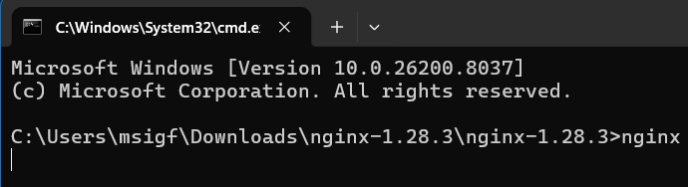
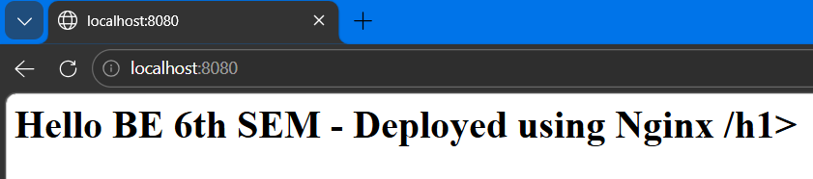
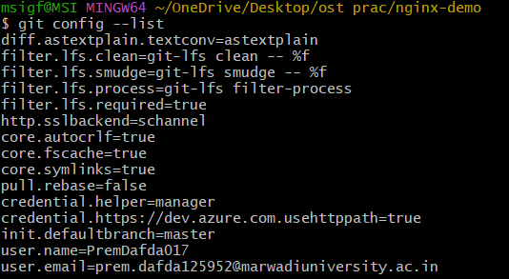

Experiment 6
AIM: Setup Nginx to handle proxy requests and load balancing.
- Make a new directory and switch to new directory. Then create a sub-directory and switch to sub-directory. Then initialize new package.json and install express.
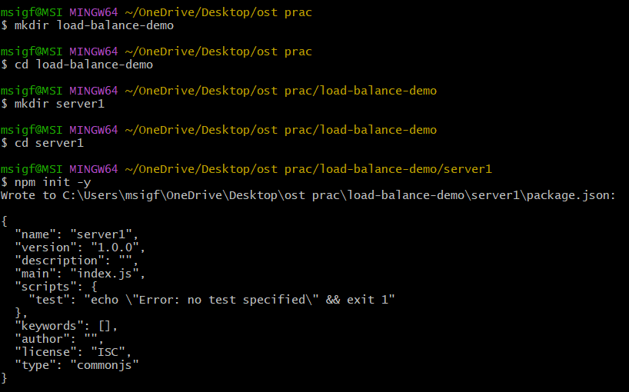
- Create server.js file and add basic express js code.
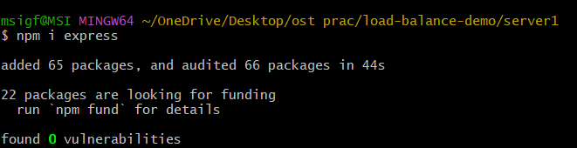

- Copy server1 as server2 and run both of them parallely.
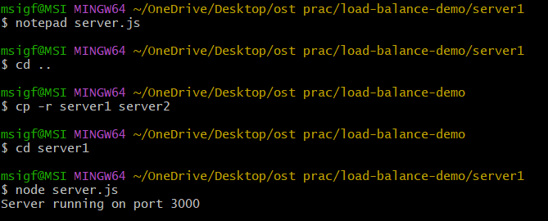

- Change nginx configuration.
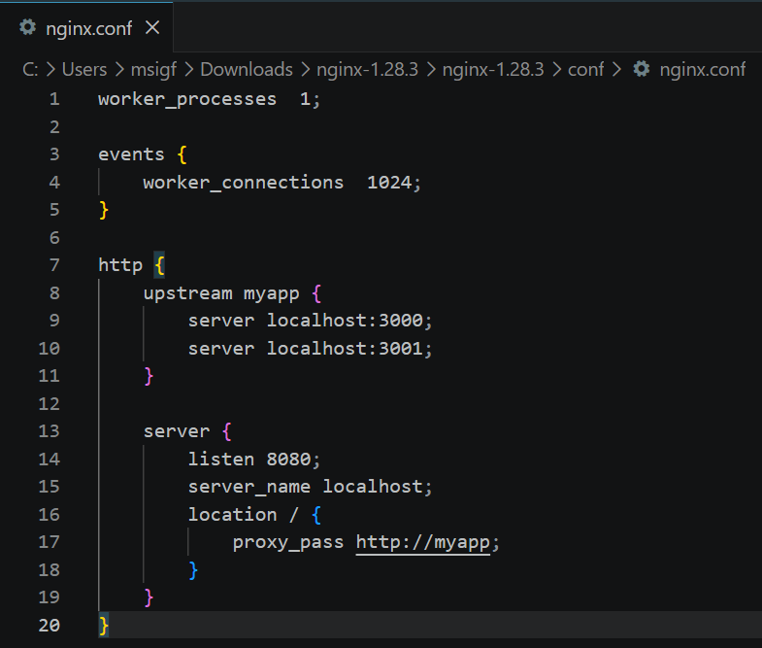
- Run nginx.
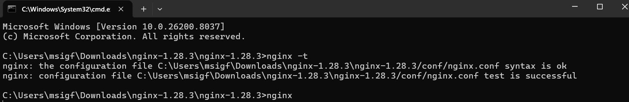
- Reload multiple times to receive response from different servers.
