Name: Somesh Jugalkishor Somani

Enroll No: 1906124

Division: H3 – C Batch

Subject: Web development using JavaScript

Practical No: 10

**Aim:** . Develop a program to access height and width properties of browser window

**Input: -**

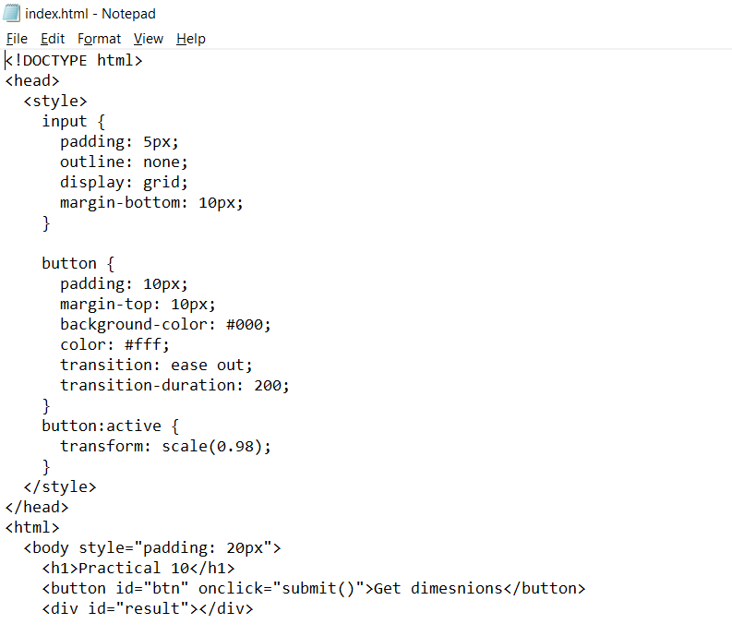

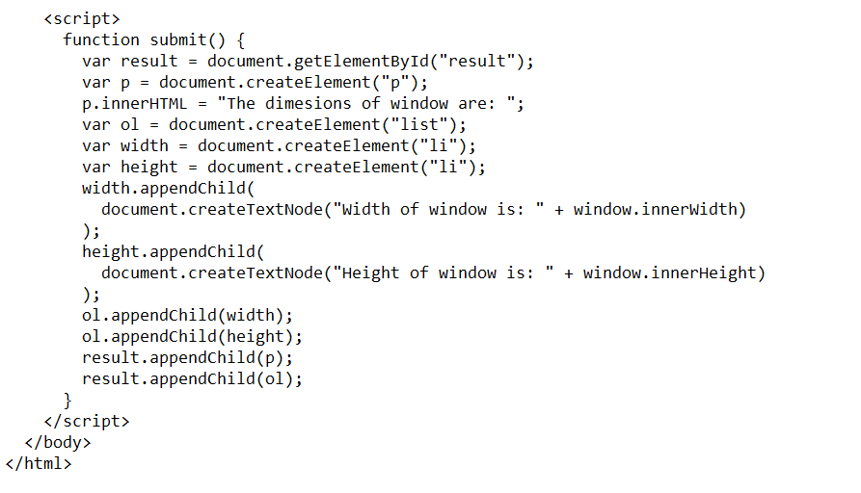

**Output: -**

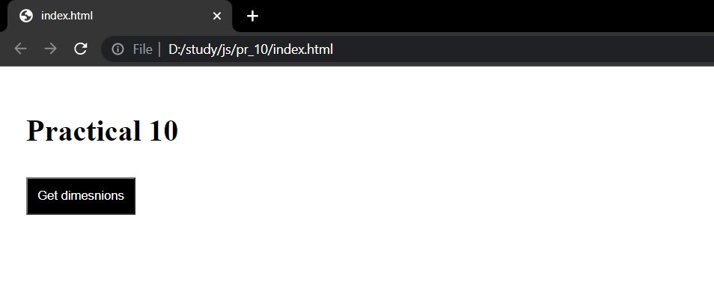

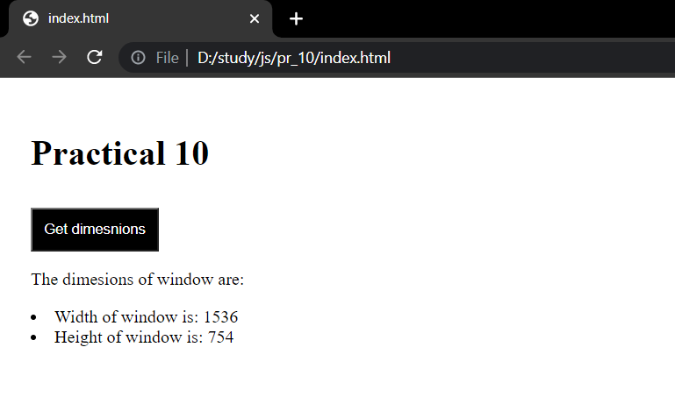

**Conclusion:** In this practical we learnt how to access browser width and height