Name: Somesh Jugalkishor Somani

Enroll No: 1906124

Division: H3 – C Batch

Subject: Web development using JavaScript

Practical No: 12

**Aim:** . Programs for implementing image Rollovers

**Input: -**

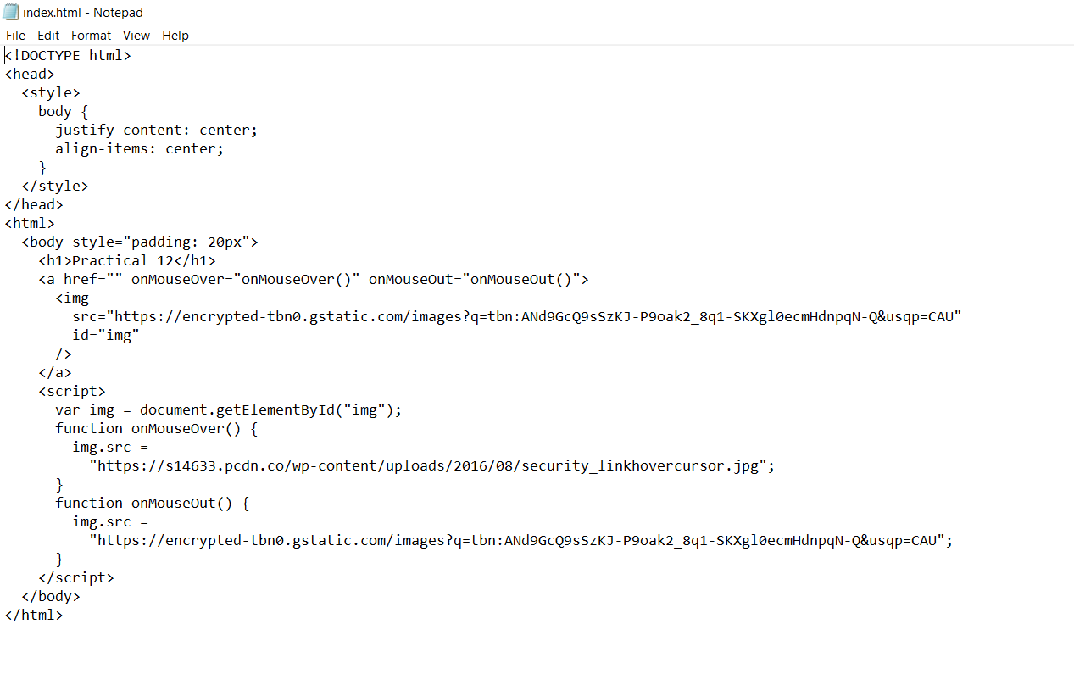

**Output: -**

**On mouse over:**

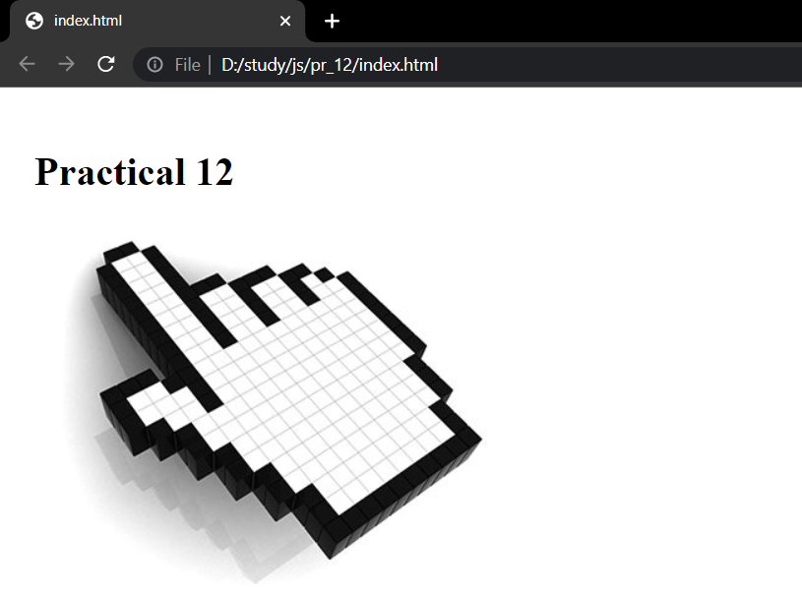

**On mouse out**

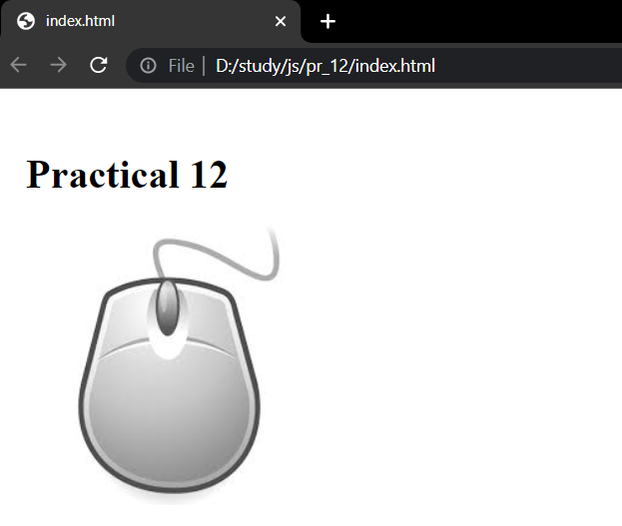

**Conclusion:** In this practical we learnt how to implement image rollovers.