Name: Somesh Jugalkishor Somani

Enroll No: 1906124

Division: H3 – C Batch

Subject: Web development using JavaScript

Practical No: 13

**Aim:** Writing basic application demonstrating Angular JS expressions and directives

**Input: -**

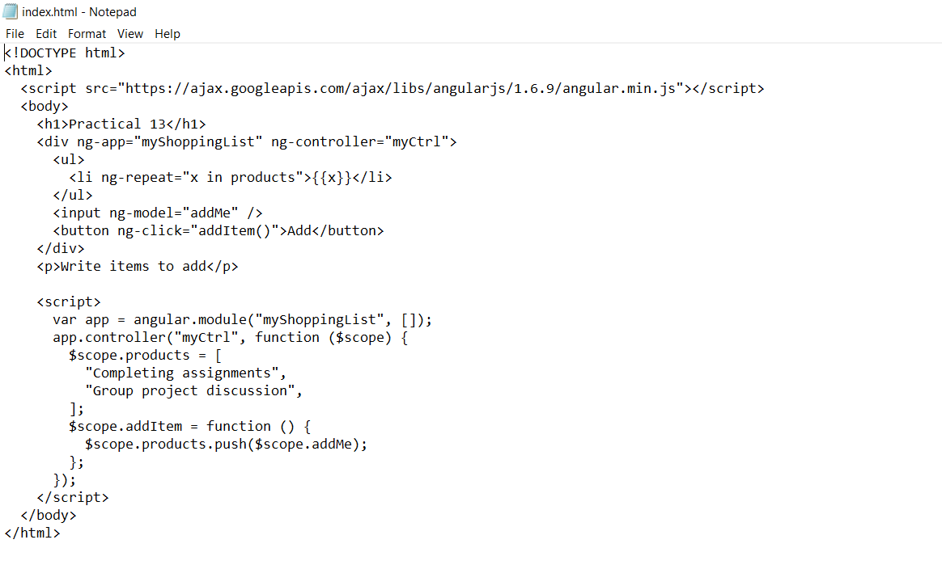

**Output: -**

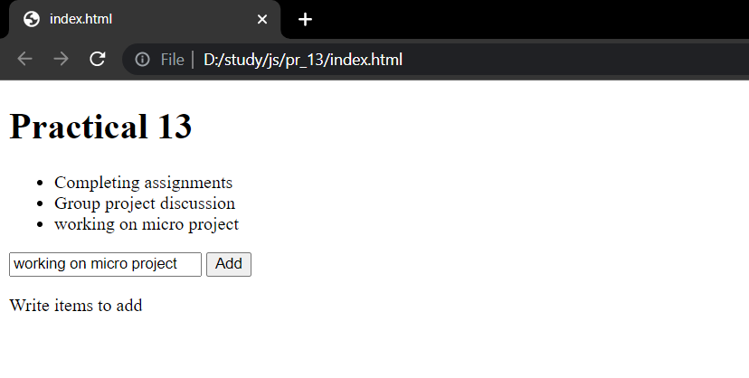

**Conclusion:** In this practical we learnt how to implement angular js and create a simple program.