Name: Somesh Jugalkishor Somani

Enroll No: 1906124

Division: H3 – C Batch

Subject: Web development using JavaScript

Practical No: 14

**Aim:** Writing Simple application using Angular JS and Forms

**Input: -**

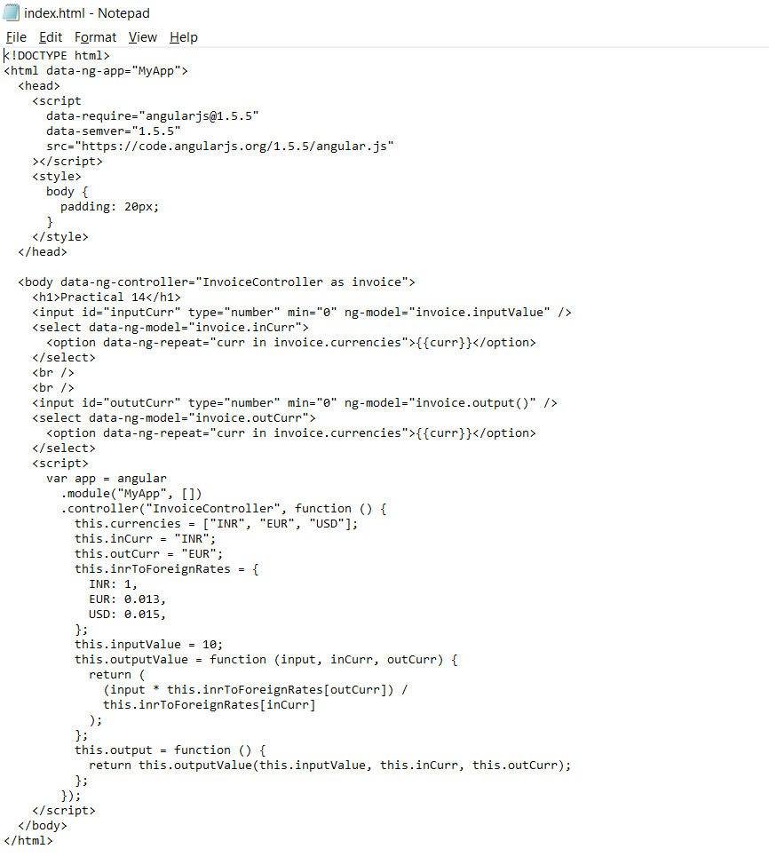

**Output: -**

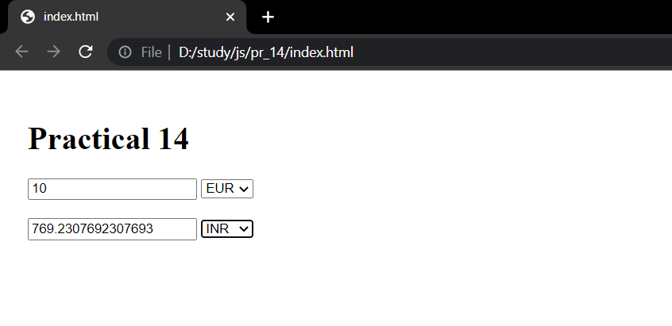

**Conclusion:** In this practical we learnt how to implement angular js and create form.