Name: Somesh Jugalkishor Somani

Enroll No: 1906124

Division: H3 – C Batch

Subject: Web development using JavaScript

Practical No: 06

**Aim:** Program to convert string to number

**Input: -**

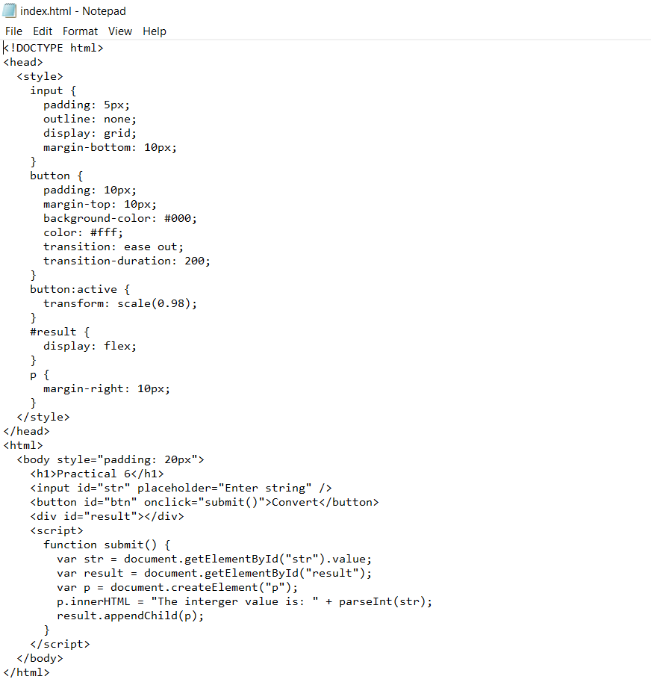

**Output: -**

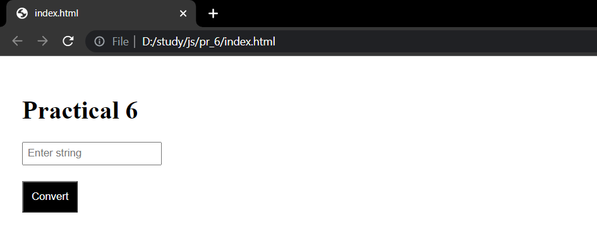

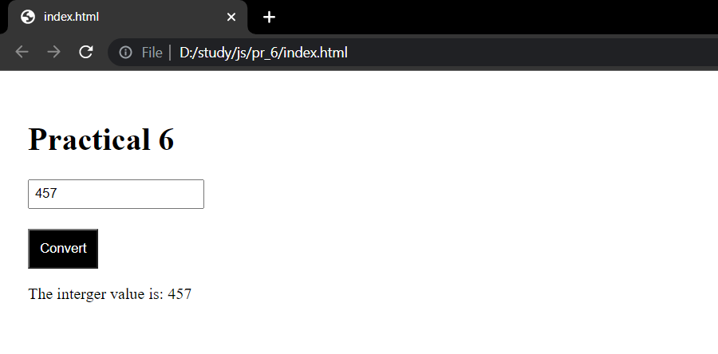

**Conclusion:** In this practical we learnt how to convert string to number using parseInt method.