Name: Somesh Jugalkishor Somani

Enroll No: 1906124

Division: H3 – C Batch

Subject: Web development using JavaScript

Practical No: 07

**Aim:** Program to design sign up page for any application

**Input: -**

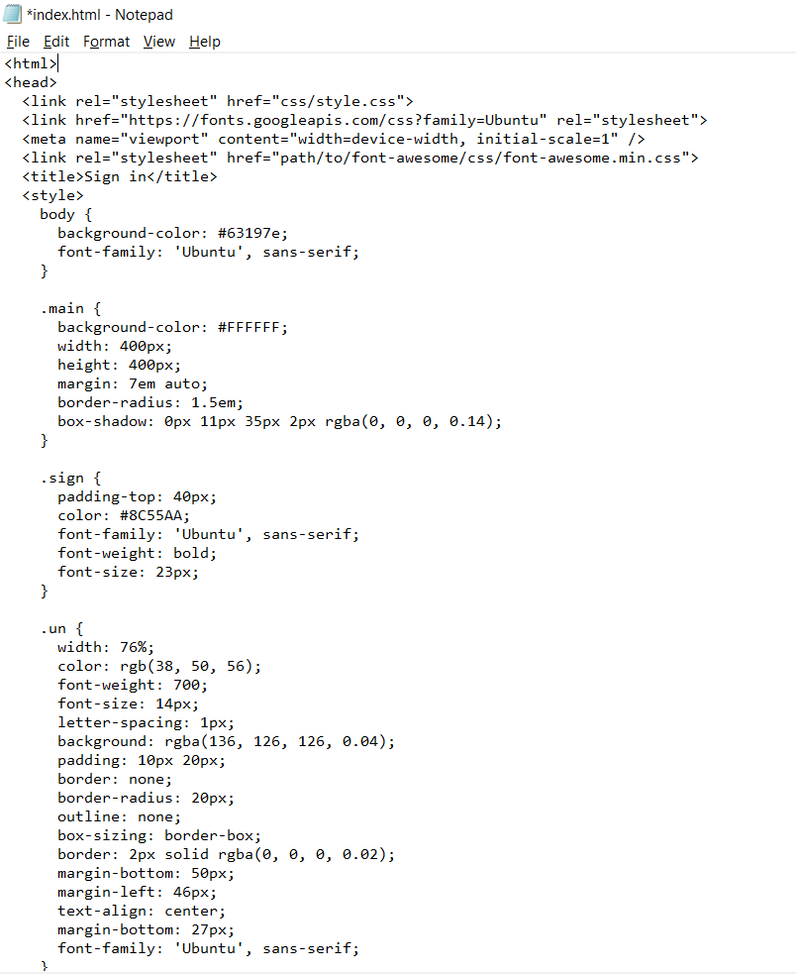

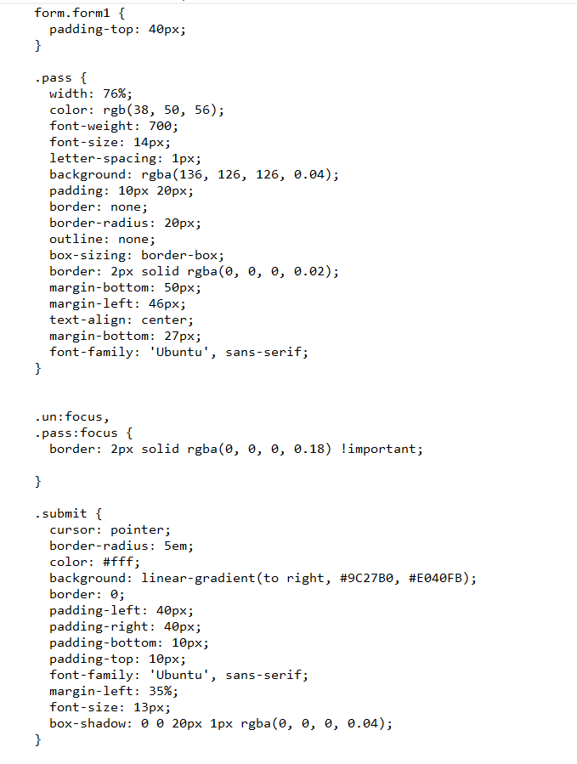

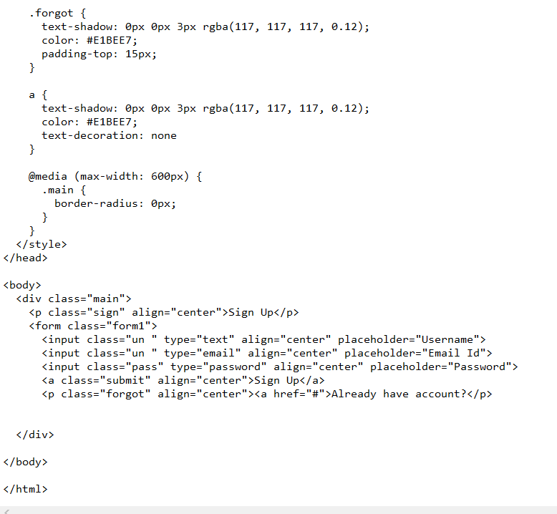

**Output: -**

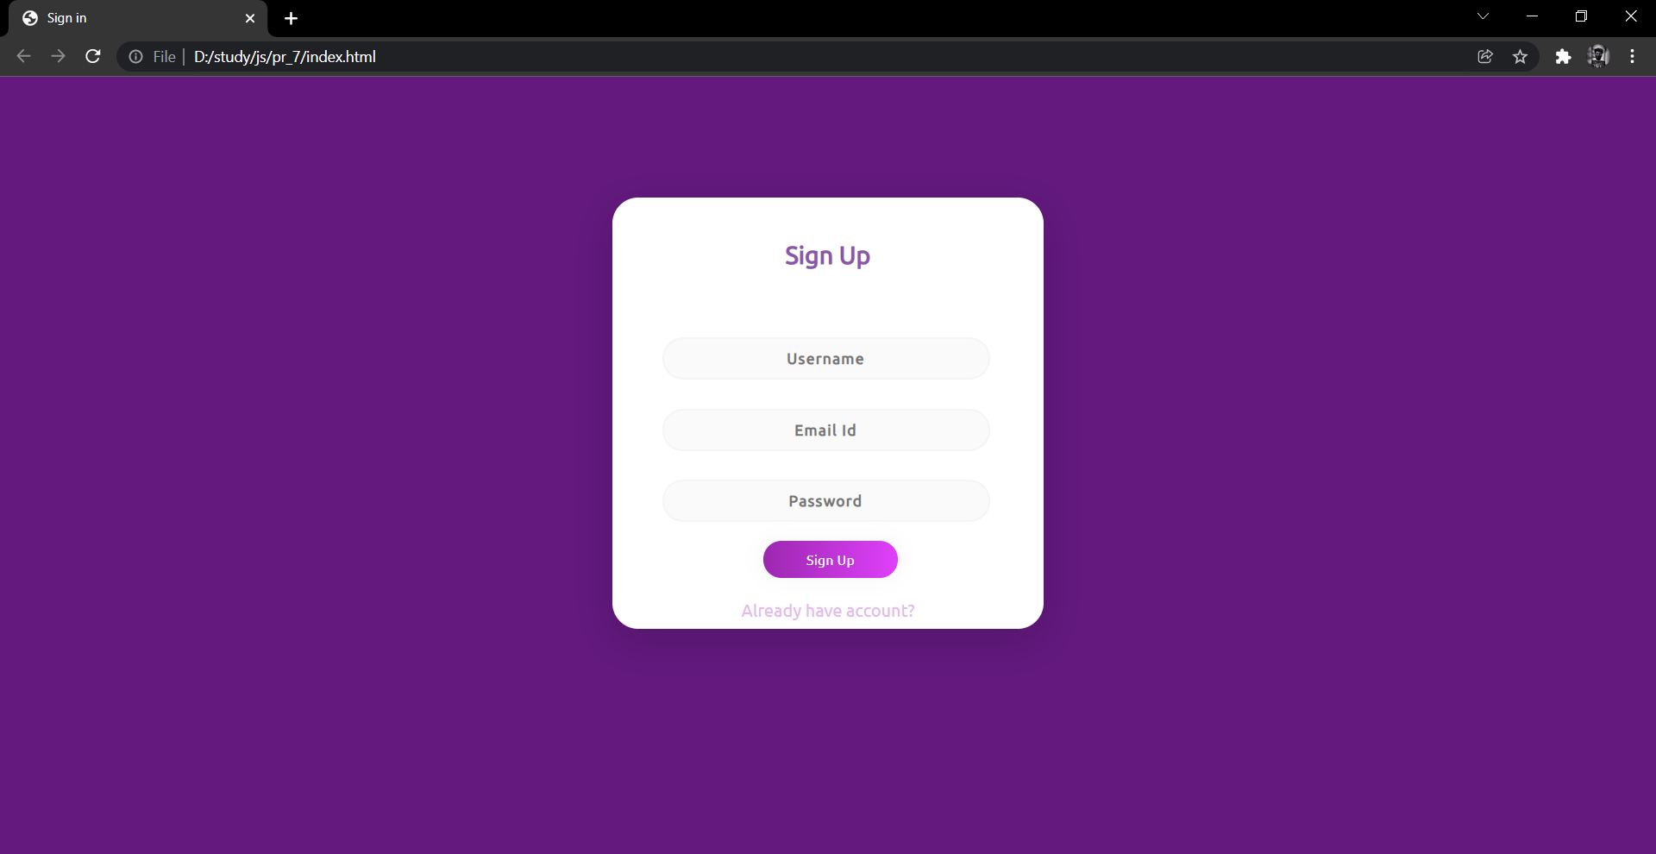

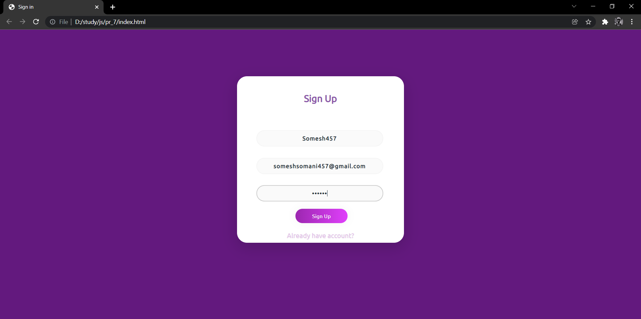

**Conclusion:** In this practical we learnt how to design a sign up page for any application