Name: Somesh Jugalkishor Somani

Enroll No: 1906124

Division: H3 – C Batch

Subject: Web development using JavaScript

Practical No: 08

**Aim:** Write a program using intrinsic java functions (use image as a button to submit and reset form)

**Input: -**

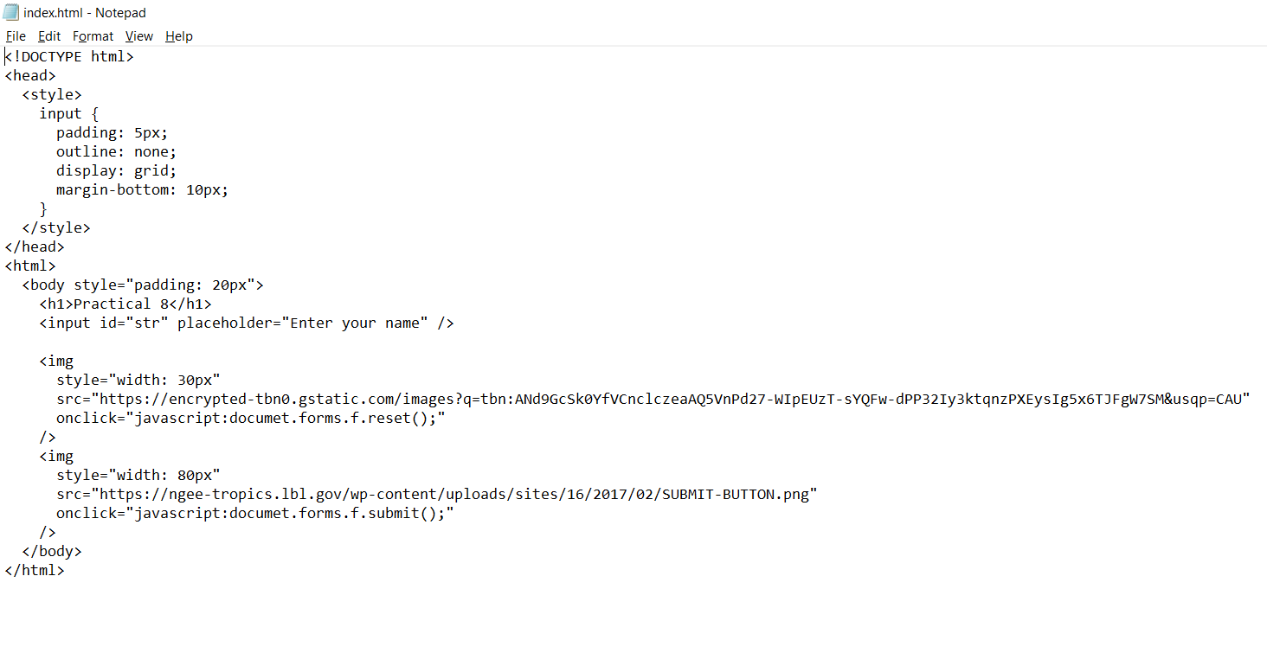

**Output: -**

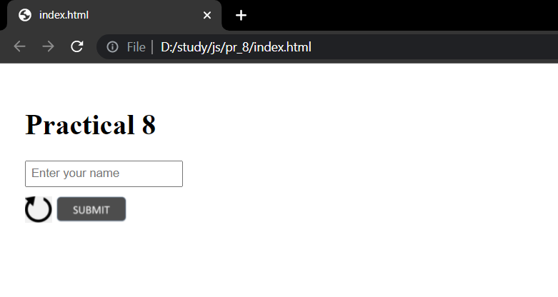

**Conclusion:** In this practical we learnt how to use image as a submit and reset button