Name: Somesh Jugalkishor Somani

Enroll No: 1906124

Division: H3 – C Batch

Subject: Web development using JavaScript

Practical No: 09

**Aim:** Develop webpage to create a session cookie.

**Input: -**

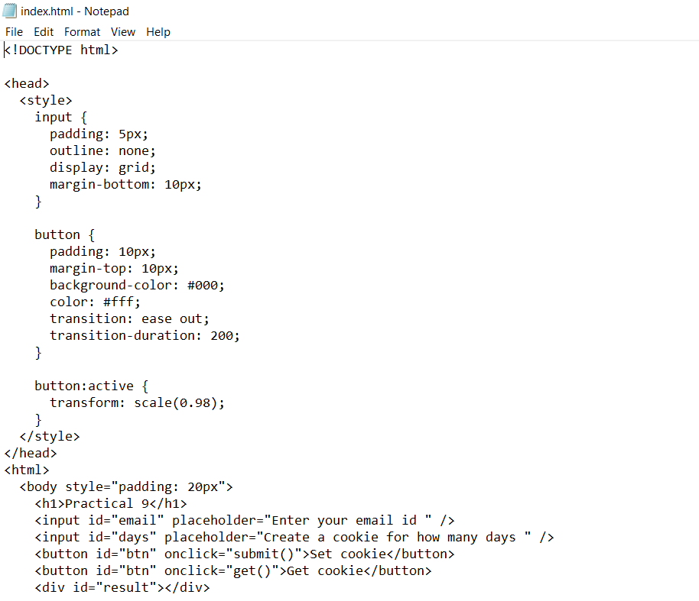

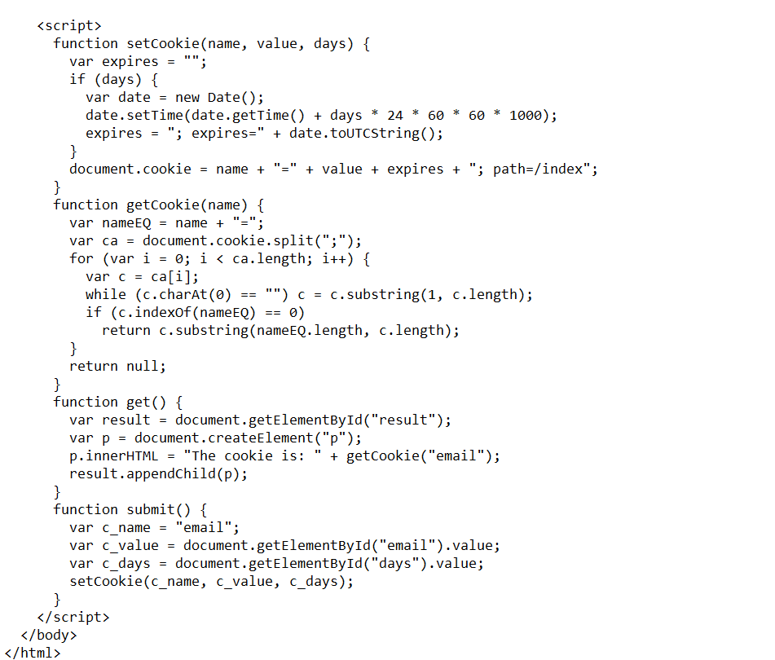

**Output: -**

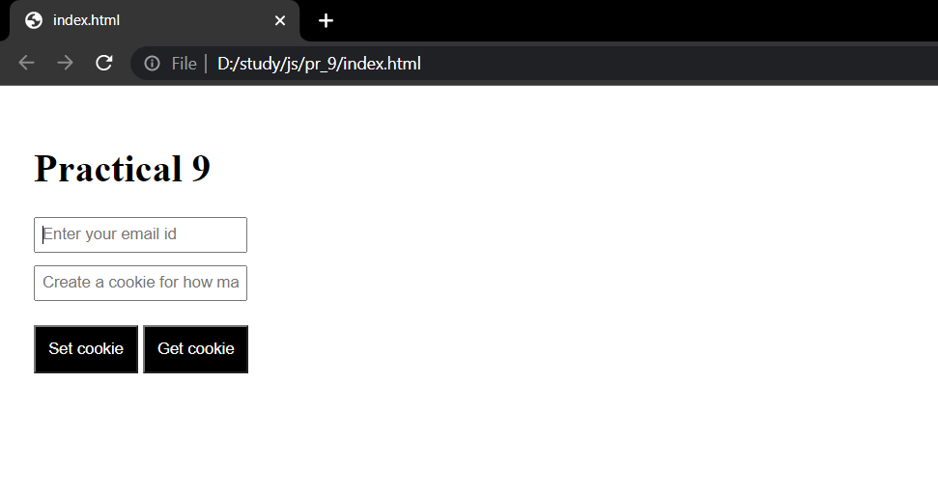

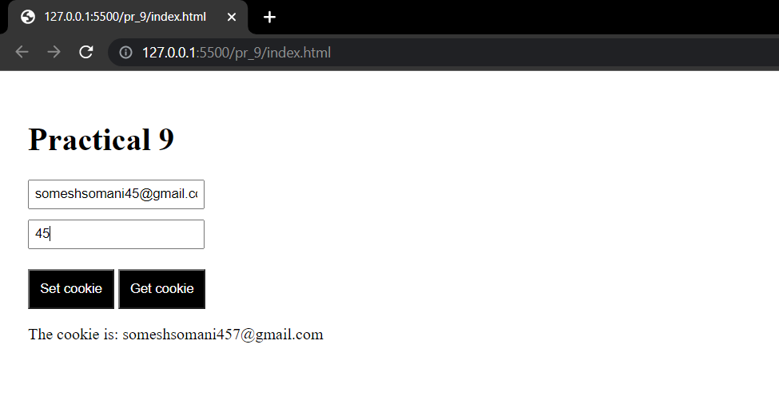

**Conclusion:** In this practical we learnt how create a cookie and get the created cookie