**SVKM’s NMIMS**

**Mukesh Patel School of Technology Management and Engineering, Vile Parle, Mumbai – 400056**

**Department of Computer Sciences**

**Business Visualization and Analytics End Semester Project:**

**To determine what factors affect the Stent Failure.**

Somesh Jadhwani (N022), Shreya Jain (N025)

## ____________________ _______________

Signature of Course Incharge Date

## Aim:

To determine what factors, affect the rate of stent failure in patients.

## Problem Statement:

To determine among all the categorical variables and measures, which factors influence the value of Stent_failure category and by what degree.

In the given dataset, there are 20 variables of which we suspect at least 15 have some effect on the rate of Stent failure. To prevent a stent from failing again, we want to determine the causes of the same and the probability of failure when using combination of variables.

To determine this, we look at all the various categorical variables and try to find a pattern using visual analytical charts such as Bar chart, pie charts and other advanced features of SAS VIYA such as links, actions, display rules etc.

## Dataset:

Dataset name: STENT_FAILURE.

Dataset statistics:

Number of Categorical Variables: 11

Number of Numerical Variables (Excluding calculated): 12

Total number of entries: 22,932

Variables Used:

|  |  |
| --- | --- |
| **Categorical Variables** | **Numerical Variables** |
| Stent Failure (Dependent) | Stent thickness (average) |
| Stent Material (Independent) | Stent width (average) |
| Hospital Name (Independent) | Stent length (average) |
| Stent cell design (Independent) | Frequency (sum) |
| Multiple Stent (Independent) |  |
| Gender (Independent) |  |

## Analysis of the Dataset:

To perform the data analysis, we have made use of SAS ODA.

**Code for reading the dataset:**

FILENAME REFFILE '/home/u62957836/sasuser.v94/Project/table_STENT_FAILURE.csv';

PROC IMPORT DATAFILE=REFFILE

DBMS=CSV

OUT=WORK.Failure;

GETNAMES=YES;

RUN;

To learn more about the data, we have applied the FREQ procedure on some columns of interest.

**Code for Freq Procedure:**

proc freq data=Failure;

tables Stent_Failure Multiple_Stent Ethnic_group Stent_Material Cell_Design ;

run;

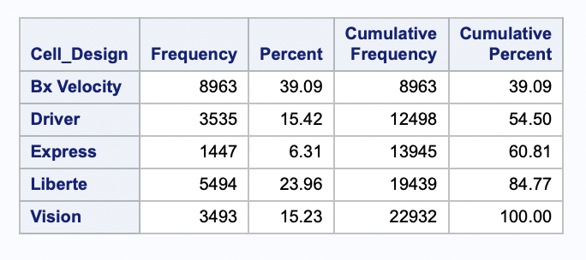**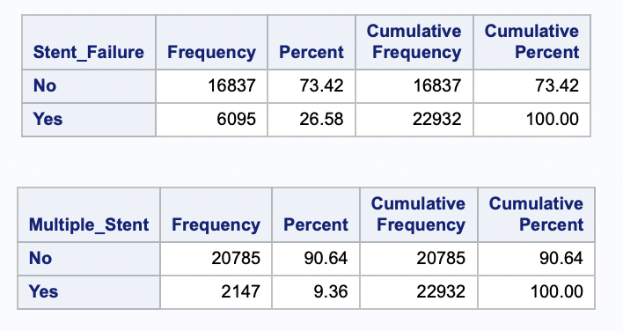Output:**

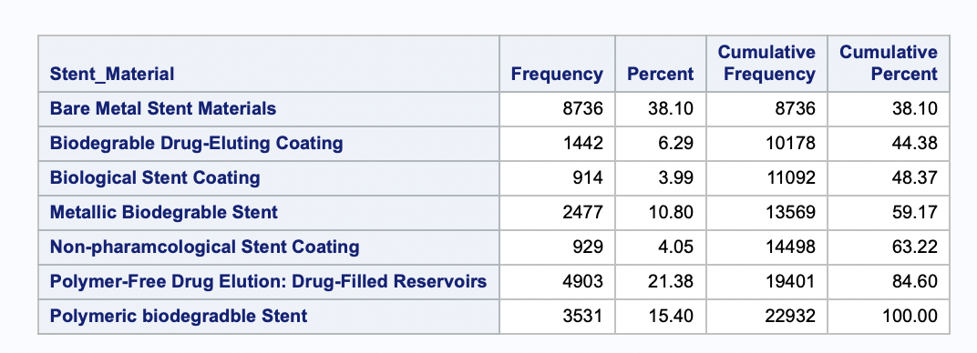

## Dashboard Planning:

To find the relation between Stent Failure and the other variables, we landed on the following proposal.

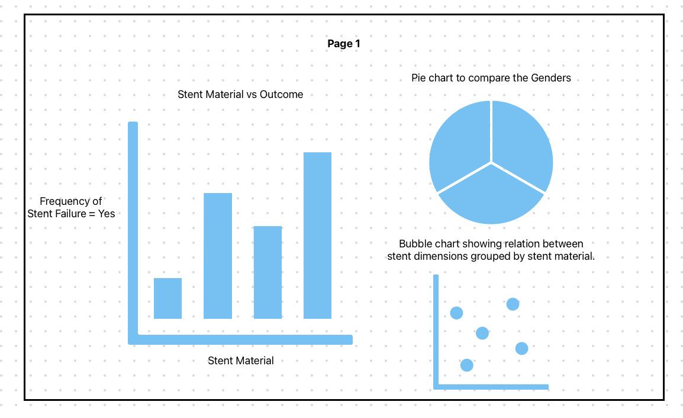

Figure 1 : Wireframe for Page 1 of report.

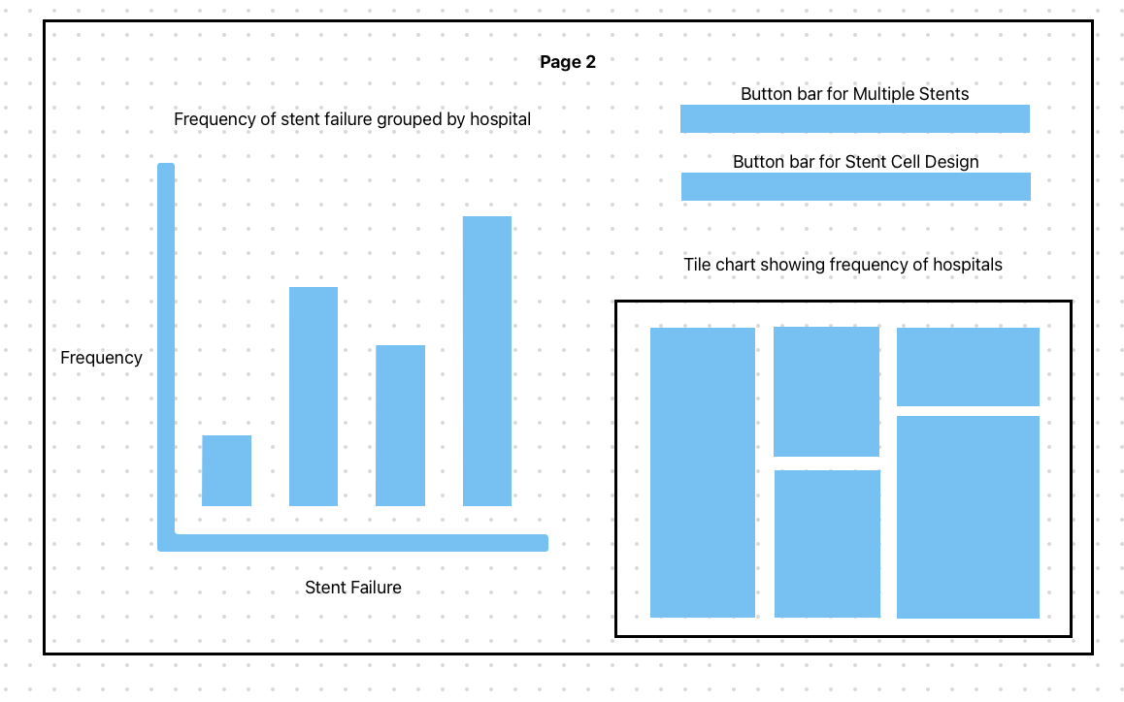

Figure 2 : Wireframe for page 2 of report.

And on the third page, we plan to have a decision tree for advanced analytics.

## Insights:

1. To determine if the chance of stent failure is higher in a certain gender.
2. To determine if the stent failure is dependent on Stent Material and stent dimensions.
3. To determine the most efficient dimensions for a given type of Stent Material in order to reduce the chance of failure.
4. To determine the most efficient stent cell design in order to reduce failure and its distribution in various hospitals.
5. To determine the effect of multiple stents on stent failure.
6. To design a reasonably accurate prediction system to determine if a certain stent may fail given 11 inputs.

## Dashboard:

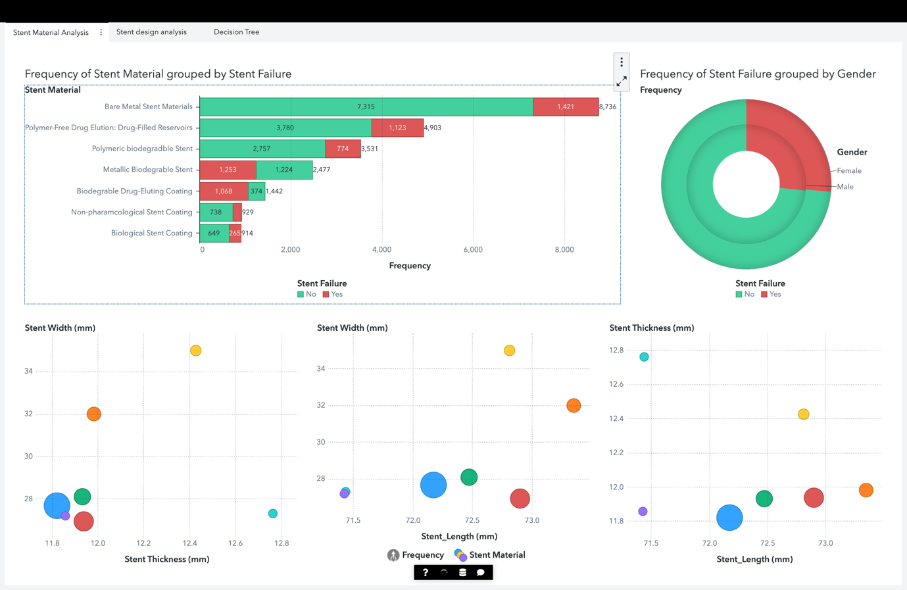

Figure 3 : Stent material analysis board.

In this page we can determine which Stent Materials have the highest failure rate.

The pie chart shows us the frequency of stent failure grouped by gender.

In the bottom we can compare the dimensions of the selected stent type to find the most efficient dimension to reduce failure.

The chart has page level interactions that highlight the bubbles in the bubble plot based on the Stent Material picked in the bar chart. This allows us to find the most reliable dimensions for a given stent material and we can pick a material with the highest success rate.

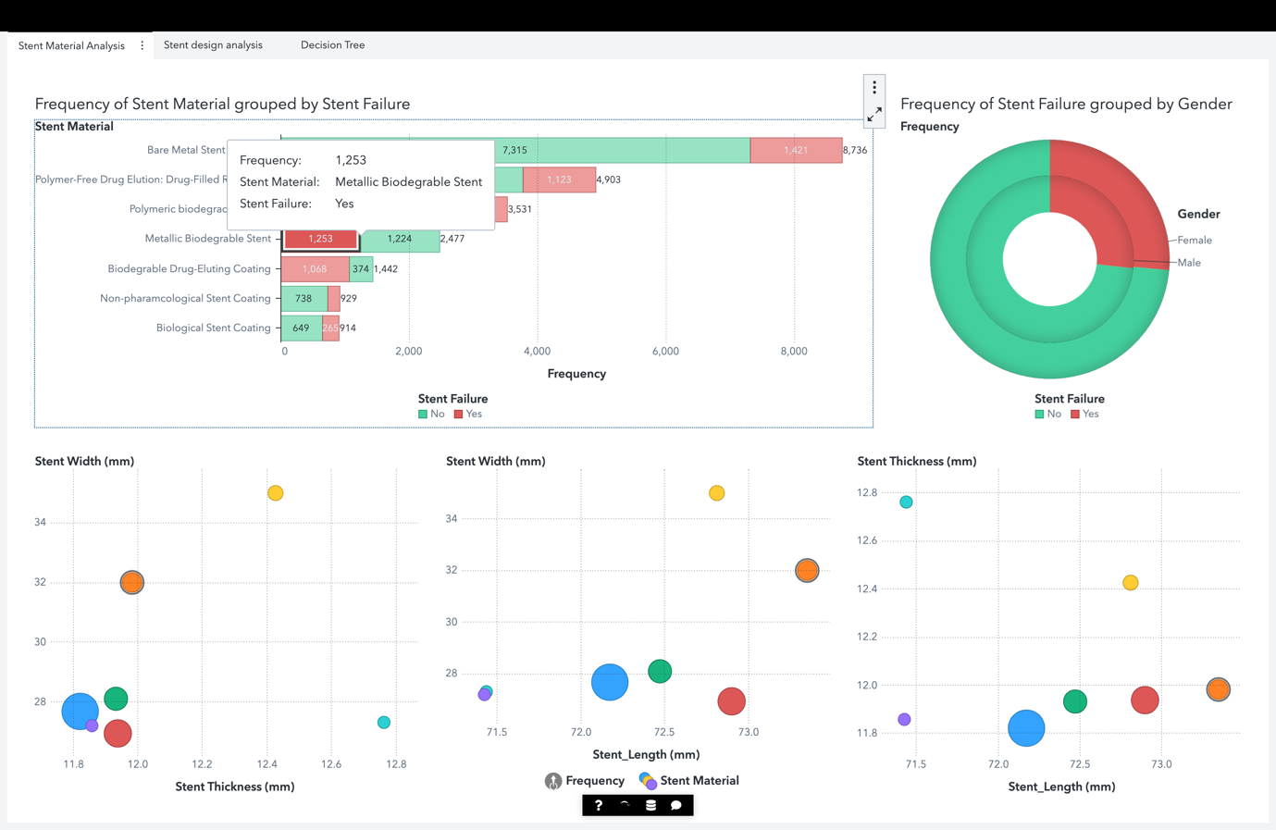

Figure 4 : Interaction of Stent Material with the bubble plots. (Orange bubble is highlighted)

Table 1 : Setup for Page 1 of report.

|  |  |  |  |
| --- | --- | --- | --- |
| **Chart Name** | **Links** | **Role Name** | **Role Value** |
| Bar chart | Bubble 1 | Category | Stent Material |
| Bubble 2 | Grouping | Stent_Failure |
| Bubble 3 | Measure | Frequency |
| Tile chart |  | Category | Gender |
|  | Grouping | Stent_Failure |
|  | Measure | Frequency |
| Bubble |  | X Axis | Stent Dimension 1 |
|  | Y Axis | Stent Dimension 2 |
|  | Size | Average Frequency |
|  | Grouping | Stent Material |

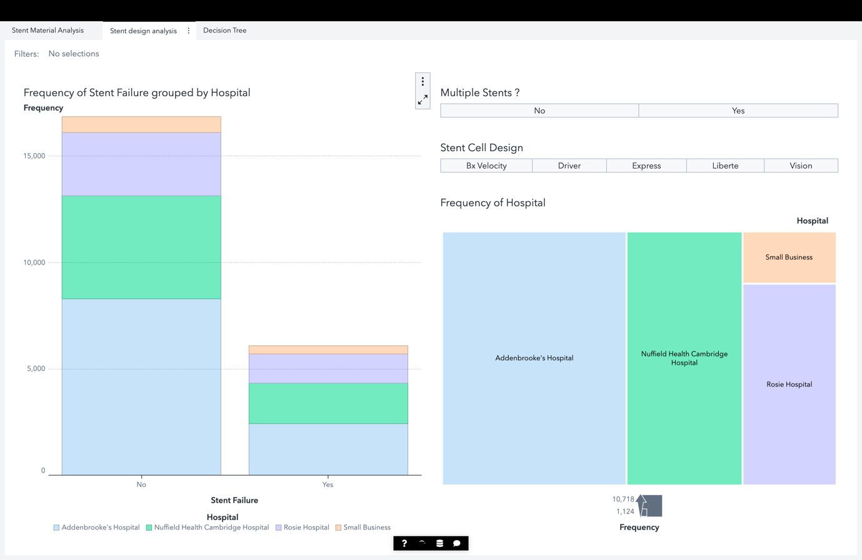  
From this deck, we can determine which stent cell designs lead to the highest failure rates and how is this metric affected by stent failure. We can also see which hospitals contribute to the largest amount of failures. To get more in-depth analysis about a given hospital, we have added an interaction between the tile plot and the bar chart. When a hospital is picked on the Tile, the bar reflects the stats of only that hospital on a blown-up scale to better highlight the contrasts.

Figure 5 : Board 2 showing the effect of Stent Cell Design and multiple stents on stent failure.

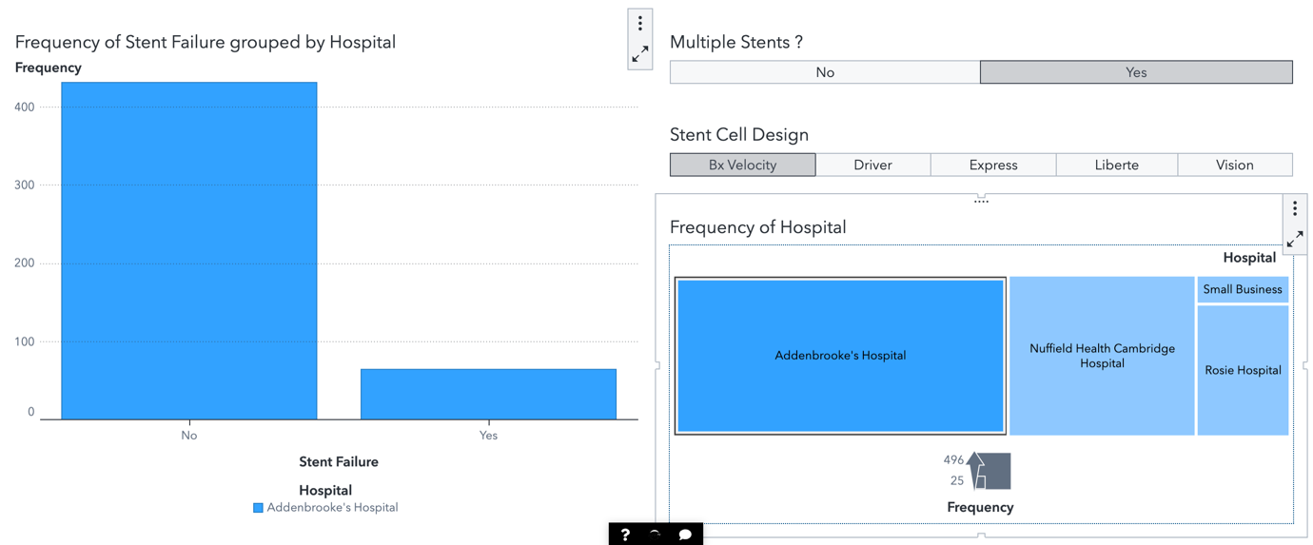

Figure 6 : Interactions on page 2 of the report.

Table 2 : Setup for page 2 of report.

|  |  |  |  |
| --- | --- | --- | --- |
| **Chart Name** | **Links** | **Role Name** | **Role Value** |
| Bar chart | Button Bar 1 | Category | Stent Failure |
| Button Bar 2 | Grouping | Hospital |
| Treemap | Measure | Frequency |
| Treemap | Button Bar 1 | Tile | Hospital |
| Button Bar 2 | Measure | Frequency |
| Bar chart |
| Button Bar 1  (Multiple Stents) | Bar chart | Category | Multiple Stents |
| Tree map |
| Button Bar 2 (Stent Cell Design) | Bar chart | Category | Stent Cell Design |
| Tree map |

On the third page we have a decision tree.

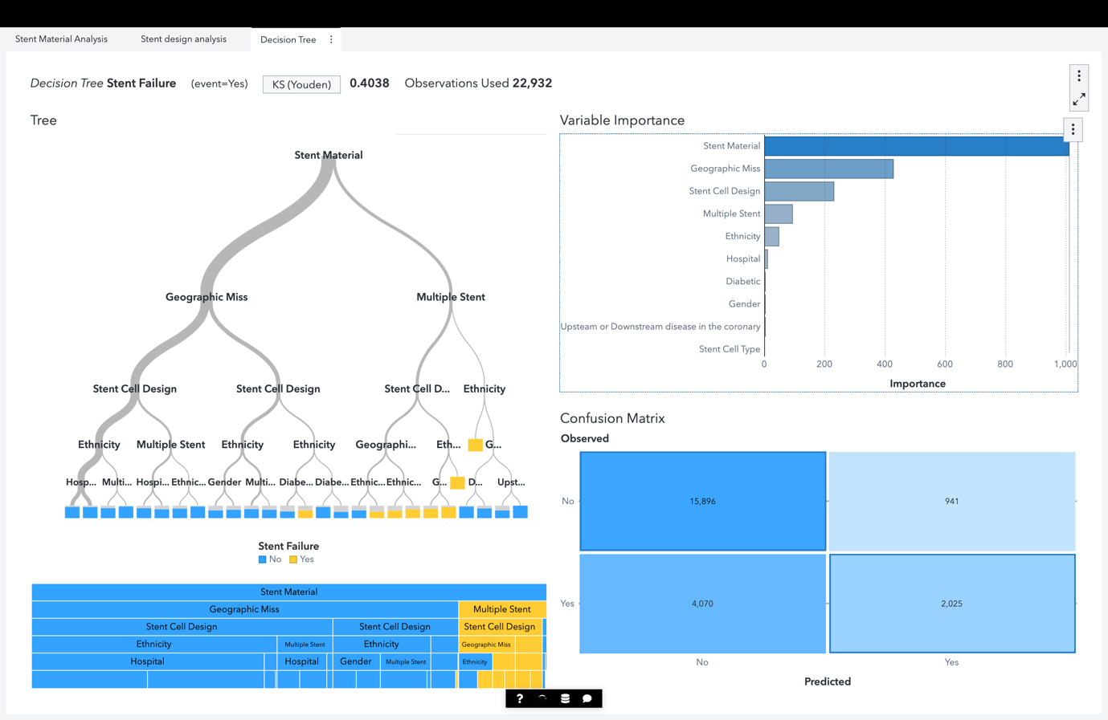

Figure 6 : Decision tree based on all 11 categorical metrics.

The decision tree can help predict the stent failure with an accuracy of ~ 80%. It uses all the categorical variables as input. It also highlights the most important variables, i.e Stent Material.

Table 3 : Setup for page 3 of report.

|  |  |  |
| --- | --- | --- |
| **Chart Name** | **Response** | **Predictors** |
| Decision Tree | Stent Failure | Hospital |
| Multiple Stent |
| Stent Cell Design |
| Stent Cell type |
| Diabetic |
| Ethnicity |
| Gender |
| Geographic Miss |
| Stent Material |

## Conclusions and Learning Outcomes.

1. We determined that the chance of stent failure is independent of the gender as seen from the pie chart in board 1.
2. The Biodegradable Drug-Eluting coating stent has the worst performance as it has the highest failure rate. The Bare Metal stent material has the best performance.
3. To further decrease the chance of stent failure, the proposed dimensions are 72.17mm, 27.67mm, 11.82mm (length x width x thickness).
4. If a patient has a single stent, then it is advisable to have the stent cell design as BxVelocity or Liberte and if the patient has multiple stents, then the performance of all designs is fairly similar.
5. A patient having no multiple stents has a higher chance of a stent failure by almost 20%.
6. The accuracy of the decision tree was found to be ~ 80%.

## Link to SAS Report:

https://v4e072.vfe.sas.com/links/resources/report?uri=%2Freports%2Freports%2Ffd0c95ca-216e-4361-8357-e90751897c9e&page=vi2693