**APPENDIX 1**

**VEHICLE BREAKDOWN ASSISTANCE**

END TERM REPORT

*by*

**Somesh Kumar Jena**

**Rupinder Pal Singh**

**Prateek Tripathi**

SECTION**: K19RH**

ROLL NUMBERS: **16, 27, 05**



**Department of Intelligent Systems**

**School of Computer Science Engineering**

**Lovely Professional University, Jalandhar**

**April 2020**

**APPENDIX** **2**

**Student Declaration**

This is to declare that this report has been written by us. No part of the report is copied from other sources. All information included from other sources have been duly acknowledged. We aver that if any part of the report is found to be copied, I/we are shall take full responsibility for it.

____________

Somesh Kumar Jena

Roll number: 16

____________

Rupinder Pal Singh

Roll number: 27

____________

Prateek Tripathi

Roll number: 05

Place: __________

Date: __________

**APPENDIX 3**

**TABLE OF CONTENTS**

**TITLE PAGE NO.**

1. **Description………………………………………………...................1**
2. **Background………………………………………………………….2**
3. **Modules Description………………………………………………...3**
4. **Description of work division in terms of roles among students….4**
5. **Technologies and framework used………………………………..5**

**APPENDIX 4**

**BONAFIDE CERTIFICATE**

Certified that the project report VEHICLE ROADSIDE BREAKDOWN ASSISTANCE is the bonafide work of SOMESH KUMAR JENA, RUPINDER PAL SINGH, PRATEEK TRIPATHI who carried out the project work under my supervision.

SHABNAM Ma’am

25560

School of Computer Science and Engineering

**Description of the Project**

**Objective**

The proposed application helps to find mechanics easily and quickly. It is difficult to find mechanics nearby area wherever you are travelling. This system helps to overcome this issue by providing mechanic details in one click. Here the locator allows you to search mechanics from different locations. Admin is allowed to access and manage mechanic details. This online mechanic locator reduces work and can easily find the mechanics from various location. Reduces your time and cost. The main objective is to provide a better service and to make the process easily and finally appointing a mechanic quickly. Proposed system is accessed by three entities namely, Admin, Mechanic and User. A mechanic can perform task such as viewing request received from users and can also send feedback to the admin. User can send a request and can appoint a mechanic on respective date-time.

**Background**

Early motorists were often capable of carrying out minor repairs themselves, but as automobiles became more complicated, it became more difficult to carry out successfully. Some early local motoring clubs tried to support their members by encouraging them to help each other. A rota of members who would help other members was kept and, in some cases, cash was put aside to hire a tow vehicle if needed.

In the UK, The RAC (a former associate of The Royal Automobile Club) and The Automobile Association (AA) offer repair services to their members on the spot, tow to a local garage or the driver's home if nearby and in some cases provide onward journey services such as hire vehicles.

When communication technology and availability made it practical, a network of emergency phone boxes, placed at intervals by the roadside, was introduced in some countries. In recent years, the widespread ownership of mobile phones has, to a large degree, supplanted the need for an emergency phone network. Mobile technology has led to the development of free applications (apps).

Some automobile manufacturers also offer roadside assistance for their customers, sometimes for free for some period after the purchase of a new vehicle. Breakdown cover may include jump-starting an automobile, diagnosing and repairing the problem that caused the breakdown, towing a vehicle, helping to change a flat tire, providing a small amount of fuel when a vehicle runs out of it, pulling out a vehicle that is stuck in snow or helping people who are locked out of their cars.

**Modules Description**

* **Navigation Bar and Header**

The header provides the logo and navigation bar.

The navigation bar is fixed and moves along with the scrolling i.e. you can use the navigation bar whenever you want while using the website.

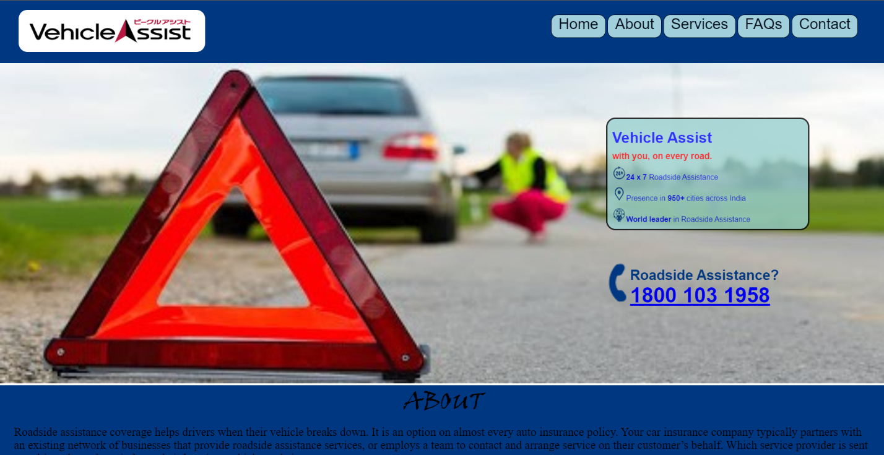

## **Home**

## It returns to the homepage of the website.

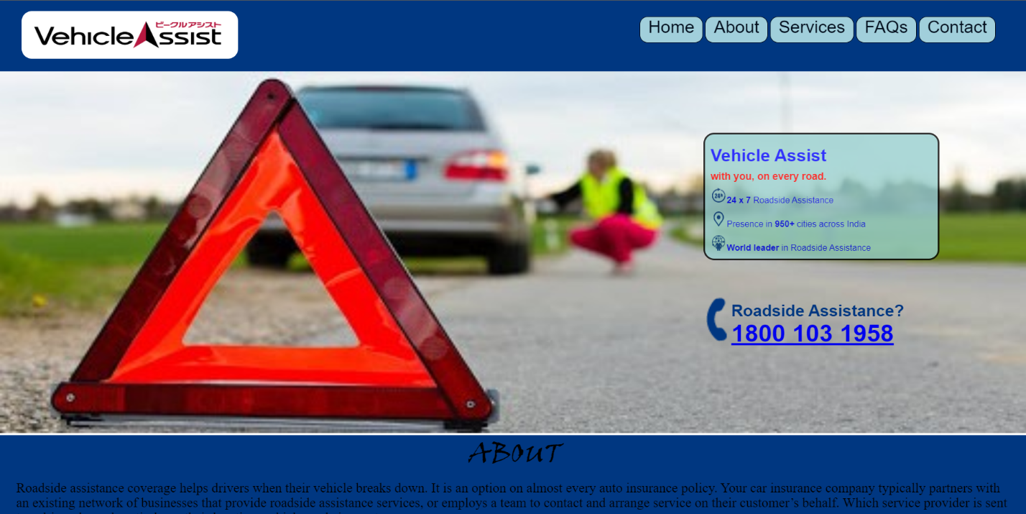

* **About**

It tells us about the website.

It provides a video which defines the vehicle roadside breakdown assistance system in an easy way.

It tells us why we should use vehicle assist website in an illustrative way.

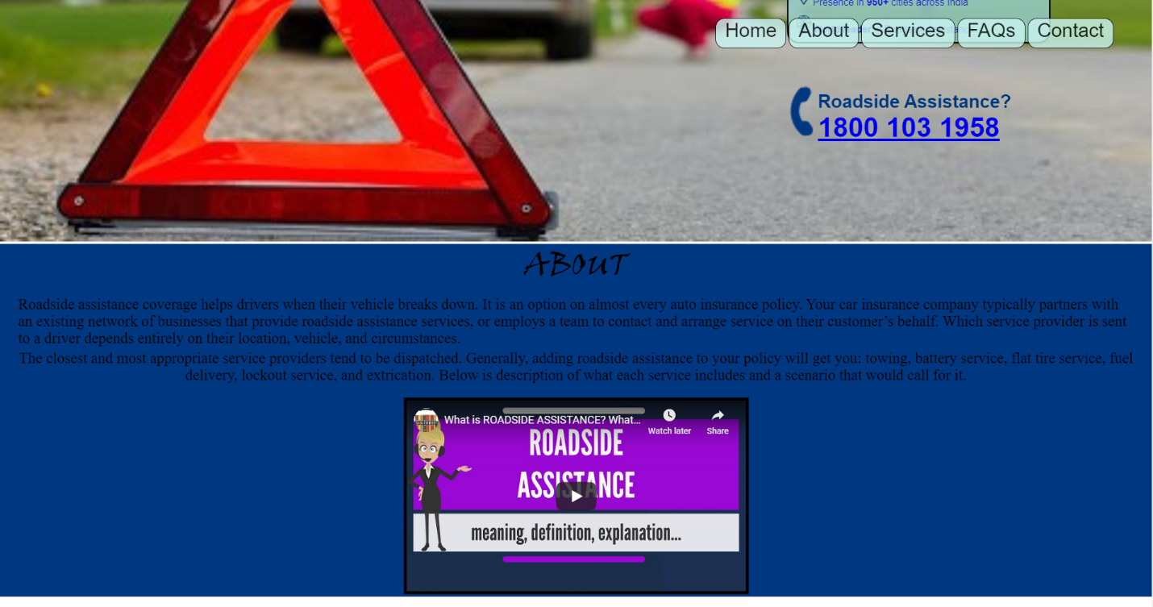

* **Services**

It tells us about the services the company offers through the website and personally in an easy and illustrative manner.

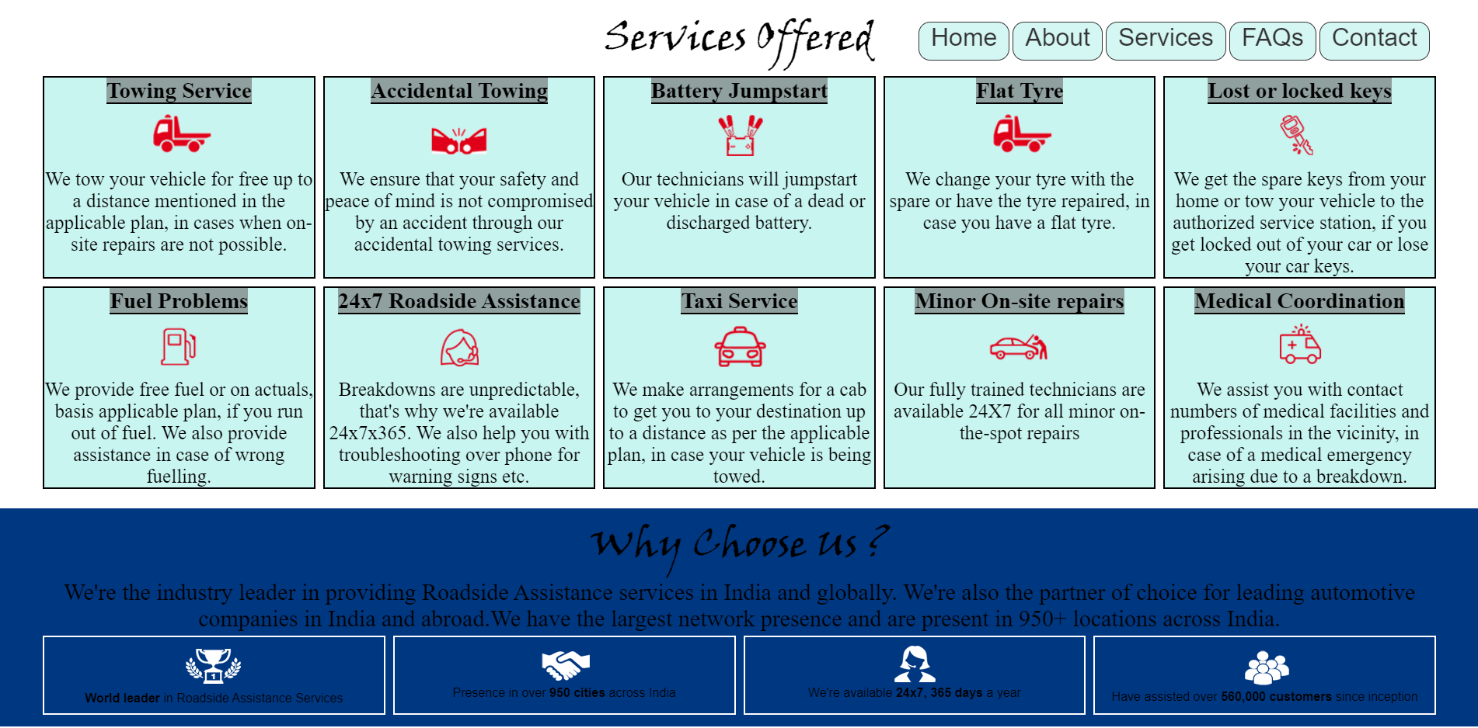

* **FAQs**

It tells us about the frequently asked questions by the users.

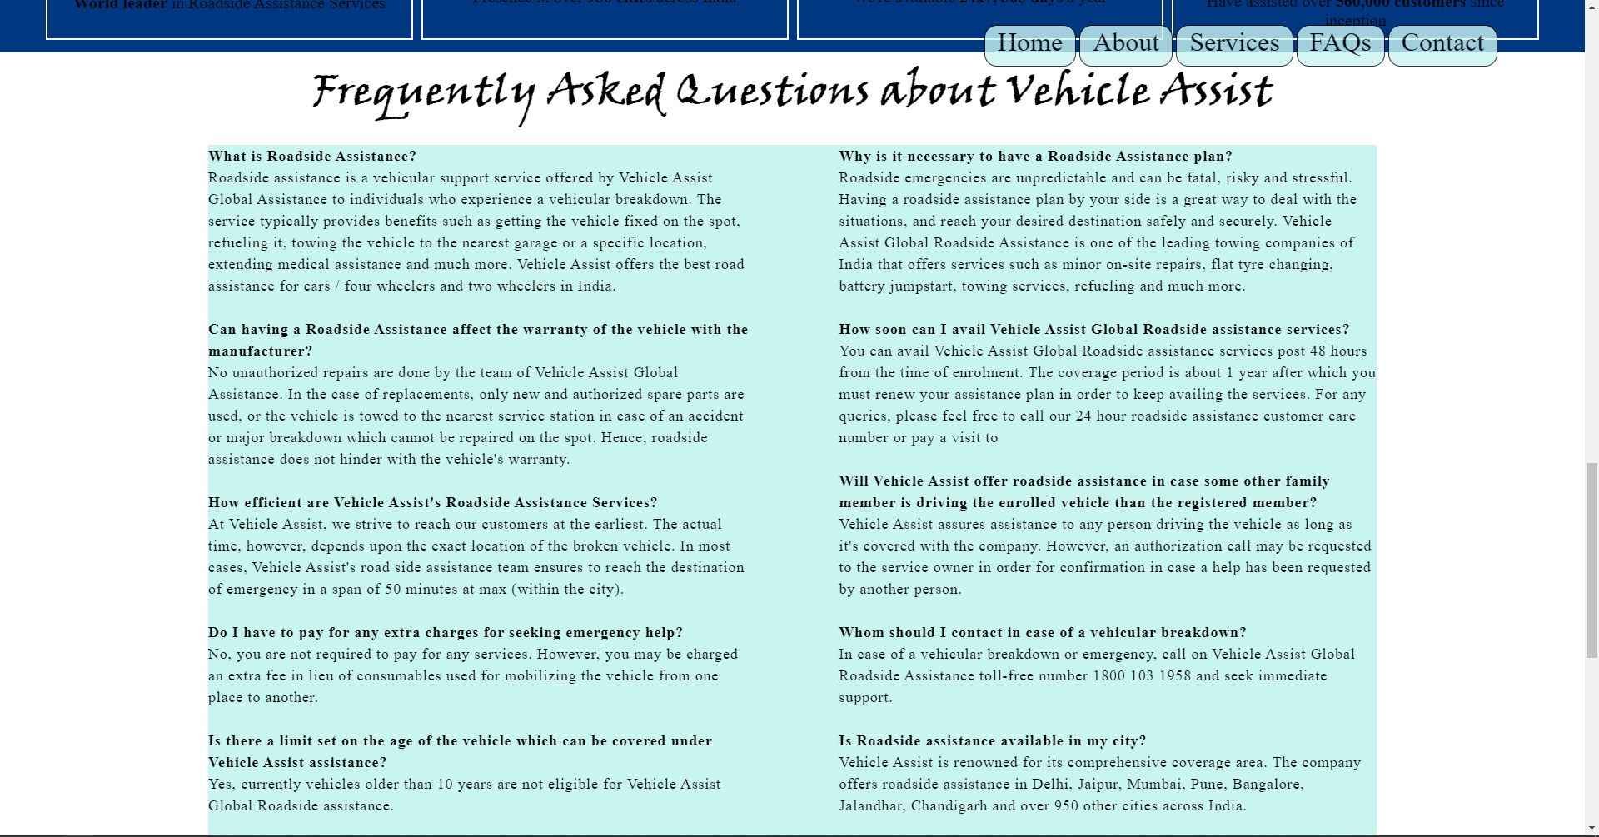

* **Contact**

It tells us the contacts information about the website and company. Like the address phone number and email address of the company.

It also asked the user to login to website to access the facilities of the website and if the user have any query then the user can ask by filling the login details.



**Description of Work Division in terms of Roles among Students**

Rupinder pal Singh (Roll- 27)

-Collect the information about the given topic

-Prepared the blueprint of the website.

Prateek Tripathi (Roll- 05)

-Prepared the report on the work and to compare the website with the blueprint.

Somesh Kumar Jena (Roll-16)

-Collected the data and images required from open(non-copyright) sources.

-Made the html for all the website.

-Made the CSS for the website.

-Uploaded Project to GitHub.

-Made the video describing the project.

**Technologies and Framework Used**

* **HTML**

Hypertext Markup Language (HTML) is the standard markup language for documents designed to be displayed in a web browser. Web browsers receive HTML documents from a web server or from local storage and render the documents into multimedia web pages. HTML describes the structure of a web page semantically and originally included cues for the appearance of the document.

* **CSS**

Cascading Style Sheets (CSS) is a style sheet language used for describing the presentation of a document written in a markup language like HTML.CSS is a cornerstone technology of the World Wide Web, alongside HTML and JavaScript.CSS is designed to enable the separation of presentation and content, including layout, colors, and fonts. This separation can improve content accessibility, provide more flexibility and control in the specification of presentation characteristics, enable multiple web pages to share formatting by specifying the relevant CSS in a separate .css file, and reduce complexity and repetition in the structural content.

* **VS Code**

Visual Studio Code is a source code editor that can be **used** with a variety of programming languages, including Java, JavaScript, Go, Node.js and C++. Instead of a project system it allows users to open one or more directories, which can then be saved in workspaces for future reuse.

All the coding of html and CSS is done in vs code using various extensions like – Beautify, HTML Snippets, Color Picker etc.

* **GitHub**

GitHub is a Git repository hosting service, but it adds many of its own features. While Git is a command line tool, GitHub provides a Web-based graphical interface. It also provides access control and several collaboration features, such as a wikis and basic task management tools for every project.