

**SHRI G.S INSTITUTE OF TECHNOLOGY AND SCIENCE**

**Department: C.S.E.**

**Subject: Design Thinking Lab-I (CO24991)**

**Title: Notify app that keep people updated about events**

**Submitted To**

**Dr. Urjita Thakar**

**Dr. Anuradha Purohit**

**Mrs. Ritambhara Patidar**

**Mrs. Priyanka Kokate**

**Submitted By**

**Ramkrishna Patidar**

**0801CS211073**

**INDEX**

|  |  |  |  |  |  |
| --- | --- | --- | --- | --- | --- |
| **S.No.** | **Contents** | **Page No.** | **Date of Submission** | **Sign** | **Remark** |
| 1 | Phase-I:  Empathy Phase | 1-4 |  |  |  |
| 2 | Phase-II:  Define Phase | 5-6 |  |  |  |
| 3 | Phase-III:  Ideate Phase | 7-8 |  |  |  |
| 4 | Phase-IV:  Prototype Phase | 9-10 |  |  |  |
| 5 | Phase-V:  Test Phase | 11 |  |  |  |

**PHASE 1**

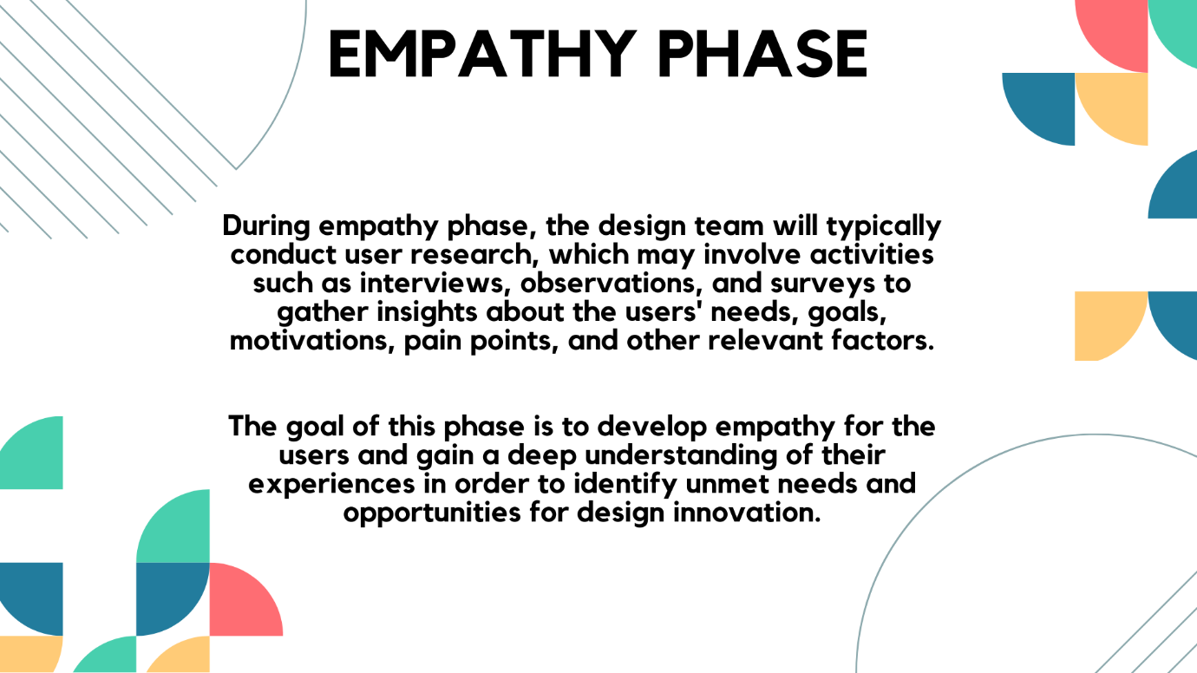

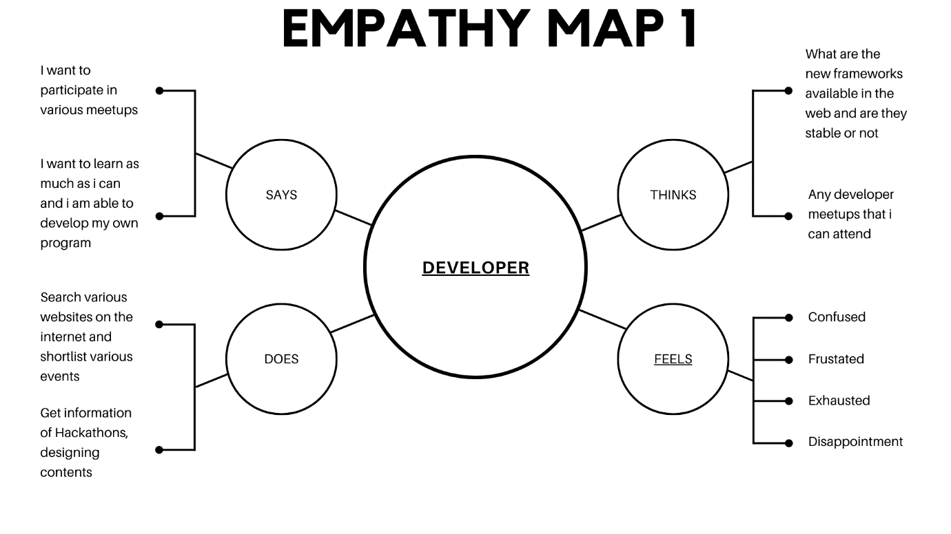

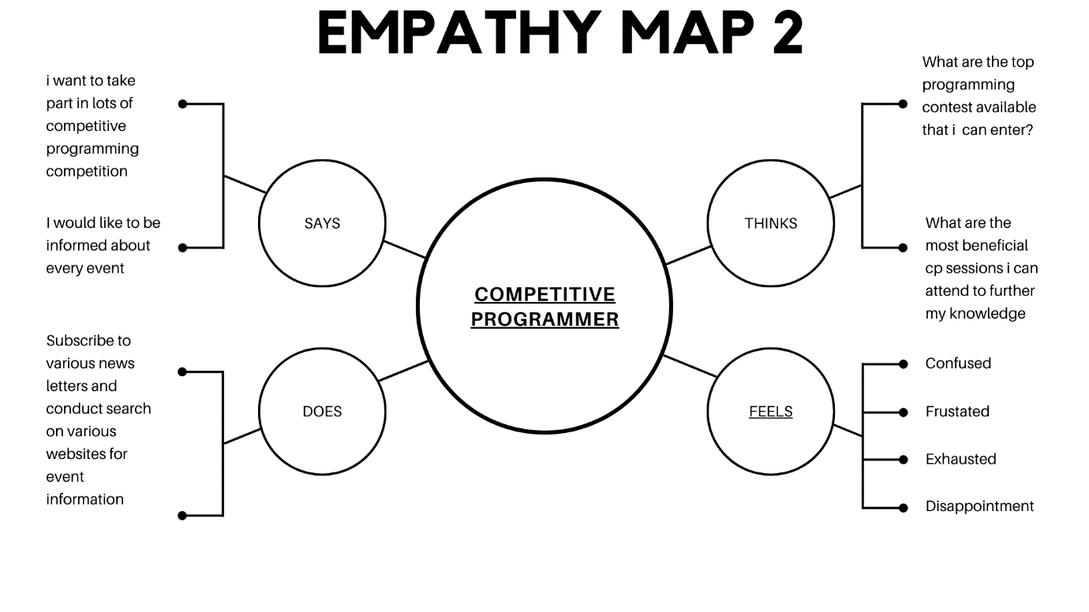

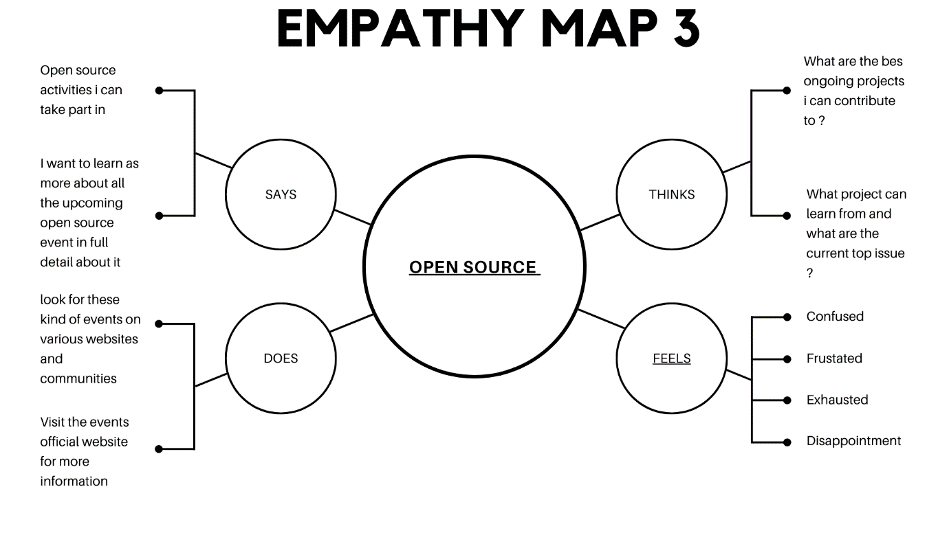

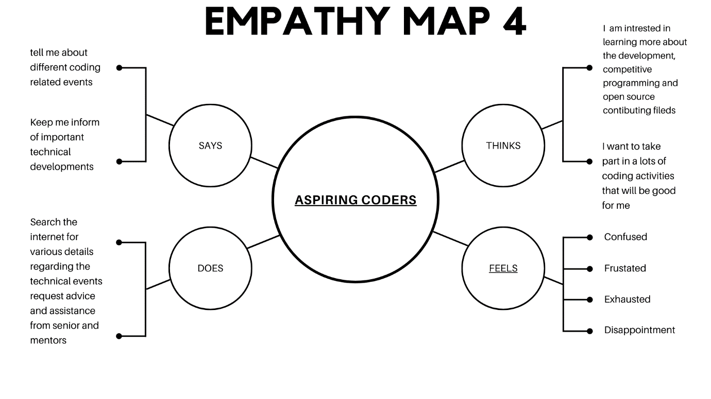

**USER PERSONAS**

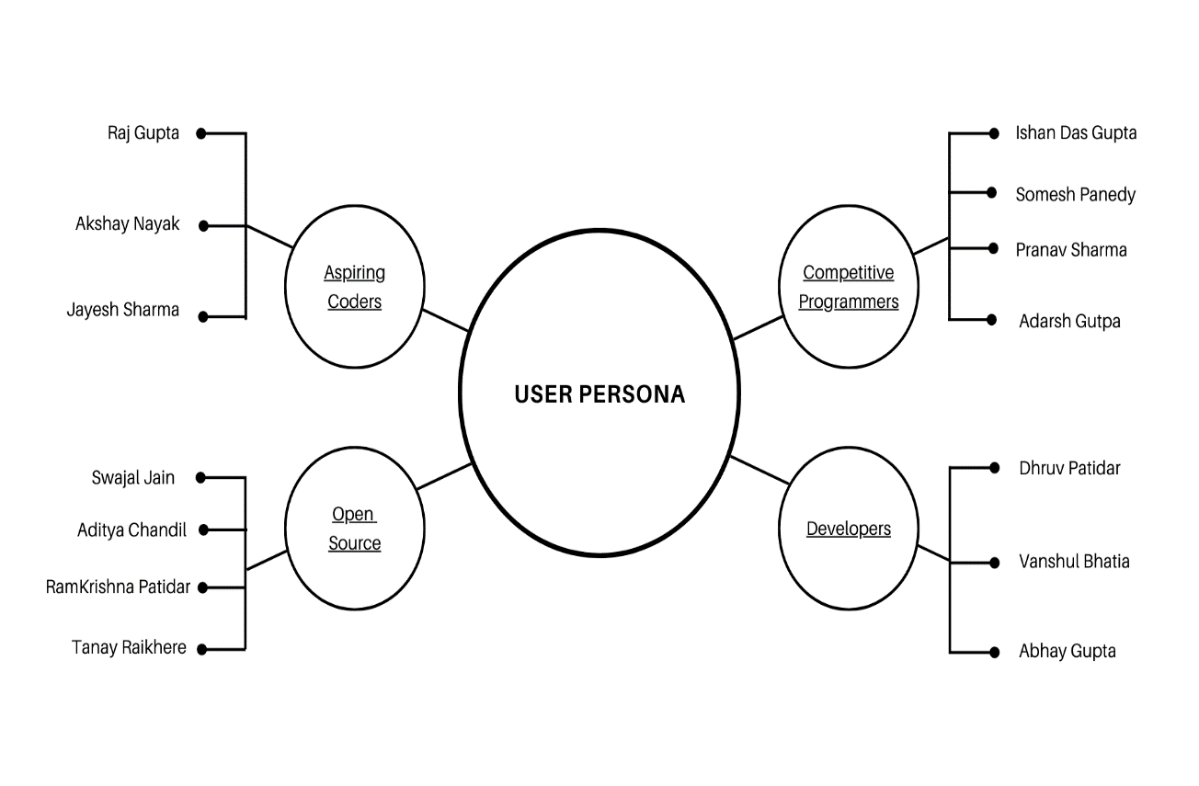

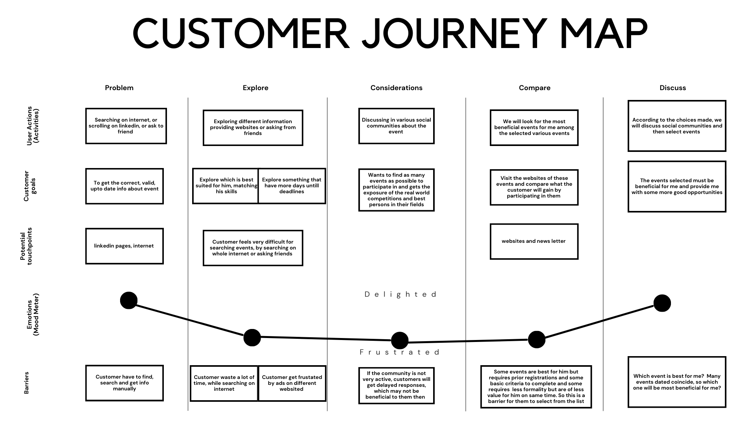

**PHASE 2**

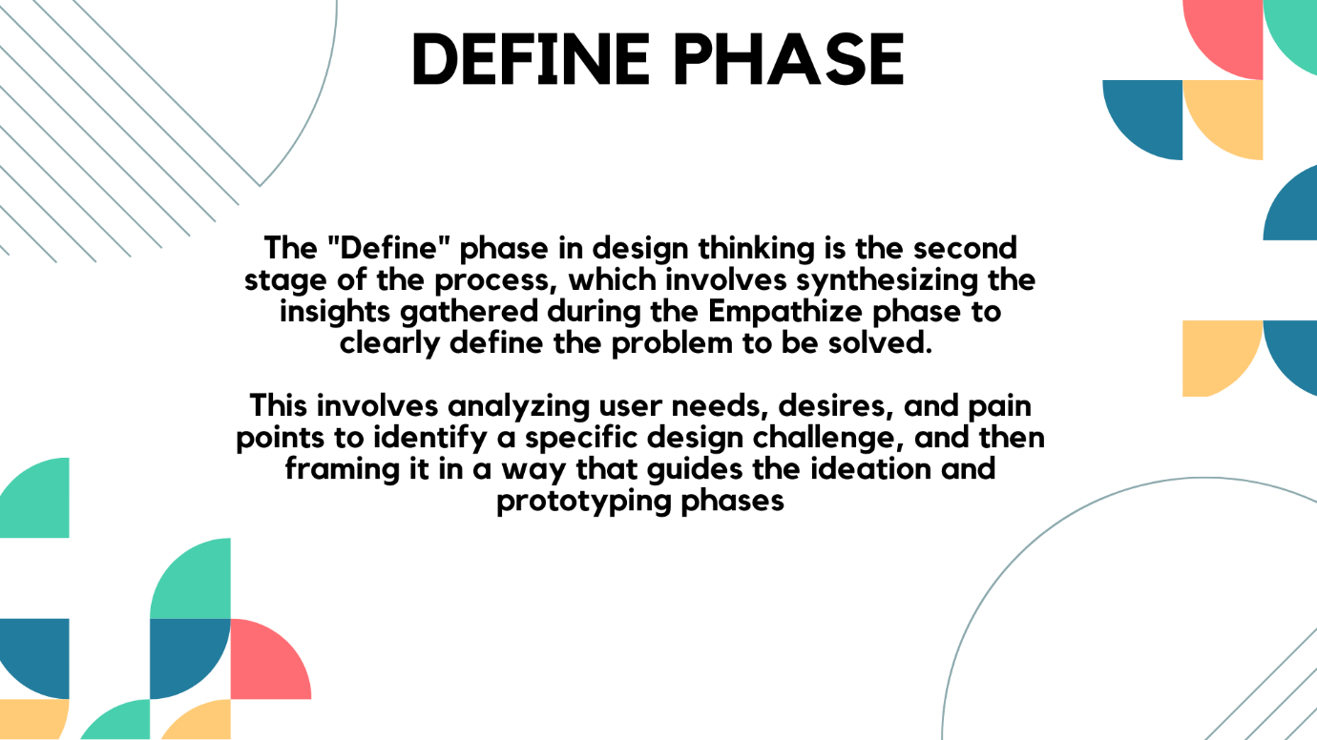

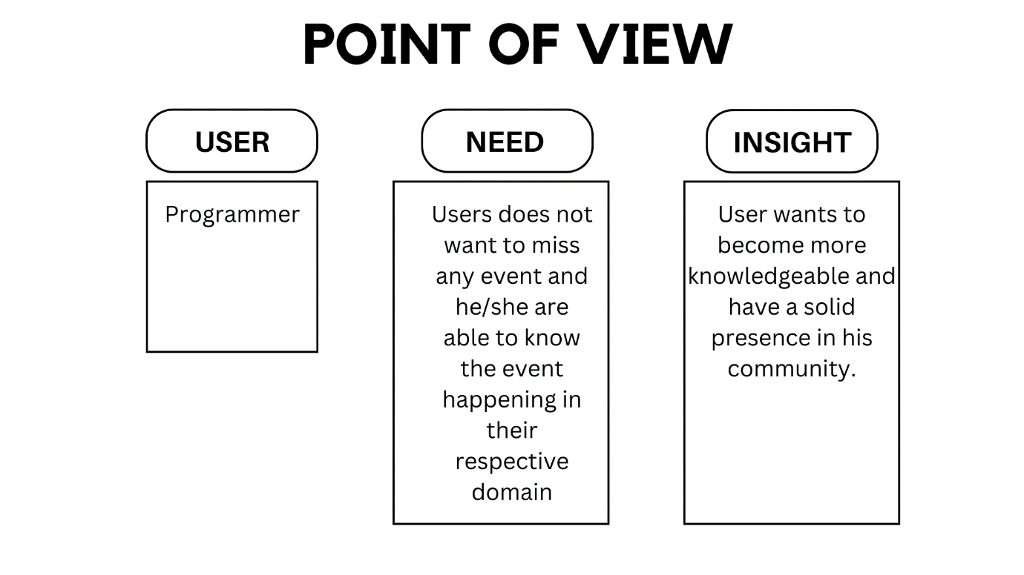

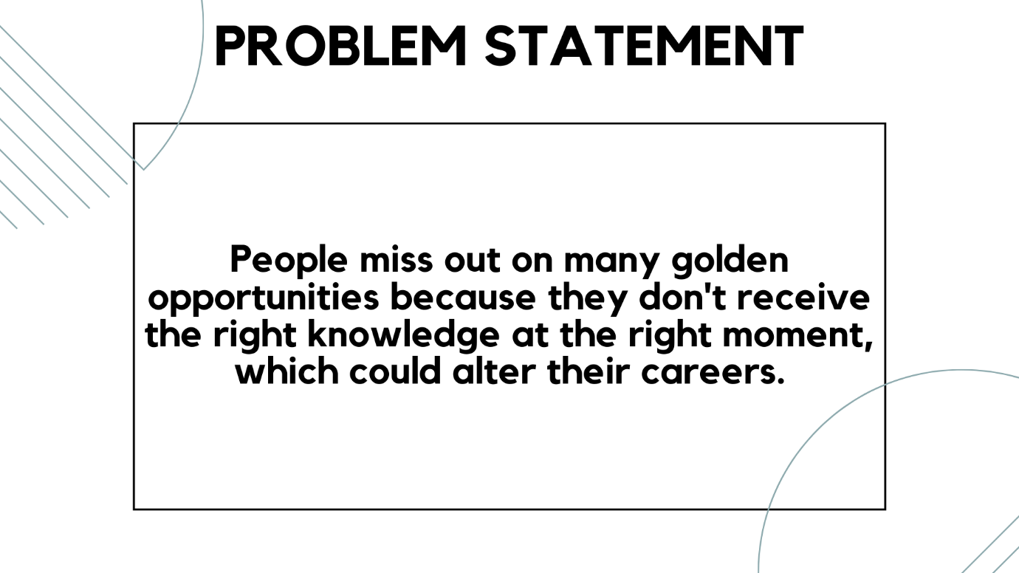

**PHASE 3**

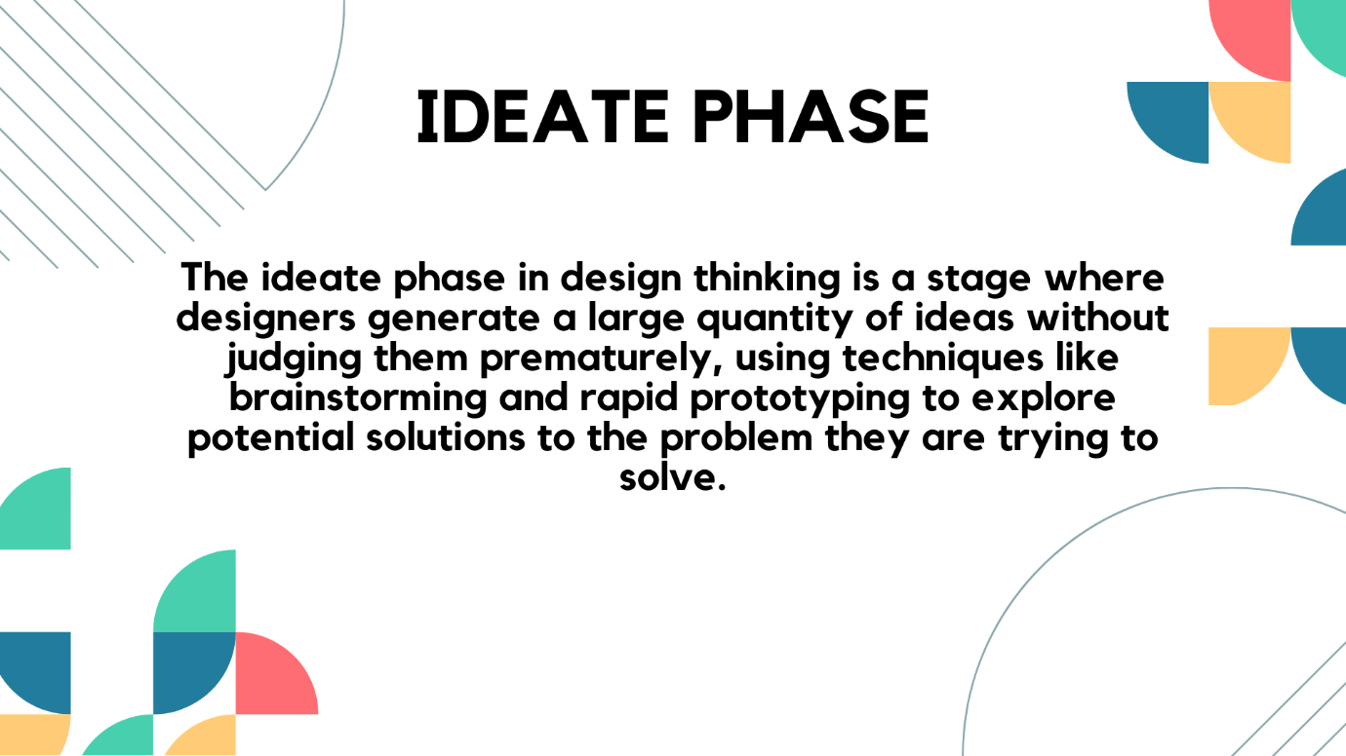

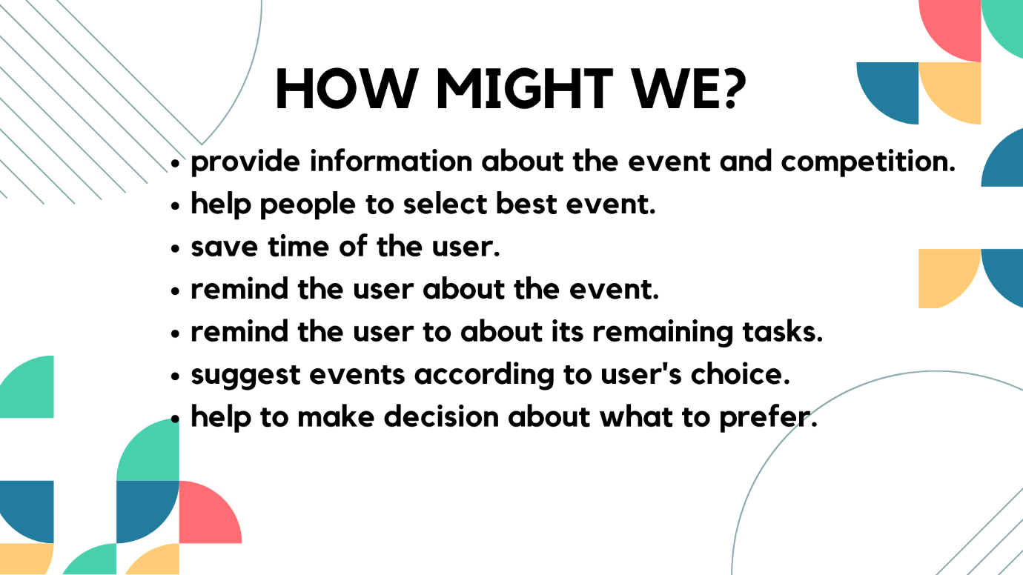

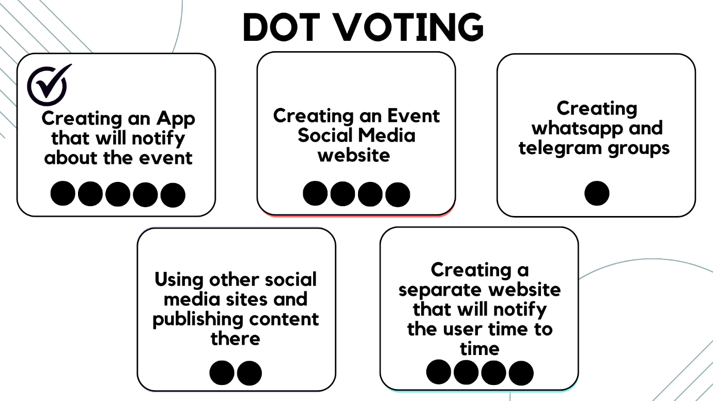

**PHASE 4**

**Prototype**

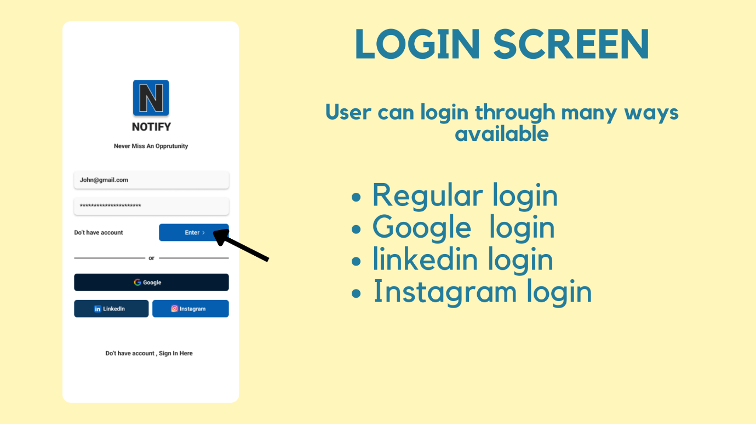

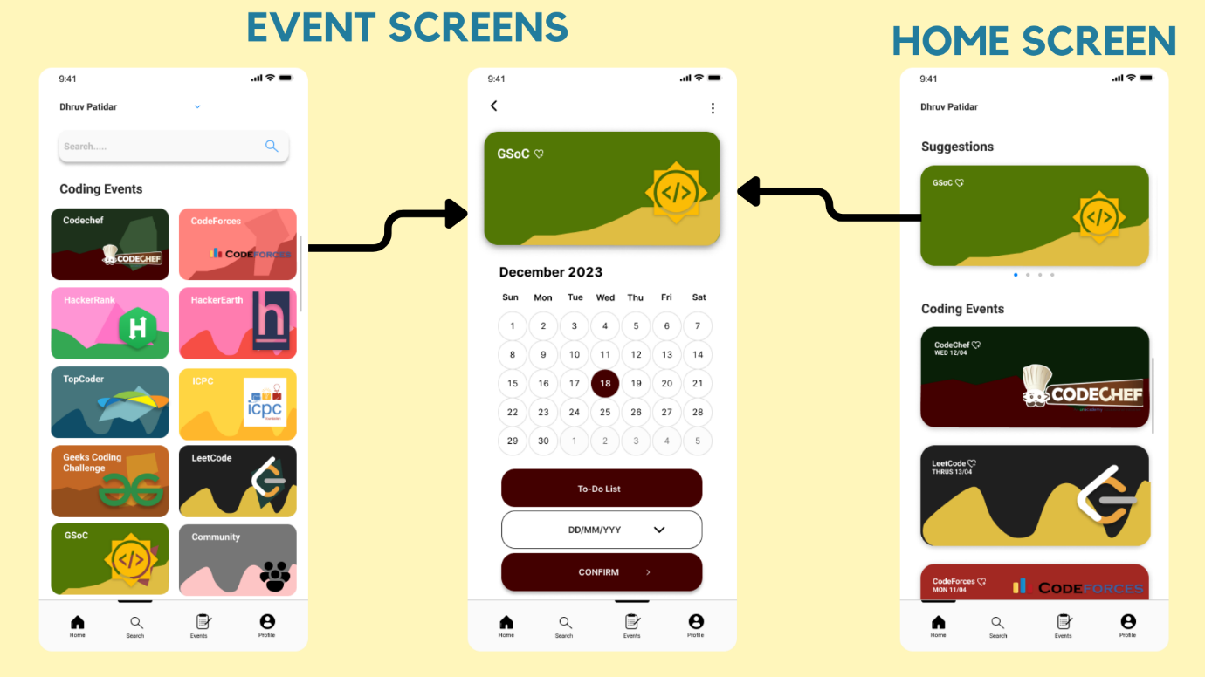

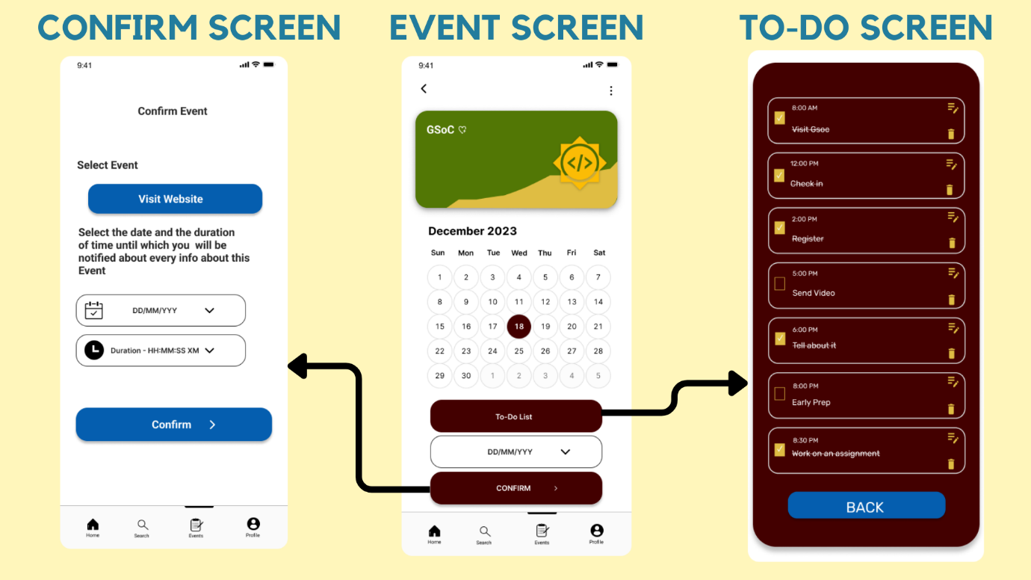

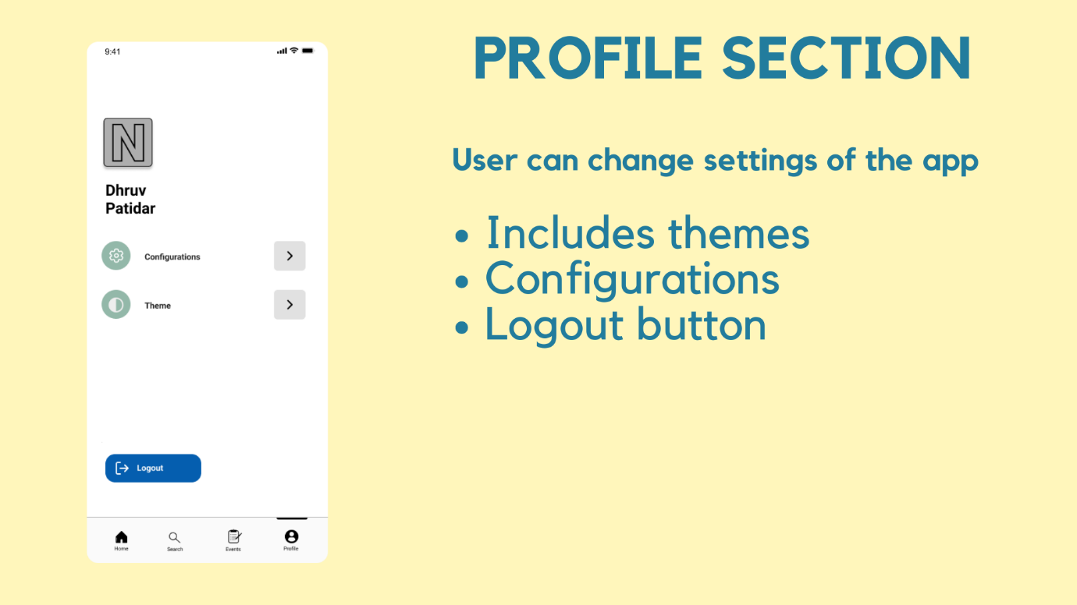

**PHASE 5**

**TESTING**

