EXPERIMENT = Design automatic led Diwali lights (consisting of 6 led’s) such that it only works during night and can generate two patterns which can be toggled with switch. a. Pattern 1 –led chaser b. Pattern 2 – even-odd led’s

CIRCUIT DIAGRAM –

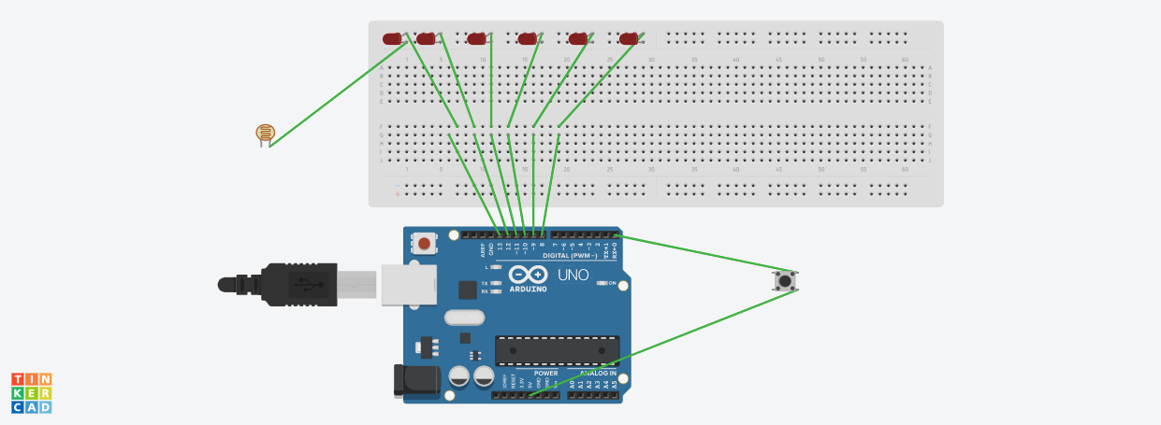

CONCEPTS USED –

Working of Arduino Uno.

Working of LEDs (Light emitting diodes).

Basic concept of making connections to make a circuit. Concept of series and parallel connections. Coding in Arduino uno and syntaxes.

Use of photoresistor. And use of switch and coding required to do so.

LEARNING AND OBSERVATIONS –

I learned how a Arduino works and how to upload code into it to do our desired work and also how to make specific connections to form a working circuit. Workings of a diode like LED’s and how a resistor prevents it from fusing off were some of other things I learned. I also learned the function of delay function more clearly and how to use it more efficiently. I observed that how on uploading certain codes into Arduino, LED’s started flashing according to pattern we wanted and

observed that codes were very similar to what we do in C programming language.

PROBLEMS AND TROUBLESHOOTING –

I faced problem in setting delays correctly between blinking of LED’s so pattern we wanted should appear clearly, I troubleshooted it by setting various delays and seeing the output and making changes simultaneously until I found the correct delay.

I faced problems in connecting the both patterns of led chaser and even odd pattern.

PRECAUTIONS –

1. Declare all the ports in use in digital input/output in the right way. 2. Check whether all your wire pieces are working correctly and all connections are good.

3. TRY to find right amount of delay by approximations and seeing the outputs

LEARNING OUTCOME – Better understanding of Arduino uno and its coding and how to use it.